山东省威海市2012年中考英语真题试题（无答案）
亲爱的同学：
你好! 答题前，请仔细阅读以下说明：
1.本试卷共12页，分第Ⅰ卷和第Ⅱ卷两部分。第Ⅰ卷1至7页，第Ⅱ卷8至12页，
共120分。考试时间90分钟。
2.请清点试卷，然后将考生信息填涂在答题卡上，并将第Ⅱ卷密封线内的项目填写清
楚。
3.将选择题答案用2B铅笔涂在答题卡对应题目的标号上，将非选择题答案用蓝色或黑
色钢笔、圆珠笔填写在试卷指定位置上。
希望你能愉快地度过这90分钟，祝你成功！
第Ⅰ卷（共70分）
一、听力测试（共25小题, 计30分）
（一）看图听句子，选择与画面意思一致的选项。每组句子听一遍。(每小题1分)

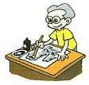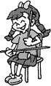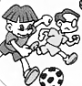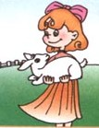
1. A B C 2. A B C 3. A B C 4. A B C
（二）听句子，选择适当的答语。每个句子听两遍。(每小题1分)
5. A. She is a nice girl. B. I’m sorry to hear that. C. What a pity!
6. A. Thank you. B. I don’t like them at all. C. Coffee, please.
7. A. That’s all right. B. That’s wrong. C. You are welcome.
8. A. Yes, I’d love to. B. I don’t mind. C. I feel terrible.
9. A. Red roses. B. Sounds good. C. I like white.
10. A. My teacher praised me. B. I lost the game. C. I’ve been to Japan.
（三）听对话和对话后的问题，选择正确答案。每组对话听两遍。(每小题1分)
11. A. Twenty-five minutes. B. Thirty minutes. C. Thirty-five minutes.
12. A. On the right. B. Next to the bookstore. C. Next to the post office.
13. A. He’s a pilot. B. He is a ship captain. C. He is a truck driver.
14. A. Husband and wife. B. Neighbors. C. Father and daughter.
15. A. In a post office. B. In a restaurant. C. In a bank.
（四）听一段长对话，然后选择能回答问题的正确答案。对话听两遍。(每小题1分)
下面你有10秒钟的读题时间。
16. Why does Mike look worried?
A. Because he is not interested in English.
B. Because he lost his bag.
C. Because he’s having trouble learning English.
17. How should Mike improve his pronunciation?
A. By watching TV.
B. By listening to the teacher’s tapes.
C.By listening to the radio.
18. What should Mike do with the new words?
A. Write them in his notebook and study them.
B. Repeat them at any time.
C.Write them on the blackboard.
19. When does the English club meet?
A. On Tuesday. B. On Friday. C. On Tuesday and Friday.
20. Mike should ______ to practice his writing.
A. find a pen pal B. write a diary C. join the English club
（五） 请听短文，然后补全短文中所缺的单词。(每小题2分)
下面你有10秒钟的读题时间。请将答案填写到第7页答题区内指定位置。
When I was fourteen, I was too nervous to talk to anyone. My classmates often laughed at me. I was sad and could do nothing. Later, something happened and 21._________ my life. My mother asked me to take part in an English speech contest. It 22._________ I had to speak in front of all the teachers and the students.
“Come on, boy. Just believe in yourself. You are sure to win.” Then we talked about many 23. . At last I chose the topic "Believe in yourself". I tried my best to remember all the speech and practiced it over 100 times. 24._________ of my mother's love, I did well in the contest. I could 25._________ believe my ears when the news came that I had won the first place.
二、选择填空（共15小题, 计15分）
从每小题A、B、C、D中选出一个能填入句中空白处的最佳答案。
26. —Did you get there by ______ bike?
—No, I took ______ taxi.
A. a; a B. 不填; a C. the; the D. a; the
27. —Excuse me, are these ______ new shoes?
—No, they aren’t. ______ are black over there.
A. your; Mine B. my; Your C. her; Her D. mine; Yours
28. —Mom, shall we have supper now?
—Oh, we won’t have supper ______ your dad comes back.
A. until B. since C. while D. after
29. —Which do you like , summer or winter?
—I prefer summer.
A. good B. well C. better D. best
30. —Your sweater looks nice, is it made of wool?
—Yes, and it’s made ______ Shanghai.
A. by B. in C. for D. from
31. —I prefer speaking to listening in English learning.
—Oh, really! I think you should be good at ______ of them.
A. both B. neither C. some D. all
32. —Yao Ming is very popular among teenagers.
—Yes. Many middle school students are his ______.
A. heroes B. stars C. fans D. brothers
33. —I feel tired and sleepy.
—Why not stop ______ for a while?
A. rest B. to rest C. resting D. rested
34. —Jack, could you help me when the plane will take off on the Internet?
—I’m sorry, my computer doesn’t work.
A. get out B. look out C. take out D. find out
35. —The little girl ______ her seat to an old man on the bus.
—What a kind girl!
A. brought B. offered C. gave D. lent
36. —Tom wants to know if you will have a picnic tomorrow.
—Yes. But if it ______, we’ll play chess instead.
A. will rain B. rained C. is raining D. rains
37. — ______ do you read English newspapers?
—I read China Daily every day.
A. How long B. How soon C. How often D. How far
38. —Must I learn all these words by heart?
—No, you ______. It’ll be fine if you copy them in your exercise books.
A. needn’t B. can’t C. shouldn’t D. mustn’t
39. —Can you guess ______ the new schoolbag yesterday?
—Sorry, I’ve no idea.
A. how much did he pay for B. how much he spent
C. how much he paid for D. how much did he spend
40. —Happy birthday to you, Mary!
— ______.
A. Thanks a lot B. The same to you
C. You’re welcome D. It’s kind of you
三、阅读理解（共三篇短文，15小题，计25分）
阅读下面A、B两篇短文，根据短文内容，从短文后面每小题所给的四个选项中选择最佳答案。（每小题1.5分）
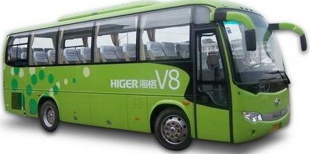

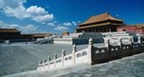
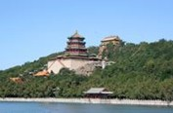
A
East Bus -– maybe the best choice on your visit to the famous places of interest in Beijing.
Sit back, relax and see all there is to see, with no need to worry about driving, finding a parking place or leaving your car with no one to watch it.
We have lots of buses taking you to visit Tan’anmen Square, the Fofbidden City, the Summer Palace, the Templeof Heaven Park, the Olympic Center and the Great Wall. The whole tour will take you there three days.
Chinese & English speaking guides.
Booking by photo four days advance(预先).
Tour price: ￥580.00 per person( half price for children under 1.2m tall), including the ticket price,breakfast and lunch.
For more information, please phone Yong’an Tourism Company at 010-23368688/23368689.
Add: 356 Chaoyang Road, Beijing.
Open 7 days a week.8:00-16:00

Our Bus Can Make Your Holidays

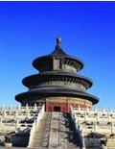

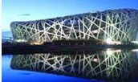
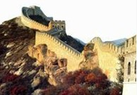

41.When they visit the places of interes on an East Bus, the visitor _________.
A.need to watch their cars
B.have to worry about the driving
C.have to find places to pasrk their car
D.can sit back and relax themslves
42.From the advertisement, we can see that East Bus is a kind of _________.
A.tourist bus B.village bus C.airport bus D.school bus
43. _________ on ab East Bus can speak two languages.
A.The guide B.The driver C.The visitors D.The children
44.Children under 1.2m tall need to pay _________ for the trip.
A.230 yuan B.290 yuan
C.320 yuan D.460 yuan
45.Which of the following is NOT true?
A.The tour price includes six meals.
B.Visitors can see six places within three days.
C. Visitors mst go to the company to book the tickets.
D.The office hour of the company is eight hours a day.
B
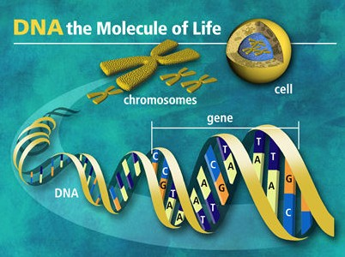
On June 26, 2000, two scientists, called Francis Collins and Craig Venter, told the world that they could now read the whole “map” of the human body: DNA. DNA is something that everybody has, and it tells the body what to do. DNA is the reason that we look like our mother and father, because we get some of their DNA to make our own.
People have been trying to understand the human body for a long time. In 1860, Gregor Mendel discovered a special reason why we look the same as other people in our family. It is because of small things named “genes” in our body. In 1953, James Watson and Francis Crick made another discovery and found out that those small parts are real messages written in the DNA with a special language.
In 1961, Marshall Nirenberg and Johann Matthaei found a message in DNA showing how DNA tells the cell (细胞) to build its parts. Scientists have now found all the words in the DNA map, but we still do not understand what they all do. By understanding what just one “word” means, we can help save more people from several illnesses.
Most people hope that this will help make better medicine and help sick people. Other people worry that when people begin to know more words and find out lots of other information, we might use it in a wrong way, just to make people more attractive, or stop sick people from getting jobs. Man would have to meet a lot of trouble if DNA technic wasn’t limited in use.
46. When did we first know why we look like other people in our family?
A. In 1860. B. In 1953. C. In 1961. D. In 2000.
47. What does the underlined word “gene” mean?
A. The “map” of DNA. B. A special language.
C. Small parts of DNA. D. DNA.
48. What did the two scientists first discover in 1961?
A. The “map” of DNA. B. A new illness.
C. The language of DNA. D. A message of DNA.
49. What can we do if we understand some “words” of the language inside the body?
A. Make people get new jobs. B. Make medicine for illnesses.
C. Make maps of human. D. Make people less attractive.
50. What do people think about this work?
A. It can cause good or bad resutls. B. It can cause only good results.
C. It can cause good results but won’t work. D. It can cause only bad results.
C
阅读短文，根据其内容简要回答问题。（每小题2分）
请将答案填写到第7页答题区内指定位置。
Draw a giraffe in your mind. How did you draw your giraffe? Does it have a long neck? Does it have long legs? Is it really tall? When people think of giraffes, they think of their long necks. A long neck and four long legs make the giraffe the tallest land animal on earth. A giraffe is 1.8m tall when it is born, and some giraffes get up to 6m tall when they are all grown up.
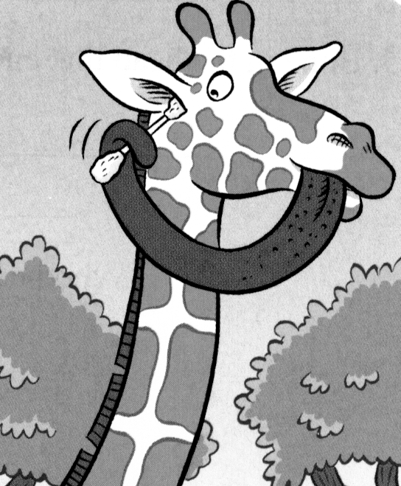
But did you know that giraffes also have long tongues? Have you seen the tongue of a giraffe before? A giraffe has a very long tongue which can hold and wrap (包) around objects. The tongue is designed for feeding, but it can be used in many different ways. For example, a giraffe can close its nose with its long tongue completely to keep out sand and dust. Also, a giraffe’s tongue is long enough to clean its owner’s ears as well!
The tongue is black in colour to protect it from getting sunburnt (晒伤). It is nearly 56cm long. Giraffe only eat plants, and a full grown giraffe can eat 33kg of leaves a day. When giraffes look for some tall trees to eat, they sometimes fight with elephants for food. Giraffes use their tongue to eat leaves from some tall trees. The giraffe’s tongue is a helpful tool for reaching leaves and breaking off branches.
51. What is this article mainly about?
52. What does a giraffe feed on?
53. What color is the tongue of a giraffe? Why?
54. Give two examples of the use of the giraffe’s tongue.
55. Translate the underlined sentence in the first paragraph into Chinese.

绝密★启用前
威海市二○一二年初中学业考试
英 语
第I卷 笔答题区

一、听力测试
得分 | 评卷人
（五）21—25小题，每小题2分

21. ____________ 22. ____________ 23. ____________
24. ____________ 25. ____________
三、阅读理解
得分 | 评卷人
（C）51—55小题，每小题2分

51. What is this article mainly about?
________________________________________________________________________
52. What does a giraffe feed on?
________________________________________________________________________
53. What color is the tongue of a giraffe? Why?
________________________________________________________________________
54. Give two examples of the use of the giraffe’s tongue.
_________________________________________________________________________
55. Translate the underlined sentence in the first paragraph into Chinese.
________________________________________________________________________
第Ⅱ卷(共50分)
四、单词拼写（共6小题，计6分）
得分 | 评卷人
得分 | 评卷人
根据句意和音标提示以适当形式填写单词。

51. There’s nothing in this box. Look, it’s e______________.
52. You’d better to keep your v______________ down when talking in public.
53. Jack is so smart that he can answer these questions ______________ (容易地) .
54. Both of my best friends were born in ______________ (十月) .
55. People will use robots to do the ______________ (家务) in the future.
56. Doing lots of listening practice is one of the ______________ (秘诀) of becoming a good English learner.
五、动词填空（共6小题，计6分）
得分 | 评卷人
得分 | 评卷人
用括号里所给动词的适当形式填空。
请将答案填写在短文后面的横线上。
Watch out for dangers at school
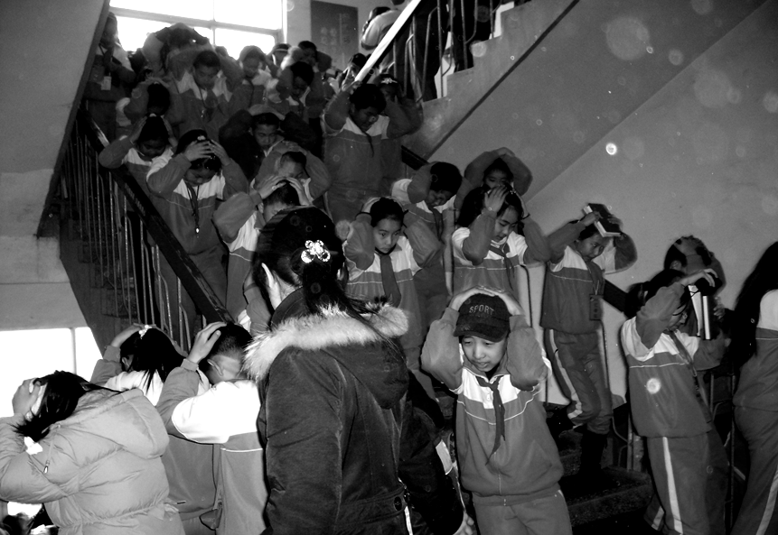
School is where we learn,make friends and grow up.But accidents happean daily in schools across the world.We hear reports of students falling from the building while cleaning the windows.Other students were hit by footballs at the playground.On December 7,2009,a had accident _________（happen）at a middle school in the of Xiangxiang,Hunan province. Some students fell down on the stairs and were stepped on by others, with sad results. What should we do to be safe at school? The students should _________（teach）safety tips at school inorder to protect themselves and others when accidents happen. The following are about the dangers at school and safety tips for you.
How to prevent a stampede
◆After class or school, don’t rush out at the time. _________（wait）until there are fewer people trying to leave.
◆When you walk with a crowd of people, stay alert and watch your steps.
◆When there _________（push）and squeezing, stand still and try to hold on to something. Or staying a corner until the crowed _________（leave）.
◆Learn to one side, curl up your body and bend your legs _________（protect）your organs.
62. ___________________ 63. ___________________ 64. ___________________
65. ___________________ 66. ___________________ 67. ___________________
六、完成句子 （共5小题，计15分）
得分 | 评卷人
根据所给汉语句子完成英语句子，词数不限。

68. 闫老师认为中学生应该把注意力集中在学习上。
__________________________________________________________________________
69. 嬉笑处于困境的人是不礼貌的。
__________________________________________________________________________
70. 这只小狗太有趣了，以至于我的生活充满欢乐。
__________________________________________________________________________
71. 辰辰如果看到这张照片，一定会想起她的爷爷。
__________________________________________________________________________
72. 汤姆，你去过中国最大的城市两次，是吗？
__________________________________________________________________________
七、短文填空(共8小题,计8分)
得分 | 评卷人
根据短文内容，选择适当的单词或短语填空，使短文意思完整。每个选项至多使用一次，有两项剩余。
请将答案标号写在短文后面的横线上。
A.around B.successful C.interesting D.changed E.enough F.more G.world H.only

When every Apple fan was waiting for the next surprise, Steve Jobs, the founder and former CEO of Apple, passed away on October 5th, 2011 at the age of fifty-six after a seven-year-long battle with cancer.
What is Jobs best remembered for? Many of us would name some great products (产品) : the iPod, the iTouch, the iPhone or the iPad. They have
73 the way we enjoy music, television, and even books.
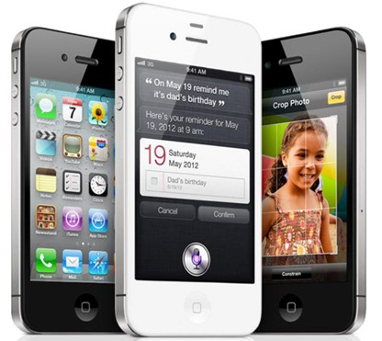
But Jobs brought much 74 to the world than these popular products. As a 75 businessman, Jobs' passion (激情) and energy encouraged the world. He told us to"do what you love". He said, "The 76 thing that keeps me going is that I love what Ido. " He believed "People with passion can change the 77 for the better. " Jobs made computers 78 and easy to use. His iPhone, iPad and iTouch are popular 79 the world. People say Jobs sold dreams, not products. As the US President Barack Obama said, Jobs was "brave 80 to think differently, bold (大胆的) enough to believe he could change the world, and talented (有才能的) enough to do it. "
73. 74. 75. 76. 77. 78. 79. 80.
得分 | 评卷人
八、书面表达（共1小题，计15分）
得分 | 评卷人
请阅读下面的BBC广播公司World Have Your
Say: “ Life in China”栏目：
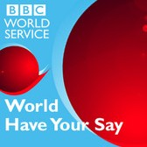
BBC World Have Your Say: “ Life in China”
Every day, BBC News on TV,radio and online brings you stories from across the world. But what we want to hear are the stories that matter to you.
Have got a story about life in China today? If you do, please put your stories here.
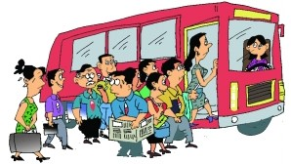  I like travaling and I have traveled a lot around China. During the trip, I often find that a number of Chinese don’t have good pulic manners(举止). They always loudly on the phone and smoke everywhere. The worst is that they often break the rules in public. For example, when I travled in HongKong in January this year, I saw a kid eating noodles on the underground, which is against the rules. However,the kid’s mother didn’t think he did wrong. Can you believe it? Let’s improve our public manners.  (Mike, Shenzhen) | 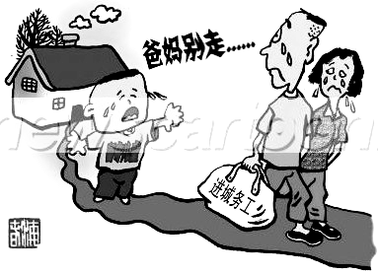  I am a 14-year-old boy from a poor village in Fuyang , Anhui Province. Like many other left-behind children(留守儿童)in China, l live with my grandparents now. my father went to work inn Shanghai several years ago. Last year, my mother went there to care for him because his health is not as good as before. They tell me to listen to my grandparents and call me about twice a month to ask about my study. I really miss my parents ans I hope I can afford to go to school in Shanghai. I think every child needs parents’love and care. (Wu Peigen, Anhui Province)
假如你是一名叫李明（Li Ming）的中学生，看了上述报道后，你想表达自己的看法。请你给栏目编辑写一封电子邮件，内容包括：
1.你对其中的哪个故事感兴趣？原因是什么？
2.你对这个故事所提及的现象的看法。
3.就该现象提出至少两条解决问题的建议。
作文要求：
1.不能照抄原文；不得在作文中出现学校真实的名称和学生的真实姓名。
2.语句连贯，词数不少于80。作文开头已经给出，不计入总词数。
Dear Editor,
I read the stories on BBC World Have Your Say today,
__________________________________________________________________________________________________________________________________________________________
____________________________________________________________________________
____________________________________________________________________________
____________________________________________________________________________
____________________________________________________________________________
____________________________________________________________________________
____________________________________________________________________________
____________________________________________________________________________
____________________________________________________________________________
____________________________________________________________________________
____________________________________________________________________________
____________________________________________________________________________
____________________________________________________________________________
____________________________________________________________________________

