绝密☆启用并使用完毕前 试卷类型A

济宁市二○一三年高中阶段学校招生考试

英 语 试 题
注意事项：
1.本试卷分第Ⅰ卷和第Ⅱ卷两部分，第Ⅰ卷为选择题，65分；第Ⅱ卷为非选择题，35分；共100分。考试时间为120分钟（含听力20分钟）。共10页。
2.答题前，考生务必先核对条形码上的姓名、准考证号和座号，然后用0.5毫米黑色墨水签字笔将本人的姓名、准考证号和座号写在答题卡的相应位置。
3.答第Ⅰ卷时，必须使用2B铅笔填涂答题卡上相应题目的答案标号，如需改动，必须先用橡皮擦干净，再改涂其它答案。
4.答第Ⅱ卷时，必须使用0.5毫米黑色墨水签字笔在答题卡上书写。务必在题号所指示的答题区域内作答。若需改动，先划掉原来的答案，然后再写上新的答案。不准使用涂改液、胶带纸、修正带，否则，答案无效。
5.考试结束后，将本试卷和答题卡一并交回。

第Ｉ卷 (选择题 共65分)

一、听力选择 (共15小题，计15分)
（一）请听录音中五个句子。每个句子后有一个小题，从题中所给的A、B、C三个选项中，选出能应答每个句子的最佳答案。（每个句子仅读一遍）
1. A. Can I help you? B. You are welcome. C. Nice to meet you.
2. A. Not bad. B. I think so. C. Goodbye.
3. A. Sorry, I won’t. B. It doesn’t matter. C. Thank you.
4. A. It’s ten o’clock. B. Don’t worry. C. Go straight and turn right.
5. A. No, thanks. B. That’s OK. C. Of course not.
（二）请听录音中五组短对话。每组对话后有一个小题，从题中所给的A、B、C三个选项中，选出与对话内容相符的图片。（每组对话读两遍）
6. What’s the weather like at present?

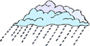
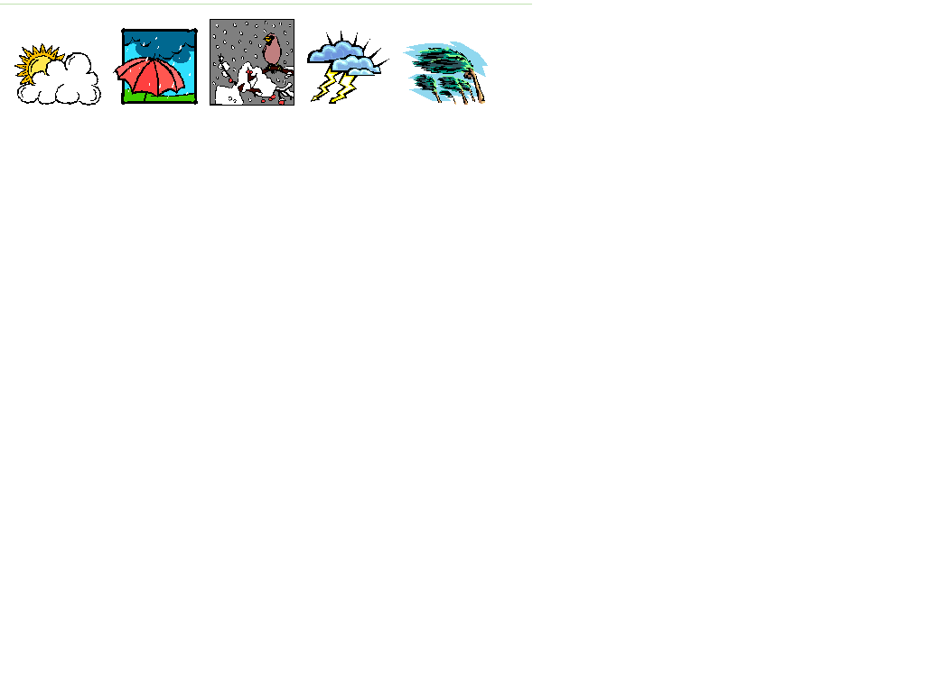

A B C

7. Which subject does Mary like better?

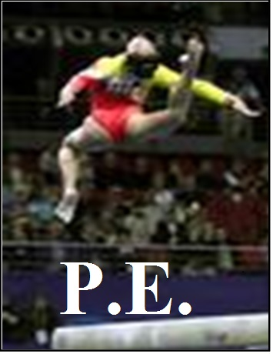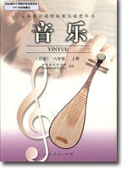
A B C
8. What’s wrong with Peter?

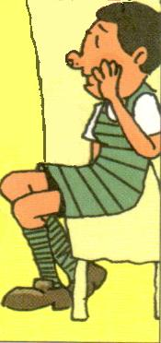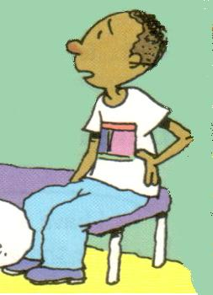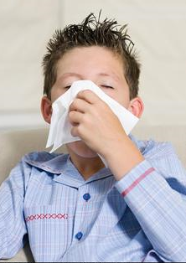
A B C

9. What is John going to do this weekend?
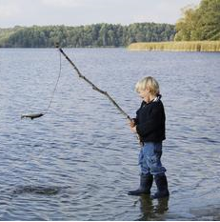

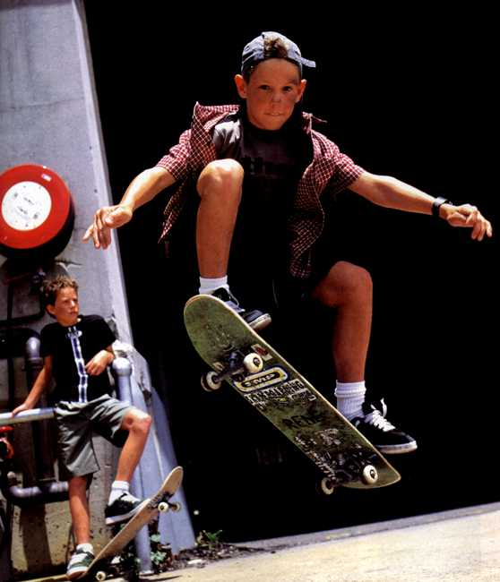
A B C
10. Where is Bob now?

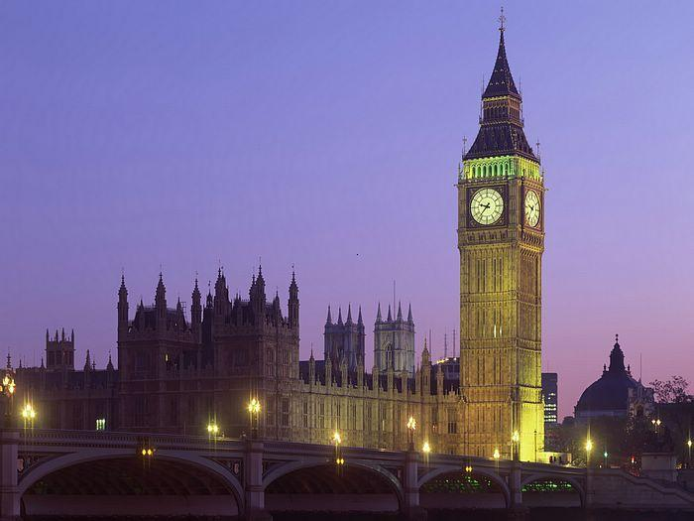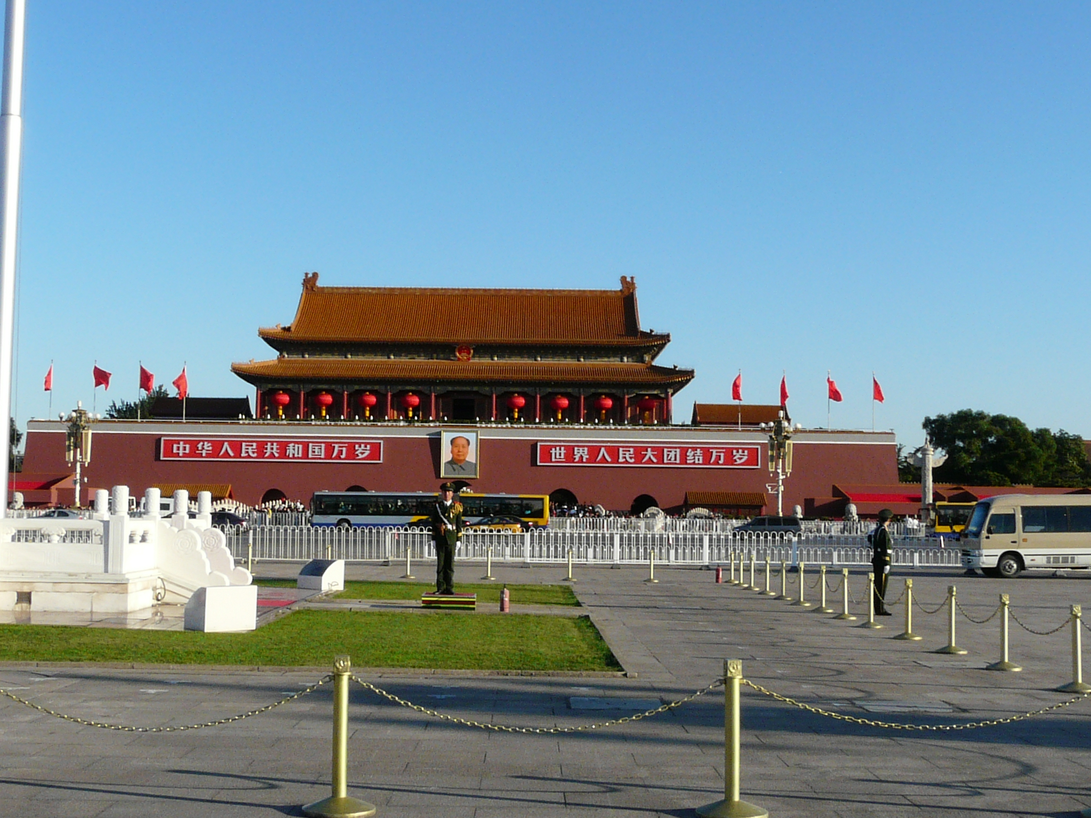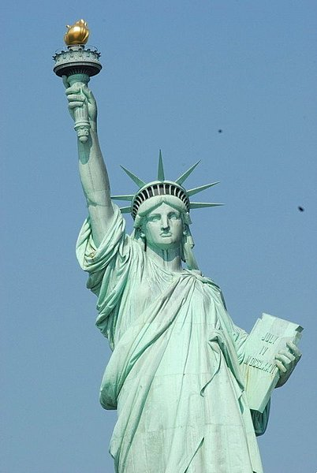
A B C
（三）请听录音中两段较长的对话。每段对话后有几个小题，从题中所给的A、B、C三个选项中，选出能回答所给问题的最佳答案。（每段对话读两遍）
听第一段较长的对话，完成第11和第12两个小题。
11. Who are going to visit the school tomorrow?
A. Some Russian teachers. B. Some Chinese visitors. C. Some American students.
12. What do people in America do when they meet?
A. Kiss three times. B. Shake hands and smile. C. Shake hands or kiss.
听第二段较长的对话，回答第13至第15三个小题。
13. What’s the girl’s favorite hobby?
A. Drawing pictures. B. Playing tennis. C. Collecting coins.
14. How many coins has the boy got?
A. About 30. B. About 300. C. About 330.
15. When are the speakers going to meet?
A. This Saturday. B. This Sunday. C. Next Saturday.
注 意：请同学们翻到第9页，找到第Ⅱ卷第四大题，继续做听力填词题。
二、语言知识运用（共两节，计20分）
第一节 单项填空（共10小题，计10分）
从每小题A、B、C、D四个选项中，选出一个能填入句中空白处的最佳答案。
16. It’s just a short distance from here to _____ restaurant.
A. a B. an C. the D.不填
17. Don’t worry about me. I can take good care of _______.
A. me B. myself C. him D. himself
18. The earthquake in Ya’an left ______ people homeless.
A. two thousands B. thousands of
C. two thousands of D. two thousand of
19. According to the new traffic law, everyone in a car ________ wear the seat belt.
A. can B. may C. must D. will
20. She looks much ________ without her glasses!
A. well B. good C. best D. better
21. — Maybe you should call him up.
— But I don’t want to talk with him ______ the phone.
A. on B. at C. in D. with
22. — Do you know the price of the ticket?
— Yes. Each ______￥180.
A. pays B. costs C. takes D. spends
23. — I will go to Harbin for my summer vacation. What about you?
— I haven’t decided where _______.
A. go B. went C. going D. to go

24. _______ necessary thing it is to join the “Clean Your Plate” Campaign（光盘行动）.
A. What B. What a C. How D. How a
25. — Do you know _______ ?
— Yes, I do. He went by skateboarding!
A. whether Paul will go or not B. when will Paul go to the party
C. how Paul went to the party D. how did Paul go to the party
第二节：完形填空（共10小题，计10分）
阅读下面短文，从每小题A、B、C、D四个选项中，选出一个能填入文中相应空白处的最佳答案。
In our life, we meet quite a lot of people：some just pass by while others can 26 our lives. Miss Bella is such a person. She taught me two years only. 27 , she has taught me a lot in many ways.
Every day she began her classes with a smile and a fresh face. She made me realize that warm 28 could change a person. I was shy but I wasn’t 29 in her classes at all. She gave lessons in a 30 way from other teachers. We had many 31 to talk about problems in English classes. Miss Bella would thumb up (竖起大拇指) to encourage us 32 someone had great ideas. Now, I 33 that I have learned much from her classes. Learning to speak out your ideas is so 34 in society. She also made me realize that I could be myself by showing opinions 35 . Her encouragement not only turned me into a confident student, but will also lead me to a successful life.
26. A. save B. give C. change D. destroy
27. A. Now B. Then C. First D. However
28. A. faces B. smiles C. seasons D. weather
29. A. alone B. active C. nervous D. excited
30. A. useful B. helpful C. necessary D. different
31. A. lessons B. choices C. chances D. topics
32. A. when B. before C. unless D. though
33. A. say B. find C. forget D. remember
34. A. easy B. hard C. interesting D. important
35. A. calmly B. bravely C. politely D. happily
三、阅读理解（共20小题，计30分）
阅读下面短文，从每小题A、B、C、D四个选项中，选出能回答所提问题或完成所给句子的最佳答案。

A
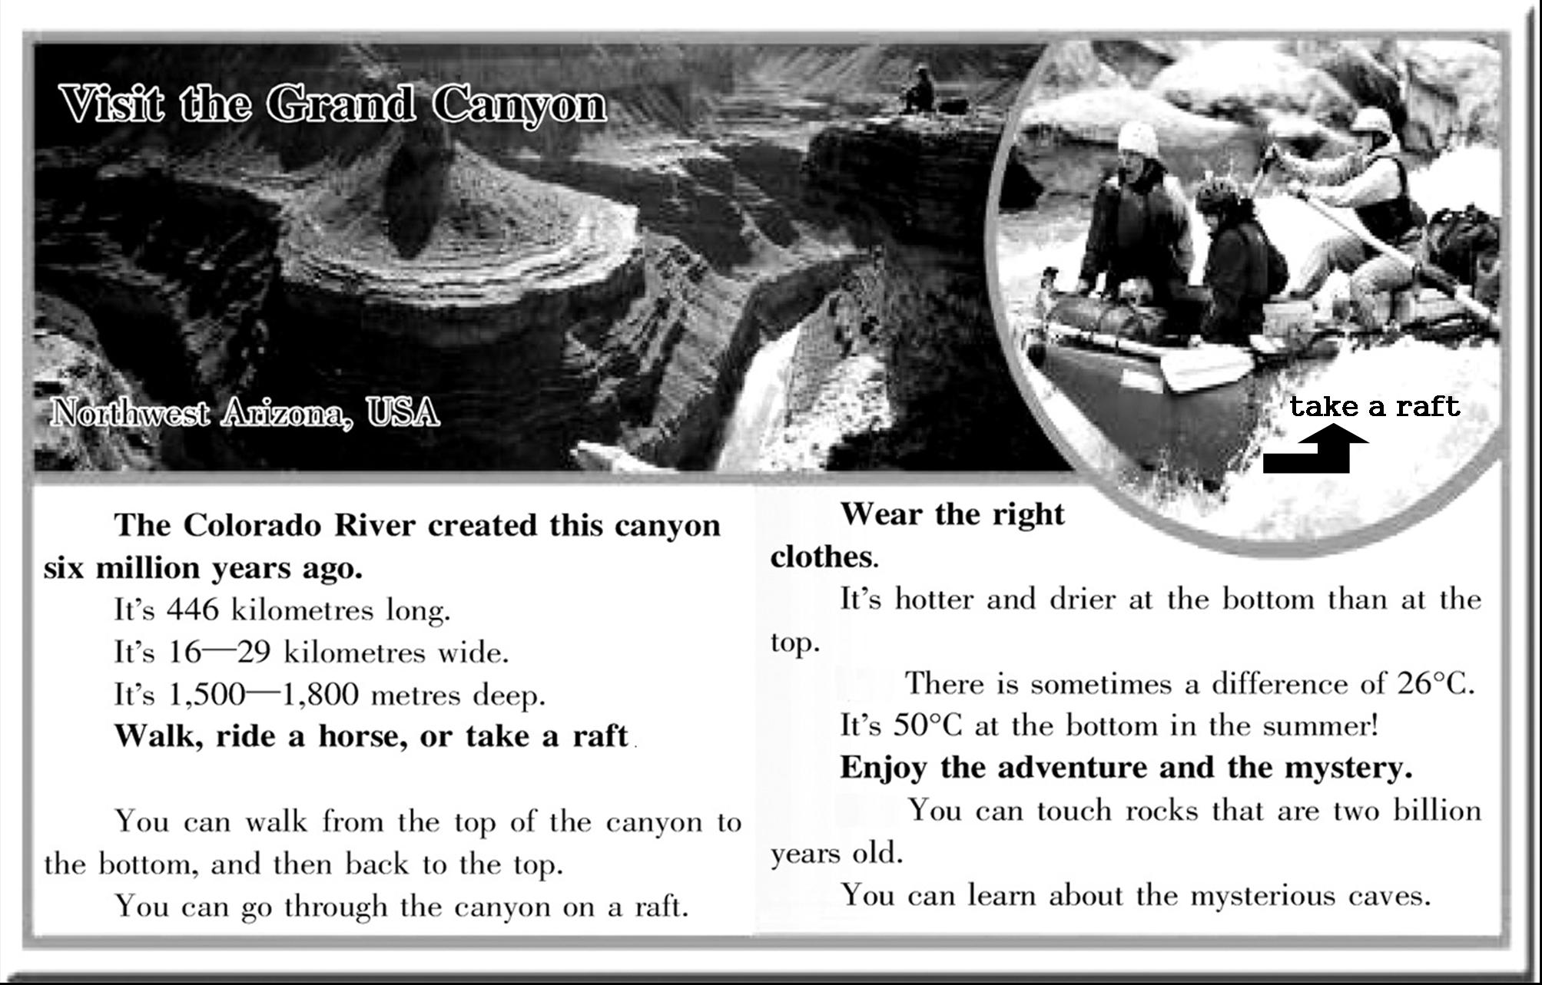

36. The Grand Canyon is in ________.
A. Britain B. America C. Canada D. South Africa
37. Grand Canyon is ________ long.
A. 446 kilometers B. 16—29 kilometers C. 1,500 meters D. 1,800 meters
38. Which of the following ways of traveling is not mentioned in the passage?
A. Going on foot. B. Riding a horse. C. Driving a car. D. Taking a raft.
39. It is very ________ at the bottom of the canyon in the summer.
A. cold B. cool C. warm D. hot
40. All of the following are mentioned in the passage EXCEPT ________.
A. you should wear the right clothes B. many tourists go to visit the canyon
C. the Grand Canyon has a long history D. you can learn about the mysterious caves
B
I took my 9-year-old daughter, and 5-year-old son, Robbie to the shopping centre. As we got there, we saw a big sign that said, “Petting Zoo”. The kids jumped up and asked, “Daddy, can we go?”
Both my wife and I were out of work. However, I said, “Sure”, giving them a quarter each. They went away, leaving only fifty cents left in my pocket.
A petting zoo is made up of a hundred of little baby animals of all kinds. Kids pay their money and stay in the enclosure(围场) pleased with the little animals while their parents shop.
A few minutes later, I saw walking along behind me. I was surprised and asked what was wrong.
She said sadly, “Well, Daddy, a ticket for Petting Zoo costs fifty cents. So I gave Robbie my quarter.” Then she said the most beautiful thing I had ever heard. She repeated the family motto(座右铭), which is “Love is Action!”
I knew clearly no one loves little animals more than Susan. She had watched both my wife and me do and say “Love is Action!” for years, and now she had put it into her lifestyle. It had become part of her, because she knew the whole family motto. It’s not only “Love is Action”; it’s “Love is SACRIFICIAL(牺牲的) Action!” Love always pays a price.
I was moved. We went back to the Petting Zoo. Susan stood with her hands and chin(下巴) resting on the fence and just watched Robbie go crazy petting and feeding the animals. I had fifty cents burning a hole in my pocket. I put my hand into my pocket and took out the money. Sure, I must do that!
41. What is the best title for this passage?
A. A Petting Zoo. B. Love Is Sacrificial Action!
C. Try Your Best to Help Others. D. An Attractive Shopping Centre.
42. From the passage we can learn that ________.
A. the family lived a hard life B. Susan didn’t like playing with pets
C. the author was strict with the children D. Robbie didn’t want to play with Susan
43. The underlined part “the most beautiful thing” in Paragraph 5 refers to（指）________.
A. their lifestyle B. the family motto
C. the Petting Zoo D. the ticket for Petting Zoo
44. Which of the following best describes Susan?
A. Kind. B. Brave. C. Honest. D. Modest.
45. What might happen next according to the story?
A. The author would get angry with Robbie.
B. The author would buy Susan some candies.
C. The author would play together with Susan.
D. Susan would play happily with the little animals.
C
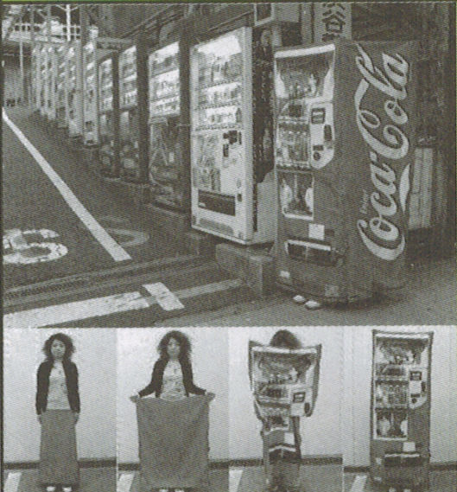
The Dress That Turns into a Coca Cola Machine
This specially designed dress looks like a normal dress，but if you unfold it and cover yourself，you may look like a Coca Cola vending machine（自动售货机）. Because there are many vending machines like that on the street，it must be easy for you to hide．If you feel that someone is following you or there is some danger，you can disappear within five seconds．But don’t use it to scare your classmates．That’ll be rude.
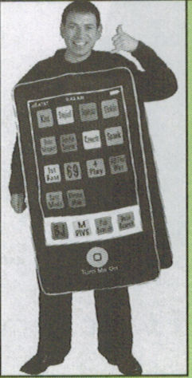
The M-Dress is a nice black dress．It is also a mobile phone．It accepts a standard SIM card and allows the wearer to receive calls without carrying an actual phone in their pocket or purse．You just need to bring your hand to your ear when you want to answer a phone call．When you finish talking and release your hand，the call will close．It is fashionable and useful．But it will certainly be an embarrassing moment when your dress rings in public．
Air Conditioned Jackets
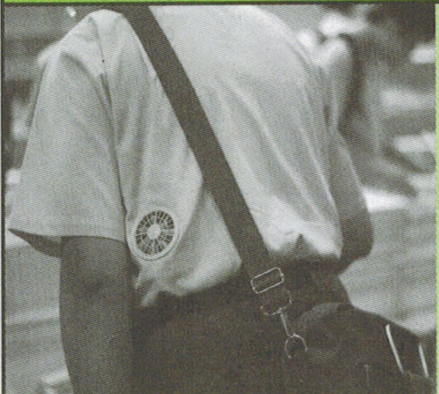
You will love these air-cooled jackets in summer time，when it is very hot outdoors．The jacket has fans that draw air in．The fan is powered by an inside battery．Now it is possible to spend nearly every second of your day with cool air．

46. What’s the main purpose of the first dress?
A. To protect the wearer. B. To scare your classmates.
C. To make the wearer look better. D. To help sell more Coca Cola.
47. The underlined word release in the 2nd paragraph means ________.
A. put up B. put down C. put on D. put out
48. The second dress is called M-Dress probably because ________.
A. it is made by men B. it is made for men
C. it is medium-sized D. it is also a mobile phone
49. The best title for the second paragraph is ________.
A. A Fashionable and Useful Dress B. M-Dress That Is Also Your Phone
C. An Embarrassing Moment in Public D. A Mobile Phone with a Standard SIM Card
50. Which of the following is TRUE of the Air Conditioned Jackets?
A. They keep you warm in winter. B. The fans must be turned by hand.
C. The fans in them provide cool air. D. The ice in them makes them cool.
D
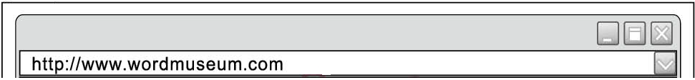

Did you know the meaning of a word may change over time? Many English words we know now had different meanings a long time ago. One example is the word nice.
Around the year 1300, nice was first used in English to mean “stupid（silly）”. Two hundred years later, nice began to carry a “better” meaning. If people said a book was written nicely, they meant the book was written “clearly” or “carefully”, not “stupidly”. After 1800, nice began to take its meaning like “kind” or “friendly”. Since then, people have thought of nice as a word with good meanings.
A good change of a word’s meaning like this example of nice is called AMELIORATION. Though we don’t use nice to mean “stupid” any more, it is fun to know how much a word’s meaning can change from its start!
- For more examples of AMELIORATION, see next page.
51. The passage is most probably taken from ________.
A. the Internet B. a newspaper C. a guidebook D. a magazine
52. 1300 years ago，when people said “a nice person”, they meant “a ________ person”.
A. smart B. happy C. stupid D. lovely
53. The second paragraph is mainly about ________.
A. what nice used to mean B. how long nice has been used
C. why the meaning of nice changed D. how the meaning of nice changed over time
54. The word AMELIORATION means a word’s meaning ________.
A. can change from its start B. changes from bad to good
C. changes from good to bad D. remains the same over time
55. What will you most probably find on the next page?
A. The meaning of the word nice changed in some other ways.
B. The meanings of some other words changed in different ways.
C. The word silly used to mean “happy”, but now it means “stupid”.
D. The word terrific used to mean “terrible”, but now it means “excellent”.
第Ⅱ卷 (非选择题 共35分)

四、听力填词（共5小题，计5分）
请听下面一段独白。根据所听到的内容，写出可以填入下表1—5空格处的适当单词，每空限填一词。（独白读两遍）
Foreigners learn Chinese
Programs | Time | Things to do
Asking the way | about 1. minutes | hear a short 2. ;  learn how to ask the way in Chinese
A 3. made by Jack | about 10 minutes | interview a great 4. , who will  tell us how to make 5.
五、单词拼写与运用（共8小题，计8分）
根据句意完成已给出首字母或汉语提示的单词，使补全后的句子意思通顺，语法正确。
1. If you are far away from your parents for a long time, you will m ____them.
2. Mo Yan is the first Chinese w____ who wins the Nobel Prize in literature（诺贝尔文学奖）.
3. The boy is so c_____ that he can work out many difficult problems.
4. Pandas are from China. And Koalas are from A_____.
5. I don’t believe the story is _______(真实的).
6. — Have you ever been to Disneyland in Hong Kong?
— No, ______（从没去过）.
7. My pen pal developed an ______（兴趣）in Beijing Opera.
8. Don’t give up. You know hard work leads to _____（成功）.
六、动词运用（共7 小题，计7分）
阅读下面短文，用括号内所给动词的适当形式填空， 必要时可加助动词或情态动词。
A
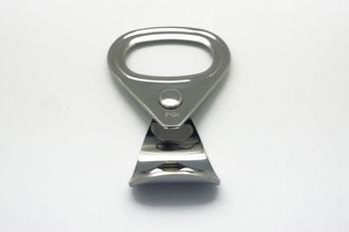
What do you usually do with your soda-can tabs (拉环) ? Throw them away?
Kayla Speelman，an American 8th-grade student, 1 now 1 (collect) soda-can tabs. She has about 20 large bags of tabs in her room. But Speelman wants 2 (get) 10 million tabs and give them to the Ronald McDonald House in her city, which gets soda-can tabs from people like Speelman to recycle. The money from the recycled metal 3 (go) to the “home away from home” project, helping the seriously ill children in hospitals.
Speelman 4 (begin) to collect tabs in 2007. And now she has about 2 million. She wants to do her part to get money for sick children and their families.
B
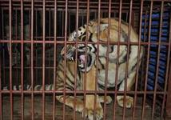
I am writing to say that I am against building a new zoo in our city. Zoos are terrible places for animals to live. I 5 (visit) many zoos in my life but none is suitable for animals to live in. They 6 (keep) in tiny cages and can hardly move at all. When 7 the animals 7 (live) in a natural environment? I hope that day will come earlier.
七、书面表达（共 1小题,计15分）
假设你是第九中学学生会主席 (chair of the Students’ Union) 李华。你校将举办一次英语演讲比赛 (English Speech Contest), 想邀请你校附近某国际学校的外籍教师Smith 女士来做评委 (judge)。请参照以下比赛通知，用英语给她写一封100词左右的邀请函(invitation)。开头和结束语已给出，不计入总词数。
English Speech Contest
Topic：Man and Nature
Time：3:00—5:00 pm, June 16
Place：Room 502
Number of Contestants (选手)：20 students
Tel.：4487665

Welcome!

要 求：需包含以下要点：
- 个人简介（姓名、职务等）；
2、比赛通知中的所有信息；
3、对被邀请人提出希望。
Dear Ms. Smith,

I am looking forward to your reply.
With best wishes,
Li Hua
绝密☆启用并使用完毕前 试卷类型A

济宁市二○一三年高中阶段学校招生考试
英语试题参考答案及评分标准

第I卷（ 选择题 共 65分）
（一）答 案:
1~5 CAACB 6~10 BCCAA 11~15 ACABC 16~20 CBBCD
21~25 ABDBC 26~30 CDBCD 31~35 CABDB 36~40 BACDB
41~45 BABAD 46~50 ABDBC 51~55 ACDBD
（二）评分说明:
1. 第I卷为选择题，共计65分。
2. 1~35小题，每小题1分,计35分；36~55小题，每小题1.5分，计30分。
第Ⅱ卷（非选择题 共 35分）
四、听力填空 (共5小题，计5分)
（一）答 案：
1. 15/fifteen 2. play 3. report 4. cook 5. dumplings
（二）评分说明：
本题共计5分，每小题1分。
五、单词拼写与运用 (共8小题，计8分)
（一）答 案：
1. miss 2. writer 3. clever 4. Australia
5. true 6. never 7. interest 8. success
（二）评分说明：
1. 本题共计8分，每小题1分。
2. 虽与答案不符，但只要单词拼写正确，符合本题要求，句意和语法皆无错误，也可给分。
3.若有拼写错误，该词不给分。
4. 若写了两种以上（含两种）的形式，即使其中一种是对的，也不给分。
六、动词运用 (共7小题，计7分)
（一）答 案：
1. is, collecting 2. to get 3. goes 4. began
5. have visited 6、are kept 7. will/can, live
（二）评分说明：
- 本题共计7分，每小题1分。
- 虽所用动词形式与答案不同，但根据上下文，语法、意义皆能讲通，也可给分。
- 虽所用时态正确，但所填单词有拼写错误，扣0.5分。
七、书面表达 (共1小题，计15分)
（一）One possible version:
Dear Ms. Smith,
I'm Li Hua , chair of the Students’ Union of No.9 Middle School. Our school is close to yours. I'm writing to invite you to be a judge at our English speech contest. It will be held in Room 502 in our school on June 16 . It will start at 3：00 pm and last for about 2 hours . 20 students will give their speeches on the topic "Man and Nature". We hope that you will accept our invitation if it is OK for you . Please call me at 4487665 if you have any questions.
I am looking forward to your reply.
With best wishes,
Li Hua
(二）评分说明：评分时，可根据内容和语言表达等方面分为四个档次：

一档 | 12—15分 | 要点齐全，能写出要求中的所有或大部分要点；语篇结构完整；语言结构丰富；句子通顺，行文连贯，表达清楚；语言基本无误（不超过3处）；书写工整；词数符合要求。
二档 | 9—11分 | 要点基本齐全，能写出要求中的大部分要点；语篇结构较完整；应用的语言结构虽不太丰富，但基本能满足任务要求；虽有一些语言错误，但基本不影响意义表达；书写较工整；词数基本符合要求。
三档 | 5—8分 | 要点不齐全，只能写出要求中的部分要点；语篇结构不完整；语言结构单一；语言错误较多，影响意思表达；书写不够工整；词数不足50。
四档 | 0—4分 | 只能写出与所要求内容有关的一些词汇；词数不足20。  凡未答题或抄写试卷其他文字内容的，一律判为零分。

附：英语听力录音材料
济宁市二○一三年高中阶段学校招生考试英语听力测试
（20秒左右轻快的音乐）
这是济宁市二〇一三年高中阶段学校招生考试英语听力部分。该部分包括听力选择和听力填词两部分。其中，听力选择含有三个大题。
注意：做题时，请先将答案标在试卷的相应位置。该部分录音内容结束后，你将有2分钟的时间将你的答案转涂到客观题答题卡上。
现在是听力试音时间。（停00’3”）
W: Ooh, it’s cold tonight.
M: Yeah, it is. But I like cold weather.
W: You do? Really?... Boy, there are a lot of people in the club tonight.
M: Yeah, it gets pretty crowded on weekends.
W: Do you come here often?
M: Yeah, I do.
W: So are you a big fan?
M: Yeah, I am. Are you?
W: No, but my brother’s in the band tonight.
M: Oh, really? Cool….By the way, my name’s Chris.
W: Nice to meet you. I’m Eve.
听力试音到此结束。听力考试正式开始。（停00’5”）
现在，请看听力选择部分。(停00’3”)
第一题、请听录音中五个句子。每个句子后有一个小题，从题中所给的A、B、C三个选项中，选出能应答每个句子的最佳答案。听完每个句子后，你都有10秒钟的时间来做相关小题和阅读下一小题。每个句子仅读一遍。(停00’5”)
录音要求：各小题间停00’10”。
No.1. Sally, this is my friend Bob. (停00’10’)
No.2. How was your school trip? (停00’10’)
No.3. You’d better not make so much noise.
No.4. Excuse me. How can I get to the library? (停00’10’)
No.5. I’m sorry to trouble you. (停00’10’)
第二题、请听录音中五组短对话。每段对话后有一个小题，从题中所给的A、B、C三个选项中，选出与对话内容相符的图片。听完每组对话后，你都有10秒钟的时间来做相关小题和阅读下一小题。每组对话读两遍。
录音要求：第一遍和第二遍之间停00’3”; 第二遍不再读No.。各小题间停00’10”。
No. 6. W: What bad weather!
M: Don’t worry. The rain won’t last long. The radio says it’ll be fine this afternoon.
No. 7. M: Do you like P.E., Mary?
W: Yes. But... I prefer music. I think it’s more relaxing.
No. 8. W: Hey, Peter, you don’t look well. What’s the matter?
M: Oh, I’ve had a cold and a cough all day.
W: Sorry to hear that.
No. 9. W: What are you doing this weekend, John?
M: I'm going skateboarding with my friend.
W: That sounds like fun.
No. 10. M: I haven’t seen Bob for a long time. Where is he?
W: He’s been studying in Britain for half a year.
第三题、请听录音中两段较长的对话。每段对话后有几个小题，从题中所给的A、B、C三个选项中，选出能回答所给问题的最佳答案。听每段对话前，你都有时间阅读各小题，每小题５秒钟；听完后，各小题将给出５秒钟的作答时间。每段对话读两遍。
听第一段较长的对话，完成第11、12两个小题。现在，你有10秒钟的时间阅读这2个小题。（停00'10''）
W: Hi, Jimmy. Some Russian teachers are coming to our school tomorrow. Can you tell me what I am supposed to do?
M: Well, do you mean when you meet them for the first time?
W: Yeah.
M: You know, in Russia, when people meet for the first time, they usually kiss each other three times, left, right, left.
W: Really? We Chinese usually shake hands and smile at each other.
M: Yeah. But people do different things in different countries. In America, however, some people shake hands, and some kiss each other.
W: That’s interesting. Thank you, Jimmy.
M: You’re welcome.
录音要求：第一遍和第二遍之间停00’3”；读完第二遍后，停00'15''。
听第二段较长的对话，回答第13至15三个小题。现在，你有15秒钟的时间阅读这3个小题。（停00'15''）
M: What’s your favorite hobby, Kathy?
W: I like Art. My favorite hobby is drawing pictures.
M: Really? Do you have other hobbies?
W: Yes. I also like playing tennis, but I can’t do it well. What about you, Jim?
M: I like collecting coins.
W: Great! By the way, how many coins have you got?
M: About 300. They are from different countries.
W: Sounds interesting! Can I have a look at your coins this weekend?
M: Sorry, I won’t be free until next Saturday. Maybe we can meet then.
W: OK. See you then.
录音要求：第一遍和第二遍之间停00’3”；读完第二遍后，停00'10''。
请同学们翻到第9页，找到第Ⅱ卷第四大题，继续做听力填词题。(停00’10”)
第四大题、听力填词：请听下面一段节独白。根据所听到的内容，写出可以填入下表1—5空格中的适当单词，每空限填一词。听前，你将有30秒钟的时间，阅读表格中的相关信息；听完后，你将有30秒钟的作答时间。独白读两遍。
(停00’30”)
Good evening! This is “Foreigners learn Chinese”. I’m . The first program today is “Asking the way”. It will last about 10 minutes. To start with, you’ll hear a short play. Then you will learn how to ask the way in Chinese. The second program is a report made by our reporter, Jack. It’s about 10 minutes. Jack is traveling around China. He interviews a great cook Mr Wang who works in a big restaurant in Beijing.Today Mr Wang will tell us how to make dumplings. Now Let’s listen to the play. In 5 minutes, I’ll explain it to you.

录音要求：第一遍和第二遍之间停00’3”；读完第二遍后，停00'30''。

听力测试到此结束，请将答案涂写到答题卡的相应位置，然后做其他题目。

