 试卷类型A
济宁市二0一一年高中阶段学校招生考试
英语试题
注意事项：
- 本试题分第Ⅰ卷和第Ⅱ卷两部分，共12页。第Ⅰ卷8页为选择题，65分；第Ⅱ卷4页为非选择题，35分；共100分。考试时间为120分钟（含听力20分钟）。
- 答第Ⅰ卷前务必将自己的姓名、考号、考试科目涂写在答题卡上。考试结束时，试题和答题卡一并收回。
3. 第Ⅰ卷每题选出答案后，都江堰市必须用2B铅笔把答题上对应题目的答案标号（ABCD）涂黑，如需改动，必须先用橡皮擦干净，再改涂其它答案。
第Ⅰ卷 （选择题 共65分）
一、听力选择（共15小题，计15分）
（一）请听录音中五个句子。每个句子后都有一个小题，从题中所给的A、B、C三个选项中，选出能回答每个句子的最佳答案。（每个句子仅读一遍）
1. A. Sure. B. Great. C. Terrible
2. A. Best wishes. B. You are welcome. C. Nice to meet you!
3. A. My pleasure. B. Thank you. C. Don’t mention it.
4. A. Not at all. B. It doesn’t matter. C. Sorry to hear that.
5. A. I’m not sure. B. Hold on, please. C. Yes, that would be fine.
(二)请听录音中五组短对话，每段对话后有一个小题，从题中所给的A、B、C三个选项中，选出与对话内容相符的图片。（每组对话读两遍）
6. What time is it?
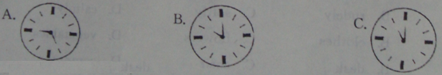7. Who is reading now?
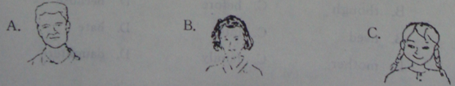
8. What is the woman probably going to buy?
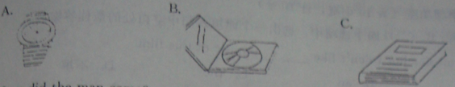

9. How did the man come?
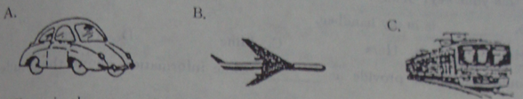
10. Where is the man going to plant the tree?
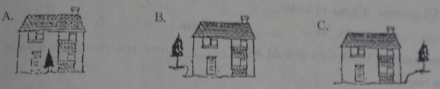
（三）请听录音中两段较长的对话。每段对话后有几个小题，从题中所给的A、B、C三个选项中，选出能回答所给问题的最佳答案。（每段对话听两遍）
听第一段较长的对话，完成第11至13三个小题。
11. What job does the woman want to do?
A. A secretary B. A reporter C. An athlete
12. What are the woman’s hobbies?
A. Swimming and singing.
B. Playing basketball and tennis.
C. Collecting stamps and playing tennis.
13. When will the woman come for the interview?
A. On Sunday at 10:00.
B. On Monday at 10:00.
C. On Monday at 9:00.
听第二段较长的对话，回答第14和15两个小题。
14. Where are the two speakers going?
A. San Francisco B. San Jose C. Los Angeles
15. What will probably help them to find the right way?
A. The map. B. The highway signs. C. The service station.
二、语言知识运用（共两小节，计20分）
第一节，单项填空（共10小题，计10分）
16. I like music, but I don’t like ______ music of this film.
A. a B. an C. the D.不填
17. ---Is this your key, Jenny ?
---No, ______ is in my handbag.
A. His B. Hers C. Mine D. Yours
18. ---Could you please provide us ______ some information about the students’ health ?
---Of course, it’s my pleasure.
A. to B. of C. from D. with
19. Most students think they should have ______ time and energy to develop their own interests.
A. few B. less C. little D. more
20. Stand over there, ______ you will get a better view of the whole city.
A. or B. and C. but D. though
21. ---Would you come to my birthday party tomorrow evening?
---I’m afraid I ______. I have to look after my sister.
A. wouldn’t B. can’t C. won’t D. mustn’t
22. Most British high school children ______ uniforms at school.
A. wear B. dress C. put on D. dress up
23. China has offered much help to Japan since it ______ by the earthquake and tsunami（海啸）.
A. hits B. is hit C. was hit D. will be hit
24. ---You never exercise.
---_______. I walk for more than one hour every day.
A. Yes, I do B. No, I don’t C. Yes, I am D. No, I’m not
25. Can you tell me ______ after this exam ?
A. what you did B. what did you do C. what will you do D. what you will do
第二节 完形填空（共10小题，计10分）
阅读下面短文，从每小题A、B、C、D四个选项中，选出一个能填入文中相应空白处的最佳答案。
On my way home I knocked into a stranger as he passed by. “Oh. I'm terribly sorry,” I said. “That’s all right. Please excuse me too; I wasn't even 26____ you. I wish I didn’t hurt you.”
We were very 27 . We said good-bye and went on our way.
But at home we often 28 our loved ones in a different way.
Later that day, while I was cooking the evening meal, my daughter stood beside me very quietly. When I turned, I nearly 29 her down. “Move out of the way.” I shouted. She walked away, tears (眼泪) in her eyes.
While I lay awake in bed, I realized how 30 I’d spoken. So I decided to get up to say sorry to my daughter. On the way to her bedroom, to my surprise, I found some 31 by the door of the kitchen. At that time my tears began to fall. I quietly went and got down on my knees by her 32 . She woke up and put her arms around my neck when I kissed her. Then I asked, “Did you pick these flowers for me?”
She smiled, “I found them out by the tree. I picked them 33 they're pretty like you. I knew you’d like them. I stood quietly in order to give you a surprise.” “Oh dear, I'm really sorry for the way I acted today; I shouldn’t have shouted at you.”
“ That’s okay. Mom. I 34 you anyway.”
I suddenly realized what a clever way it is to explain the word 35 like this: (F) ather (A) nd (M) other, (I) (L) ove (Y) ou!
26. A. saving B. helping C. calling D. noticing
27. A. sad B. angry C. polite D. proud
28. A. help B. treat C. criticize D. encourage
29. A. put B. took C. turned D. knocked
30. A. sadly B. rudely C. softly D. calmly
31. A. books B. clothes C. flowers D. vegetables
32. A. bed B. desk C. chair D. computer
33. A. if B. though C. before D. because
34. A. love B. need C. miss D. hate
35. A. father B. mother C. family D. daughter
三、阅读理解（共20小题，计30分）
阅读下面短文，从每小题A、B、C、D四个选项中，选出能回答所提问题或完成句子的最佳答案。
A
Monday, April 17[来源:学#科#网Z#X#X#K]
Dear Gramps,
I was so upset last week when somebody stole my Super Racer from the park by your house. I called up the toy company but they said they have only red, blue and green racers. Dad called Cobb's Toy Store today and found out they might have purple ones. Can we go there when I come to visit you next week?You and I were only gone for a few minutes to the shop down the street to get ice-cream and cookies. Maybe the thief was watching us. Mum was surprised when I told her the racer was stolen. She said she used to leave things at the park all the time when she was young. Once she even left her bicycle for two days near the swimming pool.
Tell Grandma that I like the food she made last time. Ask Grandma if we can have pancakes with sugar for breakfast when I come this time. I have packed in my towel, comb and soap. Tell her this time I won't forget to pack in my toothbrush.
Love
Toby
36.This letter is written by________.
A.Gramps B.Toby C. Toby's Dad D.Toby's Mum
37.The writer wants to have a________racer.
A. red B.blue C.green D.purple
38.How long did the writer leave his Super Racer at the park?
A. Two days. B.Over a week C. A few minutes D.All the time
39.From the letter, we know Supper Racer is__________.
A.a toy B. an ice-cream C. a bicycle D. a pancake
40.Which of the following is TRUE according to the letter?
A.The writer visited Gramps quite often.
B.Cobb's Toy Store is far from Gramp's house.
C.The writer took his toothbrush with him on his last visit.[来源:学科网]
D.There were lots of thieves when Tony's mum was young.
B
Foolish(silly) Freddie lived in a small village. The people of the village laughed at him. They liked to show visitors how silly Freddie was. They thought this was a funny thing to do.
One day, a visitor came to the village.[来源:Z*xx*k.Com]
"Watch this", a villager said, and called to Freddie. "Come and play a game, Freddie, " he shouted. Freddie walked slowly towards him, a silly smile on his face.
"Look! Freddie, "the villager said, "I've got something for you." He showed Freddie a dollar coin and a much larger 50-cent coin."Which would you like?" he asked Freddie.
Freddie took the 50-cent coin at once.
The villager laughed."See how foolish he is," he said."He always does that. He's too silly to learn anything." He walked away, leaving Freddie with the visitor.
The visitor felt sorry for Freddie and said to him, "Although the 50-cent coin is bigger than the＄1 coin, the＄1 coin is worth(值) much more.Two times as much."
"I know that," Freddie said."But once I take the＄1coin, they'll stop playing the game."
41.People laughed at Freddie because__________.
A.he often made up jokes B.he didn't like money
C.he looked very funny D.they thought he was a fool
42.The villagers wanted to show the visitors___________.
A.how silly Freddie was B.how clever Freddie was
C.How kind people were to Freddie D.that Freddie had much money
43.The visitor felt sorry for Freddie because he though_________.
A.Freddie did not know money was useful
B.the villager was not kind enough to the boy
C.Freddie did not get along well with the villagers
D.Freddie did not know the dollar coin was worth more
44.From the story we know that Freddie was__________.
A.poor B. kind C.clever D.silly
45.The best title for the passage should be __________.
A.Clever Villagers B."Foolish" Freddie
C.Freddie and a Visitor D.A Visitor and the Villagers

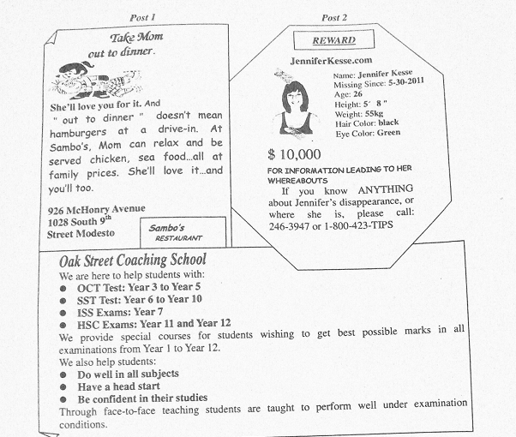
C

46. Post 1 is aimed at people who want to_______.
A. make their moms happy B. enjoy eating hamburgers
C. have cheap meals outside D. eat chicken sea food
47. The underlined word“REWARD”in Post 2 most probably means______.
A. 招聘 B. 海报
C. 悬赏 D. 求职
48. According to Post 3, a 12th-grade student takes_______.
A. OCT Test B. SST Test
C. ISS Exams D. HSC Exams
50. Oak Street Coaching School helps students to______.
A. become the best in class B. improve their grades
C. perform well at parties D. face the teachers bravely
D
You may know about “ junk food” like French fries. But do you know about “junk sleep”?[来源:Zxxk.Com]
Recently, a British survey found that electronic(电子) products in teenagers bedrooms are affecting(影响)their sleep.[来源:学,科,网Z,X,X,K]
The survey was done among 1,000 British kids from 12 to 16. It found that percent of them got just 4 to 7 hours sleep every day. But doctors say they need 8 to 9 hours.
Almost a quarter of the kids said they fell asleep more than once a week while watching TV, listening to music or using other electronic products.
“This is very worrying.” Said Dr Chris Idzikowski, a British expert, “We call it ‘junk sleep’, It means you don’t get enough sleep and the quality of the sleep is bad, too. If you don’t get good rest, you don’t perform well in school the next day.”
The survey found that 40 percent of the kids felt tired each day, with girls between 13 and 16 feeling the worst. Nearly all the teenagers have a phone, Mp4 or TV IN THEIR BEDROOM. And many of them have all three.
51. This passage is mainly about______.
A. junk food B. junk sleep
C. electronic products D. the importance of sleep
52. _______of the children in the survey sleep only 4 to 7 hours a day.
A. 200 B. 300
C. 500 D. 1,000
53. “Junk food” and “junk sleep”are similar to each other in the way that_______.
A. they are both low in quality B. they are both produced in factories
C. people enjoy both in their spare time D. they are both good to people’s health
54. Which of the following is TRUE according to the passage?
A. Teenagers need 4 to 7 hours of sleep each day.
B. Few of the teenagers have a phone in their bedrooms.
C. Teenagers spend too much time on electronic products.
D. Girls between 15 and 16 spend the least time on electronic products.
55. Which of the following is the best solution to the problem?
A. Parents watch TV together with their children
B. Forbid teenagers to use any electronic product.
C. Teenagers limit (限制) their use of the electronic products.
D. The use of mobile phone and Mp4 is not allowed at school.[来源:学科网ZXXK]

济宁市二0一一年高中阶段学校招生考试
英语试题
注意事项：
1.第I 卷共4页，用蓝(黑)色钢笔或圆珠笔直接写在试卷上。
2.答卷前请将密封线内的项目填写清楚。
3. 答卷前务必将序号填写在第10页左侧。
第II卷(非选择题 共35分)
四、听力填词 (共5小题 ， 计5分)
听下面一段演讲词，根据所听到的内容，写出可以填入下表1～5空格中的适当单词，每空限填一词。(演讲词读两遍)
Topic |  | How to succeed in your 1.______
Advice[来源:学科网] | First[来源:学_科_网][来源:学科网ZXXK] | 2._______ on purpose[来源:学科网]
Advice[来源:学科网] | Second | make a 3.______
Advice[来源:学科网] | Next | be ready to pay the 4._______
Advice[来源:学科网] | Last | 5._______give up
Advice[来源:学科网] | Most important | work hard

五、单词拼写与运用(共8小题 ， 计8分)
根据句意完成已给出首字母或汉语提示的单词，使补全后的句子意思通顺、语法正确。
1.He is an________ boy, and he never tells lies.
2. Lily asked me to keep it a s________, so I’m afraid I can’t tell you.
3. You can’t learn a f_________ language well without enough practice.
4. The class is too large, we’ll have to d_________ it into eight groups.
5. This is our Art Room. Yours is on the _________(三) floor。
6.The Smiths go to __________(教堂) every Sunday morning.
7.As we know, China is an __________(亚洲)country.
8. Let me ___________(描述)how it happened.
得分 | 评卷人
六、动词运用(共7小题 ， 计7分)
阅读下面短文，用括号内所给动词的适当形式填空，必要时可加助动词或情态动词。(请将各小题答案写在短文后相应的横线上)
A
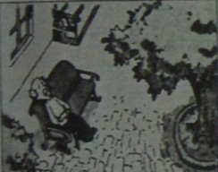
Do you still remember Old Henry? Last Sunday, he 1 (go) for a walk with Wang Wang, his cute dog. It was a nice day. Old Henry sat down and watched Wang Wang 2 (play) with a friendly black cat. Then it was time to go home. Old Henry looked for his dog. But Wang Wang 3 (be) not there! Now Old Henry is very sad. He 4 (miss) his dog and doesn’t want to do anything.
B

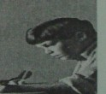
My pen pal Peter came to Beijing 3 months ago. There days he 5 (learn) Chinese in a language school. He likes travelling. And he 6 already 6 (visit) many great places of interest in our country. Next month, he 7 (fly) to Harbin for the summer vocation. I am sure he will have a good time.
1. _______ 2.________ 3.________ 4.________ 5._________ 6._______ 7._______
七、书面表达（共1小题，计15分）
英语课上，老师组织全班同学就“周末活动”话题进行小组调查，下面是你组的调查及讨论结果，为了更好的向全班同学汇报你组的情况，作为小组发言人，请你以Li Fang的名义，根据下表及表后提示，用英语写一篇发言稿。
Weekend activity survey
 | do homework | watch TV | exercise | do housework | ---------
Li Fang | √ | √ | × | ×
Zhou Hai | √ | × | √ | ×
Jim | √ | √ | √ | ×
Chen Guang | √ | √ | × | ×

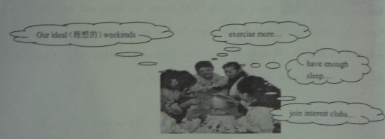

注意：
1、发言稿开头已给出，不计入总词数；
2、文中不得使用真实姓名；
3、词数：100字左右。
Good morning, everybody. I am Li Fang. Here are the results of our group survey, there are 4students in our group. All of us always __________________________________________________________
__________________________________________________________________________________________________________________________________________________________________________________________________________________________________________________________________________________________________________________________________________________________________

