济南市2015年初三年级学业水平考试
英语试题
本试题分为第Ⅰ卷（选择题）和第Ⅱ卷（非选择题）两部分。第Ⅰ卷共8页，满分为85分；第Ⅱ卷共4页，满分为35分。本试题共12页，满分120分，考试时间为120分钟。答卷前，请考生务必将自己的姓名、准考证号、座号、考试科目涂写在答题卡上，并同时将考点、姓名、准考证号、座号填写在试卷规定的位置。考试结束后，将本试卷和答题卡一并交回。
第Ⅰ卷（选择题 共85分）
注意事项：第Ⅰ卷为选择题，每小题选出答案后，用2B铅笔把答题卡上对应题目的答案标号涂黑；如需改动，用橡皮擦干净后，再选涂其他答案标号。答案写在试卷上无效。
Ⅰ.听力测试
- 听录音，在每组句子中选出一个你所听到的句子。每个句子听一遍。（5分）
1. A. His name’s Mike. B. He’s my friend. C. My brother is at home.
2. A. Are these your books? B. Do you have white shirts? C. Do they have a basketball?
3. A. She isn’t my sister. B. I don’t like hamburgers. C. We can’t be late for class.
4. A. Why does Bob like math? B. When is your art class? C. Who is that young man?
5. A. See you tomorrow evening. B. Please keep quiet. C. Let’s go at six o’clock.
B)听录音，从每题A、B、C三幅图画中选出与你听到的对话内容相符的一项。每段对话听两遍。（5分）
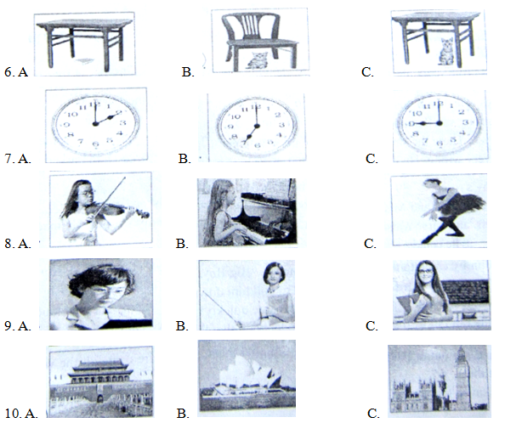

C)在录音中，你将听到一段对话及五个问题。请根据对话内容及问题选择正确答案。对话及问题听两遍。（5分）
- A. To Hong Kong. B. To Moscow. C. To Thailand.
12. A. Because it’s beautiful. B. Because it’s close to home. C. Because it has tall towers.
13. A. Go shopping. B. Visit the museums. C. Climb mountains.
14. A. By train. B. By car. C. By plane.
15. A. For a year. B. For a month. C. For a week.
D)在录音中，你将听到一篇短文及五个问题。请根据短文内容及问题选择正确答案。短文及问题听两遍。（5分）
16. A. In the UK. B. In the US. C. In Australia.
17. A. Her mother. B. Her father. C. Her brother.
18. A. At 10:00. B. At 11:00. C. At 11:30.
19. A. A red dress. B. A green skirt. C. A white blouse.
20. A. They talked about art. B. They watched a movie. C. They played games.
Ⅱ.读音选词 根据所给句意和音标，从每题A、B、C、D四个选项中，选出一个最佳答案。（5分）21. Miss Smith is _____________// with little kids.
A. god B. grade C. gold D. good
22. Mr. Jackson is my favorite teacher because he is great ________________//.
A. fat B. find C. fun D. fine
23. We have a school ______________ // every year and the students enjoy it very much.
A. trip B. tree C. true D. tape
24. Annie’s family is going to have a yard ______________ // today.
A. seat B. sale C. silk D. save
25. The boy was _______________ // from class because he was ill in hospital.
A. about B. artist C. accept D. absent
Ⅲ.选择填空 从每题A、B、C、D四个选项中，选出一个最佳答案。（30分）
26. —Tom, are you watching TV again?
—No. I’m reading a ____________.
A. chess B. ball C. game D. book
27. —Excuse me, Helen. What’s this in English?
—It’s __________ tomato.
A. a B. an C. the D. /
28. —Where’s your sister?
—I don’t know. Is _________ in the bedroom?
A. he B. she C. him D. her
29. —Look! Is that your friend Lucy?
—No, it isn’t. Lucy has __________ hair.
A. big B. tall C. short D. small
30. —___________ is your favorite day?
—Monday. Because we have P.E. and music.
A. Why B. Who C. How D. What
31. Tony gets up early in the morning. He likes to make breakfast _________ his family.
A. at B. on C. for D. from
32. I’m a little hungry now. I only drank some __________ before I came to school.
A. bread B. milk C. banana D. noodle
33. —Peter, __________ your cousin good at science?
—Yes, he is. He often helps me with my science.
A. do B. does C. are D. is
34. This is a photo of my family. These are my parents ________ this is my brother Bob.
A. so B. if C. but D. and
35. —How many American students came to visit your school yesterday?
—Nine. Five are from New York, and the other _________ are from Boston.
A. two B. three C. four D. five
36. Jeff exercises every day. He is the ____________ in his class.
A. longer B. longest C. stronger D. strongest
37. —Who lives together with this old woman?
—__________. She lives alone. Li Jing and I come to see her every Saturday.
A. Nobody B. Somebody C. Anybody D. Everybody
38. —How long does it __________ to get to the station by taxi?
—About an hour.
A. use B. have C. take D. spend
39. —David, ____________ you please sweep the floor and take out the trash?
—OK, Mum.
A. could B. may C. should D. must
40. Many badminton fans watched the 2015 Sudirman Cup last month. Which of the following is a picture of this sports event?
A. B.  C. 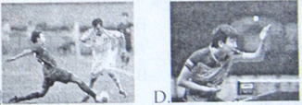
41. —Nick is not at school. ________________?
—He has a cold.
A. Who’s that B. What’s the matter C. How old is he D. How much is it
42. —I can’t stand game shows. They are too boring.
—I don’t __________ them. I think they are OK.
A. stand B. stay C. ride D. mind
43. —Is the car new or old?
—_____________. I bought it only three days ago.
A. Yes, it is B. It’s new C. No, it isn’t D. It’s old
44. —How many hours do you play computer games every week?
—_____________. My mother doesn’t allow me to do that at all.
A. Both B. Either C. All D. None
45. Before World Environment Day came, my classmates and I decided to ____________ some signs in our community.
A. put up B. come up C. look up D. grow up
46. Why not go to Sunshine Supermarket? You can buy everything ____________ there.
A. mostly B. widely C. cheaply D. heavily
47. —What about the blue skirt on the right?
—I think it will ___________ nice on you.
A. feel B. look C. taste D. sound
48. —Did you watch the soccer game last night? Our school team won the game in the last minute!
—Yes. I was __________ excited ___________ I could not fall asleep.
A. as; as B. so; as C. too; to D. so; that
49. The Chinese dream ___________ true if everyone works hard enough.
A. come B. comes C. will come D. came
50. —_________ fresh air!
—Yes. Let’s go for a walk.
A. How B. What C. What a D. What an
51. —__________ on the TV, Jim. I’d like to watch the evening news.
—OK, Dad.
A. Turn B. Turns C. Turning D. To turn
52. —There is a new amusement park in the west of Jinan. I haven’t been there.
—______________. Let’s go there this weekend.
A. Me, too B. Me neither C. I agree D. I’d love to
53. Sandy went to the shopping mall ___________ some clothes and school things.
A. buy B. bought C. to buy D. buying
54. —How long have you ___________?
—For almost ten years.
A. owned this garden B. bought this car C. arrived in Shanghai D. come to this town
55. —Excuse me. Do you know __________________?
—Well, go along this street and turn right. There’s one on the left.
A. how can I get to the bank B. where I can find a restaurant
C. when he usually gets to work D. where is the police station
IV．完形填空 阅读短文，从每题A、B、C、D四个选项中，选出一个能填入文章中相应空白处的最佳答案。（10分）
Jimmy was five years old and lived with his parents, the Watsons, in Smithville, in the southern United States. He loved his big black __56__, Big Boy. Last week, in the early hours of the morning, a strong smell suddenly woke Big Boy up __57__ his sleep. The dog got up and walked into the kitchen. There the smell and the heat grew stronger. Big Boy could __58___ that something was wrong, very wrong. He barked(吠) and ran up to the second floor. He barked and barked at the door of Jimmy’s room, __59__ there was no answer.
The he ran to Mr. and Mrs. Watson’s room. He barked again, more loudly, and tried to __60__ the door open. Mr. and Mrs. Watson didn’t wake up. Big Boy ran back to Jimmy’s room. He made as much _61___ as he could.
Finally, Jimmy came to the door and opened it. “Big Boy, what’s wrong?” Jimmy said. Big Boy took Jimmy’s __62_ in his mouth and tried to pull him down to the first floor. “Big Boy, Big Boy, stop! Stop! What are you _63__? Mum, Dad, come quickly! Help! Help!” Jimmy shouted loudly.
His parents ran out of their room. They understood that there was a fire. They __64_ picked Jimmy up and ran out of the house. Big Boy ran after them. Just then, the fire came all the way up to the top of the __65__.
Big Boy saved the family! He’s a hero today in Smithville.
56. A. hat B. boy C. bag D. dog
57. A. for B. from C. into D. with
58. A. feel B. wish C. report D. remember
59. A. so B. but C. if D. because
60. A. keep B. turn C. push D. close
61. A. food B. money C. noise D. friend
62. A. head B. nose C. neck D. hand
63. A. doing B. saying C. writing D. drinking
64. A. quietly B. slowly C. quickly D. seriously
65. A. tree B. house C. family D. mountain
V．补全对话 阅读对话，从每题A、B、C、D四个选项中，选出一个最佳答案完成对话。（5分）
Paul：Hi, Katy. 66
Katy：Fine, thanks, Paul.
Paul：How was your weekend?
Katy： 67 I visited my grandparents, and I went fishing with my grandpa.
Paul：Sounds like you had a good time, Katy. 68
Katy：Party? What party?
Paul：Tomorrow is my birthday.
Katy：Sure. 69
Paul：Around 6:00 p.m..
Katy： 70
Paul：No, I’ll buy all the food and drinks.
Katy：OK. See you tomorrow.
66. A. Are you free? B. How are you? C. Can I help you? D. How’s the weather?
67. A. Yes, we did. B. That’s too bad. C. It was great. D. He was friendly.
68. A. can you come to my party? B. what did you see?
C. did you go to Amy’s party? D. what about Sunday?
69. A. Where do you live? B. How can I get there?
C. When will it start? D. When does she arrive?
70. A. How do you make a salad? B. Is there a post office nearby?
C. What’s your favorite food? D. Do I need to bring anything?
VI．阅读理解 阅读下列短文，从每题A、B、C、D四个选项中，选出一个能回答所提问题或完成所给句子的最佳答案。（15分）
A
Philip is a school boy. On his twelfth birthday, he decided to give up eating meat. “I don’t think it’s right to eat animals,” he said. “They live on the Earth just like us and they are our friends.” Philip’s parents were not happy about that. “You are a growing boy,” his mother said. “You need meat. Do you want to stay short and be weak?” His mother put some beef, rice and carrots in front of him. “I want you to eat all your food now,” she said. “Don’t leave anything.” Philip didn’t want to make his mother sad. But he ate only the rice and the carrots.
“You’re a silly boy!” said his father. “I’m getting very angry at you.”
“I’m sorry, Mum and Dad,” answered Philip. “I don’t want you to be sad or angry. But I really don’t want to eat any meat.”
“Then have some fish, dear,” said his mother.
“Oh no, I can’t!” cried Philip. “Fish are living things too.”
“Well, you can’t have anything to eat at all if you don’t eat any meat or fish,” said his father.
The next morning Philip got up hungry. His father walked to the school with him and asked to see the teacher. “Is this what you teach the students at school?” he asked the teacher. “Philip refuses to eat meat at home. He doesn’t listen to what I say.”
“I don’t agree with Philip,” replied the teacher. “But I think he’s brave to do what he thinks is right. We teach the students to do that.”
71. Philip decided to give up eating meat on his __________ birthday.
A. fifth B. eighth C. eleventh D. twelfth
72. Philip’s mother thought that Philip would ___________ if he didn’t eat any meat.
A. stay short B. feel happy C. get hungry D. keep healthy
73. What did Philip’s mother ask him to eat when he refused to eat meat?
A. Some hamburgers. B. Some fish. C. Some pears. D. Some ice-cream.
74. Philip’s father went to the school with Philip because ____________.
A. he was a teacher there B. Philip got up very late
C. he wanted to see the teacher D. Philip had a new teacher
75. Philip’s teacher teach students _____________.
A. to go to school on foot B. to give up eating animals
C. to listen to their parents D. to do what they think is right
B
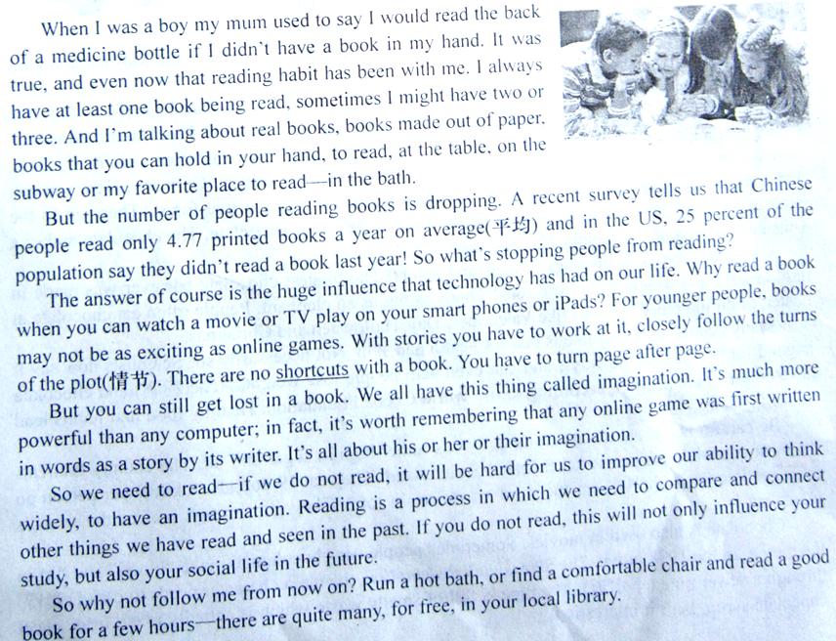
When I was a boy my mum used to say I would read the back of a medicine bottle if I didn’t have a book in my hand. It was true, and even now that reading habit has been with me. I always have at least one book being read, sometimes I might have two or three. And I’m talking about real books, books made out of paper, books that you can hold in your hand, to read, at the table, on the subway or my favorite place to read—in the bath.
But the number of people reading books is dropping. A recent survey tells us that Chinese people only read 4.77 printed books a year on average(平均) and in the US, 25 percent of the population say they didn’t read a book last year! So what’s stopping people from reading?
The answer of course is the huge influence that technology has had on our life. Why read a book when you can watch a movie or TV play on your smart phones or iPads? For younger people, books may not be as exciting as online games. With stories you have to work at it, closely follow the turns of the plot(情节). There are no shortcuts with a book. You have to turn page after page.
But you can still get lost in a book. We all have this thing called imagination. It’s much more powerful than any computer; in fact, it’s worth remembering that any online game was first written in words as a story by its writer. It’s all about his or her or their imagination.
So we need to read—if we do not read, it will be hard for us to improve our ability to think widely, to have an imagination. Reading is a process in which we need to compare and connect other things we have read and seen in the past. If you do not read, this will not only influence your study, but also your social life in the future.
So why not follow me from now on? Run a hot bath, or find a comfortable chair and read a good book for a few hours—there are quite many, for free, in your local library.
76. What’s the main idea of Paragraph 1?
A. The writer used to enjoy playing with a medicine bottle.
B. The writer has had the reading habit since his childhood.
C. The writer always has two or three books in his hand.
D. The writer often reads books at a table on the subway.
77. The number of people reading books is dropping because _______________.
A. books are becoming less interesting B. technology has greatly influenced our life
C. 25% of Americans don’t read books D. there aren’t enough printed books to read
78. What does the word “shortcuts” in Paragraph 3 most probably mean in Chinese?
A. 捷径 B. 理念 C. 缺点 D. 短文
79. According to the passage, which of the following is NOT true?
A. Reading can help to develop our imagination.
B. All online games were first written in words.
C. We need to think a lot while reading a book.
D. Younger people prefer books to online games.
80. In the last paragraph, the writer mainly suggests that we should __________.
A. run a hot bath to read books B. borrow books from the library
C. read more books in our life D. read books in a comfortable chair
C
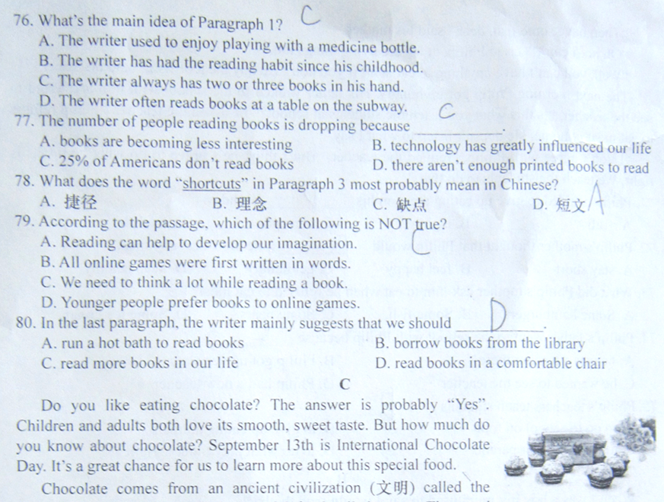
Do you like eating chocolate? The answer is probably “Yes”. Children and adults both love its smooth, sweet taste. But how much do you know about chocolate? September 13th is International Chocolate Day. It’s a great chance for us to learn more about this special food.
Chocolate comes from an ancient civilization (文明) called the Maya. The Mayan people had a special food called cocoa. The word cocoa means “gift from God”. Five hundred years ago, the Europeans found the Mayans and used cocoa to make chocolate.
All this changed when European companies started to produce chocolate bars(棒) in the 19th century. Chocolate bars took off in popularity. They also took off in space: Russian and American astronauts took them into space in the 1960s. For centuries, chocolate was eaten only by the rich. Now it’s very common and there is even a chocolate museum in Cologne, Germany. Here you can find everything about chocolate. You can first take a walk in a cocoa tree forest. Then, go to the workshop nearby. Workers there make cocoa beans into delicious chocolate. The chocolate makes a 3-meter-high chocolate fountain. You can taste it!
Chocolate comes in all shapes, sizes and colors. The biggest chocolate bar ever was made in Italy in 2011 and weighed almost 6 tons! That’s as big as an elephant. People often eat chocolate at Easter, or during other festivals like Valentine’s Day, Halloween and Christmas.
Many people say chocolate is bad for health and skin. Not necessarily so! Scientists now say it is good for health in some ways, and can even help people lose weight. Acne(粉刺) and chocolate have no direct connection, according to the World Cocoa Foundation. Healthy food and habits lead to healthy skin.
Be careful not to eat too much chocolate—it’s rather high in sugar and fat. The country that eats the most chocolate per person each year is Switzerland. They eat 19 pounds (9 kilos) per person on average! People in the US eat the most chocolate in total. They get through half of the world’s chocolate.
Chocolate is also used in movies. Sometimes people use chocolate to make “blood” and dirt in the movie. In the 1994 movie The Shawshank Redemption, the main character needs to crawl (爬行) through a sewer pipe(下水道). The pipe is full of smelly waste which is actually made from sweet chocolate syrup. Isn’t it interesting?
81. Who first made cocoa into chocolate?
A. The Mayans. B. The Europeans. C. The Chinese. D. The Americans.
82. From Paragraph 3, we can learn that _____________.
A. chocolate bars became popular in the 19th century
B. chocolate bars were produced in space in the 1960s
C. chocolate is now eaten only by some rich people
D. people can buy chocolate in the chocolate museum
83. The writer tells people not to have too much chocolate because ______________.
A. it can even help people lose weight B. it can lead to many serious heart problems
C. there is too much sugar and fat in it D. Americans eat half of the world’s chocolate
84. According to the passage, which of the following is true?
A. The biggest chocolate bar looks like an elephant.
B. People only eat chocolate at important festivals.
C. Chocolate is popular in Switzerland and the US.
D. Scientists say chocolate is very harmful to health.
85. What’s the writer’s purpose of writing the passage?
A. To show how chocolate was first made.
B. To encourage more people to buy chocolate.
C. To show how people use chocolate in movies.
D. To tell people some information about chocolate.
第II卷（非选择题 共35分）
注意事项：
请考生用0.5毫米黑色签字笔将答案写在答题卡各题目制定区域内相应的位置，答案写在本试卷上无效。
VII．选词填空（10分）
A. 阅读短文，从方框中选择适当的单词填空（每词限用一次）。
on pair than shop little
Larry is a boy from a poor family. He lives with his mother. His mother loves him and will give him anything he likes if she can. But she has（86） ______ money. Yesterday Larry walked past the shoe （87）_____ on the street corner. He liked the shoes in it and really wanted to have a（88）_____ of new shoes. But he knew his mother didn’t have enough money. Sadly, he went into a park and sat（89）_____the grass. Just then he saw a boy in a wheelchair. The boy had no feet! “It’s much better to be without shoes（90）_____without feet.” Larry thought.
B.阅读短文，从方框中选择适当的动词，并用其适当形式填空。有的需要加助动词或不定式符号（每词限用一次）。
let like sell write find
Eliza is a 16-year-old Canadian girl. She（91）_____ to make up stories. When she was a little kid, she made up stories about her pets, and her friends（92）______ them interesting. Then when she was thirteen, she started to write stories about other teenagers, their problems and what they did. Eliza has a friend called Sarah. Sarah’s father makes and sells boos. Last year Sarah told her father about Eliza’s stories. One morning, while Eliza（93）_______ a story at home, Sarah’s father called her up. He asked Eliza（94）_______ him make a book about her stories. The books came out soon. They were very popular, and they（95）_______ out very quickly. Eliza became famous in Canada.
VIII．改写句子 按括号中的要求完成句子，每个空格填一个单词。（5分）
96. I am interested in collecting stamps. (改为否定句)
I ___________ _____________ interested in collecting stamps.
97. The supermarket is two miles from the hotel. (就句子画线部分提问)
__________ ____________ is the supermarket from the hotel?
98. “Why do you study so hard?” I asked Alice. (改写句子，句意不变)
I asked Alice ____________ she ____________ so hard.
99. No matter what they may say, I’ll keep on helping the sick girl in the poor village. (改写句子，句意不变)
I won’t _____________ helping the sick girl in the poor village, ____________they may say
100. We’re not sure whether they will talk about the problem of pollution at the meeting.(改写句子，句意不变)
We’re not sure if the problem of pollution will ___________ ____________ at the meeting.
IX．完成句子 根据汉语意思完成英语句子，每个空格填一个单词。（5分）
101. 我爸爸每天骑自行车上班。
My father goes to work __________ ___________ every day.
102. 尼泊尔地震之后，其他国家向当地人民捐赠了大量的钱款物资。
After the earthquake in Nepal, other countries gave away ____________ ___________ money and things to the local people.
103. 马路上有位老人跌倒了，站不起来。我们赶紧跑上前去扶他。
An old man __________ ___________ on the street and couldn’t get up. We quickly ran up to help him.
104. 当我们遇到烦恼或问题时，应该告诉父母或朋友，而不是闷在心里。
When we meet with worries or problems, instead of ____________ them to _____________, we should tell our parents or friends about them.
105. 永远不要放弃。世界上从来没有人未经努力就取得成功。
Never give up. No one in the world has ever ____________ without making an __________.
X．任务型阅读 阅读短文，按要求完成各题。（5分）
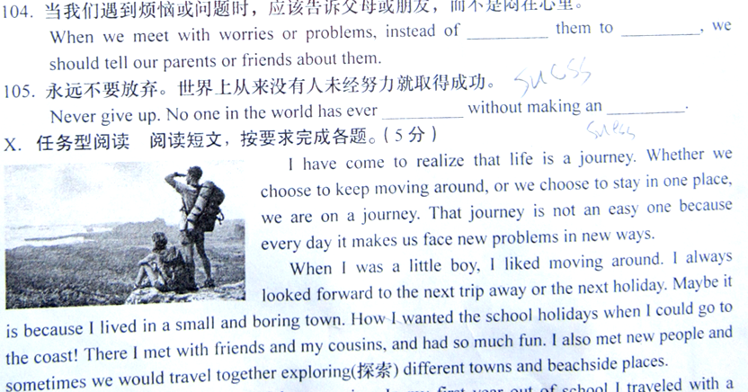
I have come to realize that life is a journey. Whether we choose to keep moving around, or we choose to stay in one place, we are on a journey. That journey is not an easy one because every day it makes us face new problems in new ways.
When I was a little boy, I liked moving around. I always looked forward to the next trip away or the next holiday. Maybe it is because I lived in a small and boring town. How I wanted the school holidays when I could go to the coast! There I met with friends and my cousins, and had so much fun. I also met new people and sometimes we would travel together exploring(探索) different towns and beachside places.
When I finished high school, I kept moving. In my first year out of school I traveled with a friend. We visited seventeen countries in Europe, working different jobs as we went. What an adventure(冒险) we had! No one could keep us still! When one place or one job became boring, we went off. If we didn’t like the people we were staying with, we said goodbye. In this way I went to three different universities to study and lived in five different towns.
All this carried on for many years until I got married and had my own family. Now having a family is a different thing because you cannot choose who they are as you want. When you stay in the same place, with the same persons, you start a whole new journey. That is the journey of facing your mistakes and trying to make them right. Rather than walk away and meet someone new when you make a mistake, you have to say that you are sorry and try again. When the ones you love hurt you, you may feel angry or unhappy. But instead of making the decision to leave, you have to try to tell them how you feel and forgive(宽恕) them.
Then you will stay in the same town, choosing one place to live and one job to remain in. There again you are challenged to face life, doing things such as paying your bills and trying hard to get along well with your boss. You have to keep on at your job when you feel like giving it all up and traveling again.
So rather than move around on different trips, you are on a new journey. This journey of staying still is just as important as all the travels in the world.
106. 根据短文内容回答问题（限10个词以内）。
Why did the writer like moving around when he was a boy?

107. 根据短文内容回答问题（限10个词以内）。
In the first year out of school, how did the writer and his friend get money when traveling?

108. 根据短文内容回答问题（限15个词以内）。
According to the writer, what should you do when your family hurt you?

109. 把短文中画底线的句子译成汉语。

110. 给短文拟一个英文标题。

XI．书面表达 （10分）
以下图画分别呈现了今年小明和小玲为妈妈过母亲节的情景。请用英语写一篇约80词的短文。
要求：1. 完整叙述图画内容。 2. 简明陈述你认为哪种方式更恰当。
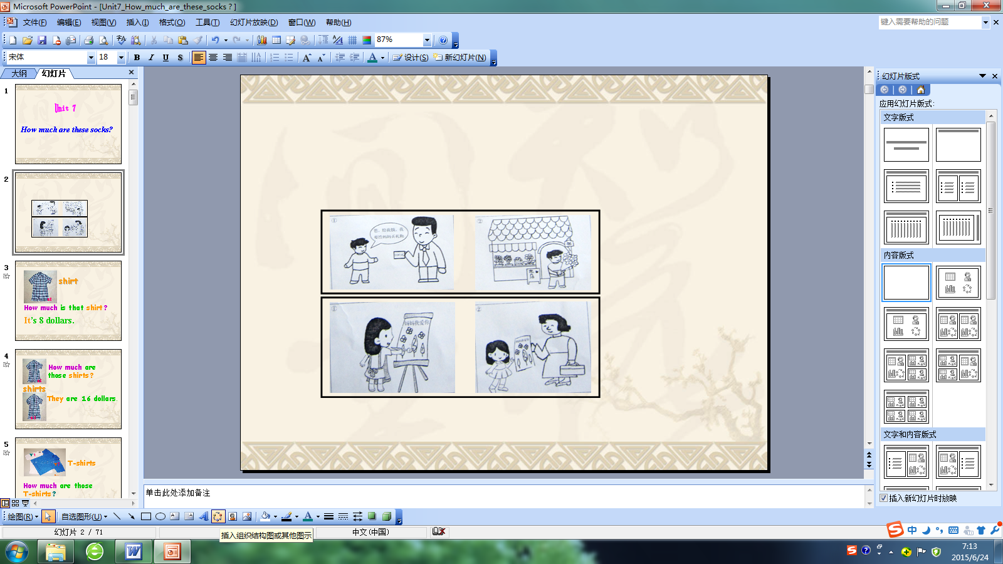

————————————————————————————————————————————————————————————————————————————————————————————————————————————————————————————————————————————————————————————————————————————————————————————————————————————————————————————————————————————————————————————————————————————————————————————————————————————————————————

参考答案
Ⅰ. 1-5 CACBA 6-10 BCBCA 11-15 BABCC 16-20 BABAC
Ⅱ. 21-25 DCABD
Ⅲ. 26-30 DABCD 31-35 CBDDC 36-40DACAA 41-45BDBDA
46-50CBDCB 51-55ABCAB
Ⅳ. 56-60 DBABC 61-65 CDACB
Ⅴ. 66-70 BCACD
Ⅵ. 71-75 DABCD 76-80 BBADC 81-85 BACCD
Ⅶ. 86.litle 87. shop 88. pair 89. on 90. than
91.likes 92. found 93.was writing 94. to let 95.were sold
Ⅷ. 96.am not 97.How far 98.why ,studied 99. stop ,whatever
100. be discussed/mentioned
Ⅸ.101. by bike 102.lots of/plenty of 103. fell down /over
104. keeping ,ourselves 105. succeed, effort
Ⅹ.106. Because he lived in a small and boring town.
107. They worked different jobs as they went.
108. Try to tell them how you feel and forgive them (instead of leaving).
109. 当你犯错时不是一走了之再找别人相处，而是要道歉后再重新尝试一次。（意思接近即可）
110. Life is a journey. / A still life journey instead of moving around. / …（答案不唯一）
Ⅺ.
参考范文：
As Mother’s Day was getting close, many children were thinking about what gift to get for their mothers, and so were Xiao Ming and Xiao Ling.
Xiao Ming asked his father for one hundred yuan and went to the flower shop for some nice flowers. He hoped his mother would feel satisfied when she saw them after a tiring working day. But differently thinking from Xiao Ming, Xiao Ling decided to do something meaningful instead of buying a usual gift. In the end she painted a nice picture by heart and wrote the following words on it: I LOVE YOU, MOM! Her mother got really moved when she received it.
As an old saying goes, “It is the thought that counts.” So I do agree with Xiao Ling, and I think I’d do the same as her next Mother’s Day.

