第I卷（选择题 共85分）
注意事项：第I卷为选择题，每小题选出答案后，用2B铅笔把答题卡上对应题目的答案标号涂黑；如需改动，用橡皮擦干净后，再选涂其他答案标号。答案写在试卷上无效。
I．听力测试
A）听录音，在每组句子中选出一个你所听到的句子。每个句子听一遍。（5分）
1. A. How are you today? B. I’m sorry to hear that. C. Why don’t you have some tea?
2. A. What does James do? B. David is from Australia. C. Is there a park near your home?
3. A. Sonia is my best friend. B. Where do you live? C. Jane has long black hair.
4. A. I’m watching TV now. B. Are you ready for class? C. Look at the picture, please.
5. A. Susan can play the piano. B. Martin runs very fast. C. Who is your English teacher?
B) 听录音，从每小题A、B、C三幅图画中选出与所听到的对话内容相符的一项。每段对话听两遍。（5分）
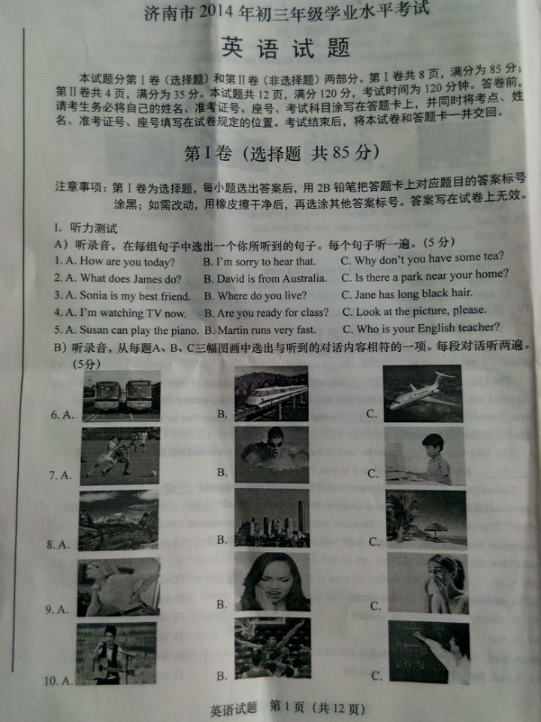

C) 在录音中你将听到一段对话及五个问题。请根据对话内容及问题选择正确答案。对话及问题听两遍。（5分）
11. A. Every Monday. B. Every Tuesday. C. Every Saturday.
12. A. An animal doctor. B. A teacher. C. A businessman.
13. A. For poor people. B. For children. C. For old people.
14. A. Once a week. B. Twice a week. C. Three times a week.
15. A. In a hospital. B. At school. C. In an old people’s home.
D) 在录音中，你将听到一篇短文及五个问题，请根据短文内容及问题选择正确答案。短文及问题听两遍。（5分）
16. A. One. B. Two. C. Three.
17. A. One week. B. Two weeks. C. Three weeks.
18. A. Their own homes. B. Their father’s house. C. Big brother’s house.
19. A. He was talking. B. He was sleeping. C. He was swimming.
20. A. Peter. B. Bob. C. Mike.
II. 读音选词 根据所给句意和音标，从每题A、B、C、D四个选项中，选出一个最佳答案。（5分）
21. Where’s my English ________ /bʊk/? I can’t find it.
A. back B. book C. bake D. bike
22. Does Tom ________ /pleɪ/ basketball every weekend?
A. play B. place C. plane D. plan
23. There’s a lot of work to do. Can you _________ /help/ me?
A. have B. keep C. help D. hope
24. My uncle does exercise ________ /'evrɪ/ day. He’s really healthy.
A. very B. every C. even D. early
25. They think the people in Jinan are _________ /'frendlɪ/.
A. friendly B. fresh C. finally D. fairly
根据音标，答案为：BACBA
III．选择填空 从每题A、B、C、D四个选项中，选出一个最佳答案。（5分）
26. —What’s that on the table?
—It’s _______ map.
A. a B. an C. the D. /
答案：A
27. My father works in a school. _______ goes to work early in the morning.
A. His B. He’s C. He D. Him
答案：C
28. —Cindy, what’s your favorite _________?
—I like soccer best.
A. color B. sport C. music D. food
答案：B
29. —Where’s your mother, Gina?
—She’s sleeping ______ the bedroom.
A. in B. of C. to D. from
答案： A
30. Aunt Sally has ________ children, two boys and two girls.
A. fourth B. forty C. fourteen D. four
答案： D
31. —Thank you for the nice birthday present.
—_____________.
A. It’s $ 10 B. You’re welcome
C. Thanks a lot D. No problem
答案： B
32. —___________ did you buy your e-dictionary, Frank?
—Two days ago.
A. Why B. When C. How D. Where
答案： B
33. Jenny, I can’t go hiking with you __________ I have to help my mum with housework.
A. so B. but C. because D. unless
答案： C
34. Which of the following is the official mascot(吉祥物) of the 2014 FIFA World Cup?
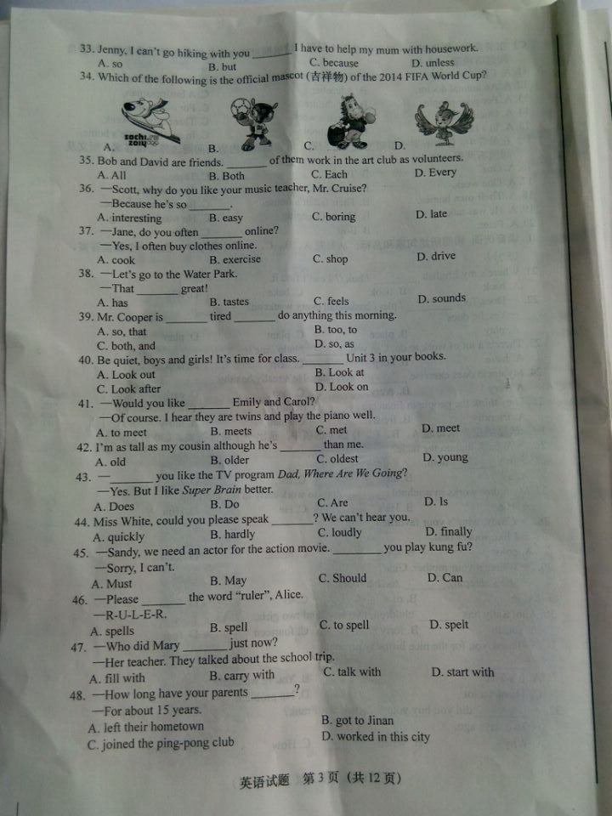
答案： B
35. Bob and David are friends. __________ of them work in the art club as volunteers.
A. All B. Both C. Each D. Every
答案： B
36. —Scott, why do you like your music teacher, Mr. Cruise?
—Because he’s so _____________.
A. interesting B. easy C. boring D. late
答案：A
37. —Jane, do you often ____________ online?
—Yes. I often buy clothes online.
A. cook B. exercise C. shop D. drive
答案：C
38. —Let’s go to the Water Park.
—That _________ great!
A. has B. tastes C. feels D. sounds
答案：D
39. Mr. Cooper is _________ tired __________ do anything this morning.
A. so; that B. too; to C. both; and D. so; as
答案：B
40. Be quiet, boys and girls! It’s time for class. __________ Unit 3 in your books.
A. Look out B. Look at C. Look after D. Look on
答案：B
41. —Would you like ________ Emily and Carol?
—Of course. I hear they are twins and play the piano well.
A. to meet B. meets C. met D. meet
答案：A
42. I’m as tall as my cousin although he’s _________ than me.
A. old B. older C. oldest D. young
答案：B
43. —___________ you like the TV program Dad, Where Are We Going?
—Yes. But I like Super Brain better.
A. Does B. Do C. Are D. Is
答案：B
44. Miss White, could you please speak _________? We can’t hear you.
A. quickly B. hardly C. loudly D. finally
答案：C
45. —Sandy, we need an actor for the action movie. __________ you play kungfu?
—Sorry, I can’t.
A. Must B. May C. Should D. Can
答案：D
46. —Please _________ the word “ruler”, Alice.
—R-U-L-E-R.
A. spells B. spell C. to spell D. spelt
答案： B
47. —Who did Mary _________ just now?
—Her teacher. They talked about the school trip.
A. fill with B. carry with C. talk with D. start with
答案： C
48. —How long have your parents ____________?
—For about 15 years.
A. left their hometown B. got to Jinan
C. joined the ping-pong club D. worked in this city
答案： D
49. The funny story made the kids _________.
A. to drink B. to work C. laugh D. to cry
答案： C
50. —Tomorrow is Father’s Day. What should I get for my father?
—I think doing ________ for him is the best gift.
A. something B. somewhere C. somebody D. sometime
答案： A
51. —On Bill’s 14th birthday, his friends had a surprise party for him.
—__________ lucky boy!
A. What a B. What C. How D. How is
答案： A
52. Which of the following is the best place to enjoy Jinan Festival of Springs from August 23rd to September 6th?
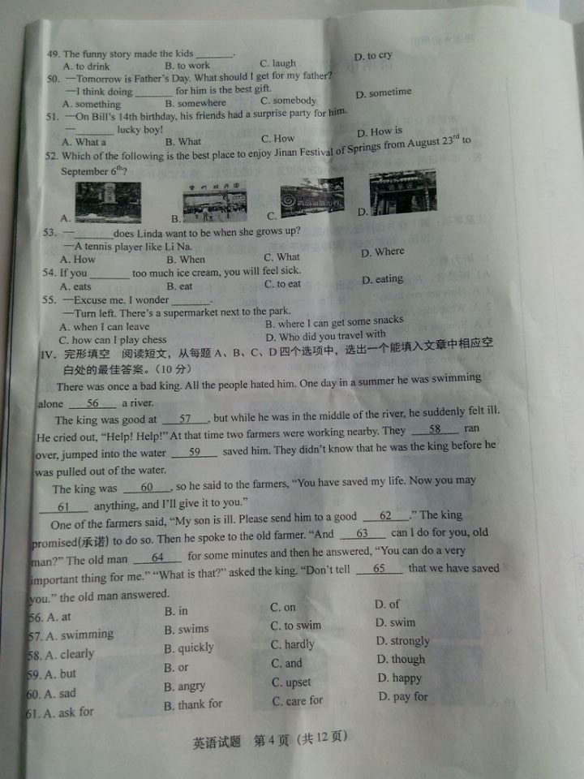
答案： A
53. —_________ does Linda want to be when she grows up?
—A tennis player like Li Na.
A. How B. When C. What D. Where
答案： C
54. If you _________ too much ice cream, you will feel sick.
A. eats B. eat C. to eat D. eating
答案：B
55. —Excuse me. I wonder ____________.
—Turn left. There’s a supermarket next to the park.
A. when I can leave B. where I can get some snacks
C. how can I play chess D. who did you travel with
答案： B

IV．完形填空 阅读短文，从每题A、B、C、D四个选项中，选出一个能填入文章中相应空白处的最佳答案。（10分）
There was once a bad king. All the people hated him. One day in a summer he was swimming alone
56 a river.
The king was good at _ 57 , but while he was in the middle of the river, he suddenly felt ill. He cried out, “Help! Help!” At that time two farmers were working nearby. They _ 58 ran over, jumped into the water _ 59 saved him. They didn’t know that he was the king before he was pulled out of the water.
The king was 60 , so he said to the farmers, “You have saved my life. Now you may 61 anything, and I’ll give it to you.”
One of the farmers said, “My son is ill. Please send him to a good _ 62 .” The king promised (承诺) to do so. Then he spoke to the old farmer. “And _ 63 can I do for you, old man?” The old man _ 64 for some minutes and then he answered, “You can do a very important thing for me.” “What is that?” asked the king. “Don’t tell 65 that we have saved you.” The old man answered.
56. A. at B. in C. on D. of
答案： B
57. A. swimming B. swims C. to swim D. swim
答案： A
58. A. clearly B. quickly C. hardly D. strongly
答案： B
59. A. but B. or C. and D. though
答案： C
60. A. sad B. angry C. upset D. happy
答案： D
61. A. ask for B. thank for C. care for D. pay for
答案： A
62. A. teacher B. scientist C. driver D. doctor
答案： D
63. A. when B. what C. where D. how
答案： B
64. A. heard B. said C. thought D. took
答案： C
65. A. someone B. one C. anybody D. nobody
答案： C
V．补全对话 阅读对话，从每题A、B、C、D四个选项中，选出一个最佳答案完成对话。（5分）
A: Hi, Jim. How’s it going?
B: 66 . Where are you going, Martin?
A: I’m going to Quancheng Square. My friends invited me to go skating there.
B: You can skateboard! 67 ?
A: Last year. It’s great fun. Would you like to join us?
B: 68 . But I can’t skateboard.
A: Don’t worry. I can teach you. 69 .
B: Great! You are so kind. Well, by the way, have you finished your homework yet?
A: Yes. 70 ?
B: Me, too.
A: Great! Let’s go.
- A. It’s shy B. Pretty good C. It’s cheap D. Good idea
答案： B
67. A. Who taught you B. Where did you learn it
C. When did you learn it D. How did you learn it
答案：C
68. A. I’d love to B. Sorry to hear that
C. It’s a pleasure D. No, not at all
答案： A
69. A. It’s easy to learn B. Dancing is difficult
C. It costs much money D. It’s boring to watch soap operas
答案： A
70. A. Do you have much homework B. Do you like homework
C. What about you D. When did you start yours
答案： C
VI．阅读理解 阅读下列短文，从每题A、B、C、D四个选项中，选出一个能回答所提问题或完成所给句子的最佳答案。（15分）
A
An old man lived with his little grandson. Every day the old man got up early to read books.
One day the grandson asked, “Grandpa, I want to read books as you do. But I always forget what I read. What are the advantages of reading?”
The grandfather didn’t answer him, but said, “Take this little basket to the river and bring me back a basket of water.” The boy did as his grandpa said, but all the water leaked(漏) out before he got back home. The grandfather laughed and said, “You’ll have to walk faster next time.”
The next time the boy ran faster, but the basket was still empty before he returned home. The boy said, “See, Grandpa, it’s no use!”
“Is it no use?” the old man said. “Look at the basket.”
The boy looked at the basket and found that the basket was different. It was cleaner, inside and out.
“That’s what happens when you read books. You might not understand or remember everything, but when you read them, you will be changed, inside and out.”
71. What did the old man do every day?
A. He carried water. B. He read books.
C. He wrote something. D. He did some chores.
答案： B
72. After the grandson read books, he _________.
A. was too busy to do it B. got up late
C. always forgot what he read D. he slept late
答案： C
73. What did the grandson use to get some water.
A. A basket. B. A bowl. C. A glass. D. A cup.
答案： A
74. How many times did the grandson go to the river to get some water?
A. Once. B. Twice. C. Three times. D. Four times.
答案：B
75. According to the grandpa’s words, what happens when he reads books?
A. We won’t have any changes. B. We can understand everything.
C. We will be changed, inside and out. D. We can never forget what we read
答案： C

B（2014·济南）
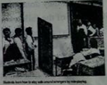
Liu Xu was robbed(抢劫)! The 13-year-old was riding home when a man jumped out from the road-side. He pulled Liu off his bike and rode away. Liu was scared, but he didn’t run after the robber. He found a telephone and called the police at 110.
“Safety is the first in such a situation,” Liu said, remembering what his teacher had told him in his aid class. “It’s not safe to run after an adult who is much stronger than you.”
Liu is a student at Shenzhen Bao’an Middle School in Guangdong. His school is one of the first in China to have required first aid education. Grade 1 students must take the class once a week.
Teenage safety has become a serious problem recently. According to a recent survey, about 16,000 teenagers die in accidents in China every year. An average(平均) of 40 students die every day from drowning(溺水), food poisoning(中毒) and traffic accidents.
Bao’an School said that the first aid classes are to “teach students skills so that they can keep themselves safe and save themselves from danger.”
Students at Bao’an often learn by role(角色)-playing in first aid classes.
Zhou Min, 12, remembered her favorite lesson. “I performed as a stranger knocking at a door. A classmate stood inside the door and asked several questions before letting me in. Then we changed roles and did it again,” Zhou said. “We learned a lot while having fun at role-playing.”
The topics of the class are regularly changed. The students have learned skills for lifesaving in earthquakes. They also deal with topics like sexual harassment(骚扰).
“The teacher told us girls that we should try not to go out alone, especially at night. If someone tries to do bad things to us, we may hit their eyes or noses or kick their deadly parts. Then we should quickly run into a crowded place,” said Zhong Hua, a 13-year-old girl.
76. From the first paragraph of the passage, we know _______.
A. the robber was of medium height
B. Liu Xu was robbed on his way home
C. the robber ran away when he saw the policeman
D. Liu Xu jumped off his bike and called the police at once
答案： B
77. Why didn't Liu Xu run after the robber when his bike was taken away from him?
A. Because the robber rode away too fast
B. Because he was too scared to run in such a situation.
C. Because the robber looked much stronger than an adult.
D. Because he remembered what he had learned in his first aid class.
答案： D
78. The purpose of the first aid classes is to ______.
A. make Grade 1 students take the class once a week
B. help the 40 students to solve their safety problems
C. complete the required art education in the middle school
D. teach the teenagers how to keep themselves safe from danger
答案：D
79. Zhou Min gives an example to show ________.
A. how they learn in the first aid classes
B. where they have their first aid classes
C. what they don't often do in her classes
D. who taught them role-playing in her classes
答案： A
80. Which of the following is NOT true according to the passage?
A. A survey shows that over ten thousand teenagers die in accidents in China every year.
B. Many students of Bao’an Middle School enjoyed themselves in first aid classes.
C. Girl students are taught what to do when someone tries to do bad things to them.
D. Topics for first aid classes are quite different from what the students have taught
答案： D
C（2014·济南）
In 2004, three young men went to a dinner party in San Francisco. Afterward(过后),they wanted to share(分享) a video from the party with their friends. They wanted to send it over the Internet. But at the time, the process(过程) of sharing videos that way was difficult. Using e-mail did not work and the friends complained that there, was no website to help them. So they created their own. They called their website YouTube. It made sharing videos easy, so the website soon became very popular. People watched 2.500 million videos in the first six months!
Today, more than 70,000 new videos go up on YouTube each day. People watch more than 1,000 million videos a day. Many last no more than 10 minutes. These videos show all kinds of things, from sleeping cats to earthquakes. Most of the filmmakers are not professionals. They are just everyday people making videos, and they use the website in many interesting ways.
First many people use YouTube to entertain others. One example is Judson Laipply. He made a funny dance video and put it on YouTube in 2006. People watched the video more than 10 million times in the first two weeks. Now people stop Judson on the street to ask, "Are you the dance guy on Youtube?" Some people have invited him to dance at their parties. A few women even asked to marry him. Judson wants to make more dance videos, and people look forward to seeing them.
Other people use YouTube to advertise a business. David Taub does this. He is a guitar teacher and he sells videos of guitar lessons on his own website. He wanted to increase his business, so he put short videos with free lessons on YouTube. People enjoyed watching the lessons on YouTube, and afterward, many decided to go to David’s own website. Now David sells hundreds of guitar lesson videos each week.
People also use YouTube to help others. Ryan Fitzgerald is one example. Ryan is friendly young man who knows that some people are lonely and have no one to talk to. One day, he made a video of himself for YouTube. In the video, he gave his phone number and invited people to call him. In less than a week, he had more than 5,000 calls and messages from all over the world. These days, he is very busy talking on the phone. He helps people when he can, but mostly, he just listens, like a friend.
Finally, some filmmakers use YouTube in a more serious way. They want to inform people about important events happening in the world. For example, they show clips(片段)of videos from countries at war, or they show people in need of help after a storm. Sometimes TV news shows do not give enough information about these events. Thanks to YouTube filmmakers, people can go to their computers and learn more.
For many people, YouTube is more than just another website to visit. It is a way to communicate with others. More and more people are using it every day, and they will probably find even more ways to use it.
81. From the first paragraph of the passage, we know three young men _______.
A. shared a video right at a dinner party
B. sent a video by using the e-mail
C. set up a new website YouTube
D. became very popular in a few months
答案： C
82. Which of the following is NOT true about YouTube?
A. YouTube makes sharing videos easy.
B. Over 70,000 filmmakers are not professionals.
C. Many videos on YouTube are short.
D. Most of the filmmakers are just everyday people.
答案： B
83. Judson Laipply became popular _______.
A. only because he was a good dancer
B. after he put his funny dance video on YouTube
C. because he wanted to make more dance videos for the website
D. because people watched all kinds of videos 10 million times a week
答案： B
84. YouTube is used by David Taub ______.
A. to sell his guitars
B. to start his new busincss
C. to advertise his business
D. to set up his own website
答案： C
85. Which of the following is NOT true according to the passage?
A. Most of new videos made by professionals go up on YouTube every day.
B. People use the website YouTube to entertain others, help others, or inform others.
C. YouTube gives people a place to put videos so they can share or enjoy different shows.
D. For many people, YouTube is not only just a website to visit but also a way to communicate with others.
答案： A

机密 启用前
济南市2014年初三年级学业水平考试
英 语 试 题
第Ⅱ卷（非选择题 共35分）
注意事项：
1. 第Ⅱ卷为非选择题，请考生用蓝、黑钢笔（签字笔）或圆珠笔直接写在试卷上作答。
2. 答卷前，请考生先将考点、姓名、准考证号、座号填写在试卷规定的位置。
Ⅶ.选词填空（10分）
A. 阅读短文，从方框中选择适当的单词填空（每词限用一次）。
make at short them books
Hello, everyone! My name is Jim. I'm tall and have hair. My best friend Jack looks similar to me. We both like reading . So we often spend time together reading and studying. I like sports. I play basketball very well and he is good it, too. I don’t think it’s easy for me to friends, because I'm quieter than most of the boys. But I think friends are like books. You don't need a lot of if they're good.
答案:
(1) short
(2) books
(3) at
(4) make
(5) them
B. 阅读短文，从方框中选择适当的动词，并用其适当形式填空。有的需要加助动词或不定式符号（每词限用一次)。
see get wake buy be
Harry is a sailor(海员). He (91)______________ to many countries since he was 18 years old. He is often on the ship for months at a time. When he (92)______________ up in the morning, he only sees the sea or sometimes an island. Harry got married one year ago and (93)______________ a house far away from the sea. One day, he returned home after sailing for 2 months on the sea. He was glad (94)______________his wife again. The next morning, he (95)______________ up by a big noise and saw many trees a few meters away through the window. He jumped out of the bed quickly, shouting, “We've hit the land!”
答案：91.has got；92.wakes；93.bought；94.to see；95.was waken
VIII. 改写句子 按括号中的要求完成句子，每个空格填一个单词。（5分）
96. The house is big enough for them to live in.（改为否定句)
The house ____________ ____________ big enough for them to live in.
97. The new sunglasses cost 29.9 dollars. （就句子画线部分提问）
____________ ____________ do the new sunglasses cost?
98. "Where were you born?" the teacher asked me.（改写句子，句意不变)
The teacher asked me____________ I ____________born.
- Nowadays, we can communicate with friends anytime and anywhere more easily and cheaply by using the WeChat（微信）.（改写句子，句意不变)
Nowadays, it is more____________ for us to communicate with friends with the ____________ of the Wechat.
100. Mr. Li pointed out the tour guide's mistakes and told him it was rude to treat the tourists that
way.（改写句子，句意不变)
The tour guide ____________ ____________ by Mr. Li because of his bad behavior towards the tourists.
答案：96.is not；97.How much；98.where；was；99.convenient；help；100.was warned
IX. 完成句子 根据汉语意思完成英语句子，每个空格填一个单词。（5分）
101. 放学后，我和朋友一起回家。
After school, I_____________ ____________ with my friends.
102. 你对转基因食品有何看法?
What do you____________ ____________ GM foods?
103. 李东早上三点就起床等待2014年巴西世界杯的开幕式。
Li Dong got up at 3:00 in the morning to____________ ____________ the opening ceremony of the 2014 Brazil World Cup.
104. 今年地球日的主题是“绿色城市”。一个绿色的城市是由能节约能源和减少浪费的设施
构成的。
The theme of the Earth Day this year is Green City. A green city ____________ ____________ of facilities that can save energy and reduce waste
105. 3D打印能帮助制造某些人类器官，它已经不像刚问世时那么神秘了。
3-D printing can help make some human organs. It isn't as____________ as it first ____________ to be.
答案：101.went home；102.think of；103.wait for；104.is made；105.mysterious；appeared
X. 任务型阅读 阅读短文，按要求完成各题。（5分）
In America, many teenagers have a part-time job. A part-time job is one that you do a few hours each week to make money. Do you have a part-time job?
Teens can have many different kinds of part-time jobs. Some teens work in a grocery(杂货) store bagging groceries. Others may work in other local business such as the clothes store or drag store. You may have friends who work in a fast food restaurant. They may make the food, or keep the restaurant clean. Many teens make extra money by baby-sitting younger children in the neighborhood. Some teens even have their own business. They cut grass and take care of pets in their neighborhoods while other people are on vacation.
Most teens who have part-time jobs work only a few hours after school, maybe two or three times a week. They often have to work all day on Saturday.
Having a part-time job has many advantages. The job teaches you new skills that you can use as an adult. The job also teaches you responsibility(责任). The person who paid you for the job expects you to be there when you are supposed to and to do your job well. The job also pays you money that you can use for many different things. Your family might need the money to help with the family budget(预算). If you're lucky, you could use the money to buy music and videos. You might want to save the money to buy a new bicycle or maybe even a car.
In some families, teens have part-time jobs to help make money to go to college. Going to college is very expensive. Many parents cannot pay for their child's education without help from the child. In some families, at least half of what a teen makes at a part-time job goes into a college savings account(账户). The teen can spend the rest of the money on what he or she needs or wants.
Many teenagers have part-time jobs and still have time for their friends and families. Many still belong to clubs at school and even have time to play sports. If you have a part-time job，you need to have a good plan to help you do everything you want and have to do. Do your homework and chores as soon as you can. Don't let the work wait and pile up(堆积). Make sure you get to your job on time. Do the things that are most important to you. Spend time with the people you care about most.
根据短文内容完成句子填空（每空限填一个单词)。
106.From the second paragraph of the passage, we know the American teenagers do ____________ kinds of part-time jobs to___________ some extra money.
107.根据短文内容完成句子填空(每空限填一个单词)。
In some families, the parents____________ the money made by their child to ____________to send their child to college.
108.根据短文内容回答问题。
According to the passage, what can the teenagers learn from doing part-time jobs?
___________________________________________________________________________________
___________________________________________________________________________________
109.把短文中画底线的句子译成汉语。
___________________________________________________________________________________
___________________________________________________________________________________
110.根据短文内容用一个完整的英文句子(限15个词以内)回答问题。
What is the main idea of the passage?
___________________________________________________________________________________
___________________________________________________________________________________
答案：
106. Different，make
107. use，help
108. The job teaches you new skills that you can use as an adult and responsibility.
109. 付你工资的人期待你能坚守你的工作岗位并且做好工作。
110. Teenagers in America like to do part-time jobs and the advantages of it.
Ⅺ.书面表达 （10分）
根据所给图画，用英语写一篇约80词的短文。要求完整叙述图画内容。
参考词汇：terminal station 终点站
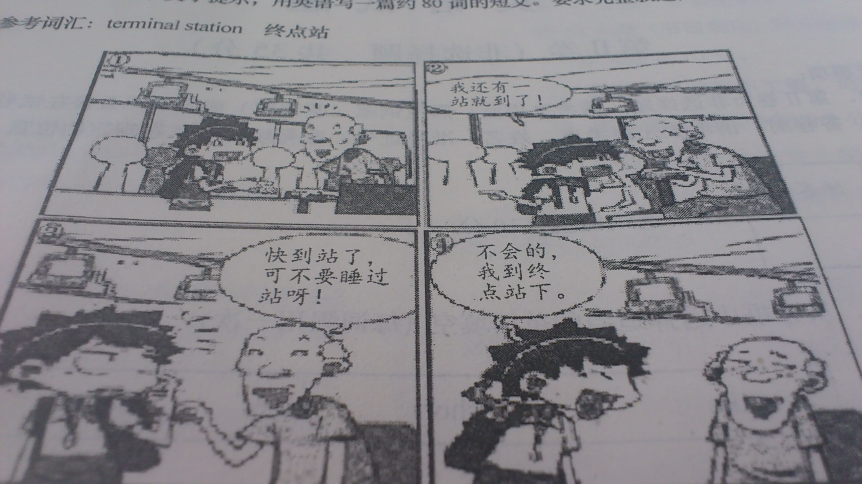
_________________________________________________________________________________________________________________________________________________________________________________________________________________________________________________________________________________________________________________________________________________________________________________________________________________________________________________________________________________________________________________________________________________________________________________________________________________________________
Example：
Tom is a kind-hearted boy. One day, he went to the museum by bus. When he got on the bus, he found a seat and sat on it. After a while the bus stopped at the next stop and an old man got on the bus. As soon as he saw him, Tom stood up and gave his seat to the man. But the man didn't accept it. Tom was worried and he came up an good idea. He told the man that he would get off the bus the next stop and the old sat on his seat. Tom stood by the man and he felt sleepy. Seeing this the old man reminded that he was going to get off the bus. Tom felt embarrassed and he told him the truth that he would get at the terminal station. What a good boy Tom was and I think we should learn from him.

