试卷类型：A
滨州市二〇一〇年初级中学学业考试

英 语 试 题
温馨提示：
- 你现在拿到的这份试卷分第I 卷和第II卷两部分。第I 卷1—8页为选择题，65分；第II卷9—12页为非选择题，35分；共100分。考试时间为120分钟。
- 答题前请将自己的姓名、考号、座号、考试科目等涂写在答题卡和第II卷的相应位置。
- 第I 卷每题选出答案后，请用2B铅笔把答题卡上对应题目的答案标号（ABCD）涂黑。 第II卷用蓝黑色钢笔或圆珠笔直接答在试卷上。考试结束后请你将试题和答题卡一并交回。
- 听力填表题为第II卷的第五大题，在试卷第9页上。

第I卷（选择题 共65分）
一、听力选择（共20小题，计20分。每小题约有8秒钟的答题时间。）
（一）录音中有五个句子，听句子两遍后，从每小题A、B、C三个选项中选出能对每个句子做出适当反应的答语。
1. A. Yes, please. B. Good idea. C. Of course, it is.
2. A. Certainly you are. B. Sure. Hold on, please. C. I’ll do that.
3. A. Oh, they are over there. B. I’m glad you’ve found it. C. Go straight and turn left.
4. A. OK, I will. B. Yes, I think so. C. Good for you.
5. A. Never mind. B. You are welcome. C. I’m sorry.
（二）录音中有五组对话，听对话两遍后，从每小题A、B、C三个选项中选出能回答所给问题的正确答案。
6. When will Mrs. White come back?
A. Right now. B. Quite soon. C. At four.
7. What sport does the woman like?
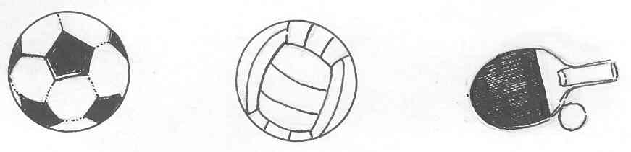
A B C
8. What does the woman prefer to do?
- To see the new play. B. To do some shopping. C. To go to the bank.
9. What are the man and woman doing?
- They are looking for a CD player in a shop.
- They are learning how to press the button.
- The man is teaching the woman how to use the CD player.
10. Why was Frank on the news last night?
A. He walked along the beach at night.
B. He swam alone in the cold water.
C. He got the boy out of water and saved him.
（三）录音中有一段对话，听对话两遍后，从每小题A、B、C三个选项中选出能回答所给问题的正确答案。
11. Where could the dialogue happen?
A. In a shop. B. In a library. C. In a hospital.
12. Why did the young man go to see the doctor?
- He didn’t know where to begin his talk.
- He felt difficult to fall asleep.
- He felt unhappy most of the day.
13. How long has the young man been ill?
A. For about two years. B. For about three weeks. C. For about six months.
14. In what season did the young man feel worse?[来源:学科网ZXXK]
A. In spring. B. In autumn. C. In winter.
15. What did the doctor ask the young man to do?
- To take some medicine.
- To burn away his worries.
- To take more exercises.
（四）录音中有一篇短文，听短文两遍后，从每小题A、B、C三个选项中选出能回答所给问题的正确答案。
16. What happened to the three boys in a cold day?
- They lost their way.
- They couldn’t find the big house.
- They had to spend the night in the open air.
17. What did the three boys ask the farmer to do?
- To give them some water and food.
- To let them stay in his house for a night.
- To tell them the way to walk out of the forest.
18. Why did one of the boys have to sleep in the big house?
- The farmer didn’t like the third boy.
- One of the boys made a loud noise when he slept.
- There wasn’t enough room in the farmer’s house.
19. Who was the first to sleep with the horses?
A. Tom. B. Mike C. Jack.
20. Why were all the horses outside at the house door?
A. Because someone drove them out of the house.
B. Because the smell in the big house was really terrible.
C. Because the horses didn’t like to stay with people at night.
（注意：请同学们翻到第Ⅱ卷第五大题，继续做听力填表题。）
二、选择填空（共15小题，计15分）
从A、B、C、D中，选出可以填入空白处的最佳答案。
21. — You’ve dropped ________ “s” in the word “necessary”.
— Oh, ________ letter “s” is doubled.
A. a; a B. a; the C. an; the D. the; the
22. —Don’t be late next time, Mike.
—____________.
A. No, I don’t B. Don’t worry C. Sorry, I won’t D. I don’t know
23. You’d better not always look up the new words ____________ the dictionary while reading. Sometimes we need to guess.
A. in B. on C. at D. from
24. _________ many children like KFC, I think they’d better try not to eat it too often.
A. Because B. When C. Although D. If
25. —Sally, could you go and help your father wash the car?
—Why ____________? I’m busy now. Amy is lying on the grass doing nothing.
A. me B. I C. him D. her
26. The shop ________ at 8:00 a.m. and it ________ for ten hours every day.
A. opens; is open B. is opened; opens
C. is open; has opened D. opened; opens
27. — Have you ever been anywhere for a trip?
— A trip? I ________ away from my hometown even once.
A. went B. have gone C. have been D. have never been
28. —____________ will you be away?
—In a couple of weeks.
A. What time B. How soon C. How often D. How long
29. —Can I help you?
—I’d like ____________ for my twin daughters.
A. two pair of shoes B. two pairs of shoe
C. two pair of shoe D. two pairs of shoes
30. — You don’t look well, Don! You’d better see your doctor.
— I ________, but he said there was nothing wrong.
A. will B. would C. had D. have
31. — How long have you ________?
— For three days.
A. got a headache B. fallen ill
C. caught a cold D. had a cough
32. I felt it hard to keep up with my classmates. But whenever I want to ____________, my teacher always encourages me to work harder.
A. go on B. give up C. run away D. give back
33. How time flies! Three years ____________ really a short time.
A. is B. are C. was D. were
34. Beijing, the capital of China, is one of __________ cities in the world.
A. the biggest B. bigger C. much bigger D. big
35. The World Expo (世博会) ____________ in Shanghai now.
A. being had B. is having C. is holding D. is being held
三、完形填空（共10小题，计10分）
阅读下面短文，从每题所给的A、B、C、D四个选项中，选出一个能填入文中相应空白处的最佳答案。
April 27 is a special day in Britain. It’s called Take Our Daughters to Work Day. It was __36__ to Britain in 1994 from America. On that day thousands of girls take a day __37__ school and go with one of their parents to their work places. By doing this, it can __38__ girls more about the society where they live.
Now the girls can have a close look at __39__ their parents are doing. This may help them to be calmer when they have to choose a __40__. Mary experienced a day of work at her mother’s office. This helped her __41__ her mother’s work better. She said that this made her feel more confident about her future.
Schools and many companies __42__ the activity, too. Some schools __43__ make the day a necessary part of school life.
Experts think that girls with more self-confidence are more likely to be __44__ than common girls. __45__ parents can set good examples both at work and at home for them, they will do better than others. Take Our Daughters to Work Day is surely a step in the right direction.
36. A. sent B. given C. brought D. taken
37. A. off B. at C. away D. of
38. A. talk B. keep C. teach D. make
39. A. which B. what C. that D. whom
40. A. place B. school C. friend D. job
41. A. thank B. understand C. praise D. remember
42. A. hold B. refuse C. choose D. support
43. A. just B. never C. even D. ever
44. A. successful B. polite C. friendly D. knowledgeable
45. A. Because B. If C. While D. Though 四、阅读理解（共20小题，计20分）
阅读下面短文，从每题所给的A、B、C、D四个选项中，选出能正确回答所提问题或完成所给句子的最佳答案。
A
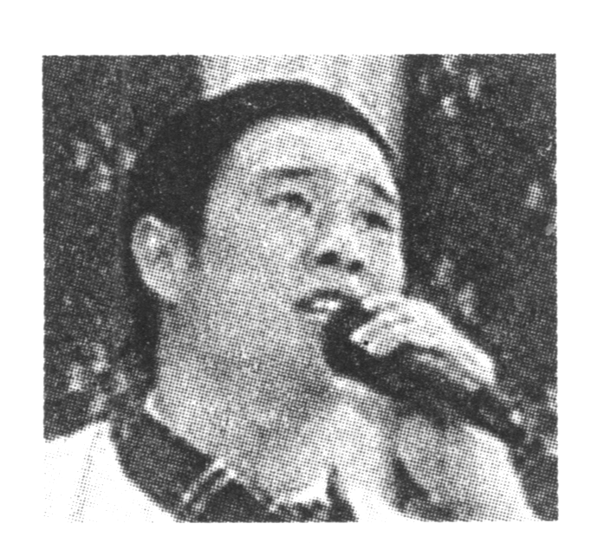 | Xiao Shenyang was born in 1981 in Liaoning, China. He became famous after taking part in the CCTV Spring Festival Gala. He became a student of Zhao Benshan, a famous comedy actor, in 2006. He is good at Er Ren Zhuan, a popular folk (民间的) song-and-dance duet in northeast China. Many people enjoy his Er Ren Zhuan performances.
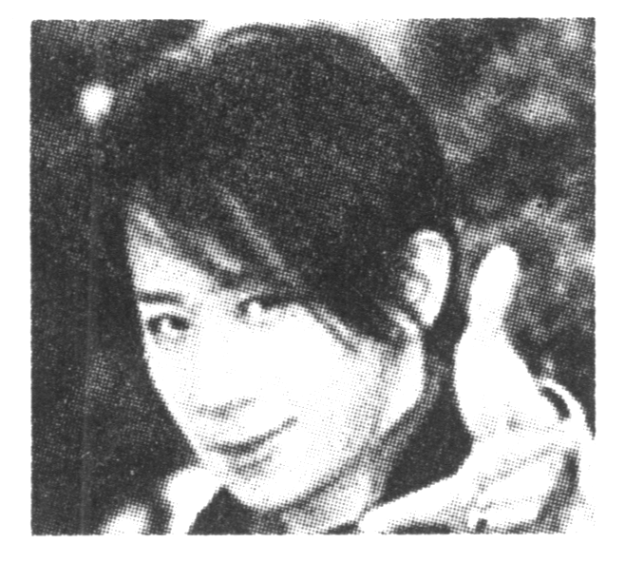 | Can you find a ring in an egg? But Liu Qian, a well-known magician（魔术师） from Taiwan, found it in front of the audiences at 2009 CCTV Spring Festival Gala. Liu Qian was born in 1976. At the age of 12, he won Taiwan’s Youth Magic Competition. To make his performance better, he often performed on streets, roads and other places for people.
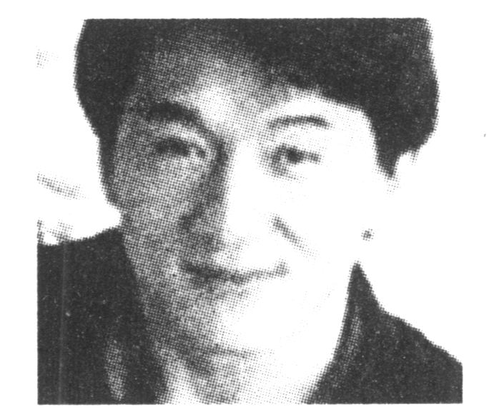 | Jackie Chan was born on April 7, 1954. His parents called him “Chan Kongsang”, which means “born in Hong Kong”. In the early 1980s, Jackie went to Hollywood. Today, he is well- known all over the world. Many people like his action movies very much.
46. When he was ____________ years old, Xiao Shenyang became a student of Zhao Benshan.[来源:学&科&网Z&X&X&K]
A. 23 B. 24 C. 25 D. 27
47. Where was Liu Qian born?
A. In Liaoning Province. B. In Taiwan.
C. In Hong Kong. D. In Beijing.
48. When did Liu Qian win Taiwan’s Youth Magic Competition?
A. In 1976 . B. In 1980. C. In 1988. D. In 2006.
49. Jackie Chan is a well-known ____________.
A. actor B. magician C. pianist D. player
50. Which of the following is WRONG according to the passage?
A. Zhao Benshan is a famous comedy actor.
B. Xiao Shenyang is younger than Liu Qian.
C. Jackie Chan was born in Hong Kong, China.
D. Liu Qian performed in the street to make money.
B
☺Letter 1
Whatever I do, I always think about if other people will like it. How can I stop worrying about what they think? —Eva, 14, Illinois
☺Letter 2
My dream is to be on the Olympic team for gymnastics. My dad thinks I started too late and I’ll never be able to make it. He puts me down, but I want his support. What should I do? —Erica, 9, Texas
☺Letter 3
What should I do if I failed a test? I’m afraid to tell my mom because she might get mad at me and I can’t play soccer. And soccer is like the world to me.
—Ashley, 12, Wisconsin
☺Letter 4
I just moved and I’m kind of shy, so how do I make new friends?
—Jessica, 11, Canada
Dr. Molly’s Answer ①
You should tell him about your dream and that if you work really hard, it might happen even though you started late. The sooner you tell your dad how you feel, the sooner you’ll be able to work on making your dream come true.
Dr. Molly’s Answer ②
Nobody knows you at your new school. You have nothing to lose, so gather up all your courage and go over to someone who looks friendly and introduce yourself. You can ask that person about your teacher or the other kids in your class to break the ice. Good luck!
Dr. Molly’s Answer ③
It’s better to tell your mom the truth than for her to find out another way. When you tell her, explain why you failed the test. Ask her if she can help you study in the future, so you’ll do better on your tests and also have time for the soccer you love.
Dr. Molly’s Answer ④
Just be yourself and try not to care about what others think. The more you think about it, the worse you will feel. Always act strong and confident. Even if you are a little unsure of something, don’t doubt (怀疑) your abilities to do things right. Just relax.
51. Jessica ____________.
A. wonders how to make new friends
B. wishes to be on the Olympic team
C. is afraid to tell her mom about her failing a test
D. keeps worried about what other people think about her
52. ____________loves playing soccer best.
A. Erica B. Eva C. Ashley D. Jessica
53. Erica’s dad doesn’t support her because he thinks she___________.
A. is a little shy and can’t do it well B. didn’t start at a very early age
C. is too young to be on the team D. doesn’t work hard
54. According to Dr. Molly, Eva should ____________.
A. hold on to her dream B. always tell the truth
C. be brave to say hello to others D. be confident of herself
55. Which is the correct order of Dr. Molly’s answers to the four letters?
A. ①④③② B. ③④②① C. ②③①④ D. ④①③②
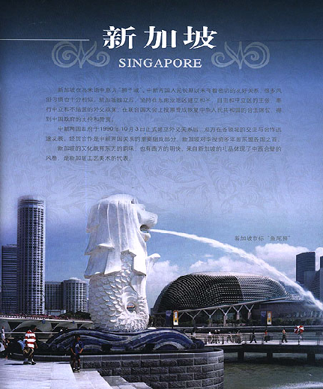
C
Singapore’s public transport system (公共交通系统) is one of the best in the world, so you should have no problem finding your way around like a local (当地人). There are three main forms of public transport that you would find in any other major city—trains, buses and taxis.

TRAINS
Trains run from 6 a.m. to midnight. Single trip tickets start at 80 cents. If you buy an EZ-Link card for $15, you can ride the trains and buses all you like.
If you need more information, just call Transit Link on 1800 767 4333.
BUSES
There are several bus services in Singapore and fares (车费) start at 80 cents. Be sure to always ask the driver the cost of your ticket as he can not give changes.
If you need help, just call Transit Link on 1800 767 4333.
TAXIS
There are three main taxi companies—City Cab (6552 2222), Comfort (6552 1111) and Tibs (6552 8888). Booking (预订) can also be made easily by calling the numbers listed above.
RENTAL (租) CARS
Driving in Singapore is a pleasure and if you like to travel at your own pace, renting a car is a good choice. Renting takes away the hassle of getting to places around Singapore. Just sit back and enjoy the city. It also means you’ll get to see a lot more that a train or a bus won’t let you see.[来源:学+科+网Z+X+X+K]
For car rental, call Avis on +65 6737 1668.
56. If you need to find the bus number, you may call____________.
A. +65 6737 1668 B. 6552 8888
C. 1800 767 4333 D. 6552 2222
57. By an EZ-Link card, you can take____________.
A. both buses and trains B. only trains
C. both buses and taxis D. only rental cars
58. When you take a bus there, always remember to ____________.
A. take your own license with you B. ask the driver how much your ticket is
C. buy the bus map of Singapore D. book your ticket ahead of time
59. What does the word “hassle” mean in Chinese?
A. 麻烦 B. 乐趣 C. 景点 D. 费用
60. What do you know about traveling in Singapore from the passage?
A. A local has no trouble finding his way around.
B. It’s much cheaper to go around by bus than by train.
C. You can see a lot more in Singapore only by renting a car.
D. It’s very convenient for visitors to travel in Singapore.
D
Life in the twenty-first century
The World Future Society is a group of people from more than 80 countries who are interested in how modern technology is making our world better, and who write reports about how it will change our lives. The things that we will be able to do in the twenty-first century (since the year 2000) should help us live better lives in many ways, at home and at work, in our own country and around the world. Here are just some of them, put into five groups.
People
People may live for up to 120 years and use new technology to help when people go blind, deaf and have other problems. The number of people over a hundred years old could go from 135,000 today to 2.2 million people by 2050. By 2015 people think that 100 million workers will be able to work from home for a company in a different country by using the Internet.
Money
Worldwide e-business will become even more successful with online shops that sell special products for each person, which will be brought to their house the next day.
Environment
The technology for making energy from wind and the Sun is growing very quickly. In the future wind and Sun energy could become much cheaper and many more countries could use it. This would be very useful in poor countries. The air in big cities would also become much cleaner and healthier as a result.
Society and culture
The Internet will help to create more worldwide friendships. Families may spend more time together as people will be able to do 24-hour online banking and shopping.
Technology
The new science of “nanotechnology” (very small robots or machines) will make all sorts of products smaller and lighter. Very, very small machines could take away rubbish, make things in factories, and help inside the human body by taking away fat. By 2012 people will be able to wear these small machines that look like watches, which will give them lots of information about their body and keep them healthy.
61. What does the World Future Society do?
A. Look at how technology will make people happy.
B. Look at how technology will change the world.
C. Make technology work better for themselves.
D. Make small machines to make us healthier.
62. How will technology help people?
A. Help all people live for over 120 years.
B. Help disabled people to get jobs.
C. Make people healthier and live longer.
D. Help workers to use the Internet.
63. How will people go shopping?
A. In special shops.
B. Using the Internet at certain times.
C. Using the Internet any time of the day.
D. Using nanotechnology.
64. How will technology help the environment?
A. Poor countries will have enough energy.
B. Wind energy will be cheaper than Sun energy.
C. We will not need wind and Sun energy.
D. Wind and Sun energy will be cheaper.
65. The new science of “nanotechnology” will _______.
A. drive small machines to work for people
B. make good-quality watches
C. allow people to eat more
D. make very small products

试卷类型：A
滨州市二〇一〇年初级中学学业考试
英 语 试 题


第Ⅱ卷 （非选择题， 35分）
注意事项：
1、第Ⅱ卷共4页，用蓝黑色钢笔或圆珠笔直接答在试卷上。
2、答卷前将密封线内的项目填写清楚。[来源:学*科*网]
五、听力填表（共5小题，计5分）
得 分 | 评卷人

录音中有一篇短文，听短文两遍后，根据所听内容填写下面的表格。（每空不多于三个词）
Places | Signs | What to do or not to do
Cinema | (66) _________________ | Enter the cinema.
Cinema | EXIT | (67) _________________ from here.
(68) _________________ | NO PHOTOS | Don’t take photos here.
Street | (69) _________________ | Don’t park your (70) _______________ here.

得分 | 评卷人
六、单词拼写(共10小题，计5分)
根据句意及首字母或汉语提示，填写句中所缺的单词。

71. There was a big fire in the office yesterday. L_________________, all the people were saved.
72. Li Lei is an h__________________ boy, he never tells lies.
73. The West Lake a__________________ thousands of tourists to Hangzhou every day.
74. The apartment is so expensive that Mr. Green can’t a__________________ it.
75. Mom, I’m so h__________________. Can I have something to eat?
76. There are __________________ (较少的) apples in this basket. I prefer that one.
77. Both of my best friends were born in ________________ (十月).
78. We are often told not to be __________________ (紧张的) in the examinations.
79. On my ________________ (第九) birthday, I got a computer from my aunt.
80. The camera was one of the greatest _________________ (发明) in the 19th century.

得分 | 评卷人
七、动词应用（共10小题，计5分）
阅读下面短文，用括号内所给动词的适当形式填空。(必要时可加情态动词或助动词)
Henry and Charlie were good friends. They worked in a shop. These days Henry did not come to work, but Charlie did not know why.
The shopkeeper said there were too many workers in the shop, so he (81) _______________ (send) some away. Charlie heard of it and wanted to tell his friend Henry about the shopkeeper’s plan. He went to him after supper. When he got there, he (82) _______________ (meet) Henry’s wife at the door.
“Henry (83) _______________ (go) out, hasn’t he?” asked Charlie.
“No, he (84) _______________ (be) in bed,” answered the woman.
“What’s wrong with him?”
“He (85) _______________ (not feel) well,” said his wife.
“What on earth is happening?”
“He (86) _______________ (not fall) asleep the whole night.”
Charlie went into the bedroom and saw his friend (87) _______________ (lie) in bed, crying loudly in pain.
“Have you seen a doctor, Henry?” asked Charlie.
“Not yet,” said Henry, “My wife bought some medicine for me and I took some just now.”
“You’d better (88) _______________ (go) to see a doctor. They will help you, I think.”
“Sorry, I (89) _______________ (not agree) with you,” said Henry, “Last year I had a terrible stomachache, the doctor cut off part of my stomach. Last week I got a bad toothache and the dentist had my tooth (90) _______________ (pull). God knows what the doctor will do with my head this time!”
得分 | 评卷人
八、翻译（共5小题，计5分）
将下列汉语句子译成英语，英语句子译成地道的汉语。

91. 学英语最好的方法是尽可能地多说。
____________________________________________________________________
92．你能告诉我滨州新汽车站在哪吗？
____________________________________________________________________
93. 没有人知道将来会发生什么事。
____________________________________________________________________
94. Liu Ying is not as good at sports as her sister.
____________________________________________________________________
95. Maybe when I leave school I’ll think about becoming an English teacher rather than a tour guide!
____________________________________________________________________
得分 | 评卷人
九、口语交际（共5小题，计5分）
根据对话内容，从方框内选择恰当的句子,并将其字母标号填入对话相应的空白处，使对话完整，合乎情景。（有两个多余选项)
Jack: Was the concert good?
Sadie: (96) ___________________
Jack: Why are you angry then? (97) ___________________
Sadie: Well, after the concert I waited outside the theatre—in the rain. I wanted their autographs.
Jack: Did you see them?
Sadie: (98) ___________________
Jack: Did they talk to you?
Sadie: No, they didn’t. They didn’t wave. They didn’t smile. They didn’t say hello.
(99) ___________________ They just jumped into a big, black car and then disappeared.
Jack: (100) ___________________
Sadie: Yes. But that was yesterday.

- They didn’t even look at us.
- No. You love them as before.
- Yes, it was great!
- What’s the matter?
- Were they friendly to you?
- You once loved them so much.
- Yes, I did.
得分 | 评卷人

十、书面表达（共1题，计10分）

紧张的初中学习生活就要结束了，你即将迎来一个轻松的暑假。请根据下面方框内的提示写一篇短文，谈谈你的假期计划。

暑 假 计 划
1、好好休息，学会放松
2、读书，因为读书既有趣又能学到很多知识
3、陪父母聊天，帮他们做家务
4、参加社会活动，了解社会
5、……
注意：
1、词数80～100；
2、文中不得出现真实的地址和姓名；
3、方框内容不必逐字翻译，可适当发挥。
参考词汇：知识 knowledge, 社会活动 social activities

滨州市二○一○年初级中学学业考试英语试题 (A)
参考答案及评分说明

第I卷（选择题 共65分）
第一至第四题 （65分）
（一）答案:
1－5: BBCAC 6－10: CCBCC 11－15: CCACC 16－20: ABCAA
21—25: CCACA 26—30:ADBDD 31—35:DBAAD 36－40: CACBD
41－45: BDCAB 46－50: CBCAD 51—55: ACBDD 56—60: CABAD
61—65 : BCCDD
(二)评分说明：
1—65题，每小题1分；与答案不符不得分。

第II卷（非选择题 共35分）
五、听力填表（5分）
（一）答案：
66. ENTRANCE 67. Leave 68. Museum 69. NO PARKING 70. car
（二）评分说明：
1、本题共5分，每小题1分；
2、与答案不符不得分。大小写错误每两处扣0.5分。
六、单词拼写（5分）
（一）答案：
71. Luckily 72. honest 73. attracts 74. afford 75. hungry
76. fewer 77. October 78. nervous 79. ninth 80. inventions
(二) 评分说明：
1、本题共5分，每小题0.5分；
2、与答案不符，但只要符合题意也可得分。大小写错误每两处扣0.5分。
七、动词应用（5分）
(一)答案：
81. was going to/would send 82. met 83. has gone 84. is 85. is not feeling/doesn’t feel
86. didn’t/couldn’t fall 87. lying 88. go 89. can’t /don’t agree 90. pulled
（二）评分说明：
1、本题共5分，每小题0.5分；
2、未用所给动词者不得分。与答案不符，但只要形式正确，符合题意也可得分。大小写错误每两处扣0.5分。
八、翻译（5分）
（一）答案：
91. The best way to learn English is to speak as much as possible.
92. Could you tell me where the new bus stop of Binzhou is?
93. No one knows what will happen in the future.
94. 刘英在体育方面不如她姐姐好。
95. 也许，毕业后我将考虑去当一名英语教师而不是导游。
（二）评分说明：
1、本题共5分，每小题1分；
2、虽然与答案表达方式不同，但与参考答案意思一致，无语言错误，也可酌情给分。单词拼写错误每两处扣0.5分。
九、口语交际（5分）
(一)答案: 96—100: CDGAF
（二）评分说明：
本题共5分，每小题1分; 与答案不符不得分。
十、书面表达（10分）
（一） One possible version:
The summer holiday is coming. I’m going to have a good rest and learn to relax myself. I will read more useful books because reading more books is not only interesting but also can make me learn more knowledge. I will try to spend more time in chatting with my parents and help them to do some housework. I am going to take part in the social activities so that I can know more about the society. If possible, I’d like to go to Shanghai for a visit of the World Expo. I’m sure I’ll have an interesting and meaningful summer holiday.[来源:学科网]
（二） 评分说明：
要求考生用适当的时态、语态、句式和词语，完整准确地表述所提示的内容，书写工整。本题共10分，分四档评分：
１、短文通顺完整，表达清楚, 语言基本无误，9－10分;
２、短文较通顺完整，表达基本清楚，语言有少量错误，6－8分;
３、能写明基本要点，短文不够通顺完整，语言有较多错误，但尚能达意，3－5分;
４、仅能写明部分要点，短文不完整，语言错误多，影响意思表达，0－2分。
注意：1、内容要点可用不同的方式表达；
2、对紧扣主题的适当发挥应予以鼓励。

滨州市二〇一〇年初级中学学业考试英语试题(A)
听力测试（录音材料）
一、听力选择（每小题约有8秒钟的答题时间。）
（一） 录音中有五个句子，听句子两遍后，从每小题A、B、C三个选项中选出能对每个句子做出适当反应的答语。
1. What a nice day! How about going out for a picnic?
2. Hello! May I speak to Linda?
3. Excuse me. Where is Room 246?
4. Will you please close the window when you leave?
5. I’m afraid you can’t smoke here, sir.
（二）录音中有五组对话，听对话两遍后，从每小题A、B、C三个选项中选出能回答所给问题的正确答案。
6. M: Hello! May I speak to Mrs. White?
W: I'm sorry. She isn't here right now.
M: I see. Will she be back soon?
W: She won't be back until four.
M: Thanks.
Q: When will Mrs. White come back?
7. M: Do you watch a lot of sports on TV?
W: Not really. But I like to play ping-pong.
M: I like football and volleyball. And I enjoy watching ping-pong match. The Chinese ping-pong team is the best in the world.
W: I agree.
Q: What sport does the woman like?
8. M: Hey, why don’t we go to see the new play on Sunday?
W: I’d rather not. I’m not really interested in the play.
M: Well, how about going shopping instead?
W: That sounds good. And let’s go to the new supermarket near the bank.
M: OK.
Q: What does the woman prefer to do?
9. W: Can you tell me how to use this CD player?
M: Sure. First you have to turn it on. Just press the first button.
W: OK. Do I have to open this now?
M: Yes. Open it.
W: How do I open it?
M: Just press the button on the right.
Q: What are the man and woman doing?
10. W: We saw you on the news last night, Frank.
M: Oh, yeah.
W: So tell us what happened?
M: Well, I was walking alone on the beach when I heard someone calling out for help. I looked, and there in the water was a little boy. I jumped into the water and saved the boy.
W: You’re really great!
Q: Why was Frank on the news last night?
（三）录音中有一段对话，听对话两遍后，从每小题A、B、C三个选项中选出能回答所给问题的正确答案。
W: Morning. So, what seems to be the trouble?
M: Well, I hardly know where to begin. I feel unhappy most of the day.
W: OK, do you have trouble sleeping?
M: No. I’m always sleeping and often feel too tired to do even simple things.
W: Do you get worried a lot?
M: All the time. I worry about my exam. I worry about my homework. I worry about being late for school.
W: Mmn.
M: I’m quite worried about everything in the school.
W: And how long has this been going on?
M: Well, about two years.
W: That’s a long time. Have you spoken to anyone about this before?
M: No, I thought it would just go away and it does get a lot better in spring and summer.
W: Aaah, so you feel worse in winter?
M: Yes. I’m feeling much better now. The sun seems to burn away my worries.
W: Do you find you have more coughs and colds between September and April?
M: Yes, more than usual, I’d say. Doctor, do I need to take some medicine?
W: No, you needn’t. There is nothing seriously wrong with you. But you must take more exercises. Play football or basketball for at least half an hour every day. You’ll soon feel well again.
M: Thanks, doctor.
Questions:
11. Where could the dialogue happen?
12. Why did the young man go to see the doctor?
13. How long has the young man been ill?
14. In what season did the young man feel worse?
15. What did the doctor ask the young man to do?
（四）录音中有一篇短文，听短文两遍后，从每小题A、B、C三个选项中选出能回答所给问题的正确答案。
Tom, Mike and Jack once lost their way in the forest in a cold day. They came to a farmer’s house and asked the farmer if they could stay in his house for the night.
“Sure,” the farmer said, “but I only have a room for two of you in the house. The other one will have to sleep with my horses in another big house. I’m afraid the big house may smell terrible.”
“I’ll sleep in the big house,” Tom said.
But half an hour later there was a loud knock on the door of the farmer’s house. Tom stood outside the door and said, “The smell there is terrible. I can’t sleep at all.”
“All right,” said Mike. “I’ll sleep in that house.” So he went off to it.
After a few minutes there was another knock on the door. “I can’t sleep, either,” said Mike.
“How can that be?” said Jack, “Let me try.”
About twenty minutes later came another knock. When they opened the door, Tom and Mike saw all the horses outside.
Questions:
16. What happened to the three boys in a cold day?
17. What did the three boys ask the farmer to do?
18. Why did one of the boys have to sleep in the big house?
19. Who was the first to sleep with the horses?
20. Why were all the horses outside at the house door?

（请同学们翻到第II卷第五大题，继续做听力填表题。）

五、听力填表
录音中有一篇短文，听短文两遍后，根据所听内容填写下面的表格。（每空不多于三个词）
There are many different signs in public. They tell you what to do or what not to do in a place. For example, if you go to see a film, you should enter the cinema at the ENTRANCE and leave through the EXIT. You will also find NO SMOKING signs in many cinemas. If you visit a museum, don’t take any photos inside the halls. You are not allowed to. You will find NO PHOTOS signs in many museums. When you drive your car, don’t park in a street with a NO PARKING sign. Make sure you understand the signs and you won’t get into any trouble.

