二0一二年山东省青岛市初级中学学业水平考试
英语试题
（考试时间：120分钟；满分：105分）
第一卷（共60分）
第一部分听力测试（25分）
I．听句子，选择最佳答语。每个句子读一遍。你将有10秒钟的时间完成有关小题和阅读下一小题。（共5小题，每小题1分，共5分）
1. A. It’s 9:00. B. It’s Wednesday. C. It’s June 13
2. A. I’d like to. B. That’s right. C. It doesn’t matter.
3. A. He’s really tall. B, He’s outgoing. C. He*s pretty funny.
4. A. It’s Nancy’s. B. It’s on Zhongshan Road. C. It rains every day.
5. A. 2 hours. B. 10 kilometers. C. Once a year.
II．听对话和问题，选择正确答案，对话和问题读两遍。你将有10秒钟的时间完成有关小题和阅读下一小题。 （共5小题，每小题1分，共5分）
6. A. 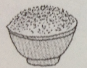 B. 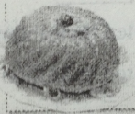 C. 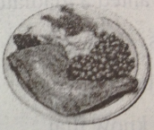
7. A. 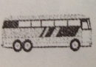 B. 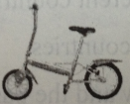 C. 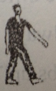
8. A. A. doctor. B. A college. C. A student.
9. A. Clean the house. B. Do the dishes. C. Do his homework.
10. A. Yes, he did. B. No, he didn't. C. Because he was late.
III.听对话，回答问题。对话读两遍。你将有10秒钟的时间完成有关小题。（共5小题，每小题1分，共5分）
听第一段对话，回答11-12小题。
11. Where are Jim and Betty?
A. In the museum. B. At the movie theatre. C. At the video room.
12. Who is with Mary?
A. Lucy. B. Jim. C. Betty.
听第二段对话，回答13-15小题。
13. What does Dad think Tina should wear?
A. A dress. B. Something comfortable. C. A skirt.
14. Can Tina take her computer?
A. Yes, she can. B. No, she can’t. C. She has no computer.
15. What do you think Tina will do at night? She will________.
A. take part in camp activities B. stay up studying C. play games
IV．听短文，完成下列任务。请将此题的答案写在第二卷相应的横线上。（共10小题，每小题1分，共10分）
听第一遍录音，将人物与所听到的相关信息匹配，并将其字母代号填写在第二卷相应的横线上。你将有1 5秒钟的时间阅读下面的内容。
A. 12 years old B. England C. science D. a good cook E. jokes
(l) Jim _______ (2) Susan _______ (3) Tommy _______ (4) Claudia ________ (5) Kate________
再听录音，根据录音内容完成句子，每空一词。请将答案填写在第二卷相应的横线上。你将有15秒钟的时间阅读下面的内容，短文将再读两遍。
(6) Maybe Jim’s dream will _____ ______some day.
(7) I don’t know ______Susan is unhappy these days.
(8) Tommy is so helpful that he has made many _______.
(9) Claudia has good _______ in painting.
(10) Kate is one year _______ than Susan.
第二部分 笔 试 （3 5分）
V单项选择 从每小题所给的四个选项中选出能够完成或回答这一小题的最佳答案。（共20小题，每小题1分，共20分）
- - Would you mind getting out of the shower, Anna?
-_________.
A. OK. 1’11 do them right away B. Sorry. It’ll get up now
C. Sorry. I won’t be long D. No, I won’t
17. Steve got over ten letters _____ his pen pals ______their New Year’s resolutions last year.
A. from, about B, to, of C, about, from D. to, about
18. Abbreviations “gr8” and “ICQ’ are _____used in e-mail English. People use them to chat online.
A. carefully B. finally C. hardly D. normally
19. _______ we don’t support our zoos, it will be difficult for them to take good care of animals.
A. Unless B. If C, What if D. Though
20. - I don't have white shoes for tomorrow’s speech contest.
- My brother has _____ pair. Would you like to try _______on?
A. a, it B, one, it C. one, them D. two, them
21. - ______ do the children take art lessons a week?
- Three or four times.
A. How long B. How many times C. How soon D. How often
22. – Andy never breaks the school rules.
-_________.They behave well at school.
A. So Rosa does B. So does Rosa C. Neither Rosa does D. Neither does Rosa
23. – Remember _____to my daughter’s dance show next Friday.
- Of course I will. I’II never forget _______her dance for the first time last year.
A. to come, to see B. coming, to see C. to come, seeing D. coming, seeing
24. Ellen has to talk to her grandpa loudly because there’s something wrong with the old man’s_____.
A. eyes B. teeth C. throat D. ears
25. – Mom, _____I hang out with my friends now?
- Sure, but you ______clean up your bedroom first.
A. can, need B. may, have to C. must, need D. Need, must
26. – Will you please sing for the sick at the city hospital to cheer them up?
-_______.
A. Excuse me. I’m afraid not B. It’s very kind of you
C. Certainly. I’ll be glad to D. I’m sorry to hear that
27. Lots of fast food restaurants use the color red _________make customers_________.
A. to, eating faster B. want to, eat fast C. to, eat faster D. to, to eat fast
28. Holly has _______fed the dog, but she hasn’t watered the plants______.
A. still, already B. already, yet C. yet, still D. yet, already
29. Being a volunteer, I’ll try my best to offer ______help as I can to old people.
A, so much B. as many C. as much D. so many
30. -- Have you ever been to Paris, one of _____cities in Europe?
- No. But one day I might go there on vacation.
A. the pleasant B. the most excited C. more wonderful D. the liveliest
31. - I want to know________.
- Why not ring her up to ask?
A. why does Alexis like game shows B. what time is Alexis arriving
C. that this hair band belongs to Alexis D. how Alexis w川 come to my party
32. _______Rita _______her mother know my address. They often drop by my home.
A. Not, but B. Both, and C. Either, or I D. Not only, but also
33. A concert will be held to ________money for homeless people.
A. collect B. give up C. send D．Spend
34. Students at Green High School often _______books from their school library and can _____them for a week.
A. borrow, keep B. lend, keep C. borrow, borrow D. keep, borrow
35. – I ______a fruit salad half an hour ago. Can it ________now?
- One more minute, please.
A. ordered, be served B. have paid for, serve
C. have ordered, be served . D. paid, serve
VI.阅读理解阅读下列短文，做出正误判断或选出最佳答案。A篇为判断正(A)误(B)题，B、C篇为选择题。（共15小题，每小题1分，共1 5分）
A
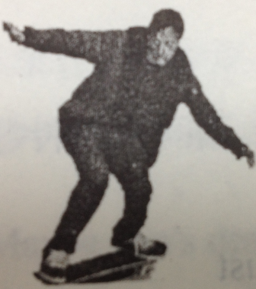
Tony Hawk is crazy about skateboarding. He comes up with new skateboarding tricks（技巧） all the time. In all, he has made up about 100 new tricks.
There are 360 in a circle. So two and one half circles is 900U. Hawks dream was to flip（轻抛） two and one half circles in the air. Hawk would only have two seconds橫少） to do these flips. That’s how long he could stay in the air before hitting the ground. Hawk called it the”9001. Hawk worked years getting ready for the “900“， He worked on each part of the trick. Hawk did thousands of “360” flips in the air. He practiced skateboarding hour after hour, day after day. There was no coach telling him what to do, He could decide for himself when to start and when to stop.
At last on June 27, 1999, he felt ready to do it. He would try the 900” at the X Games in San Francisco. On his first try, he fell. He fell on his second try, too. Then his third and his fourth tries. But each time he was getting closer. The other skaters stopped their shows to watch. On his eleventh try, he did it. The other skaters jumped with joy. This is the best day of my life,” Hawk told the crowd.
36. Tony Hawk has made up about JOO new tricks.
37, There are 9000 in two circles.
38. Hawk could stay in the air for only two seconds.
39. Hawk has got professional training for skateboarding.
40. Hawk succeeded in 1999 after he tried 10 times,
B
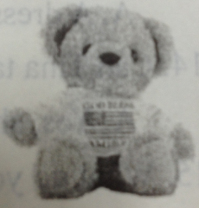
Children everywhere like toy bears. People have been making them for hundreds of years. Children also like stories about bears. The most famous storybook bears are Rupert Bear, Winnie the Pooh (Pooh Bear) and Paddington Bear. Most children in Britain and the US are also familiar with the story Goldilocks and the Three Bears! Now toy bears are very popular with adults as well as children. And many stores sell just toy bears of a/l kinds.
Many people call toy bears Teddy Bears, but this name has only been used since the early 1900s.The name “Teddy’ is short for Theodore, and there was an American president named Theodore Roosevelt. He was very popular and people soon started calling him Teddy Roosevelt. While he was out hunting ~T猎) one day, Roosevelt refused to kill a bear. As soon as people heard about this, they started calling their toy bears Teddy.
41. The first toy bears were made_______.
A. 100 years ago B, hundreds of years ago
C. in the early 1900s D. when Roosevelt was president
42. Teddy Roosevelt was_______.
A. a person who made toy bears B. a bear in a store
C. an American president D. a children’s city
43. Toy Bears are often called Teddy Bears because_______.
A. of President Roosevelt B. Teddy is another name of bears
C. a man called Teddy sold bears D. it is a name of a famous storybook bear
44. People called Theodore Roosevelt as Teddy Roosevelt because________.
A. he refused to kill a bear B. they liked their toy bears
C. he was very popular D. toy bears are so popular today
45. The article mainly tells us about________.
A. President Theodore Roosevelt B. famous people who like bears
C. killing a bear D. toy and storybook bears
C
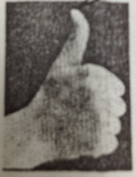
Different gestures（手势） mean different things in different countries. Sometimes a gesture that is polite in one country is not polite in another and should not be used. Different meanings of gestures can also cause problems in understanding what another person is trying to say. A gesture that many people do not understand is one that uses the thumb. Most westerners will sometimes show that they like something by holding out a closed hand with the thumb lifting in the air, This is called give someone or something “the thumbs up.” Often, only one thumb is used, so it should be “the thumb up.”
The usual explanation（解释） for the origin of this gesture is not really correct. It says that in ancient Roman times, when people were pleased with the way a gladiator（角斗士） had fought, they showed their thumbs up, When they were not pleased, they gave the thumbs down. When a gladiator was given the thumbs up, the emperor allowed him to live. When a gladiator was given the thumbs down, the emperor ordered him to be killed.
The truth is, however, it was translated into a wrong meaning by mistake. If people wanted to save the gladiator, they put out their hands and hid their thumbs in their hands. If they wanted the gladiator to die, they pointed their thumbs straight at him.
46. Westerners lift their thumbs when they______.
A. want someone to die B. want to go to a playground
C. like something D. want someone to live
47. Most people think that in ancient Rome, “thumbs up” meant that_______.
A. the emperor could die B. the people wanted the gladiator to live
C. the fighting could continue D. the people were not pleased
48. In fact, if people wanted a gladiator to live, they _______.
A. hid their thumbs B. pointed their thumbs down
C. lifted their thumbs up D. pointed their thumbs at him
49. From the article we know that ________
A. different gestures have different meanings in different countries
B. a friendly gesture is always the same in different countries
C. the meaning of “thumbs up” is the same both now and the past
D. we should often use the thumbs
50. The main idea of this article is about________.
A. gestures around the world B. closed thumbs
C. gestures in ancient Rome D. the thumbs-up gesture
第二卷（共45分）
VII.综合填空（共1 5小题，每小题1分，共1 5分）
- 用所给词的适当形式填空，每词限用一次。（7分）
Look for, interest, tour, work, leave, take away, call
l. The light bulb gives people more time ________________every day.
2. You are not supposed to visit a friend’s house without ________first when you’re in Switzerland.
3. Don’t bring food to the classroom, or it___________.
4. Mr. King __________ six countries over the years.
5. - Why are you still here? The movie was over fifteen minutes ago.
-Oh, I ____________ my wallet.
6. -- Do you like the exhibition?
- The photos of the countryside are so great that they ________me a lot.
7. Nancy shut the door and _______the office.
B. 选择恰当的单词填空，将答案填写在文章下面的横线上，每词限用一次。（有两个多余的选项）（8分）
and, arrived, ,voice, myself , answered, nearly, happy, noise, including, reached
Long long ago, all feelings lived on an island（岛）： Happiness, Sadness, Knowledge and all of the others, 8 Love. One day it was said that the island would sink, so all of the feelings were busy making boats and ready to go.
The crucial moment came at last! When the island 9 sank, Love gave her boat to poor people who couldn’t make a boat. Now it was Love’s turn to ask for help.
Richness（财富）was passing by Love in a boat. Love said, “Richness, can you take me with you?” Richness 10 , “No, I can’t. There is a lot of treasure（金银财宝） in my boat. There is no room here for you.” Just at that time, Sadness was nearer, so Love asked, “Sadness, let me go with you.” “Oh, Love, I am so sad that I need to be alone by 11 .” Happiness passed by Love, too, but she was too 12 to hear clearly what Love said to her.
Suddenly, there was a 13 , “Come on, Love, I will take you.” It was an elder. Love even forgot to ask him where they were going. When they 14 dry land, the elder went away. Love asked Knowledge, another elder, “Who helped me?”
“It was Time.” Knowledge answered.
“Time?’ asked Love. “But why did Time help me?’
Knowledge smiled_ 15 answered, “Because only Time can understand how important Love is.’
8.________9._________10._________11._________
12.________13.________14._________15.________
VIII．阅读表达（共1 5分）
- 阅读下列图示，完成短文。（每空不超过两个词。）（每空1分，共5分）
How to Make Pancakes?
Pancakes
You need:
2 cups of flour l cup of water
1 cup of milk l egg
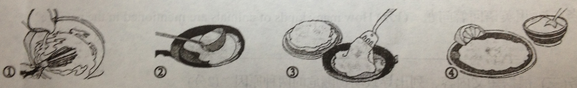
Here are_________ for making pancakes.
To make pancakes, we need 2 cups of flour, 1 cup of water, 1 cup of milk and_____. Get all the ingredients ready _ _cooking. First, mix everything together. _______ put some of the mixture into a frying pan（平底锅）．Cook the pancakes on ________ sides. It is more delicious if we add lemon and sugar.
- 阅读下面短文，按要求完成各项任务。（5分）
10 million reptiles (爬行动物), such as snakes, crocodiles, turtles, are killed every year. Their skin is used to make fashion items, like handbags and shoes,
The whales are in danger because man kills them for their meat and oils.
Orangutans（猩猩） live in rainforests. They want to live in peace, but people are cutting down the trees for wood and farming. This is a big problem because the trees are the orangutan’s homes. They are very difficult to find and study because they are shy animals. They are also our cousins!
There isn’t enough bamboo for pandas to eat because man has cut down nearly half the bamboo forests. Research has shown that there are only about 600 pandas in the wild world. Most of them live in China.
Some people take the turtle’s eggs to eat. The skin of the turtle is used to make some jewelry.
In the Far East, rhinoceros’（犀牛） horns（角） are used to make medicines. They are also used to make ornaments（饰品）．
There are only about 2,500 manatees in the US. They are endangered because some of the swamps have become polluted. Also, there sometimes isn’t enough food for all of them.
So what can you do to protect them?
·Try not to buy jewelry made from animals.
·Try to keep the planet clean and free from pollution.
·Tell other people about what you’ve learned.
任务（一）选择与动物名称相匹配的图片，将图片的字母代号填写在相应的横线上。（1分）
A. 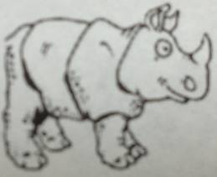 B. 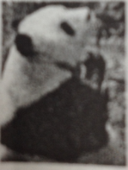 C. 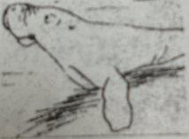 D. 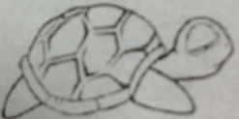

l. panda__________ 2. rhinoceros___________ 3. turtle _________ 4. manatee___________
任务（二）用英语回答问题。（1分）How many kinds of animals are mentioned in the passage?
____________________________________________________
任务（三）根据短文内容，列出导致动物濒危的两种原因。（2分）
①__________________________________________
②__________________________________________
任务（四）请将文中They are also our cousins!翻译成中文。（1分）
____________________________________________
- 阅读下面短文，按要求完成各项任务。（5分）
It brings us a lot of pleasure when we see people we love and things we enjoy. But without the sense of sight, we would miss those enjoyable moments. We must take care to protect our eyesight and eyes.
Remember
*Never stand with your face over a pan of frying food. Popping（进,溅）oil can hurt your eyes.
*When working at your computer, remember the 20-20-20 rule. After every 20 minutes of screen time, look at something 20 feet away for 20 seconds. This allows your eyes to relax and change focus.
Put your computer screen five to nine inches（英寸） below eye level. This keeps your eyes partly closed, allowing ①them to blink（眨） correctly and remain moist（湿润），
*Carefully watch children and their ~handicraft projects. Everyday things such as scissors, paper knives and pencils can cause eye injures.
*Never allow children to play with or light fireworks.
任务（一）从文中找出与所给句子意思相同或相近的句子。（1分）
Your face should never be over a pan of frying food.
____________________________________________
任务（二）请根据短文内容完成句子。（2分）
When we work at the computer for 20 minutes, we should _____________________, and also we should put our computer screen____________________________.
任务（三）请根据上下文，写出句中画线单词指代的意思。（1分）
This keeps your eyes partly closed, allowing ①them to blink correctly.
them:_____________________________________________________
任务（四）选择②handicraft的词义。（1分）
( ) A．与手有关的 B．手 C．手工艺品
IX.书面表达（共1 5分）
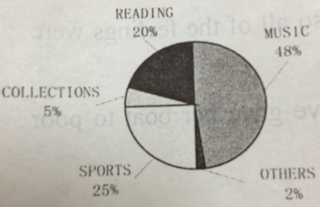
当前，学生的学校生活多姿多彩，业余爱好也丰富多样。左图是我们对某所中学300名学生业余爱好的调查结果。请根据以下要求，用英语写一篇短文。
要求：1．必须包括①调查结果②你自己的爱好、选择的原因及带来的益处。
2．文中不得出现真实的校名与人名。
3．字数80-100（文章开头已给出，不计入总字数）。

Many students have hobbies. Here is the result of the survey about what 300 students usually do in their free time.________________________________________________________
______________________________________________________________________________________________________________________________________________________________________________________________________________________________________________________________________________________________________________________________________________________________________________________________________________________________________________________________________________________________________________________________________________________________________________________________________________________________________________________________________________________________________________________________________________________________________________________________________________________

2012中考英语试题答案
听力部分
1-5 BCABB 6-10CACCB 11-15CABBA
单顶选择
16-20 CADBC 21-25 BDCDB 26-30 CCBCD 31-35 DBAAA
阅读理解
36---40 ABABA 41-45 BCACD 46-50 CBAAD
听力部分
IV.听短文，完成下列任务。（共10小题，每空1分，共10分）
(1)B (2)A (3)E (4)D (5)C
(6) be achieved / come true (7) why (8) friends (9) taste (10) older
综合填空（共15小题，每小题1分，共15分）
A. l. to work 2. calling 3. will be taken away 4. has toured
5. am looking for 6. interest 7. left
B, 8. including 9. nearly 10. answered 1l. myself 12. happy 13. voice
14. reached 15. and
阅读表达（共1 5分）
A. l. steps / instructions /tips 2. 1 / one/ an / egg 3. for /before
4.Then / Next 5．Both / 2
B. 任务（一）1. B 2，A 3.D 4．C
任务（二） Eight／8
任务（三）
l. People are cutting down the trees for wood and farming.
2. Man has cut down nearly half the bamboo forests.
3. Some people take the turtle’s eggs to eat. / The skin of the turtle is used to make some jewelry.
4. Rhinoceros’ horns are used to make medicines. / Rhinoceros are used to make ornaments．
5. Some of the swamps have become polluted./There sometimes isn’t enough food for all of them.
任务（四）它们还是我们的近亲呢！(cousins译为“表兄妹”扣0.5分)
C．
任务（一） Never stand with your face over a pan of frying food.
任务（二） look at something 20 feet away for 20 seconds ; five to nine inches below eye level
任务（三）(your) eyes
任务（四）C
Ⅸ．书面表达（共1 5分）
Possible version:
Many students have hobbies. Here is the result of the survey about what 300 students usually do in their free time. Nearly half the students like music, and a quarter of them usually spend their time playing sports on weekends, twenty percent enjoy reading books. A few students like collecting things they like such as stamps, coins and so on, Few students have other hobbies.
As for me, I prefer listening to music. Because it can give me pleasure when I’m unhappy and make me relaxed after hard study. Sometimes I listen to English songs. I can learn English words or phrases from them. It really improves my English a lot.

