2010年山东省青岛市中考英语试题及答案详解

星火英语测评研究所 张新峰
(满分105分，考试时间120分钟）
第I卷(共60分）
第二部分笔试(35分）

V.单项选择从每小题所给的四个选项中选出能够完成或回答这一小题的最佳答案。（共20小题，每小题1分，共20分）
16. —I am crazy about chocolate.
— . That's probably why I am becoming fatter and fatter.
A. So I am B. So I do C. So do I D. So am I
17. —What is your little brother like?
— . He enjoys telling jokes.
A. He is tall and thin B. He is shy and quiet
C. He is outgoing and funny D. He is strong and heavy
18. My daughter for me until I came back last night.
A. didn't wait B. waited C. is waiting D. waits
19. The movie was ，I fell asleep halfway through it.
A. funny B. boring C. exciting D. thrilling
20. —Which hair band do you like best, madam?
—I can't decide now. I really don't know .
A. to choose which one B. choose which one
C. which one to choose D. which one I should choose it
21. —I am going to Alison's birthday party tonight.
— your new jacket, Betty. You are not supposed to your old one.
A. Dress, put on B. Wear, dress C. Wear, put on D. Put on, wear
22. —Where is John?
—He to the library and he there for an hour.
A. has been, has been B. has gone, has been
C. goes，went D. has been, will be
23. I wonder if the talent show next month. If they it, I must get ready for it.
A. will hold，hold B. will hold, will hold
C. will be held，hold D. is held, will hold
24. —How do you like the concert given by New Ocean Waves?
—Exciting, one piece of the music wasn't played quite well.
A. so B. because C. though D. and
25. —What will you do if you see someone in line?
—I will say "Would you mind joining the line?”.
A. wait B. cuts C. waiting D. cut
26. He may leave now, because there is work for him to do.
A. a little B. some C. no D. any
27. The students make model toys old TVs and sell them to raise money for the children in the poor areas.
A. out of B. into C. of D. from
28. Sometimes the ads but don't tell you anything about the quality of the product
A. look well B. sound good C. taste good D. seem bad
29. What a beautiful painting it is! I've never seen painting.
A. such a B. a C. such D. this better
30. Between the travel plans, I'd like the one with a price because I don't have so much money.
A. higher B. lower C. cheaper D. more expensive
31. —Where are the ？
—They are playing violin in the school hall.
A. girl students， B. girls students，the
C. girl students, the D. girl student, the
32. —Do you know ？
—Yes. He came here by train.
A. when he came here B. if he will come here
C. why he came here D. how he came here
33. Jim was going to meet me early this morning at the aquarium but he didn't .
A. show up B. give up C. stay up D. set up
34. I can't write a complete report unless you me with enough informatio about the competition.
A. offer B. give C. provide D. tell
35. The young college students jumped into the river and swam to the boys they heard them crying for help.
A. as soon as B. before C. because D. till

VI.阅读理解阅读下列短文，做出正误判断或选出最佳答案。A篇为判断正(A)误(B)题,B、C篇为选择题。（共15小题，每小题1分，共15分）A
CHILDREN'S BOOKSHELF
Black Baby, White Hands ：
A View From the Crib
by Dr. Jaiya John
Soul Water Rising. May 2005
$17. ISBN 0-971-33081-6
The author is a young African American who was adopted(收养）from the crib(婴儿床）by a white family in New Mexico in the 1970s. Dr. John tells about his feelings as he was trying to understand how best to deal with them.
Hewitt Anderson's Great Big Life
by Jerdine Nolen，illustrated(插图）by Kadir Nelson
Simon Schuster Books for Young Readers. January 2005
$ 16. 95. ISBN 0-689-86866-9
Ages 5 — 10
Hewitt is everything his parents could want in a son. But there's just one problem“he's very, very small while other members of his family are all proud giants(巨人）.But it turns out that Hewitt's great，big character is all he really needs.
36. Jaiya John is from Mexico.
37. Dr John is more than 30 years old now.
38. Hewitt Anderson's Great Big Life costs $ 17.
39. Hewitt Anderson's Great Big Life is written for children aged 5 — 10.
40. Hewitt is a proud giant.
B
Students in our school have one thing in common-an interest in sports. According to their different aims in doing sports, they fall into three groups.
Many students go to the playground when they feel tired after a few hours of study. These students put much more stress on their study efficiency(效率）than the fun of sports. They just want to go back to their classrooms from the playground with a clearer and quicker mind. So they don't actually care whether they can enjoy themselves on the playground. Most of them choose long-distance running, the kind of exercise which few real sportsmen like. So this group of students can be well regarded as study-oriented participants(参加者）.
Students that make up the second group are real sports lovers. Sometimes they even put aside their studies for a match. They participate in the sport that interests them most, not caring whether it is good for their health. They may be called fun-oriented sports participants.
The third group want beauty from sports. Boys want to become strong； girls want to be slim and graceful. Those who consider sports the only way of losing weight also belong to this group. They are very careful in choosing the kind of exercise they do, and are afraid that certain sports may influence their body shapes. The proper name for this group may be beauty-oriented sports participants.
No matter which group we belong to, we all benefit(受益）from sports. If you look around the school yard, you will find that bookworms have disappeared, and instead, there are healthy, strong, clever and modernized students everywhere.
41. The common interest of the three groups is .
A. study B. sports C. fun D. beauty
42. The study-oriented group .
A. think the study efficiency is more important
B. enjoy themselves on the playground
C. choose long-distance running as real sportsmen do
D. want to study sports
43. Which of the followings belongs to the second group?
A. They care if sports are good for their health.
B. Mostly they are interested in the sports.
C. They want to have a clearer and quicker mind.
D. They choose the kind of exercise they do carefully.
44. In the beauty-oriented group, students .
A. just want to lose weight
B. want to be strong
C. want enough exercise
D. think beauty is the most important
45. According to the passage，we can find all over the school yard.
A. students are good at sports
B. bookworms have appeared
C. healthy, strong, clever and modernized students
D. students belong to many different groups

C
After finals，I was ready to move out. It wasn't too hard for me, but for a lot of my friends, it was a big event. After packing my suitcase and helping my friends move，it was time to say goodbye. I had reached the end of my first year in the university!
A friend from Chinese Taipei who is studying in Washington D. C. came to visit, so my brother and I took him sightseeing. But these were not this month's highlights. The high point was coming back home, a moment I'd been expecting since the day I left.
I arrived home early on the morning of May 15th. When I saw my parents，I gave them a big hug and kiss. Being at home with my parents, standing on this land， and feeling the humid and hot air，I knew I was home. The first thing I did was to go to Mei&Mei for a big breakfast. It was so much better than the school cafeteria(自助餐厅）！ Mei&Mei was just a start. There are so many foods I have to eat and so many friends I want to see.
The hot air is burning my face and the sweat(汗）is evaporating from my skin. I love this feeling. This is where I belong.
46. From this passage we can know that the writer is a .
A. university student
B. senior high school student in Taipei
C. high school student in Washington D. C
D. first year university student in China
47. The writer went home .
A. after one year studying B. after a big event
C. after one semester D. at the end of a year
48. Which of the following is Not True according to the passage?
A. The writer took a friend sightseeing with his brother.
B. The writer's friend was studying in Taipei.
C. The writer stayed far away from his home.
D. The writer had been expecting back home since the day he left.
49. The writer came back .
A. when he was tired of the school cafeteria
B. at the time when the weather was humid and hot
C. because he missed his parents
D. to have a big breakfast
50. From the last paragraph, we can know that the writer .
A. loves his hometown very much
B. enjoys the feeling of being at home
C. is happy though he feels hot all over
D. A，B and C are all right

第II卷(共45分）

VII.综合填空(共15小题，每小题1分，共15分）

A.用所给词的适当形式填空，每词限用一次。（7分)
explain，take part in，not mean，know, miss，invite，discuss
1. I am sorry you the last train. It left thirty minutes ago.
2. The young teacher thought it easy the project to the students.
3. The volunteers from our city some training before they go to Tibet.
4. —As a well-known actor, are you feeling happy?
—Not really. Sometimes I have a hard time who my real friends are.
5. A famous inventor to our school last summer vacation.
6. Don't bother your brother while he something with his classmates.
7. Singing English songs well you can speak English well.
B.短文填空选择恰当的单词填空，每词限用一次。（有两个多余的选项)(8分）
by，nobody，popular，invented，can，quickly，and，beginnings, anyone，make
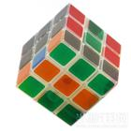
Pick up one of these cubes and you probably won't be able to put it down. How hard (8) it be to rearrange(重新排列）the nine colored squares on each side of the cube? In fact, there are 43×10³⁰ possibilities ！ It has been 31 years since the cubes were sold in stores around the world. Its (9) ，however, began years earlier as a simple classroom example. In 1974, Dr. Erno Rubik (10) the “Magic Cube” as he called it.
He did this to help his students understand 3-D concepts. This classroom model was quickly changed into a (11) toy.In 1979，Ideal Toys bought the rights(权利）（12) sold it as "Rubiks Cube”. The invention (13) became a 1980s cultural icon.
As time went (14) ，the cube's popularity became less, however, it made a comeback with the Internet. Now (15) can go online and find many videos that show ways to solve the cube. Erik Akkersdijk of the Netherlands holds the present world record. He finished it in just 7. 08 seconds ！
8. 9. 10. 11. .
12. 13. 14. 15. .

VIII.阅读表达(共15分）

A.阅读下列图表，完成短文，每空词数不限。每空1分，共5分）
Many villagers have left to make a living in big cities. As a result, their children have become “leftover children”（留守儿童）.The survey below is from 200 children rhnspn tn answer the niipstions. Here are the results.
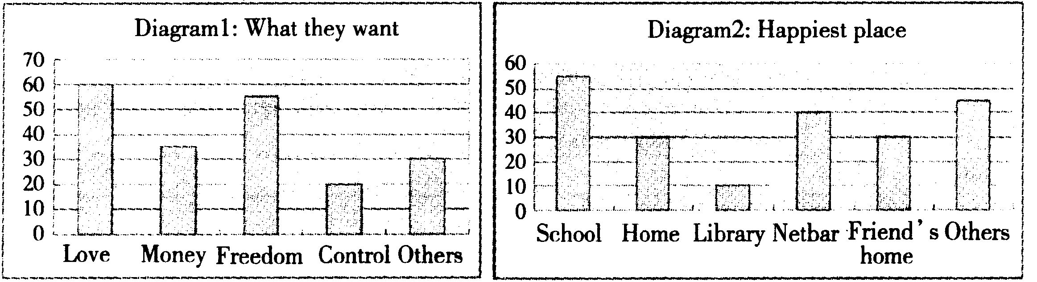
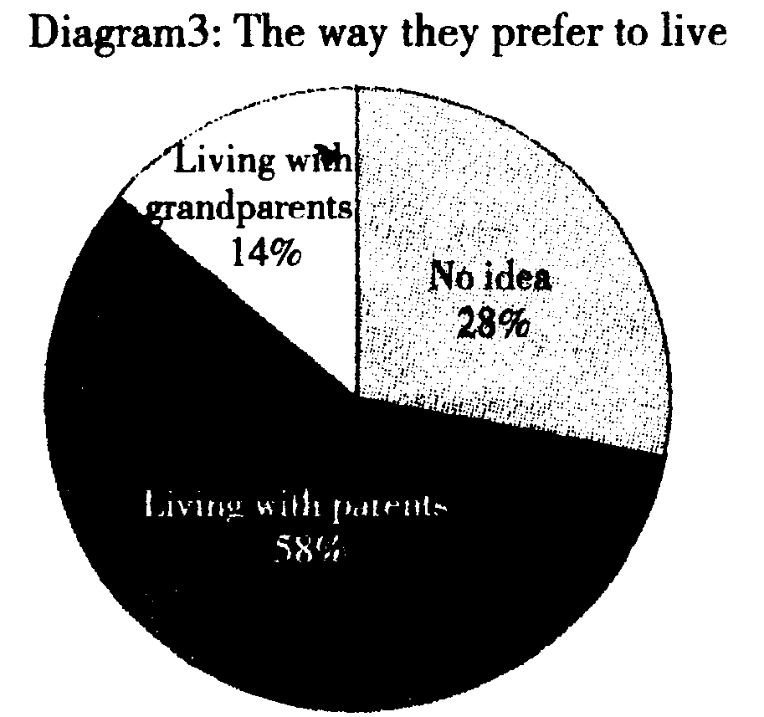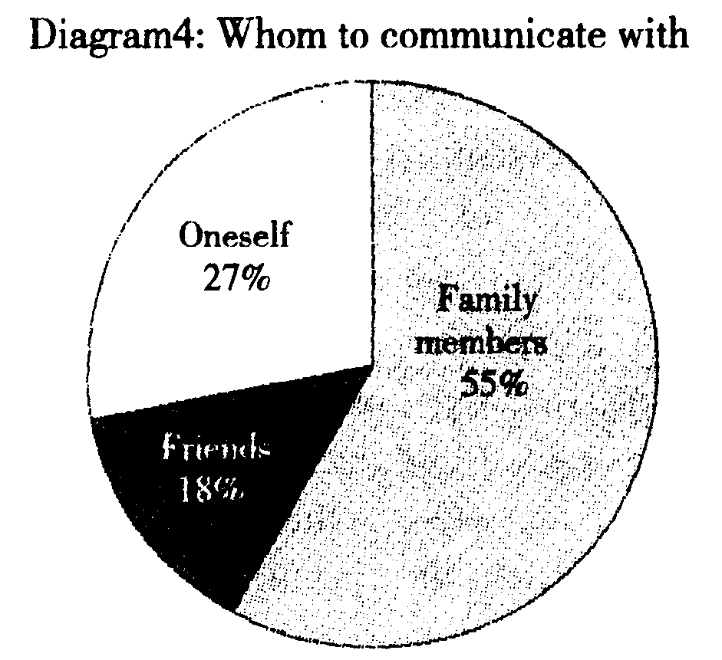

Diagram 1 shows the fact that "leftover children” want (1) .
most. Most students feel happiest to (2) and 10% of the students love to go to the library. 58% of the students like (3) .
better than with their grandparents. According to Diagram 4，the number of the甘落后students who like to communicate with family members is the (4) . The second largest is the students who communicate with (5) .
From the survey, we learn that "leftover children” need more care. We should give them more love.

B.阅读下面短文，按要求完成各项任务。（10分）

NEWS1.

Techniques(技术) used in the fireworks(焰火）displayed at the opening ceremony of Expo 2010 Shanghai will be popularized and widely used for fireworks in the future.
The fireworks employed special-effect technologies to project the logo (标识）of Expo 2010 Shanghai in the sky on the night of the opening ceremony. The research and development of the special technique took three years to perfect the firework for the first time that night.
In the future，people may use fireworks to design words like “ Happy Birthday" and flowers on special moments.
NEWS 2.
With the visitors，comes the garbage.
The large number of visitors to Expo 2010 Shanghai are bringing traffic pressure, long lines at many pavilions(展览馆），and also more waste.
About 160,000 visitors a day during the first five days of the Expo operation (运转）created nearly 200 tons of waste each day.
"Expo organizers have been trying to promote(推广）waste separation(分类） by putting separated bins for different types of waste. However, the idea has been poorly received by the visitors and not many people have put waste into separated bins." authorities said.
NEWS 3.
Collecting Expo passport(护照）stamps(印章）from pavilions has become so popular that the passports are sold out soon after the gates open every morning at the Expo Garden. They are now one of the hottest at the Expo Garden.
On Saturday, the opening day of the Expo, the 110,000 Expo passports were sold out within a few hours, leaving more than 100，000 visitors disappointed. Because of the shortage, visitors are coming up with creative ways to collect the stamps without using the 30 -yuan passports. Hou Peiqi is one of thousands of visitors to the Expo Garden who failed to get an Expo passport.
In the face of such a shortage，some visitors have been creative, asking pavilion staff to stamp their maps, books, newspapers and even T-shirts.

1.把下面的标题与相应段落的信息匹配。（1分）
a.Passports become hot at the Expo
b.High technique fireworks
c.Trash results at the Expo
News 1. News 2. News 3. .

2.从文中找出与所给意思相同或相近的句子。（1分)
Visitors are thinking up some other ways to collect the stamps besides the 30-yuan passports.
3.把句子With the visitors，comes the garbage.翻译成汉语。(1 分）

4.回答问题。（1分)
How many visitors during the first five days came to the Expo?

5.根据三段信息，完成下面的表格。（1)题，2分;（2)(3)题，每题1分;（4)〜（7)题， 每题0.5分。(6分）
Who | What to do
People | spent three years (1) .
People | the special technique to perfect the fireworks.
The large number of visitors to the Expo | are bringing (2) ，long lines at many pavilions，(3) .
Visitors | collect the stamps in the Expo passports or ask the pavilion staff to stamp (4) ，（5) ， (6) and (7) .
IX.书面表达(共15分）
为了生活得更舒适、便捷，人类在不断开发利用资源，研发高科技产品。与此同 时，我们的生存环境也会受到影响。为了建设资源节约型、环境友好型城市，青岛市 政府提出了“Creating beautiful environment, building pleasant homes”的理念。请以此为题，根据自己的亲身感受或所见所闻，用英语表达自己的看法。
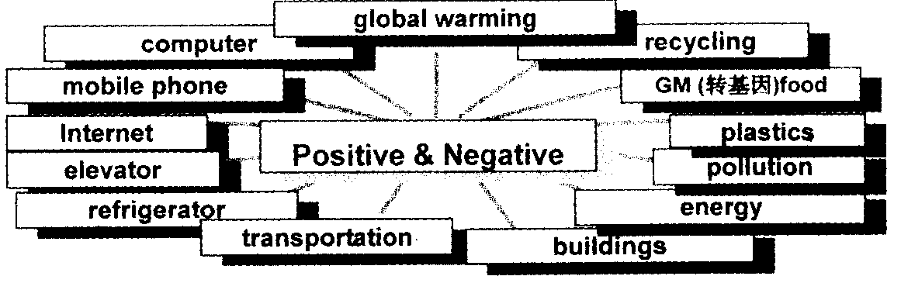

写作要求：

1.参考图表中所给提示，任选两个方面，谈谈它们的利与弊。

2.作为中学生，应该怎么做？怎样带动家人、朋友及社区的人们，为建设我们美 好的家园而努力。写出至少2种具体做法。

3.词数80〜100。（标题和开头句不计入总词数）
Creating Beautiful Environment, Building Pleasant Homes
With the help of high technology，life is getting more and more comfortable and convenient.

【写作指导】

一、审题

本篇作文的体裁为记叙文，要求谈谈在当今提倡环保的 时代，明确哪些做法有利于建设资源节约型、环境友好型城 市，为建设我们美好家园我们需要做些什么。时态用一般现 在时。写作时，要注意内容要点齐全，语言准确，宇数符合要 求，语篇连贯，短文和所给信息应融为一体。

二、写作要点
1.生活便捷:high technology, comfortable and convenient
2.环境问题:cause pollution
3.具体傲法：walk to school, save water and energy, recycle
waste things
4.产生效果：pleasant and beautiful

三、重点短语及句型
kinds of, all year round, cause pollution, at the same time,instead of, need to do，a bit, more pleasant and beautiful One possible version
Creating Beautiful Environment, Building Pleasant Homes
With the help of high technology，life is getting more and more comfortable and convenient. Most families have refrigerators, computers, mobile phones, cars and so on. We can eat kinds of fresh fruit and vegetables all year round.
However, at the same time, green land has become less and more pollution has been caused.
As students, we really need to do something, such as going to school on foot, by bicycle or by bus instead of by car. We should save water and energy at any time and anywhere. We could urge more people to recycle waste paper, bottles，batteries and many other things.
If everyone does a bit, our homes will become more pleasant and beautiful.

16. D【解析】本题考查倒装。“so+助动词(或情态动词）+ 主语”指主语与上文中提到的人一样或做了同样的事情; “serf主语+助动词（或情态动词)”指对上文主语做的事 加以肯定。根据下文中说话者的发胖状况及上文“lam crazy about chocolate”可知选 D。
17. C【解析】本题考查动词短语辨析。be like—般回答性格 方面的特征;look like—般回答长相方面的特征。根据后 文中提到的enjoys telling jokes可知，弟弟的性格是外向 的、逗人的。故选C。
18. B【解析】本题考查动词时态。非延续性动、词跟until连 用时,一般用否定形式;wait是延续性动词，¹"跟until连用 时,直接用肯定形式。同时该动作发生在过去，所以用过 去时。故选B。
19. B【解析】本题考查形容词辨析。根据后文中的“fell asleep half way through it"可知选 B
20. C【解析】本题考查非谓语动词。“疑问词+不定式”相 当于know的宾语从句。不定式须置于疑问词之后，故 选C。
21. D【解析】本题考查动词辨析。put on“穿上”，强调穿衣 的动作;wear“穿着”，强调穿衣的状态。第一空强调Betty “穿上”新衣服，而第二空强调她不应该“穿着”旧衣服。故 选D。
22. B【解析】本题考査动词时态。has gone to指去了某地 (未回来）；has been to指去过某地（已经回来了）；has been in指在某地待了一段时间(持续到现在）。根据句意可知 选B。
23. C【解析】本题考查时态和语态。第一句中if引导宾语 从句，根据时间状语next month可知用一般将来时,且宾 语从句的主语the talent show与动词hold之间为动宾关 系,故用被动语态；第二句中if引导条件状语从句，主句用 一般将来时，从句用一般现在时表示将来。故选C。
24. C【解析】本题考查连词用法。Exciting与后文中所讲的
内容之间为转折关系，故选C。
25. D【解析】本题考查动词see的用法。see sb do sth看见 某人做了某事；see sb doing sth看见某人正在做某事。根 据句意及答语中的joining the line可知是看到有人cut in line,故选 D。
26. C【解析】本题考查不定代词的用法。句意为：他现在可 以离开了，因为他没有事可做了。由句意可知应用否定词 修饰work，故选Co
27. A【解析】本题考査动词短语辨析。make of, make from 通常用于被动语态；make out of“用……制造出”,make into“做成……”。句意为：这些学生用旧电视机做成玩具 赚钱为贫困孩子募捐。故选A。
28. B【解析】本题考査系动词辨析。look well指人的气色 好，taste good指食品的口味好，二者不符合题意。根据句 意可知广告并未涉及商品的质量,故选B。
29. A【解析】本题考查名词限定词的用法。表示惊叹时，常 用“such+ _{a}/an(+形容词）+名词”这一结构，它相当于 “曾见到(或听到的)最……的”。故选A。
30. B【解析】本题考查形容词辨析。根据下文中的原因I don't have so much money可知此处是“少花钱”“低价”； 修饰 price 要用 low/high,不能用 cheap/expensive。故 选B。
31. C【解析】本题考査名词的数。女学生的复数是“girl students”，而乐器前面要加定冠词the，故选C。
32. D【解析】本题考查宾语从句。根据答语中的came here by train可知询问的是交通方式，故选D。
33. A【解析】本题考查动词短语辨析。show up露面，give up放弃，stay up熬夜，set up建立。根据上下文得知， 选A。
34. C【解析】本题考查动词辨析。give，tell, offer后面可以 直接跟名词，即give/tell/offer sb. stK ；而provide后加名 词时要加介词with，故选C。
35. A【解析】本题考查连词用法。句意为：年轻大学生们一 听到孩子的求救声就跳进河里救人。故选A。
【文章大意】本文简单介绍了两本儿童图书的基本情况。
36. B【解析】本题考查细节理解。根据第一篇中The author is a young African Americaa ..可知 Jaiya John 不是墨西 哥人。故此判断错误。
37. A【解析】本题考查推理判断。根据第一篇中...was adopted (收养）...in the 1970s可知，作者年龄已经超过 30。故此判断正确。
38. B【解析】本题考查细节理解。根据Hewitt Anderson、 Great Big Life的定价为$ 16. 95可知此判断错误。
39. A【解析】本题考查细节理解。此句与文章内容相符，故 此判断正确。
40. B【解析】本题考查细节理解。根据第二篇中he's very， very small...可知此判断错误。
【文章大意】我们学校的学生除了学习外还有一个共同的爱好一运动。作者按运动的目的将学生分成了三种类型：学习型、趣味型和健美型。
41. B【解析】本题考查细节理解。根据文章第一句可知，三 组人都喜爱sports，故选B。
42. A【解析】本题考查细节理解。根据第二段中第二句可 知，学习型参加者认为学习效率更重要。故选A。
43. B【解析】本题考查推理判断。根据第三段内容及real sports lover可知，第二组人大多对运动感兴趣。故选B。
44. D【解析】本题考查推理判断。根据第四段内容可知，这 组人把健美作为首选运动目的。而且本段第一句也提到 want beauty from sports。故选 D
45. C【解析】本题考查细节理解。根据文章最后一句话可 知，校园里到处是健康、强壮、聪明、现代化的学生。故选C。
【文章大意】每个人都留恋故乡，本文作者描写了经过一年的大学生活之后回到老家的感受。一点一滴，情真意切。
46. A【解析】本题考查细节理解。根据文章第一段最后一 句可知，作者刚读完大一，但是全文并未提及大学在中国， 故选A。
47. A【解析】本题考查细节理解。根据本文前三段可知 选A。
48. B【解析】本题考查细节理解。根据第二段内容可知作者 的朋友是台北人却没在台北学习。故选B。
49. B【解析】本题考查推理判断。根据第三段内容可知,作 者回家不单纯是因为想念父母，也不是_于吃腻了学校餐 厅或者在家乡享受美食。第四段中家乡的天气情况最贴 切。故选B。
50. D【解析】本题考查作者态度。根据最后一段可知,作者 热爱故乡、陶醉在故乡生活中。故选D。

1. have missed【解析】本题考查动词时态。末班车30分钟 前离开，因而选择“miss”，而且强调对现在的影响，故用现 在完成时。
2. to explain【解析】本题考查非谓语动词。句意为：年轻老 师认为跟学生解释这个方案很容易。explain sth. to sb.为 固定搭配。本句中it是形式宾语，真正宾语是不定式短语。
3. will take part in【解析】本题考查动词时态。先确定跟 training搭配合适的应该是take part in。本句是复合句，包 含一个由before引导的时间状语从句,从句用一般现在时 表示将来，但是主句仍然用一般将来时。
4. knowing【解析】本题考查非谓语动词。名演员很难知道 谁是真正的朋友，这是他不开心的地方。所以选择know。 have a hard time后可接不定式或者现在分词短语作定语，
to do—般表示未发生的事,doing表示正在或已经发生的 事。本句内容是一般现在时，所以使用现在分词短语作定语。
5. was invited【解析】本题考查动词的被动语态。根据句意 可知，著名发明家是被邀请到我们学校，所以用invite的被 动语态；同时由于时间发生在过去，故用一般过去时。
6. is discussing【解析】本题考查动词时态。不让弟弟打扰， 有可能是和同学在讨论问题或者商量事情，故选择 discuss。主句是祈使句，从句再现在时，while引导的时间 状语从句多用进行时态，故用现在进行时。
7. doesn't mean【解析】本题考查谓语动词。英语歌唱得好 并不意味英语说得好，选择not mean。现在分词短语作主 语,谓语动词要用第三人称单数形式,需加助动词does表 示否定。
【文章大意】魔方很神奇，至今仍是一种流行的有难度的游戏，然而你知道它的历史吗？本文介绍了它的起源与发展的情况。
8. can【解析】本句是一个特殊疑问句，主语前缺少助动词或 者情态动词，故选择can。
9. beginnings【解析】本句中its后应该加名词，与后面began 呼应，因此选择beginnings。
10. invented【解析】本空前面是某人，后面是某物，缺少谓语 动词，且时间状语表示过去,故要用动词的过去式，所以选 invented .
11. popular【解析】本空前有冠词，后有名词,需要填入形容 词，故选popular₀
12. and【解析】本空前的bought the rights(权利）和后面的 sold it as “Rubik，s Cube"都是由 Ideal Toys 所做的，为并 列关系，故用and。
13. quickly【解析】本句意思完整，不缺少主要成分,故用副 词quickly强调事情发展迅速。
14. by【解析】go by为固定短语，指(时间)过去。
15. anyone【解析】此句中缺少主语，且有“任何人”之意，故 选 anyone

【文章大意】本文以留守儿童为主题用四个图表的形式展示了对留守儿童进行的4项调查结果，揭示出留守儿童渴望被关爱的心理需求。
1. love【解析】从表1可知，love远远超出其他。因此，“they want love most” .
2. go/stay at school/be at school 【解析】从表 2 可知，65 % 的 留守儿童喜欢学校，而学校在他们喜欢的地方中排在第一位。
3. living/to live with (their) parents【解析】表 3 中有明确的 数字。注意like之后使用动词不定式短语或者现在分词 短语。
4. largest【解析】由表4可知，喜欢跟家庭成员交流的人数最多。注意修饰人数用large，根据句意可知应使用最高级 形式。

5. themselves【解析】喜欢跟自己交流的人数排在第二位，反 身代词与主语保持一致，使用第三人称复数。

【文章大意】本文以当下国人引以为豪的上海世博会为背景， 摘录了三条新闻。
新闻一：体现高科技的开幕式焰火；
新闻二 ：随着大批游客的拥乂,世博会面临的垃圾问题
新闻三：世博的护照热销。
1. News 1. b【解析】短文讲述世博会开幕式的高科技焰火， 故选 High technique fireworks。
News 2. c【解析】短文谈到世博会开始几天由于人多而 产生了大量的垃圾。故选Trash results at the Expo。 News 3. a【解析】短文讲述人们热衷于收集世博会护照 印章，故选 Passport become hot at the Expo₀
2.本句意思是：除了 30元的护照，参观者想出一些其他方法 来收集印章。短文中与之意思相近的是：Visitors are coming up with creative ways to collect the stamps without using the 30-yuan passports.

3.随着参观者/游客的到来，产生了(大量的)垃圾(问题)。
4. About 800,000 visitors.【解析】由短文中 About 160,000 visitors a day during the first five days of the Expo operation (运转）created nearly 200 tons of waste each day.通过计算 可得出前五天的总人数。
5. (1) (in) doing the research and development of/on the research and development of/researching and developing 【解析】短文主语讲的是某项技术，所花的时间用... take...结构；如果主语换成people，与之搭配的结构是 spend... on sth.，spend doing sth.，spend in doing stK
(2)traffic pressure
(3)more waste
(4) (their) maps
(5)books
(6) newspapers
(7)(even) T-shirt

