徐州市2016年初中毕业、升学考试
英 语 试 题
姓名 考试证号
注意事项
1. 本试卷共8页，满分为110分，考试时间为100分钟。
2. 答题前，请将自己的姓名、考试证号用0.5毫米黑色墨水签字笔写在本试卷及答题卡指定
的位置。
3. 答案全部涂、写在答题卡上，写在本试卷上无效。考试结束后，请将本试卷和答卡一并交回。

一、选择填空 （共15小题，每小题1分，满分15分）
从A、B、C、D四个选项中选出可以填入空白处的最佳选项。
- — _______ you play tennis?
—Yes, and I’m a good player.
A. Can B. May C. Must D. Should
- It’s not cool but it isn’t as _________ as yesterday.
A. hot B. hotter C. hottest D. the hottest
- Have you read the Harry Potter series __________ J.K. Rowling?
A. of B. for C. with D. by
- I love __________. I hope one day I can take part in one of them , answer all the questions and win a big prize!
A. chat shows B. game shows C. cartoons D. documentaries
- —Is your friend British or American?
— __________. She is Canadian.
A. Both B. Either C. Neither D. None
- If someone is in your way, you should say “___________” and be polite enough to wait till he or she moves.
A. excuse me B. I’m sorry C. thank you D. never mind
- My cousin works for an airline. He flies planes. He is __________.
A. an inventor B. a scientist C. an explorer D. a pilot
- When you are home, give me a call to let me know you __________ safely.
A. arrived B. have arrived C. will arrive D. are arriving
- Anita spoke _________ quietly that o could hardly hear her.
A. too B. such C. so D. very
- I will see what I can do, but I can’t _________ you anything.
A. plan B. prepare C. promise D. protect
- The teacher encourages the children to feel _________ about asking questions when they don’t understand.
A. nervous B. confident C. excited D. practical
- We should save energy by _________ the lights when we leave a room.
A. getting off B. showing off C. taking off D. turning off
- I went to work the next day, __________ I was still feeling unwell.
A. because B. until C. unless D. though
- David said that the glass was broken and warned me __________ it.
A. don’t touch B. to not touch C. not to touch D. no touching
- Which of the following sentences is a FACT?
A. Xuzhou is in Jiangsu Province. B. Xuzhou is a beautiful place to go.
C. Life in Xuzhou is getting better. C. People in Xuzhou are friendly.

二、完形填空 （共15小题，每小题1分，满分15分）
根据短文内容，从各题所给的A、B、C、D四个选项中选出最佳选项。
Kevin sat at the desk in his study, pencil in hand. He had to write a story for his English class by Friday. “I don’t know what to 16 ,” he complained to his dog, who was asleep at his feet. Kevin was talkative when speaking to his friends, yet he had 17 finding words he had to write.
By bedtime Kevin had drawn a picture of his dog smiling. He had drawn a tree with its branches(树枝) blowing in a high wind. He had also written a 18 asking his friend to go to the movies on Saturday. 19 he had not written a single word of his story. [来源:学科网ZXXK]
On Wednesday, Mrs Scott, Kevin’s English teacher, asked the class to 20 the first draft() of their stories. Kevin had to turn in the only work that he had—the page with his name, the 21 , and the note.
Kevin wasn’t 22 when Mrs Scott asked him to stay after class the next day. But he was surprised by what 23 said to him. “Kevin, this is a fantastic story—the dog, the movie, the tree in the 24 . I can’t wait to find out how they all fit together. I think you have the idea of a story there. Look at your note and the pictures and try to see 25 a story comes to you.”
That night Kevin sat at his desk, and this was what he wrote: “One Saturday Tom went to meet his friend at the 26 . it looked as if it might rain, so Tom 27 his umbrella. Suddenly a big storm blew in. The noise of the wind 28 like Tom’s dog Spotty. Spotty really hated storms and barked whenever he wanted to be let inside. Then Tom saw Spotty running after him down the busy street, barking. The sound was full of blame(责备). Tom felt 29 because he had left Spotty outside. He turned and headed home with Spotty. Tom let Spotty in the door just and the rain started to pour down.”
Kevin had a story after all. The last thing he did was to write his name 30 at the top of the page.

- A. talk about B. worry about C. write about D. care about
- A. trouble B. fun C. help D. experience
- A. report B. notice C. letter D. note
- A. And B. But C. So D. Or
- A. hand in B. hand out C. take in D. take out
- A. photos B. maps C. writings D. drawings
- A. cheerful B. surprised C. scared D. satisfied
- A. I B. you C. he D. she
- A. wind B. rain C. snow D. fog
- A. when B. why C. if D. where
- A. theatre B. cinema C. bank D. museum
- A. carried B. lost C. sold D. hid
- A. looked B. felt C. sounded D. acted
- A. energetic B. angry C. guilty D. curious
- A. smoothly B. proudly C. hurriedly D. properly

三、阅读理解 （共12小题，每小题2分，满分24分）
阅读下列短文，从各题所给的A、B、C、D四个选项中选出最佳选项。
Mrs White had a problem. Her young son, Timmy, hated to go to bed at night. Mrs White read to him and gave him warm milk, but Timmy refused to fall asleep. No matter what she did, Timmy wanted to stay up. One day Mrs White had an idea.
Ever since Uncle Charlie had taken him sailing, Timmy wanted to be a sailor. He loved fishing with his father. He loved to watch the waves wash against his hair. “some day,” Timmy said, “I’m going to have my own boat. And I’m going to be the captain.”
So Mrs White had a boat built—one that could be hung from the ceiling in her son’s bedroom. She felt that if he could sleep in the boat, he would want to go to bed at night.
The boat builder made the boat and hung it in Timmy’s bedroom. Timmy loved it.
34 Finally Timmy was happy to go to bed.
- Who once took Timmy sailing?
A. Mrs. White. B. Mr. White. C. Uncle Charlie. D. The boat builder.
- One of Timmy’s dreams was to be ____________.
A. a captain B. a story—teller C. a fisherman D. an engineer
- Mrs. White had a boat built for Timmy to _________.
A. go fishing in B. play with C. go sailing in D. sleep in
- Which sentence is the most suitable to be put in the last paragraph?
A. But Mrs. White disliked it. B. And Mrs. White loved it too.
C. But Mrs. White doubted it. D. And Mrs. White couldn’t fall asleep.

B

Alice, Sue and Simon are having a
Chinese New Year Party at Simon’s house at
6 p.m.
Wear something red!

- What is NOT included?
- When to have the party.
- Where to have the party.
- What colour to wear at the party.
- What activities to do at the party.

Believe it or not, our eyes are the same size from birth, but our nose and ears never stop growing. Have you ever noticed it?
- What never grows in one’s life?
- Eyes B. Nose
C. Ears D. Hair

John was driving home from work. Suddenly he stopped the car. He could hardly believe what he saw. A camel was standing in the middle of the road! Later he learned the camel had run away from the zoo. What a story John would have to tell!
- What is this passage mainly about?
- A lucky camel’s story.
- John’s unusual experience.
- How John got home from work.
- A camel running away from the zoo.

Some trees communicate with each other. Willow trees are be best known of these trees. When insects begin biting a willow tree, the tree sends out a special smell. Other willow trees in the area can catch this smell. This tells them that harmful insects are nearby. The willows quickly make a chemical(化学物质) in their leaves. This chemical, which insects do not like, drives the insects away from the willow trees.
- What is the best title for this passage?
- How insects communicate with each other
- How insects communicate with willow trees
- How willow trees communicate with each other
- How willow trees send out a special smell

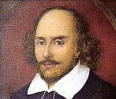
C

William Shakespeare is one of the greatest writers in English literature. His plays can be divided into three categories: histories, tragedies(悲剧) and comedies. Shakespeare wrote eighteen comedies, although two were lost. These comedies usually have happy endings and a light-hearted tone and style that are quite different from his tragedies.
All of Shakespeare’s comedies have five acts and the most important or exciting point always takes place in the third act. The hero does not appear until after other characters have talked about him. Shakespeare had some themes that he usually wrote about: the fight between good and bad, love’s great effect on people, and the difference between first appearance and a person’s true personality or face. Shakespeare also wrote his play in a certain style. For example, Shakespeare used words in such a clever and humorous way that they had more than one meaning. Some of the characters changed their appearances so that people didn’t know who they were.
Even though the tone is lighter in these plays. Comedies in Shakespeare’s day were quite different from modern-day comedies because their purpose was not to make people laugh. Shakespeare’s comedies are very emotional(有感染力的) and often include serious topics to think about.
- How many Shakespeare’s comedies can people enjoy now?
A. 18 B. 16 C. 5 D. 2
- Which word has the same meaning as the underlined word “categories” in Paragraph 1?
A. type B. parts C. copies D. pages
- When does the hero in Shakespeare’s comedies appear?
- At the beginning of the play. B. In the middle of the play.
C. Near the end of the play. D. Not until other characters have mentioned him.
- Which sentence is WRONG according to the passage?
- All Shakespeare’s comedies have five acts.
- Shakespeare’s plays are written in a certain style.
- The purpose of Shakespeare’s comedies is to make people laugh.
- The fight between good and bad is one of the themes Shakespeare wrote about.
四、词语运用 （共16小题，每小题1分，满分16分）
- 选出方框内的单词或词组填空，其中有一个单词或词组是多余的。[来源:学§科§网Z§X§X§K]
reminded wonders carry on aloud opposite against

- It’s important for students to read English ▲ every day.
- The post office is just ▲ my home.
- I’m glad you ▲ me of the meeting. I had completely forgotten it.
- The Great Wall of China was first built over 2,000 years ago. It is one of the ▲ of the world.[来源:学。科。网]
- Let’s donate money to ORBIS for doctors to ▲ with their work.
- 根据句子意思，用括号中所给单词的真确形式填空。（每空限填一个单词）
- Robin never bought ▲ (I) a drink when we were together.
- Sandy came first in the race. She ran the ▲ (fast) of all.
- We will provide a high level of ▲ (serve).
- I had the ▲ (comfortable) feeling that I did it wrong.
- I’m not ▲ (worry) about my younger sister-she can take care of herself.
C）用括号中所给动词的正确形式填空，使短文完整。
Dr Watson was a good friend of the famous detective Sherlock Holmes. One morning they 53 (eat) breakfast when suddenly Holmes said, “I have to go to a place 54 (call) Coland. A horse has disappeared from there, and the police can’t find it. Will you come with me?”
“Do you think that the horse 55 (steal) the other day?” Watson asked.
“I don’t know,’ Holmes replied. “ I need to go to Coland 56 (find) out.”
“Why is this horse so important, Holmes?” Watson asked.
“Because I 57 (run) in a big race. If it wins, a lot of people will win a great deal of money. There are also people who 58 (not want) it to win.”
An hour later, they were on the train to Coland.
五、阅读填词。（共10小题，每小题1分，满分10分）
阅读短文，根据所读内容在文章后表格中的空格里填入一个最恰当的单词。
Brazil is a country in South America. It will host the 2016 Olympic Games.
Brazilians are very friendly people and are generally relaxed, so it is important to say hello and goodbye to everyone. Women kiss men and each other, but men usually just shake hands. Brazilians stand very close to each other and touch each other’s arms, elbows(肘) and back regularly while speaking. You should not move away if this happens.
If you go to a business meeting, you are not expected to take a gift. On the other hand, if you are invited to someone’s house, you should take a gift—for example, flowers or chocolates. However, you shouldn’t take anything purple or black, as these colours are related to death. If you are invited to dinner, arrive at least half an hour late, but always dress well because appearances are very important to Brazilians.
Football is very important in Brazil. People play football everywhere, and everyone plays. Adults and children play football in their free time. They usually play on football fields, but sometimes they football on the beach or in the street. Brazil has many world-famous footballers, like Pele, Kaka, and Ronaldinho. In total, there are more than 13 million players and 29,208 football clubs.
Football is not the only popular sport in Brazil. Capoeira is an important part of Brazilian culture. It is a mix of martial arts(武术), exercise and music. People do capoeira in groups. You can watch capoeira groups in the park or in the street. People around the world come to Brazil to learn it.
Customs and popular sports in 59
Customs

Personalities: Friendly and 60

Greetings :Women greet men and each other with a 61 ,
but men just shake hands.

While 62 : Brazilians stand very close to each other and touch each other regularly.

Popular sports
Giving gifts: There is no 63 to take a gift when going to a business meeting. Take a gift when you are invited to someone’s house, but 64 taking purple or black gifts.

[来源:学#科#网]
65 dinner: Arrive at least thirty minutes late and get well-dressed.

Football: People play it 66 —on football fields, on the beach or in the street. There are 67 13 million players and 29,208 football clubs.

Capoeira: A mix of martial arts, exercise and music. People do it in 68 . People around the world come here to learn it.

六、任务型阅读（共5小题，每小题2分，满分10分）
阅读短文，按要求回答问题。
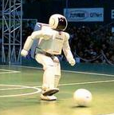
In 1986, the Honda automotive company wanted to see if it could make a human-like robot, to help in home, play football, balance on one foot, and even dance. Over the years there were some problems but soon the researchers managed to get a robot named ASIMO. It could walk on uneven(不平坦的) surfaces, and move its center of gravity like we do to climb stairs.
More recently, ASIMO was improved so it could turn round and run at six kilometers per hour, using its upper body to control movement.
ASIMO is designed to be friendly. It is hoped that robots like this could be used to help elderly people in their home. Honda are also using this technology to help people with disabilities. It can also push a cart(手推车) and open and close doors. ASIMO can even shake hands. It stands 120 centimeters tall, so that it can look into adult faces when they are sitting down. It can hold two kilos in its hands. It can even carry a tray without dropping the contents.
So, where next for this kind of robot? Well, while ASIMO is attractive, it is still controlled by a human. Researchers in the USA are working on the robots that can learn about the world around them, and give a reply to human touch and voice. The robots are even learning to recognize(辨认) objects, people and vocabulary. Soon the descendants(后代) of these robots may be serving you drinks or helping with jobs at home and at work.
- At what speed could ASIMO run after it was improved?
- Can ASIMO make tea or push a cart?
- Why is ASIMO designed to be 120 centimeters tall?
- How many kilos can ASIMO hold in its hands?
- Put the main ideas (A-D) in the order that the passage is arranged.
- Users for ASIMO
- What similar robots will be able to do in the future
- Background and history of ASIMO
- Recent improvements to ASIMO
__________ → __________ → __________ → __________
七、书面表达（满分20分）
王平现在美国上学。今天他将外出一天。请你以王平的名义给房东Mrs Black 写一张留言条， 要点如下：
计划 | 内容
上午去图书馆 | （1）还书 （2）……
下午跟朋友去公园 | （1）……(2) 回来路上顺便帮Mrs Black买…
晚上六点前回家 | 晚饭想吃…….
另：Mrs Black的女儿Helen 一大早来电话，说……,请尽快回电

注意： 1. 词数90 左右。 留言条已给出的部分（见答题卡）不计入总词数。
2. 不要逐字翻译。 可适当增加细节， 使行文连贯。
3. 文中不得出现真实姓名和校名。

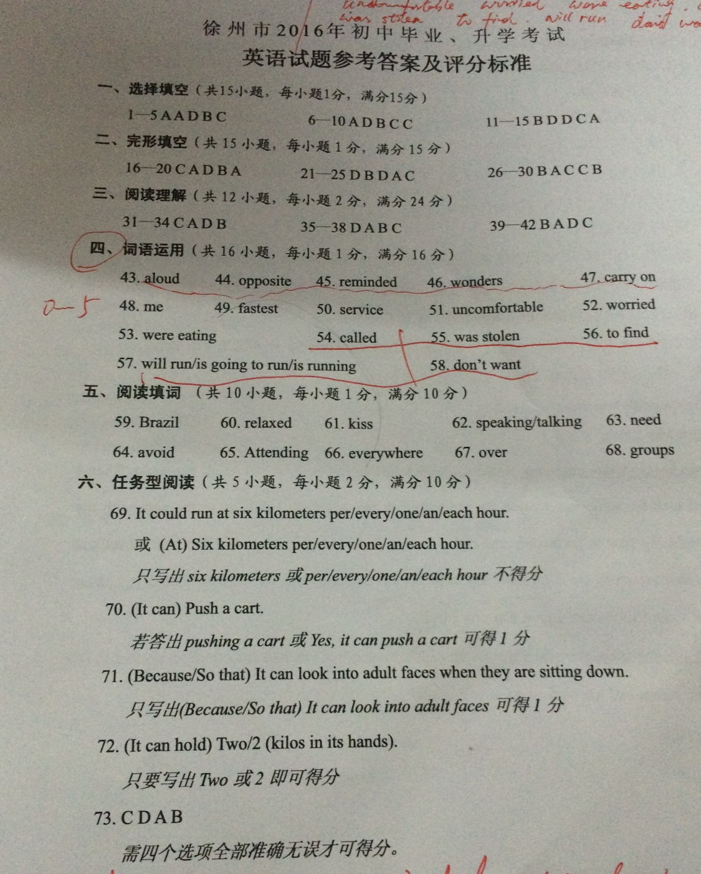

[来源:学科网]

七、书面表达（满分20分）
1、评分时根据内容和语言确定档次给分，主要考虑要点、词汇和语法结构的准确性及上下文的连贯。
2、拼写和标点符号是语言准确性的一个方面，评分时应根据对表达的影响程度给予考虑。
3、词数少于70，从总分中减去2分。
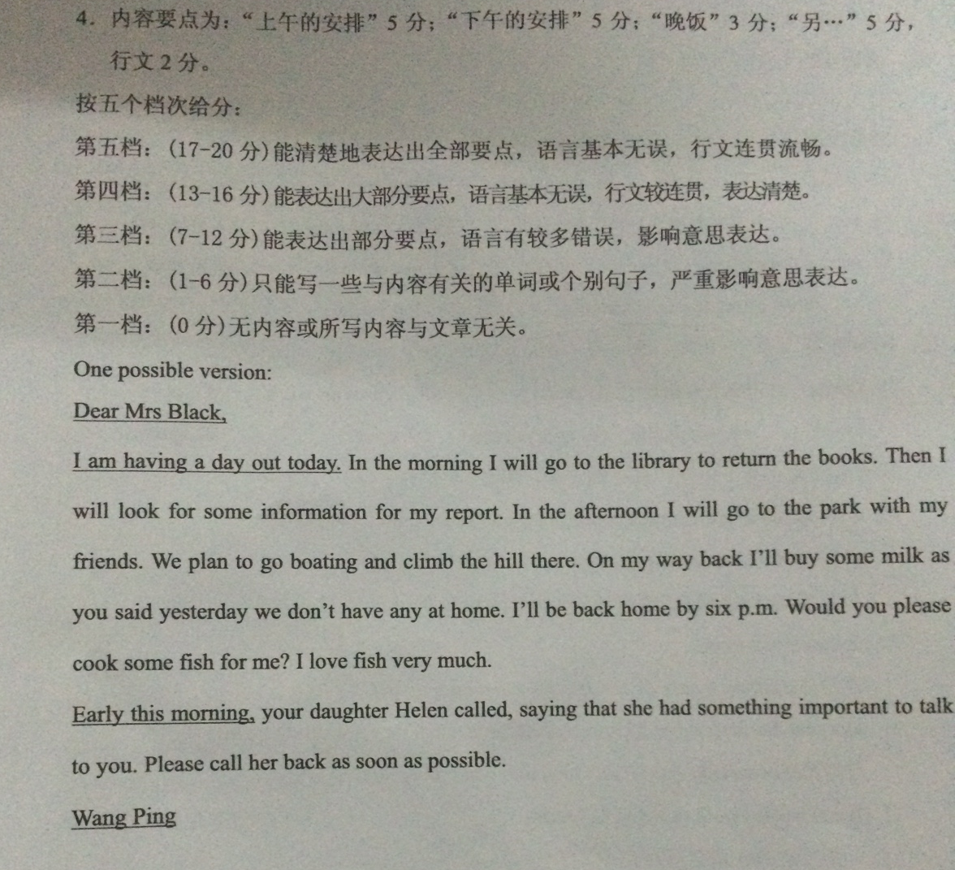

[来源:学科网ZXXK]

