镇江市2 0 1 6年中考英语试卷
(满分：9 0分 考试时间：l 00分钟)
一、单项选择(共1 5小题；每小题l分，满分l 5分)
从A、B、C、D四个选项中选出可以填入空白处的最佳选项。
( )1. It's fantastic to work as volunteer for the Special Olympics World Games.
A. a B. an C. the D. 不填
( ) 2. After chatting happily with the new student in my class, I gave her my QQ number and she gave me .
A. she B. hers C. her D. herself
( )3. Leonardo has acted in 36 films. He finally won the Oscar for Best Actor February 28, 2016.
A. in B. at C. on D. to
( )4. Some people buy stamps not for sending letters now. They________them as their hobby.
A. sell B. design C. receive D. collect
( ) 5.-- Do you know the famous basketball player Kobe has said goodbye to the NBA?
--Yes. I'm afraid I will see him on screen.
A. sometimes B. often C. always D. seldom
( ) 6. --Could you go to the bookshop with me? I want to buy The Grass House by Cao Wenxuan.
--Sorry, I . I've promised Mum to go home right after school.
A. can B. couldn't C. needn't D. mustn't
( )7. Our country encourages more students football. Now many
football clubs have been set up in schools.
A. play B. playing C. to play D. will play
( ) 8. --The world top player South Korean Lee lost the game against the computer program Alphago.
---_________surprising news!
A. What a B. What C. How D. How a
( )9. --Have you been to Suning Plaza(苏宁购物中心) in our city?
--No. Although it for more than a week, I'm far too busy to go there.
A. has started B. has been on C. has been open D. has opened
( )10. Last year, five Chinese teachers to a school in the UK to teach the British students in Chinese style for four weeks.
A. was sent B. were sent C. have sent D. sent
( ) 11. --Which would you like to read, paper books or e-books?
---My parents only allow me to read paper books. They my eyes.
A. talk about B. hear about C. learn about D. worry about
( ) 12.---In Chinese culture, children born in the Year of the Monkey are said to be smart.
---Yes. They are always full of energy, so I think they are also_________;
A. honest B. generous C. lively D. modest
( )13. The engineers a new computer in our classroom the whole yesterday morning, so we had our classes in the school hall.
A. were fixing B. fixed C. have fixed D. are fixing
( ) 14. --It's so careless of you to make a spelling mistake again.
--Sorry. I couldn't remember .
A. when I learnt the word
B. if I have learnt the word
C. where should I put the silent "t"
D. in which class did you teach the word
( ) 15. ---I'm going to Disneyland in Shanghai next month.
--_____________. There are many wonderful things to see and to do there.
A. That's all right B. Have a good time C. Good luck D. I hope so
二、完形填空(共10小题；每小题l分，满分l 0分)
阅读下面短文，根据短文内容，从短文后各题所给的A、B、C、D四个选项中，选择最佳选项。
Dear children,
How time flies! As your teacher, I'd like to talk about "behaving like a grown-up" with you before you leave school.
During our lives, we need the strength of other people to achieve our goals. 16 of us can make it on our own.
In an 17 world, we would all have thoughtful, helpful people to guide us in life. Imagine having a 18 who is devoted to keeping you healthy. Or imagine having a boss who wants you to enjoy your job and make progress in your 19 . But many of us have difficulty dealing with (打交道) grown-ups who seem 20 in their changeable moods. If we have immature(不成熟的) adults 21 trustworthy adults around us, we will certainly get into real trouble.
What's more, if we are always 22 that we're right all the time, while others are wrong, then we are like those immature adults. Our own personalities could be the 23 .
A mature adult is someone who makes problems better, not worse. When this type of people face a bad 24 , they try to find ways to be calm and in control. They keep practicing solving problems 25 they become members of mature adults.
Maybe you're now too young to behave like a mature adult. When you run across a problem, try to stay calm and think more before taking actions, then you're really on the way to be a grown-up. Yours faithfully, Vivien
( )16. A. None B. Most C. Any D. Many
( )17. A. ancient B. ideal C. unknown D. equal
( )18.A. director B. teacher C. policeman D. doctor
( )20. Atrapped B. surprised C. bored D. frightened
( ) 21. A. in front of B. as well as C. instead of D. along with
( )22. A. reporting B. guessing C. thinking D. discussing
( )23. A. problem B. project C. purpose D. power
( )24. A. production B. suggestion C. instruction D. situation
( )25. A. unless B. as C. until D. when
三、阅读理解(共1 0小题；每小题2分，满分20分)
阅读下面的三篇短文，根据短文内容，从短文后各题所给的A、B、C、D四个选项中，选择最佳选项。
A.
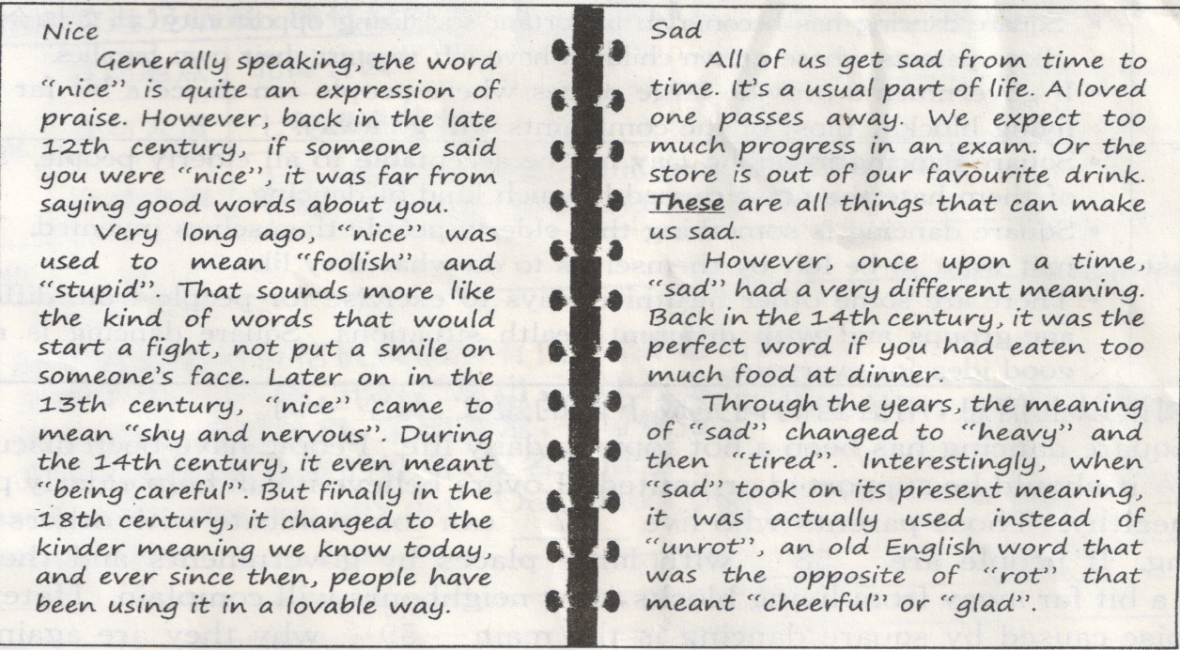
Several days ago,，1 went to my aunt’s home and saw my cousin who is studying English linguistics in a university． He showed me his learning materials．H ere are two pages of t
Now I know at some point in history, the meanings of some common words that we see every day meant something much different. The English language is developing all the time.
( )26. When did "nice" come to mean "shy and nervous"?
A. In the late 12th century. B. In the 13th century.
C. During the 14th century. D. In the 18th century.
( )27. The underlined word "these" refers to指代) the following except that________.
A. a loved one passes away
B. we expect too much progress in an exam
C. the store is out of our favourite drink
D. we have eaten too much food at dinner
( )28. The purpose of the passage is to tell us .
A. the meanings of all words are different at some point in history
B. my cousin learns English well because of his learning materials
C. we should know about all the different meanings of words in history
D. the meanings of some words are changing because language is developing
B
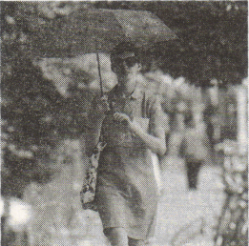
In summer, it's common on the street to see many Chinese women holding parasols¹ to protect themselves from the sun. But when Amy, an exchange student in Beijing from the US, first saw this, she found it strange, even impossible to understand. She wrote on her blog, "Unlike Chinese women, American women like to put on their tank tops and sunglasses during summer. If you walk around an American college campus², you will probably see girls out on the grassy fields reading, but they really hope to get a head start on their summer tan³. "
This may be caused by the different standards of beauty between the US and China. Many Americans don't want white skin. They would rather be tanned³. Amy also wrote, "Having darker skin is so popular that many women and men will pay for fake⁴ tans so that they can keep their sun-kissed appearance during the winter months, too. "
Why do they like tanned skin? Michelle Louis reported in her research, "The process of tanning can help make people's skin smooth and hide marks. " She further explained, "Tans make people's skin appear healthier and make them appear thinner than when they have pale skin. "
Perhaps there is no real ideal standard of beauty. In different cultures and at different times of history, the standards change. On Amy's blog, she also gave two examples: Some women carried parasols around trying to keep their white skin in the US 150 years ago; During the Tang Dynasty in China, heavy women were thought attractive. But now, Chinese women prefer to be slim.
In a word, different standards of beauty should be respected. People may grow up with only one idea of what beauty is, but it doesn't mean that it's necessarily the correct or the best idea.
New words:
1. parasol n. umbrella used to protect people from the sun 阳伞
2. campus n. grounds of school, college or university校园
3. tan n. the brown colour of sun-kissed skin 晒成的棕褐
v. become brown by the sun 晒成棕褐色，晒黑
4. fake adj. not real 假的
( )29. What did Michelle Louis report in her research?
A. Many Chinese prefer white skin to tanned skin.
B. Darker skin is popular among American women and men.
C. Tans make people's skin appear healthier and make them look thinner.
D. Some women would like to keep their skin white in the US 150 years ago.
( ) 30. Which of the following is NOT true according to the passage?
A. People in the US like to have tanned skin only in hot summer.
B. American college girls read on the grass because they want to be tanned.
C. Many Chinese women carry parasols to protect themselves from the sun.
D. Amy thought trying to keep white skin with parasols seemed strange at first.
( )31. The writer really wants to tell us .
A. we should respect different standards of beauty
B. the standards of beauty change at different times
C. different countries have different standards of beauty
D. it's common for people to have only one idea of beauty
C
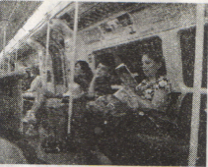
One day, I took an underground to work, I saw something that made me very sad. On the tube( underground in London), a mother kept looking at her phone screen and playing a game with her daughter sitting beside her. The little girl, about 5 years old, was talking to her mother about herday, repeating the next stop's name cheerfully, praising her mother's long nails--trying to draw her mother's attention. Her mother just nodded and mumbled "Mm, hm" with her eyes glued to the screen, busy passing the levels of the game. I watched the girl give a final try to at least get her mum to look at her, but it was no use. Then the little girl turned silent. It was a shame the mother didn't notice that.
It broke my heart and got me wondering--what kind of game would make the mother forget she has the most beautiful thing in the world, the human she created, the person she loves with all her heart? What it meant when she couldn't look into her daughter's eyes and even stop to listen to the girl?
Some parents are almost like the teenagers, always on their phones with mindless games or going through Facebook. Perhaps parents have many things to deal with, but sometimes they are everything to their kids.
This is not an isolated example. I've seen too many such examples. I might not be a parent myself, and probably still have a long way before becoming one, but I know what I saw isn't right.
The scene used to be seen among teenagers very often when parents complained how their children were crazy about their mobile phones. Look how the situation has changed! The parents have become "technology slaves", that is to say, they can't control themselves while using mobile phones. Now some middle-aged parents hold the best iPhones or Samsung phones, which are probably the only two brands they know. They are playing the simple games with so expensive mobile phones. I'm uncertain whether to laugh or to cry. But my hope is that this storm passes.
( )32. Which of the following is TRUE according to the passage?
A. The girl failed to attract her mother's attention.
B. The mother felt sorry after her daughter turned silent.[来源:学#科#网]
C. The writer has much experience about being a parent.
D. Middle-aged parents know many brands of mobile phones.
( )33. The underlined word "isolated" in Paragraph 4 means .
A. spreading fast B. happening once
C. increasing quickly D. appearing suddenly
( )34. In the passage, the writer mainly wants to express .
A. the worries that children are crazy about mobile phones
B. the happiness that parents are now able to use modern technology
C. the sadness that the best smart pldones cost parents too much money
D. the hope that parents use new technology4ike smart phones properly
( )35. What's the best title of the passage?
A. Middle-aged parents B. A scene on the tube
C. Technology slaves D. Mindless phone games
四、词汇运用(共1 0小题；每小题l分，满分l 0分)
A)根据句意，用括号中所给单词的正确形式填空，每空一词
36. The boy's uncle is good at (train) dogs. His dogs can do wonderful tricks.
37. Some citizens waited for the workers to repair their broken water pipes quite long, and they became (patient).
38. TFBOYS (sing) several songs at the concert last night. Their fans screamed excitedly.
39. How (heavy) it rained in Europe! Some museums along the River Seine had to be closed.
40. Xijin Ferry( 西津渡) is one of new (couple)favourite places to take their wedding photos.
B)根据句意及汉语提示，写出各单词的正确形式，每空一词。
41. Yang Jiang (翻译) many foreign books into Chinese in her life. Among them, Don Quijote(«堂吉诃德») is the most famous one.
42. Grandma went to the market and bought some meat, eggs and (西红柿) for lunch.
43. Wolong Nature Reserve is in Sichuan Province, the (西部) of China. Travellers can watch giant pandas there.
44. Paul.is an excellent student at school. His perforance always (使……满意)us.
45. With the development o{ society, people are used to searching for the_________( 最新的) information on the Internet.
五、短文填空(共1 0小题；每小题l分，满分l0分)
根据短文内容及所给首字母提示写出所缺单词，使短文意思完整，每空一词
When you have dinner, you follow table manners. When you have a 1 46 , you obey the rules in the classroom. But have you ever thought about needing to m 47 your manners in the digital(数码的) world when you use phones, e-mails and social media, like QQ, WeChat, etc?
As new research by Oxford University noted, "It's just important to treat people with respect online as it is in real life. " The study came up with some rules of good manners to live by in the digital age. Their first a 48 is not "over-sharing" on social media, which means not posting every detail about your life online, because some of us are not creative e 49 to always show off our thoughts and lives on social media. The manners also i 50 not looking through others' phones and not gossiping(说闲话) about others over messages, e 51 when you choose "reply all" to send a message to a group of people.
Although gossip is not h 52 chat that can make conversations exciting, it can also be a way to spread something untrue about other people. Gossip can be even stronger on social media than in real life, so it's b___53_____ not to gossip.
Moreover, when you have bad news for someone, do not leave text messages on social media, chat with him or her by c___54___ personal messages.
Nowadays technologh has o__55_____us different ways to contact others. It is important to remember how to behave toward others online.
46.____________ 47.____________48.___________49. ___________ 50._______________
51. 52. 53. 54. 55.
六、任务型阅读(共1 0小题；每小题l分，满分l 0分)
A
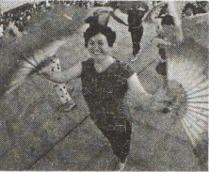
Square dancing has been popular for quite a few years. Its lovers believe it is good for elderly people's health But in recent years, it has many haters as well. They think too loud music or dancing too late into night influences people's life. Should square dancing be supported or limited? Here are opinions from two groups of people.
For | - Square dancing is a helpful way for elderly people to stay fit.  - Square dancing has become an important socializing opportunity(社交机会) for those parents whose grown children have left to start their own families.  - If governments provide large places where people can dance a bit far from  living blocks, most of the complaints will go away.
Against | - Square dancing in public may not be acceptable to all elderly people. Some  of them hate the noise caused by such kind of dancing.  - Square dancing is something that elderly people themselves invented. They  just want to be left by themselves to do what they like.  - There are some other healthier ways to exercise for people from different  age groups and with different health .situations. Square dancing is not a good idea for everyone.
阅读以上信息，用恰当的词完成下面的短文，每空一词。
Square dancing has been a hot topic in daily life. People have been discussing 56 it should be supported or limited. Lovers believe it can help elderly people stay healthy. Those parents who live 57 can communicate with others while dancing. If people are 58 with large places by governments and they can dance a bit far away from living blocks, few neighbours will complain. Haters say the noise caused by square dancing is the main 59 why they are against it. They think square dancers just do what they like to do without 60 others' feelings. And square dancing.is not the only good way for all people to exercise.
56. 57. 58. 59. 60.
B
Everyone wants to find happiness. But sometimes looking for happiness can be as hard as looking for lost treasure. Just when you think you nearly reach it, something unexpected happens. This may puzzle(使困惑) you a lot. Here are some tips for helping you find happiness.
- Don't put all your eggs in one basket. If you depend, on one thing or one person to make you happy, it may be impossible. You need to enlarge your circle
of friends and activities.
- Follow your heart. When we go against our own thoughts, we usually feel sad. Follow your strong feeling and let it guide you toward people and things that will improve your life. Day by day, you will be happier than before.
- Organize your ideas. Many people push away happiness when they think too much. Don't keep everything in head. Try making a list of the things that seem too big to manage on your own. You may find the list isn't as long as you thought. You can do most of the things by yourself.
- Look at your life as a whole. Most of the things that prevent us from feeling happy .are just some little things. Remember life is always going on, and whatever the little thing is, it will end.
- Remember yore. values(价值观). We all have a value system, a way we have decided to go through life, which makes us feel like a good person. The important thing is to remember your values when life becomes hard. Keeping your values strong will help create happiness.
Happiness can be hard to feel at times, so don't think there is something wrong with you if you don't feel it. The ways above will help you to feel more of it.
阅读以上信息，用恰当的词完成下面的表格，每空一词。
Something puzzling | Happiness is sometimes hard to get.
Tips for  solving the  puzzle[来源:Zxxk.Com] | - Make more friends and take part in rmre activities. There may be no___61___ for you to find happiness if you depend on one thing or one person.[来源:学科网ZXXK][来源:Zxxk.Com]
Tips for  solving the  puzzle[来源:Zxxk.Com] | - Let your heart guide you toward people and things that will improve your life. In this way, your happiness will 62 .
Tips for  solving the  puzzle[来源:Zxxk.Com] | - Write down the things that you seem 63 to manage on your own. You will be happy to find you can do more things than you thought.
Tips for  solving the  puzzle[来源:Zxxk.Com] | - Look at your life as a whole. Most unhappy things will end sooner or later..
Tips for  solving the  puzzle[来源:Zxxk.Com] | - Keep your values strong after you've made a 64 on how to spend life. Being a good person even when life is hard will help create happiness
Conclusion | You will 65 get happiness with the help of the five tips.

61. 62. 63. 64. 65.
七、书面表达(共上赵；满分15分，)
假如你是阳光中学校报英语专栏的小记者，上周日参加了学校为迎接世界环境日绢织的远足活动，请你给校报写一篇报道。
活动情况 | 活动地点 | 北海公园
活动情况 | 参与人员 | 七年级全体师生
活动情况 | 活动内容 | 上午：环保(environmental protection)演讲比赛  下午：自由活动(唱歌、游戏、放风筝……)
┃活动评价
要求：
1．所写内容必须包括提供的所有信息，并适当发挥。
2．文章不少于90词，开头已给出，不计人总词数。
3．语意通顺，意思连贯，条理清楚，书写规范。
4．文中不得出现真实的姓名、校名等信息。
Last Sunday was a sunny day．Our school organized a hiking to greet World
Environment Day． ____________________________________________________________
________________________________________________________________________________________________________________________________________________________________________________________________________________________________________________________________________________________________________________________________________________________________________________________________________________________________________________________________________________________

答案
- 单项选择
1-5 ABCDD 6-10ACBCB 11-15 DCAAB
- 完形填空
16-20 ABDBA 21-25 CCADC
- 阅读理解
26-28 BDD 29-31 CAA 32-35 ABDC
- 词汇运用
A)36 training 37.impatient 38sang 39.heavily 40.cCouples’
B)41. translated 42.tomatoes 43. west 44.satisfies 45.latest/up-to-date
五、短文填词
46. lesson 47.mind 48.advice 49.enough 50.include 51.especially 52.harmful 53.better 54.calling 55.offered
六、任务型阅读
56.whether 57.alone 58.provided 59.reason 60.considing/caring
61.possiblity/possibilities 62.grow/increase 63.unable 64.decision 65.easily/soon/successfully
七、书面表达
【审题】本题是表格文字提示性作文。要求根据表格提供的信息写一篇报道。文章所写内容是学校为迎接世界环境日组织的远足活动，可以从活动地点、参与人员、活动内容、活动评价等方面入手，来叙述远足活动的情况。注意：
1．围绕表格中的提示要点，加以适当的发挥。为使行文流畅，可适当运用一些关联词语和使用适当的句式；
2．本作文是记叙文体，讲述的是上周的事情，故全文使用一般过去时态表达；在陈述信息时，应该使用第一人称。
One possible version:
Last Sunday. was a sunny day. Our school organized a hiking to greet World Environment Day. All the Grade 7 students and teachers took part in the activity in Beihai Park.
In the morning, we had a speech competition on environmental protection. The speakers talked a lot about protecting environment, like saving water, reducing air pollution. In the afternoon, we did what we like. We sang and played games together. Some of us enjoyed flying kites. Some volunteered to pick up rubbish in the park.
It's a meaningful and exciting day. We've realized it's our duty to help protect the environment. We had a lot of fun the whole day. I hope more activities like this will be organized in our school.

