2016年陕西省初中毕业学业考试试题
英语试卷
第I卷 （共65分）
A 卷
听力部分（20分）

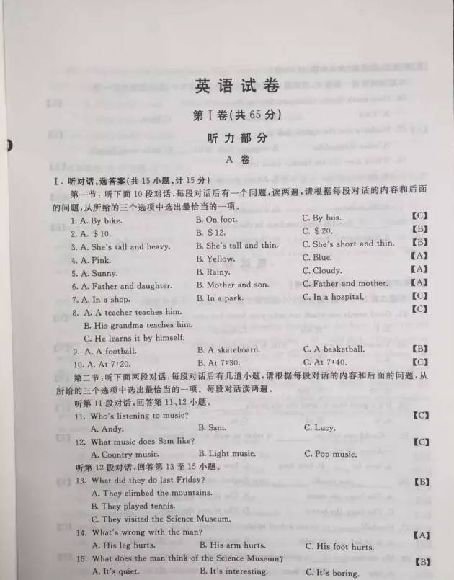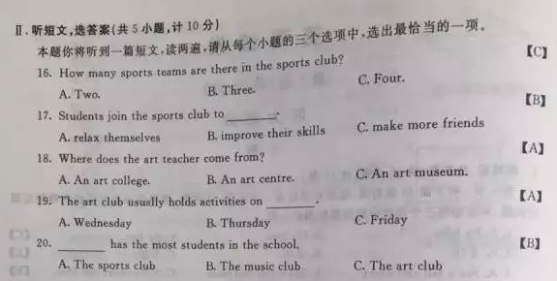
笔试部分
III. 单项选择（共10小题，计10分）
本题共有10个小题，请从每个小题的四个选项中，选出一个答案。
21. Good words can touch not only your heart but also .
A. I B. my C. myself D. mine
22. Yesterday I saw film. It moved me deeply.
A. a B. an C. the D. /
23. The dress is really beautiful, it is too small for me.
A. or B. but C. so D. and
24. It’s a good idea to send the old books the children who need them.
A. at B. of C. to D. by
25.---Could you tell me it takes to walk to the Disneyland?
--- About 20 minutes.
A. how far B. how long C. how often D. how soon
26. you speak, your English will be.
A. The less; the more B. The more; the better
C. The less; the better D. The more; the less
27. Football to our school subjects last year.
A. is added B. adds C. was added D. added
28. My mother a good example for me since I was young.
A. was B. has been C. will be D. is
29. ---Volunteers from Lantian Saving Team have saved many travelers in the
mountains.
--- .
A. How great a man B. How great men
C. What a great man D. What great men
30. I didn’t accept his help I wanted to try it myself.
A. because B. though C. until D. unless
IV. 完形填空（共10小题，计10分）
阅读下面一篇短文，理解大意，然后从各小题的四个选项中选出一个最佳答案， 使短文连贯完整。
One day during a Spring Festival, I was taking a walk near my house when suddenly there came a voice, “Excuse me, sir.” I turned around and saw an old beggar(乞丐). “Have you 31 some money, about fifty yuan, around here? I lost it just now.” He looked at me and 32 my reply. “Sorry, I haven’t,” I answered. He went away saying in a low voice, “Where is it? 33 Should I do now? I really need the money.”
I could sense that he was 34 . Then I got an idea. I took out a fifty-yuan note(纸币) and dropped it on the ground. “Here! Here is the money!” I picked it up and 35 it to him. Then I walked towards my house.
A week later, on a snowy afternoon, I heard someone knocking at the door. It was the old beggar with a heavy bag on his shoulder. He put down the bag36
and said “Thank you so much. I knew you gave me your own 37 that day, for the money I lost was in change(零钱)。 But my wife was38 , and I really needed it to buy some medicine for her. So I didn’t return it to you.” He added, “I have nothing to pay for your, here’s some rice I got from door to door for your
39 children. As the saying goes, ‘A child who is fed by many families grows stronger.’ I will be pleased 40 you like it” Hearing his words, my wife and I were so moved that tears ran down our faces.
31. A. made B. lent C. seen D. dropped
32. A. looked for B. paid for C. left for D. waited for
33. A. How B. Which C. What D. Why
34. A. worried B. bored C. interested D. relaxed
35. A. pushed B. passed C. led D. threw
36. A. carefully B. easily C. carelessly D. hardly
37. A. food B. drink C.cloth D.money
38. A. well B. sick C.busy D.free
39. A. cuteness B. illness C.kindness D.sadness
40. A. before B. whether C. though D.if
V. 阅读理解（共10小题，计10分）
第一节：阅读下面一篇短文，判断下列句子是否符合短文内容，符合的用“A”表示，不符合的用 “B”表示。（共5小题，计5分）
A
There are twenty seven bridges over the River Thames. And the Tower Bridge is the first bridge you have to pass if you go to London from the sea. It is close to the Tower of London, from which it got its name. It is a symbol (象征) of London.
The Tower Bridge was set up over the River Thames in London in 1894 and is one of the finest and most famous bridges in the world. It is the only bridge over the Thames that can be raised and opened in the middle. The middle part can be raised to let the huge ships pass. It used to be raised about 50 times a day, but now it is raised only 4 to 5 times a week. If you are lucky enough to see the bridge with its two arms open high in the air, you will never forget it.
The Tower Bridge stands just on the south side of the Tower of London. People often think they are of the same age. But in fact, the Tower of London was built a thousand years ago, while the Tower Bridge only has a history of over one hundred years.
The Tower Bridge was first painted chocolate brown. Then in 1977, it was painted red, white and blue. Its picture also appeared in the opening of the 2012 Summer Olympic Games held in London. So come to visit the famous bridge. You are sure to have a wonderful experience.
41. The color of the Tower Bridge hasn’t changed for more than a hundred years.( )
42. In 1894, the Tower Bridge was built in London. ( )
43. The Tower of London has a much longer history than the Tower Bridge. ( )
44. The Tower Bridge is now raised less often than in the past. ( )
45. This passage means to introduce the Tower of London. ( )
第二节：阅读下面B、C、D三篇短文，从各小题所给的四个选项中选出能回答问题所提问或完成所给句子的一个最佳答案。（共10小题，计15分）
B
Li Chunlin, a farmer, used to live in a poor village in the north of Shaanxi. In the 1980s, he went to Shenzhen to make a living with his wife.
Years later, they became rich and returned to their hometown. To their surprise, the land around the village was covered with sand. That made them feel sad. After thinking carefully, Li and his wife made up their minds to fight against the sands.
They bought thousands of young trees and planted them around the village. However, only a few survived(存活), because the trees were not regularly watered. But how to get water was a big problem. They dug a well(井) but it became dry soon. Then they asked a drilling team to dig a deep well. Clear water appeared, but their money was used up. They couldn’t afford to buy young trees. They went to several banks for help but got nothing. Finally they turned to a friend who was also from the village. The friend had a big business. Learning what they were doing, their friend was moved and decided to do something for their village too. So he offered the money the needed.
With the money, they bought trees and had them planted. They looked after the trees as if they were their own children. After some time, green leaves came out. When the villagers saw the changes, some started to join Li and his wife in the fight. Then more joined. Years went by. And now larger areas around the village are covered with green trees.
46. When Li and his wife returned from Shenzhen, they were sad because .
A. the land around the village was covered with sand.
B. they didn’t have enough money to buy trees.
C. their village was not as beautiful as Shenzhen.
D. they didn’t have enough water to drink.
47. Which of the following is TRUE according to the passage?
A. Li and his wife dug a well with enough water themselves.
B. Li and his wife got much money from the bank.
C. The villagers didn’t join Li and his wife in the fight.
D. Their friend gave Li and his wife some money to buy trees.
48. This passage is mainly about how Li and his wife .
A. tried different ways to find water
B. made money in Shenzhen.
C. fought against the sands.
D. bought and planted trees.
C
Most animals on land are known to us, but many living things underwater are not. Now let’s get to know some of them.
Sea cucumber
Sea cucumber are strange animals living at the bottom of the sea. They wear brown or pale green coats with many sticks up. When summer comes, they stay deep to sleep because they are afraid of heat. And when it is autumn, they move to shallow (浅的) water and get their food.
Pike
The pike is a kind of freshwater fish. They are good swimmers and like swimming near boats, waiting to be fed. They have sharp teeth to catch fishes. When they are young, they live in groups. However, when they grow up, they prefer to live alone.
Cuttlefish
A cuttlefish can swim quite fast, so it is also called rocket(火箭) fish. It has eight arms and two feelers on its head, just around its mouth. It ejects ink (喷墨) when it is in danger. Its meat is delicious, and it is often the first choice for many people.
Octopus
An octopus has long arms, with which to catch food and protect itself. When it is sleeping, one or two of its arms are still on duty, keeping moving. Once it feels something dangerous, it can wake up at once to take action.[来源:Zxxk.Com]
49. Sea cucumbers stay deep to sleep in summer because they .
A. are afraid of high temperature B. want to get strong and fat
C. are afraid of their enemy D. want to live alone
50. According to the passage, likes to swim near boats.
A. the sea cucumber B. the pike C. the cuttlefish D. the octopus
51. What happens if a cuttlefish meets its enemy?
A. It rushes at the enemy at once. B. It cuts off one of its arms.
C. It bites with its sharp teeth. D. It ejects ink to the enemy.
52. The of an octopus can help protect it when in danger.
A. color B. arms C. sound D. smells
D
Reading makes one wise, but many adults seldom read. They say they are too busy to have time to read. Sure. They have work to do. They have families to support. But these are only excuses. The fact is that they haven’t got a reading habit. A reading habit isn’t something natural. It needs to be trained. And it’s never too late to develop a reading habit.
Scientists believe proper books are very important for children to develop a good reading habit. A book in rich colors and with simple patterns(图案) such as lines and circles is a good choice for babies of three months old. When they reach six months, they will become interested in simple story books in rich colors.
When children get old enough to read by themselves, it’s necessary to buy books that are both interesting and right for them to understand. Books which are either too easy or too difficult are not good for kids to keep their reading habits.
Only buying books for children isn’t enough. For kids, parents are their first teachers. So parents should read books to set an example. Children will follow them. Scientists say imitating the adults is a born skill. And it is the most valuable way for children to learn. This will certainly help them develop a reading habit in the end.
53. According to the writer, many adults seldom read because they .
A. don’t have enough time B. have to work all the time
C. haven’t got a reading habit D. have to support the family
54. The underlined word “imitating” here probably means .
A. copying B. reading C. testing D. missing
55. We can learn from the passage that .
A. story books are better than books in colors B. a reading habit comes from certain training
C. a three-month-old kid likes simple stories D. too easy books help keep a reading habit
第II卷 (共55分)
VI. 完成句子：根据所给汉语意思，用单词或短语完成下列英文句子。（共5小题，计10分）
56. 我想邀请他参加我们的俱乐部。
I want to join our club.
57. 窗户旁边有一架钢琴。[来源:学科网]
There is a piano .
58. 聚会结束时我唱了一首歌。
I at the end of the party.
59. 每当国旗升起时，我们都很激动。
We all feel very excited when the is being raised.
60. 没有知识，你成功的可能性就会小一些。
Without , you may have little chance to achieve success.
VII. 短文填空：用方框中所给单词的适当形式填空，使短文完整正确。（每个单词限用一次。每空只填一个单词。）（共10小题，计10分）
clean, give, can, encourage, try, he, borrow, student, easy, happy
Last week I went to an art show. A painting caught my eye. To my amazement, it was painted by Steven, one of my 61 . Then many thing about him came into my mind.
Steven was from a poor family. His parents 62 not afford to buy him some basic things that he needed, once our school provided gloves for poor children. I put Steven’s name on the list. He was so 63 when he received a pair. He loved to wear them and they were always 64 than anybody else’s.
Steven had a gift(天赋) for painting and he could 65 understand what I described in class. But he didn’t have money to buy the paper for painting. So sometimes, I 66
him some. He practiced hard. And I often showed his paintings to the class. He was greatly 67 .
One day just before the summer vacation, he came to 68 some art books. When the new term began, he showed some of 69 paintings to me. I felt shocked(震惊). They were very good. Then we talked a lot. He said he would keep on.
Later he was admitted (录取) to a famous art university. After graduation, he had many difficulties, but he never gave up. He was always 70 his best to improve himself. His hard work and strong mind led to his success.
VIII任务型阅读：阅读下面短文，根据短文内容，完成下列各题。（共5小题，计10分）
Stanford is a world famous university on the west coast of the U. S. . It was built by Stanford and his wife in memory of their only son who died of a strange disease.
Tourists are often surprised at the beauty of Stanford. Among the green trees, buildings with yellow walls and red tops make up a beautiful picture. Many tourists wonder why yellow and res were chosen. That’s because they were the favorites of Mrs. Stanford.
The big church is the most important building in Stanford. It stands at the centre. It was built by Mrs. Stanford to remember her husband who devoted (贡献) himself to the university. There, students and teachers can communicate with God and hold great activities, such as concerts and celebrations.[来源:Z,xx,k.Com]
The tallest building in Stanford is Hoover Tower, which is the land mark of the university. A man named Hoover had done a lot for the university. The things he once used can be seen on the first floor. On the top of the tower, tourists can have a good look at the whole campus(校园).
As one of the world top universities, Stanford has many subjects that stand among the top ones in the world. And computer science has been the first for many years. If you want to study computer in a university abroad, maybe it is your best choice.
71. Why did Mr. Stanford build the university?
Because they wanted to remember .
72. What color did Mrs. Stanford like best?
She preferred to other colors.
73. What does the third paragraph mainly tell us?
It tells us the big church is in Stanford.
74. Where can visitors see the whole campus of Stanford?
They can see the whole campus on the top of .
75. What does “it” in the last sentence of the passage refer to?
It refers to .
IX. 补全对话（共10小题，计10分）
- 根据对话内容，将方框内符合对话情境的句子抄写在对话空白处，使对话恢复完整。选项中有两项是多余的。
A: Hi, Li Qiang. I haven’t seen you for days. 76.
B: I have been to Beijing.
A: What did you do there?
B: 77. .
A: Really? How did you perform?
B: 78. .
A: Congratulations! You’re always the best. Whose poem did you choose?
B: I chose Li Bai’s. He is my favorite poet.
A: I love his poems, too. 79. .
B: Fantastic. You know, our Chinese ancient poems are really great. We should learn more.
A: 80. . It’s our duty to keep and spread our traditional culture.
B: That’s right.
Why did you go there? I agree with you.
Where have you been? I won the first praize.
Do you like Li Bai? And what do you think of the competition?
I took part in the First Chinese Ancient Poem Reading Competition.
(B) 根据下面对话中的情境，在每个空白处填入一个适当的语句，使对话恢复完整。
A: Hello, Dad. I have come back home. 81. ?
B: I’m in the supermarket now. What’s up?
A: Er, it’s a special day today, isn’t it?
B: 82. . It’s Father’s Day.
A: Do you have a plan?
B: Not yet. 83. ?
A: What about spending the day with my grandpa?
B: Good idea. What can I buy for him?
A: 84. . His sports shoes are too old.
B: OK. Then wait for me at home.
A: 85. ?
B: I will be back in an hour.
X.书面表达（共1题，计15分）
假如你是李明，你准备和父母周末去附近的村庄游玩。请根据提示语，给恰逢来你校交流学习的David写一封e-mail, 邀请他一同前往。
要求：1.参考提示语，可适当发挥；
2. 语句通顺，意思连贯，书写工整。
3. 文中不得出现任何真实信息（姓名、校名和地名等）；
4. 词数：不少于70词。（开头和结尾已给出，但不计入总词数。）
提示语：feed animals
pick fruit and vegetables
make tea
learn to cook
play games
…

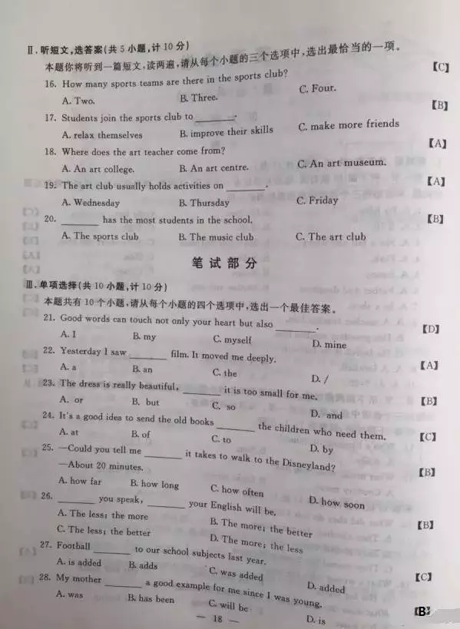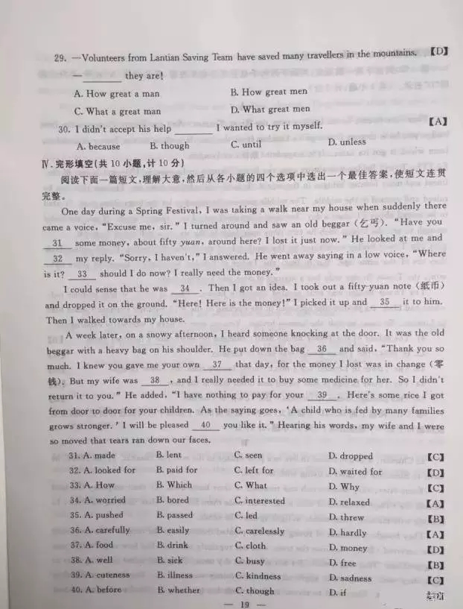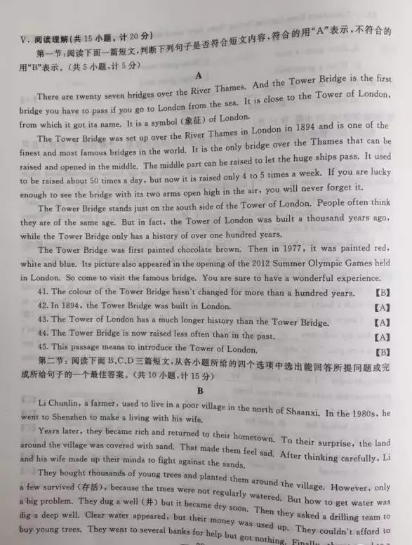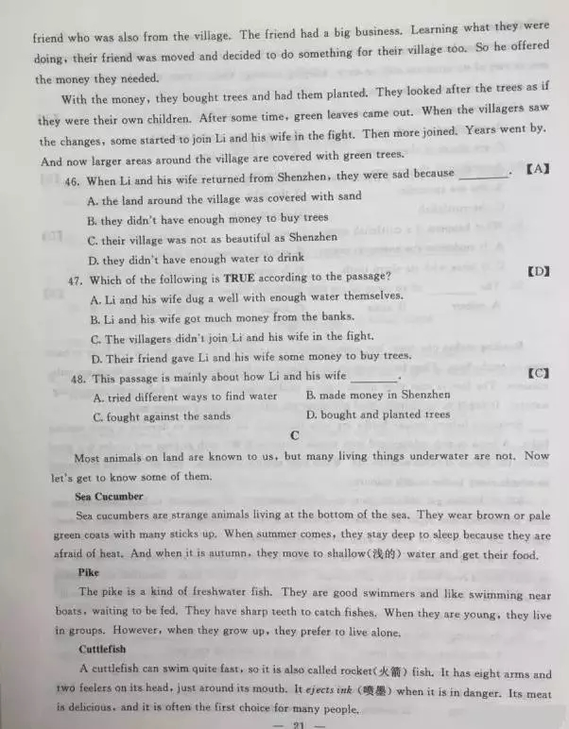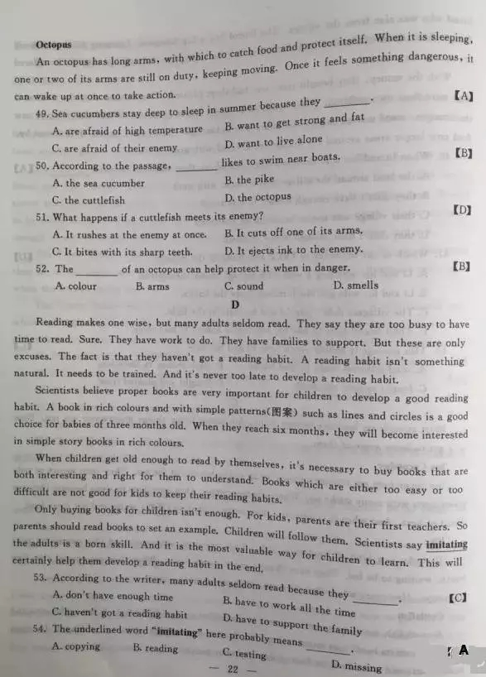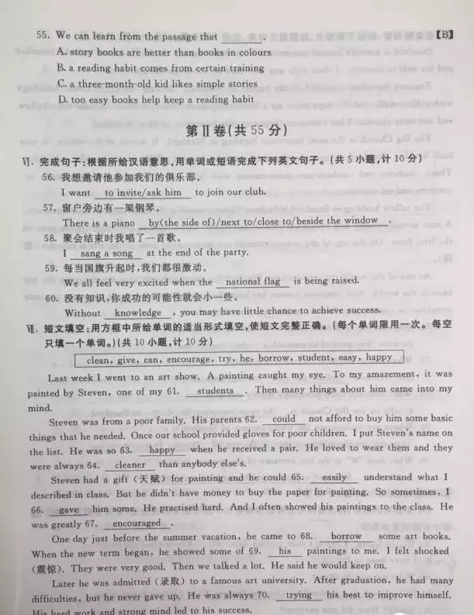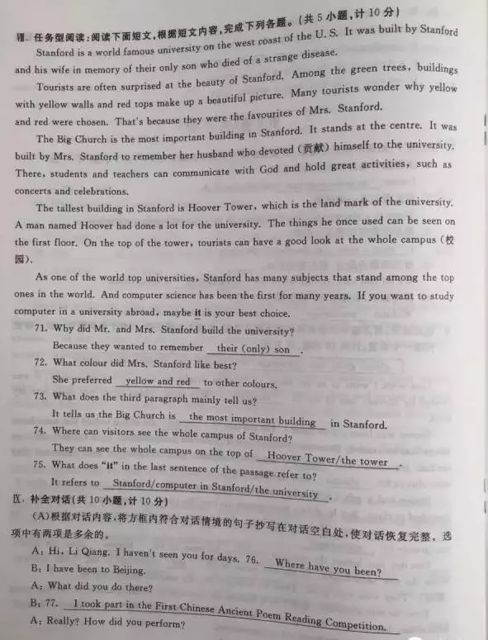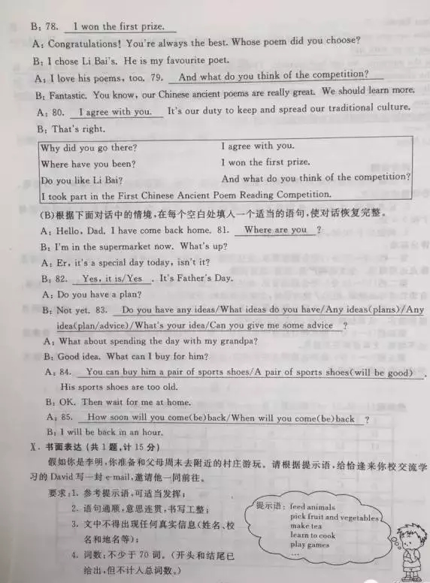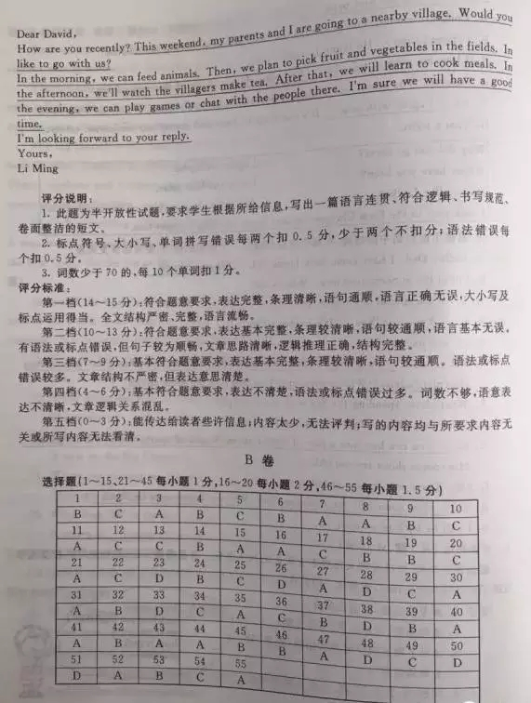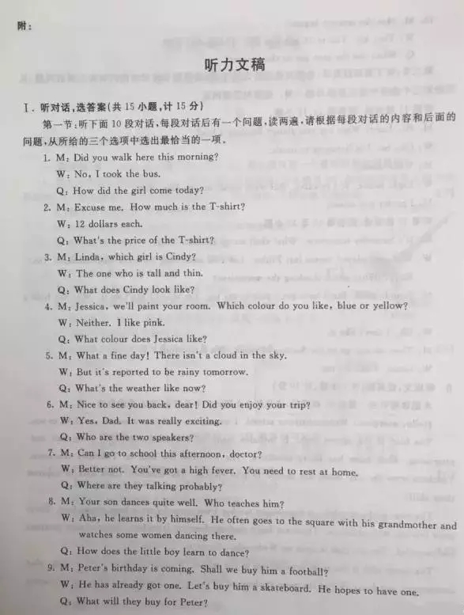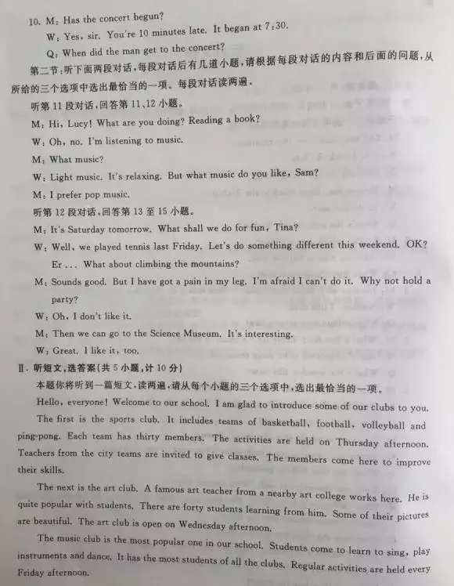

[来源:Zxxk.Com]

