2016年郴州市初中毕业学业考试英语试卷
本试卷共8页，分四个部分，76小题，时量90分钟，满分120分。
I. 听力技能（两个部分，共20小题，计20分）
第一节对话理解听下面的对话，从题中所给的A、B、C三个选项中选出最佳答案。听每段对话前，你将有时间阅读各个小题，每小题5秒钟；听完后，各小题将给出5秒钟的作答时间。（共15小题，计15分）
听下面五段对话，每听完一段对话后，回答1个小题。
1. What is Scott’s favorite animal?
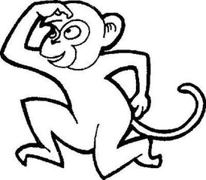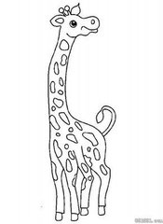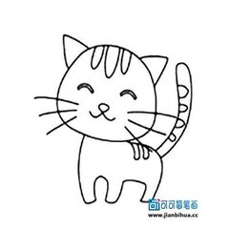
A. B. C.
2. What was Lucy doing at nine last night?
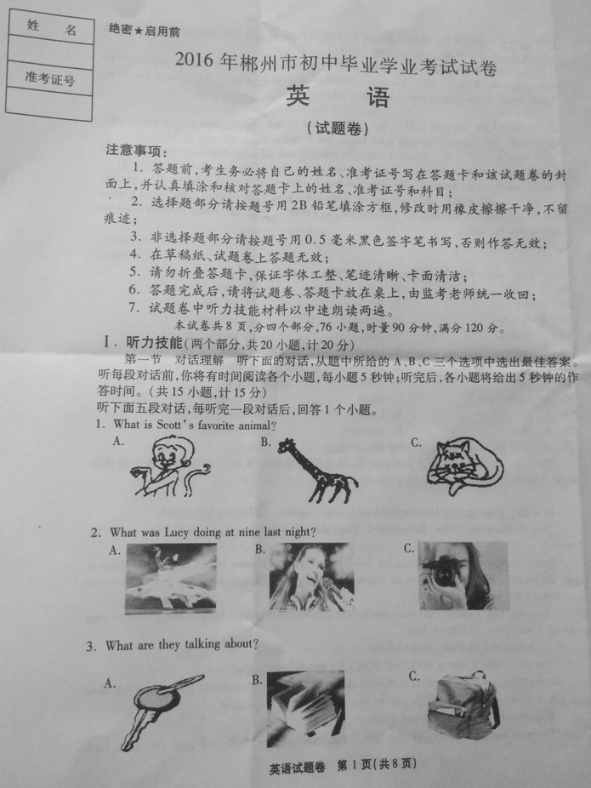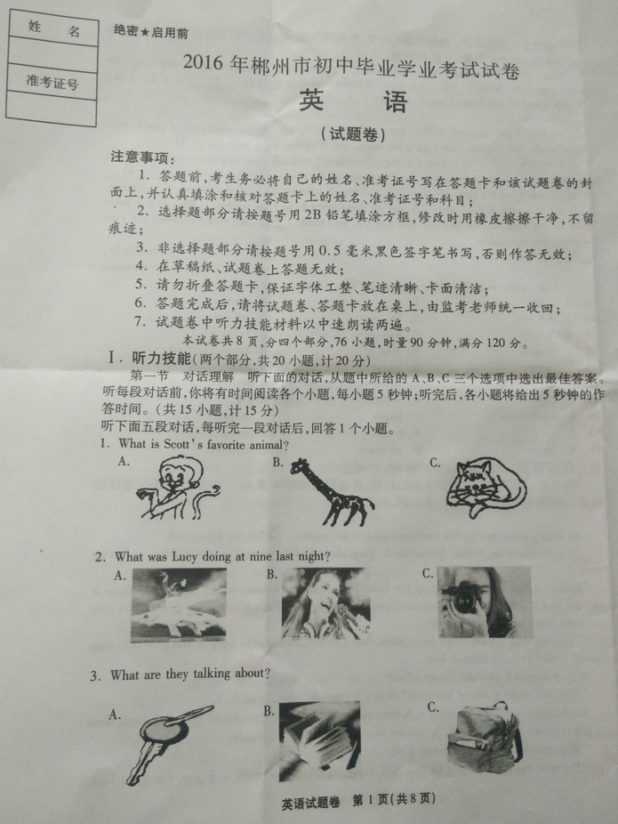
A. B. C.
3. What are they talking about?
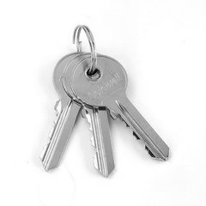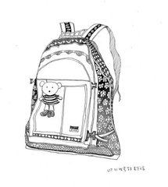
A. B. C.
4. What does the man want?
A. Noodles. B. Beef. C. Chicken.
5. How was Tom’s school trip?
A. Terrible. B. Boring. C. Wonderful.
听第六段对话，回答第6、7小题。
6. What color is Helen’s sweater?
A. Red. B. Yellow. C. Blue.
7. How much is the sweater?
A. 102 yuan.B. 120 yuan. C. 200 yuan.
听第七段对话，回答第8、9小题。
8. When did Tina go to Sanya?
A. Last year. B. Last month. C. Last week.
9. How did Tina go there?
A. By train. B. By air. C. By car.
听第八段对话，回答第10至12小题。
10. What’s the matter with Mrs. Brown?
A. She has a headache. B. She has a cold. C. She has a stomachache.
11. What did she eat yesterday?
A. Hamburgers and ice cream.
B. Sandwiches and ice cream.
C. Hamburgers and sandwiches.
12. What should she do?
A. Drink some water. B. Take some medicine. C. Take some rest.
听第九段对话，回答第13至15小题。
13. What is Tom’s plan for the future?
A. To do business in Guangzhou.
B. To be an English teacher in Guangzhou.
C. To be a businessman in Chenzhou.
14. What do the two speakers agree to?
A. Going to the evening school. B. Practicing business. C. Improving English.
15. What is the probable relationship between the two speakers?
A. Teacher and student. B. Classmates. C. Brother and sister.
第二节笔录要点根据你所听到的内容，写出下面表格中所缺的单词，每空仅填一词。听材料前，你将有时间阅读各个小题，每小题5秒钟；听完后，各小题将给出5秒钟的作答时间。（共5小题，计5分）
Weather Report
City | Weather | 17._________ temperature | Lowest temperature
16.____________ | Windy | 28°C | 20°C
Shanghai | 18.___________ | 31°C | 25°C
Changsha | Sunny | 33°C | 19._________
Guangzhou | 20.___________ | 32°C | 28°C
II．知识运用（两个部分，共25小题，计25分）
第一节单项填空从A、B、C三个选项中选出可以填入空白处的最佳选项。（共15小题，计15分）
21. —When is Father’s Day in the United States?
—It’s on ___________third Sunday in June.
A.a B. the C. /
22. —The oranges ____________sweet.
—Of course. They are from Yongxing, Chenzhou.
A. taste B. eat C. drink
23. —What happened to Billy?
—He ___________ because of his drunk-driving.
A. is caught B. was caught C. has caught
24. —Why are you so excited?
—Nancy invited me ___________ on a trip to Dongjiang Lake just now.
A. to go B. go C. going
25. —Look! A woman with three children____________ crossing the street.
—Let’s help them.
A. is B. are C. was
26. —Mum, I’m going climbing. Must I clean the room now?
—No, you_____________. You can do it this evening.
A. can’t B. mustn’t C. needn’t
27. —Mrs. White, can I leave my homework for tomorrow?
—I’m afraid not. Don’t ___________what you can do today till tomorrow.
A. put off B. get off C. take off
28. —I feel upset because I am too heavy.
—____________ do more exercise to lose some weight?
A. Why don’t B. Why not C. Why not to
29. —David, look at the man in black over there. Can you tell me ____________?
—He is an engineer.
A. who is he B. who he is C. what he does
30. Though Betty and Lily are twins, Betty isn’t so ____________ as Lily.
A. more outgoing B. most outgoing C. outgoing
31. —The summer vacation is coming. I’m looking forward ___________ it.
—Me too.
A. at B. to C. on
32. Yangjiang, a famous female writer, _____________for abut a month so far.
A. died B. has been dead C. has been died
33. The workers will complete the new bridge in ____________.
A. two and a half months B. two months and half C. two and a half month
34. —Which invention do you like best?
—QQ. It is an invention ____________ can help us communicate with others online freely.
A. what B. that C. who
35. —I haven’t been back to my hometown for years.
—______________! Your parents must miss you very much.
A. Of course B. No problem C. What a shame
第二节完形填空通读下面的短文，掌握其大意，然后从各题所给的A、B、C三个选项中选出一个最佳答案。（共10小题，计10分）
Last week the manager of an old shop received a letter. Because he was very busy, he didn’t read the letter 36 tea time. When he opened it,£10 37 onto his desk. Together with it was a short letter. It read:
Dear sir,
In 1935 I got engaged(订婚), but 38 I lost my job. At that time a lot of people were out of work. Six months later I got a job again, but of course I was still very 39 .
I came to your 40 to buy a ring. The salesgirl took out some rings for me to look at, but she was called away for a moment, and I put one of the rings in my pocket. When she 41 back, I said I did not know the size of my girl-friend’s finger. So I left the shop 42 paying.
My wife died a short while ago and all these years I’ve been feeling 43 that I never paid for her ring. At that time the ring cost £2, so I think 44 may cost £10 now, and I am sending you the money.
Yours truly,
A customer
“Well, well, well,” said the manager. “Life is full of 45 .”
36. A. until B. when C. since
37. A. fell into B. fell over C. fell out
38. A. luckily B. unluckily C. excitedly
39. A. famous B. poor C. hard
40. A. factory B. house C. shop
41. A. came B. gave C. returned
42. A. for B. without C. by
43. A. comfortable B. happy C. sorry
44. A. it B. I C. you
45. A. jokes B. surprises C. dangers
III. 阅读技能（两个部分，共20小题，计40分）
第一节阅读选择阅读下面的材料，从每题所给的A、B、C三个选项中，选出最佳选项回答或完成句子。（共15小题，计30分）
A
In class, Peter put up his hand and said to his teacher, “I lost my baby tooth.”
“Congratulations,” Mrs. Gilbert said. Then she asked the class if anyone had any advice for Peter.
Keiko, a Japanese girl, put up her hand first. “If it is a lower tooth, you should throw it over the roof of your house; if it is an upper tooth, you should put it under the floor. Then your new adult tooth will grow properly.”
“You shouldn’t throw your baby tooth away, Peter. You should keep it and give it to your mother,” said Jack, a French boy.
“Why should I do that?” asked Peter.
“She will make it into a necklace(项链) for you to wear,” said Jack.
Jorge, who was from Mexico, had some different advice. “You should take your tooth home and put it under your pillow(枕头) when you go to sleep,” Jorge said.
“Why should I do that?” asked Peter.
“Because the tooth fairy(牙仙) will come to keep your tooth and give you good luck. Sometimes she even brings a small toy.”
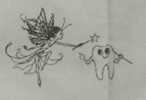
Peter liked Jorge’s advice the best. Mrs. Gilbert said to him, “Whatever you decide, you should show your mother your tooth when you et home.”
When Peter got home, he showed his mother his tooth and told her his plan. The next morning, Peter woke up and looked under his pillow. The tooth was gone. In its place, he found a dollar and a letter. This is what the letter said:
Dear Peter,
Congratulations! You lost your first tooth. I will keep it forever. You should buy something nice for yourself with this money.
Love,
The Tooth Fairy
46. Peter put up his hand to ___________.
A. answer the teacher’s question
B. ask the teacher a question C. tell the teacher he lost his baby tooth
47. ____________ is from France.
A. Keiko B. Jack C. Jorge
48. What did Peter do with his lost baby tooth?
A. He threw it over the roof of his house.
B. He asked his mother to make a necklace for him.
C. He put it under his pillow.[来源:Z+xx+k.Com]
49. From the passage, we can infer(推断) that Peter is a ____________.
A. primary school student B. high school student C. college student
50. In fact, who gave Peter a dollar?
A. Mrs. Gilbert. B. The Tooth Fairy. C. Peter’s mother.
B
Nowadays, cell phones are part of our lives. Many people have cell phones. They can help us easily find people anywhere at any time. However, using cell phones too often may cause cancer(癌症). It’s reported that people who use a cell phone for 10 years or more may get brain cancer.
The suggestions below may help you reduce(减少) the risk of cancer:
When using your cell phone, try to keep it away from your body as much as possible. Don’t put it on the bedside table when you go to sleep.
When you’re on the cell phone, use the speaker(扬声器). In this way, you have just 1/100th of the contact(接触) with radiation you have when you hold it to your ear. An earphone is also a good idea.
Try to keep your conversations short. If you need to talk longer, use an ordinary phone instead.
Change ears when you’re using your cell phone. Before putting it to your ear, wait until the person you are calling picks up the phone.
Your phone gives out radiation when you talk or send messages, but not when you’re listening or getting messages. Listening more and talking less can lower the risk of cancer.
Do not use your cell phone when the signal(信号) is weak or when moving at a high speed, for example in a car or on a train. At high speeds your phone is trying to pick up signals, and this increases the radiation it gives out.
51. According to the text, using cell phones too much may cause ___________.
A. toothache B. cancer C. heart disease
52. The underlined word “radiation” in Paragraph 4 probably means “____________” in Chinese.
A. 辐射 B. 电池 C. 网络
53. You’d better______________.
A. use your cell phone when the signal is weak
B. use your cell phone on a high-speed train
C. change ears when you’re using your cell phone[来源:Z§xx§k.Com]
54. Which of the following is TRUE according to the text?
A. Using an earphone is a good way to reduce the radiation.
B. You can put your cell phone on the bedside table when you go to sleep.
C. Listening less and talking more can lower the risk of cancer.
55. The purpose of the text is to tell us how to properly ____________.
A. buy a cell phone B. use a cell phone C. repair a cell phone
阅读下面的图表，完成56-57小题。
C
Found  April 15th, 2016  A dictionary was found in the library on the afternoon of April 15th.Please call 0735-2169338 or come to the Lost and Found to get it.  Tim | Sports Club  For young peop0le from 13 to 18 years old  Every Sunday 7:30 a.m. ―8:30 p.m.  Renmin Road 32  Tel: 0735-2351683/ 2351782  Just 10 yuan a time  Basketball, swimming, badminton and skating
56. Where did Tim find a dictionary?
A. In the library. B. In the classroom. C. At the Lost and Found.
57. What can we do in the Sports Club?
A. Swim and dance. B. Play volleyball and skate. C. Play basketball and swim.
阅读下面的图表，完成58-60小题。
Chinese Café
Monday—Saturday Lunch  12:00―14:00  Lunch $6 (Under10 $4) | Take away  $5 Each Box  (Put whatever you want into one box)
Friday—Saturday Evening  17:00―23:00  Dinner $12 (Under10 $6) | Free Bottle of Wine For Each Table of Four  (Evening and over 18 only)
Sunday Lunch  12:00―15:00  Lunch $7 (Under10 $4) | Enjoy your meal!  Tel: 4655 9651  Green Avenue, Londbridge
58. You can have lunch in this Chinese Café ___________.
A. at 12:30 on Tuesday B. at 14:30 on Thursday C. at 11:30 on Sunday
59. Steven and his nine-year-old son go to have dinner in this Chinese Café on Friday evening. They should pay ____________.
A. $6 B. $12 C. $18
60. ____________sitting at one table can enjoy a free bottle of wine for dinner.
A. Four 12-year-old boys B. Four adults C. A couple with their child.
第二节回答问题阅读短文，然后根据短文内容简要回答问题。（共5小题，计10分）
Once upon a time, in the forest there lived a baby elephant, who had no friends. None of the animals wanted to be his friend because he was too large.
One day, a wild fire happened in the forest. The animals ran to safer places. The dry trees caught fire and the fire was sure to go all around the forest. The baby elephant ran to the nearest river, collected much water in his trunk(象鼻) and rushed to the burning trees. He sprayed(喷) the water on the fore. Finally, he put out the fire.
Later, while he was resting after the hard job, all the animals and birds came to him and expressed their thanks for his kind help in time. They were now ready to regard him as their good friend and their hero. They said, “A friend in need is a friend indeed.”
The baby elephant was happy to get so many friends and played games with them. He walked through the forest, carrying several small animals and birds on his back.
61. Why did the baby elephant have no friends at first?

62. Where did the wild fire happen?

63. Who put out the fire in the end?

64. At last, did all the other animals regard the baby elephant as a good friend?

65. What can we learn from the story?

IV. 写作技能（三个部分，共11小题，计35分）
第一节完成对话通读下面的对话，然后根据上下文补全对话。（共5小题，计10分）
A: Hello. May I speak to Bob?
B: Hello. 66. . Is that Tony?
A: Yes. Bob, 67.?
B: I’m just listening to music. What’s up?
A: I’m going to your city to take part in a competition.[来源:学#科#网]
B: Glad to hear that .68. ?
A: I’m arriving on June 24th. Can you meet me at the airport at 4 p.m. on that day?
B: 69. , but I’m afraid I can’t. I will ask my brother Henry to meet you.
A: Oh, but I don’t know Henry. 70. ?
B: He has brown hair and wears glasses. He looks exactly like me.
A: OK. See you then.
第二节英汉互译阅读下面的短文，将划线部分的句子译成汉语或英语。（共5小题，计10分）
My best friend Michael is a 15-year-old boy. We are in the same class. He works very hard. He is never late for school and 71. 他所有功课都学得好。He is always ready to help others. My math is very poor, so he often helps me with it after class. 72. His parents are both teachers and they are really busy, so he often helps do the housework at home.He is a little shorter but he is stronger than me. He likes playing football very much at school. We often play football together and he plays it well. 73. But I’m more interested in art.He gets on well with our classmates. Everyone in our class likes him. But now it’s time to graduate and 74. 我们即将离开学校。 Michael and I are going to different high schools. In the future, he wants to be a policeman and I hope to be a musician. 75. We believe our friendship will be forever.
71.
72.
73.
74.
75.
第三节情境作文（计15分）
假如你是李华，你的美国朋友Jeff向你了解你校的课堂教学形式，请你根据提示内容用英语给他写封电子邮件，并谈谈你的感受。
要点提示：1. 我们的课堂是开放自由、生动有趣的。
2. 我们在课堂上经常讲故事，做游戏。
3. 老师在课堂上经常使用电脑，给我们听音乐、看录像等，使我们学到更多知识。
4. 在课堂上老师给我们足够的时间进行自主学习和自由讨论。
5. 我们有更多的机会展示自我。
要求：（1）短文须包含要点提示中的信息（不要逐字翻译），并在此基础上适当发挥；
（2）词数：80左右（短文开头已给出，不计入总词数）；
（3）文中不得出现真实姓名、校名和地名。
可能用到的词汇：study and think for oneself, ability of independent study, discuss in groups freely, show/ express oneself

Dear Jeff,
I was glad to receive your letter and I’d like to tell you something about how we study in class.

[来源:Z&xx&k.Com]
[来源:学科网ZXXK]
Li Hua

参考答案
一.听力测试材料
听下面五段对话，每听完一段对话后，回答1个小题。
1. W: Scott, do you like monkeys?
M: Sure. They are my favorite animals.
2. M: what were you doing at nine last night, Lucy?
W: I was singing with my friends.
3. W: Is this your schoolbag, Steve?
M: No, it isn’t. It’s Peter’s.
4. W: May I have your order, sir?
M: Yes. I’d like some chicken.
5. W: Tom, how was your school trip yesterday?
M: Wonderful. We had a lot of fun.
听第六段对话，回答第6、7小题。
6. M: Helen, you look nice in this red sweater.
W: Thank you.
M: How much did it cost?
W: 120 yuan.
听第七段对话，回答第8、9小题。
7. M: Tina, have you ever been to Sanya?
W: Yes. I went there last year.
M: How did you get there?
W: I took a plane.
听第八段对话，回答第10至12小题。
8. W: Good morning, doctor.
M: Good morning, Mrs. Brown. You look terrible. What’s the matter with you?
W: I’ve got a stomachache.
M: What did you eat yesterday?
W: I had lots of hamburgers and ice cream.
M: You shouldn’t eat so much next time. Um, nothing serious. Just lie down and have a rest.
听第九段对话，回答第13至15小题。
9. M: Hi, Mary.
W: Hi, Tom. We haven’t seen each other since we graduated from high school.
M: Yeah. You now look even prettier than at school.
W: Thank you. How’s everything going? Any news?
M: I’m going to do business with foreigners next month.
W: Really? Very glad to hear it. Where are going to do business?
M: I will go to Guangzhou.
W: Sounds good. There are more chances for business there than in Chenzhou. By the way, I think English is very important in the job.
M: Yes, it’ll be very useful in many ways, so I practice English every day.
W: Hope you’ll be a successful businessman there.
M: Thank you.
第二节笔录要点根据你所听到的内容，写出下面表格中所缺的单词，每空仅填一词。听材料前，你将有时间阅读各个小题，每小题5秒钟；听完后，各小题将给出5秒钟的作答时间。
Hello, everyone! Here is tomorrow’s weather report for big cities in China. Beijing is windy. The highest temperature is 28°C and the lowest temperature is 20°C. The weather is quite pleasant. Shanghai is cloudy. The highest temperature is 31°C and the lowest temperature is 25°C. Changsha is sunny. The temperature is from 27°C to 33°C. Guangzhou is rainy. The temperature is between 28°C and 32°C. Remember to take an umbrella if you go out. Thanks for listening.
二、参考答案
1-5 ABCCC 6-10 ABABC 11-15 ACACB
16. Beijing 17. Highest 18.Cloudy 19.27°C 20. Rainy/ Raining
21-25 BABAA 26-30 CABCC 31-35 BBABC 36-40 ACBBC
41-45 ABCAB 46-50 CBCAC 51-55 BACAB 56-60 ACACB
61. Because he was too large.
62. In the forest.
63. The baby elephant.
64. Yes. / Yes, they did.
65. A friend in need is a friend indeed. /…
66. This is Bob speaking. / Bob speaking./ Speaking./ This is Bob./ …
67. What are you doing?
68. When are you arriving (at the airport) (here)?/ When will you arrive (at the airport) (here)? / When will you get here? / When are you getting here?/…
69. Sorry/ I’m sorry/ I’d love to
70. What does he ( your brother/ Henry) look like? / What is he like?/…
71. he does well in / is good at all his lessons / subjects / study.
72. 他的父母都是老师，工作很忙，所以他经常在家帮着做家务。
73. 但我对艺术/ 美术更感兴趣。
74. we are going to leave our school./ …
75. 我们相信我们的友谊将永存/ 天长地久。

One possible version:
Dear Jeff,
I was glad to receive your letter and I’d like to tell you something about how we study in class.Now our classes are open and free. All of our classmates feel the classes are interesting and lively as we often tell stories and play games. Thus, we can not only learn but also have fun. The teachers often use the computer in class. We can learn more by listening to music and watching videos. Our teachers give us enough time to study and think for ourselves to develop our ability of independent study. We also have more chances to discuss in groups freely and so we can learn how to communicate with each other and learn from each other. Sometimes we even express ourselves in front of the whole class. And we can ask questions during or after class freely.
Li Hua

