绝密★试卷类型A
二〇一六年聊城市初中学生学业水平考试
英语试题
亲爱的同学，伴随着考试的开始.你又走入了一个人生驿站。请你在答题之前，一定要仔细阅读以下说明:
I.试题由选择题与非选择题两部分组成.共10页。选择题65分.非选择题55分，共120分。考试时间120分钟。
2.将姓名、考场号、座号、考号填写在试题和答题卡指定的位置。
3.试题答案全部写在答题卡上.完全按照答题卡中的“注意事项”答题。
4.考试结束.答题卡和试题一并交回。
愿你放松心情，放飞思维.充分发挥，争取交一份圆满答卷.
选择题（三大题，共计65分）[来源:学,科,网Z,X,X,K]
- 听力理解（共25小题；每题1分，满分25分）
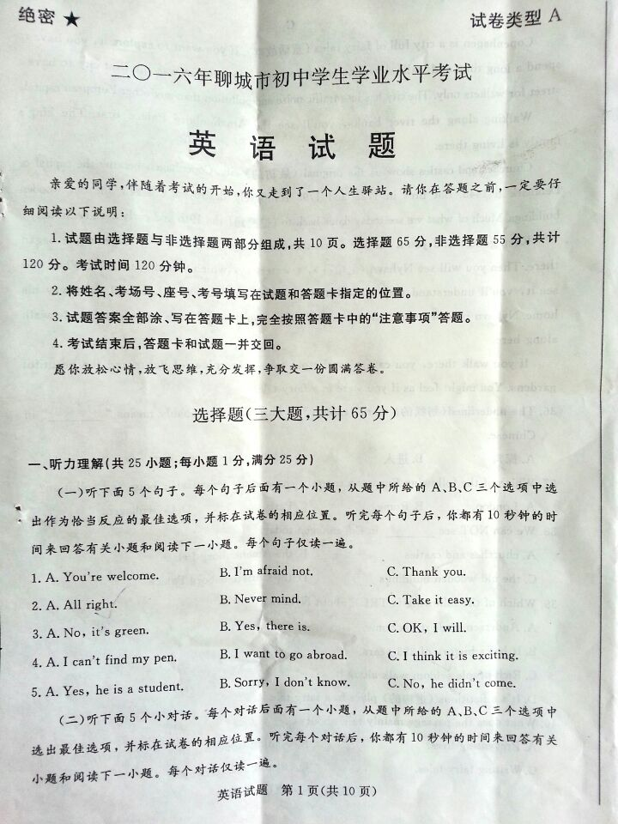
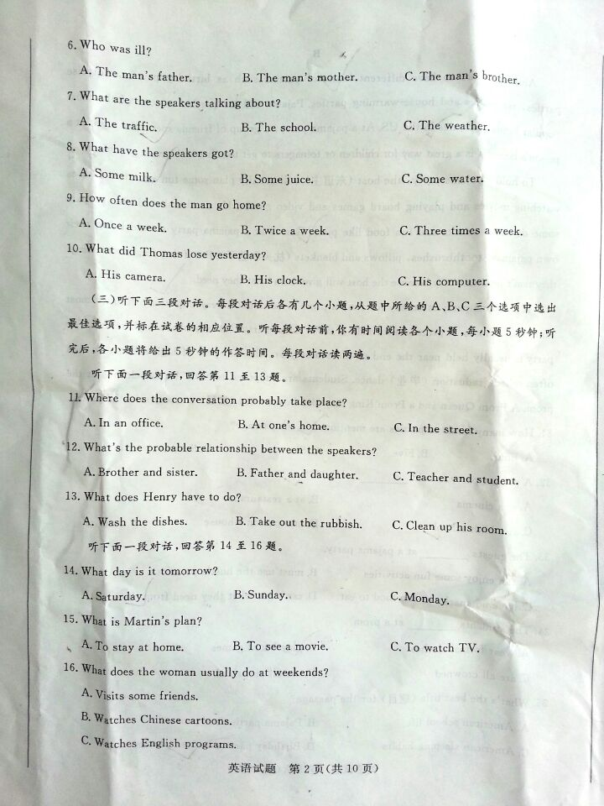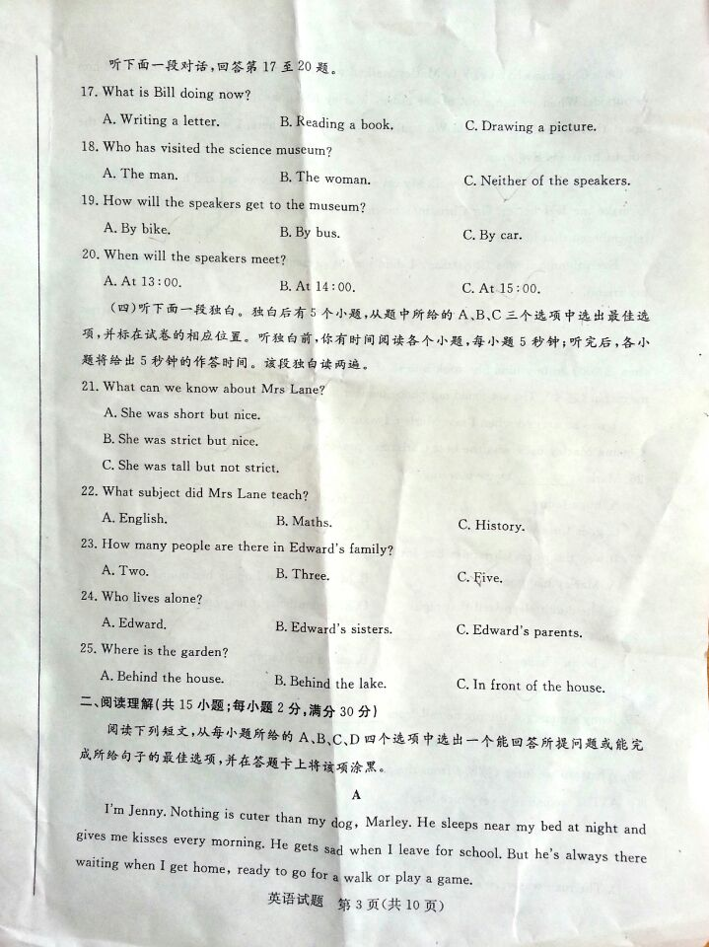
- 阅读理解（共15小题；每题2分，满分30分）
A
I’m Jenny. Nothing is cuter than my dog, Marley. He sleeps near my bed at night and gives me kisses every morning. He gets sad when I leave for school. But he’s always there waiting when I get home, ready to go for a walk or play a game.
On a Christmas Eve（前夕），Marley walked with my family to a store. My mum tied him up outside. When we came out of the store, Marley had gone. My mum called the police to report that he had been stolen. We couldn’t find him anywhere. I was very sad. It was the worst Christmas Eve ever.
That night, I didn’t sleep well. My cat seemed to know I was sad and hugged（拥抱）me to make me feel better. On Christmas morning, I woke up and called for Marley. Then I remembered that he had gone.
Even though it was Christmas, I didn’t want presents. I didn’t want anything, except my friend.
Then my mum got a phone call. Someone found him! A woman saw a man on the street trying to sell a scared（恐惧的）dog. She felt bad for the dog and used her own money (more than $200) to buy him. She took him to a vet（兽医）.The vet scanned（扫描）the dog for a microchip（芯片）. The vet found our phone number in the microchip and called my mum.
I was so excited when I saw Marley. I went to say thanks to that woman. She’s my hero. Getting Marley back was the best Christmas present ever.
26. Marley ___________ every morning.[来源:学&科&网]
A. hugs Jenny B. plays a game
C. goes for a walk D. gives Jenny kisses
27. I t was the worst Christmas Eve for Jenny because____________
A. Marley had gone B. Marley was tied up by her mum
C. she didn’t sleep well that night D. her mum bought no present for her
28. On Christmas morning, Jenny ______________
A. became happy B. called for Marley
C. called for the cat D. wanted many presents
29. Jenny’s mum got the phone call from____________[来源:Zxxk.Com]
A. the police B. the woman C. the wet D. the man
30. What can we infer（推断）from the passage?[来源:学科网ZXXK]
A. The woman is a very nice lady.
B. Jenny’s mum gave the woman $400.
C. The vet put the microchip in Marley years ago.[来源:Zxxk.Com]
D. The man was very scared when selling Marley.
B
Americans like to have different kinds of parties such as birthday parties, surprise parties, tea parties and house-warming parties. Pajama（睡衣）parties are one of the most popular kinds of parties in the US. At a pajama party, a group of friends spend the night at a person’s house. It is a great way for children or teenagers to get together and have a good time.
To hold a pajama party, the host（东道主）will usually plan some fun activities such as watching movies and playing board games and video games. He or she should also prepare some delicious snacks and fun food like pizza. Guests at a pajama party should bring their own pajamas, toothbrushes, pillows and blankets（枕头和毯子）. But if they forget something, they don’t need to worry because the host will give them what they need.
If a pajama party is mainly for fun, a prom is no doubt a very important thing in most American schools. A prom is a formal（正式的） dance party that is held at a high school. The party is usually held near the end of the senior year, the last year of high school, so it is often called graduation （毕业）dance. Students are supposed to wear formal clothes at the prom. A Prom Queen and Prom King may also be crowed （加冕）at many schools’ proms.
31. How many kinds of parties are mentioned in the passage?
A. Four B. Five C. Six D. Seven
32. A pajama party is held__________
A. at a cinema B. at a restaurant
C. at a high school D. at a person’s house
33. The guests ________at a pajama party.
A. can enjoy some fun activities
B. must use the host’s pajamas
C. have no snacks or fun food to eat
D. can’t get what they need from the host
34. The students _________ at a prom.
A. wear formal clothes B. paly board games
C. are all crowned D. are all surprised
35.What’s the best title （题目）for the passage?
A. American school life B. Pajama parties and proms
C. American sleeping habits D. Birthday parties and tea parties
C
Copenhagen is a city full of fairy tales（童话故事）. If you want to explore it, you have to spend a long time and walk slower to enjoy yourself. Copenhagen was the first city to have a street for walkers only. The city has less traffic noise and pollution than any other European capital.
Walking along the river banks,you’ll see the Amalienborg Palace first. The king’s family is living there.
Churches and castles show us the original city. Copenhagen became the capital of Denmark in 1445. But fires in 1728 and 1795 completely destroyed（摧毁） the old wooden buildings. Much of what we see today dates back to（追溯到） the 19th and early 20th centuries.
Keep going, and you’ll see the Christiansborg Palace. The town of Copenhagen began there. The you’ll see Nyhavn（尼哈芬），a waterway, which was dug in 1673. When you see it, you’ll understand why Hans Christian Andersen made this beautiful waterway his home. Nyhavn is a peaceful and wonderful place. You’ll usually see some rich people walk along here.
If you walk there, you can enjoy the old trees, the colorful lights and the beautiful gardens. You might feel as if you were in a fairy tale.[来源:Z+xx+k.Com]
- The underlined（划线的）word “explore”in paragraph 1 probably meansin Chinese.
A. 探索 B. 进入 C. 找到 D. 离开
37. Which of the following European capital cities has the least traffic noise and pollution?
A. London B. Rome C. Paris D. Copenhagen
38. We can Not seein Copenhagen today.
A. Churches and castles B. the Amalienborg Palace
C. the old wooden buildings D. the Christiansborg Palace
- Which of the following is TRUE about Nyhavn?
- Andersen made it his home. [来源:学.科.网Z.X.X.K]
B. It has a history of 383years
C. Rich people seldom walk along it
D. It’s a fictitious（虚构的）place in a fairy tale.
- What does the passage mainly talk about?
A. Preventing fires. B. Visiting Copenhagen
C. Writing fairy tales D. Digging a waterway
三、完形填空（共10小题；每小题1分，满分10分）
阅读下面短文，掌握其大意，然后从短文后所给的A、B、C、D四个选项中，选出可以填入空白处的最佳选项，并在答题卡上将该项涂黑。
Manyue is a 3-year-old girl. Her father 41 AIDS(艾滋病) and died. Her mother also fell sick with the same illness. One day, Grandpa Wang took Manyue to the 42
to see her mother, who looked pale and tired. She said, “My dear child, I’m going to 43 you soon and stay with your father.” “Can I go with you?” Manyue asked. Mum said 44 , “Your father is too far away and you’re too young to go there, 45 we will come back to see you on the night with a full moon.”
Soon after Manyue’s visit, her mother 46 her journey to see her dad. Manyue began to live with Grandpa Wang. “The 47 moon will come during the harvest (收获的季节) just like your mother said,” Grandpa Wang told her sadly.
48 the moon was full, Grandpa Wang and Manyue had their visitors from a 49 . Manyue was shy in front of the strangers. Smiling kindly, a young lady said, “I’m going to be 50 mother. Please come home with me. ” Then Manyue went to her new home. Now she lives in a tall building in the city. She’s happy now.
41. A. caught B. took C. brought D. received
42. A. school B. factory C. hospital D. shop [来源:Z。xx。k.Com]
43. A. meet B. help C. call D. leave
44. A. loudly B. softly C. shyly D. proudly
45. A. or B. because C. if D. but
46. A. stopped B. repeated C. started D. refused
47. A. full B. lovely C. beautiful D. bright
48. A. Usually B. Immediately C. Impossibly D. Finally
49. A. town B. city C. village D. farm
50. A. your B. their C. his D. her

非选择题（五大题，共计55分）[来源:Z&xx&k.Com]
- 补全对话（共5小题；每小题1分，满分5分）
根据对话内容，在每个标有题号的空白处填入一个适当的句子，使对话完整，合乎情境。
A:51 ?
B:I will go to the old people’s home.
- 52 ?
- Because I want to look after the old people. They have no children around and they are very lonely.
- 53 ?
- I can clean up their rooms, wash their clothes and tell them something interesting around us. Would you like to go there with me?
- 54 .I also want to do something for the old .
- You sing well, I think you could sing songs to cheer them up.
- And I think we should ask more friends to join us so that we can serve the old people better.
- 55 .
五、语法填空（共10小题；每小题1分，满分10分）
阅读下面短文，在空白处按要求填入适当的单词或括号内单词的正确形式。每空1个单词。
Chelsea Fearce is seventeen years old. There are five __56__( member ) in her family. They are poor and they live in a shelter(收容所). “Getting a shower, food and clean clothes was not easy for _57___ ( I ),” Fearce said. “I’m worried __58 __( 介词 ) my family and my home life. I know I have to become stronger, __59__( 连词 ) I study hard.”
When she was in high school, Fearce often __60__ ( stay ) up late. She wanted to have a __61__( good ) life than before. She just told herself to keep __62__(work).
Fearce overcame ( 克服 ) all the __63__( difficulty ). She got high grades and she became a college student. “Never __64__( give ) up! Do what you have to do right now so that you can have __65__( 冠词 ) future that you want, ”Fearce told everyone.
六、单词拼写（共10小题；每题1分，满分10分）
根据下面所给英语句子的句意及括号内所给汉语提示或音标提示写出单词的正确形式。每空一个单词。
66.Carrots and______________(鸡蛋)are good for your eyes.
67.Please________________(传递)the ball to me.
68.I think_________________（两者都）of you are right.
69.Alexander Bell____________(发明) the telephone in 1876.
70.There’s_______________(厚的) ice on the lake.
71.In spring,Kunming is ______________ than Liaocheng.
72.I ________________ you will succeed.
73.There are ____________ students in our group.
74.It took us______________ two hours to get there.
75.Smoking is harmful to your______________ .
- 阅读表达（共5小题；每小题2分，满分10分）
阅读下面短文，根据其内容完成后面各项任务。
Running away is a serious problem. There are lots of runaway and homeless kids living in the streets around the world.
孩子们为什么想离家出走呢？
★Some kids run away because they have problems with their families.
★Some kids run away because they’re afraid to tell their parents the bad things that they did at school or in society.
★Some kids run away because there is violence(暴力) in the family.
★Some kids run away because their parents divorce(离婚) o人marry again.
★Some kids run away because they have problems at school.
What will you do if your friends wants to run away from home?
If your friends is thinking about running away, tell him or her that it is difficult to survive(幸存) in the streets. Try to help your friend feel less alone.
Whatever he problem is, there are other ways to solve it. Maybe you can’t think of the ways right now, but an adult(成年人) will know how to help you. You should tell an adult that your friend plan to run away as soon as possible. Being a real friend doesn’t mean keeping a secret that may hurt someone. And running away isn’t a solution(解决方法) for either of you. It only makes more problems and danger.
- 将文中划线部分的汉语句子译成英语。

- 回答问题：
Kids run away because of many reasons. How many reasons are connected with their schools?

- 将文中划线部分的英语句子译成汉语。[来源:学科网]

- 从文中找出小面所给句子意思相同的句子。
If a secret may hurt someone, you shouldn’t keep it even though you’re someone’s real friend.

- 回答问题：
What does the underlined word “It” in the last sentence refer to(指的是)？

八、书面表达（满分20分）
假如下图是你学校的平面建筑示意图，请你根据所给提示，以My School为题，写一篇80词左右的英语短文，介绍你学校的建筑布局情况并谈谈你对学校的看法。
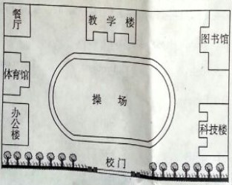
注意：
- 短文中不能出现真实的学校名称和考生姓名；
- 短文开头已给出，不计入总词数。
My School
This is a map of my school.

