黑龙江省龙东地区2016年初中毕业学业统一考试
英 语 试 题
考生注意：
本考场试卷序号
（由监考填写）
1、考试时间120分钟
2、全卷共五道大题，总分120分
题号 | I | II | III | IV | V | 总分 | 核分人
得分
第一部分 语言知识运用(共计65分)
得分 | 评卷人
I. Multiple choice (本题共30分,每小题1分)
Choose the best answer from A, B or C according to the meaning of the sentence.
( ) 1.—Who is ______ girl behind the tree ?
—Which one ? The one with ______ umbrella ?
A. a; the B. the; an C. the; a
( ) 2.— How far is your home from school ? — About ______ walk.
A. five minute’s B. five minutes’ C. five minutes
( ) 3.Whenever Tom reads an interesting novel, he can’t keep it to ______ and wants to
share it with his classmates.
A. him B. he C. himself
( ) 4.About ______ of the land ______ c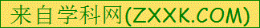overed with trees and grass.
A. three fifths; is B. three fifths ; are C. three fifth; are
( ) 5.—I saw your mother in the library just now.
—It ______ be her. She went to Beijing yesterday.
A. can’t B. mustn’t C. needn’t
( ) 6. —Do you know Shanghai is one of ______ in the world ?
—Yes, it’s bigger than ______ city in China.
A. the biggest city;any B. the biggest cities;any C. the biggest cities;any other
( ) 7.You’d better get up earlier, ______ you’ll be late for school.
A. and B. or C. but
( ) 8.Lei Feng ______ for many years, but his spirit is still encouraging us.
A. died B. has been dead C. has died
( ) 9.Though she often makes her little brother ______ , she was made ______ by him
this morning.
A. cry ; to cry B. to cry ; cry C. cry ; cry
( ) 10.We advise parents ______ their children at home alone in order to keep them away
from danger.
A. not to leave B. not leave C. not leaving
( ) 11.I often hear the little girl ______ the piano in the next room.
A. practicing playing B. practice to play C. practice playing
( ) 12.To be a better man is the best soap opera ______ I have ever seen.
A. that B. where C. who
( ) 13.He ______ newspapers when the earthquake happened in Japan.
A. was looking through B. looked through C. had looked through
( ) 14.I don’t know if you ______ to Mary’s party next Sunday. If you go, ______.
A. go ; so will I B. will go ; so will I C. will go ; so do I
( ) 15.Taiwan lies ______ the east of Fujian, ______ the southeast of China.
A. on ; in B. to ; in C. on ; to
( ) 16.We each ______ WeChat nowadays, even the old people.
A. play B. plays C. playing
( ) 17.The temperature in June is still low. ______ bad the weather is!
A. What B. How C. What a
( ) 18.I tried two bookstores for the book I wanted, but ______ of them had it.
A. none B. either C. neither
( ) 19.A Christmas Carol is a famous short novel ______ by Charles Dickens.
A. written B. was written C. wrote
( ) 20.When the boy heard the words, his face ______ red.
A. got B. turned C. changed
( ) 21.— Would you mind my opening the window ?
— ______ . It’s so hot in the room.
A. Of course not B. Certainly C. Better not
( ) 22.— May I speak to Mr. Lee ?
— Sorry, he ______ Harbin, he ______ the city for two days.
A.has been to; has been in B.has gone to; has been to C.has gone to; has been in
( ) 23.My grandfather _____ live in the countryside, but now he ______ living in the city.
A. used to ; used to B. got used to ; gets used to C. used to ; gets used to
( ) 24.—Mum, could you tell me ______ ?
—In two weeks.
A. how soon will dad come back
B. how soon dad will come back
C. how long dad will come back
( ) 25.Lu Han is ______ an excellent actor ______ most teenagers like him.
A. such ; that B. so ; that C. too ; to
( ) 26.The Belt and Road Initiative(一带一路倡议) will help China improve the ______
related(相关的) countries, especially Pakistan.
A. relationship B. agreement C. environment
( ) 27.Let’s go to Disneyland in Shanghai in August, ______ ?
A. shall we B. will you C. won’t you
( ) 28.— Look! What’s on the ground ?
— Oh, it’s my sweater. Please ______ for me.[来源:学科网]
A. pick up it B. pick it up C. pick it out
( ) 29. — The box is heavy. Could you please help me carry it ?
— ______ !
A. My pleasure B. You are kidding C. Good idea
( ) 30.Which of the following signs means something can be recycled?
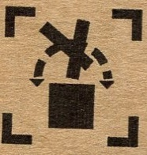
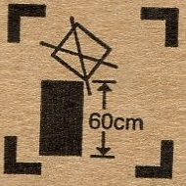
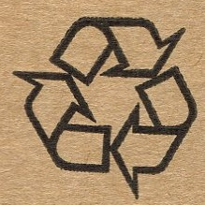
A. B. C.

Ⅱ.Close test (本题共15分,每小题1分)
得分 | 评卷人
Choose the best answer to complete the passage.

In our country we think being modest(谦虚的) is a virtue(美德) and being proud is a bad thing. One day, I heard an American boy say to a Chinese student, “You speak very good English.” But the girl answered, “No, no. My English is very poor.” The foreigner was quite 31 at the answer. Thinking he had not made himself understood or the girl had not heard him 32 . He said, “Yes, indeed, you speak very well.” 33 the girl still kept saying, “No.” In the end the American boy could not understand and didn’t know 34 to say.
What’s wrong with the girl’s answer? She didn’t 35 a compliment(恭维) in the same way as the American people do. She should answer “Thank you” instead of “No”. She 36 understood what the American boy had said, but she thought she should be modest. In the 37 ,
people will feel 38 and confident when they are praised. So if someone says the 39 you have cooked are very delicious, you should say, “Thank you”.
If you are modest and say, “No, I’m 40 I can’t do it well”, while working in a western country, people may think that you really can not do it. If you often say, “No”, you’ll certainly be looked down upon by 41 . When asking 42 a job, if one says something like, “Yes, I can certainly do it” instead of “Let me have a try”, he or she will 43 get it. So in the west, you should be brave to show your self-confidence. In my opinion, being confident does not 44 being proud, so sometimes you should be confident 45 being modest.

( ) 31.A.excited | B. surprised | C. frightened
( ) 32.A.clear | B. clearly | C. not clearly
( ) 33.A.Though | B. And | C. But
( ) 34.A.which | B. what | C. how
( ) 35.A.accept | B. refuse | C. disagree
( ) 36.A.hardly | B. really | C. badly
( ) 37.A.east | B. south | C. west
( ) 38.A.proudly | B. pride | C. proud
( ) 39.A.dishes | B. cups | C. glasses
( ) 40.A.afraid | B. active | C. angry
( ) 41.A.the other | B. other | C. others
( ) 42.A.for | B. as | C. to
( ) 43.A.fail to | B. expect to | C. succeed in
( ) 44.A.think[来源:学,科,网Z,X,X,K] | B. say | C. mean
( ) 45.A.as soon as | B. as well as | C. instead of

Ⅲ. Communication (本题共20分, 每小题2分)
(A) Choose the best choice from A to F to finish the dialogue. You have one more answer. Each choice should be used only once.
得分 | 评卷人

(At the doctor’s)
A: Good morning, doctor !
B: 46 What’s wrong ?
A: I have a sore throat. 47
B: 48
A: Since yesterday morning.
B: 49
A: Yes. My temperature is OK.
B: Open your mouth. Say “Ah...”.You have a cold.[来源:学科网ZXXK]
A: Is it serious？
B: Nothing serious. 50 You’ll get better soon.
A: Thank you, doctor.
- I am feeling terrible.
- I’m sorry to hear that.
- Good morning, young man!
- Have you taken your temperature？
- How long have you been like this?
- Take this medicine three times a day.

46 47 48 49 50
(B) Complete the dialogue with proper words or sentences.
A: Morning, Li Ming! Did you watch the news on CCTV yesterday evening ?
B: No, I didn’t. 51 ?
A: Yes, there was. Chairman Xi came to Heilongjiang.
B: Really? When did he come to Heilongjiang ?
A: A few days ago.
B: 52 ?
A: He came here because our country wants to promote the economy of the Northeast Industry Base(振兴东北工业基地).
B: I’m so excited to hear the news. Being a member of Heilongjiang, I think we should do what we can to make our hometown better and better.
A: 53 . I’m going to be an engineer when I grow up.
B: 54 ?
A: I’m going to study hard to get more knowledge.
B: 55 after you graduate from the university ?
A: I’m going to work in our hometown.
B: I hope your dream can come true.
第二部分 阅读理解(共计40分)
Ⅳ. Reading comprehension (本题共40分, A, D每小题1分, B, C,
得分 | 评卷人
E每小题2分)
( A )
Five Ways to Fight Germs(细菌)
( ) 56. If you have a cold or flu, you’d better not pass it on to anyone else. Just use a napkin every time you sneeze or cough. Put used napkins in the dustbin.
( ) 57. Always wash your hands with running water and soap before you eat anything, after
you use the bathroom and after you sneeze or blow your nose. The germs won’t stand a chance.
( ) 58. Stations, hospitals, supermarkets are places filled with germs that make people sick. When people cough or sneeze, the germs spread widely, landing here and there. Unless it’s necessary, go out less often.
( ) 59. You should always buy pets from a good pet shop and take them to the animal doctor
regularly. Keep pets as clean as possible and always wash your hands after you play with them.
( ) 60. When you go food shopping, buy all the things for the fridge, and put them away as soon as you get home. Always prepare for food with clean hands.
Choose the best topic from A to F according to the meaning of the passage.
A. Use a napkin | B. Use a fridge
C. Love your pets | D. Keep off public places
E. Wash your hands often | F. Keep pets clean and healthy

( B )
Have you ever seen a horse with toes? Millions of years ago, horses had many toes. They had four toes on each front foot. They had three toes on each back foot. The horses were no bigger than the cats. These small horses lived in the forest. The toes helped the horses run on the soft, wet ground.
At first, it was very hot in the forest. But the weather changed. It became very cold. Many trees could not live in cold weather. The trees died and fell. Open fields took the place of forests. The sun made the ground dry and hard.
Horses began to change, too. They began to get bigger. This took a long time. On the dry, hard land, horses needed only their middle toes for running.Their middle toes became hard. After a long time, horses had only one hard toe on each foot. Now we call this hard toe a hoof(蹄子).
Judge the following sentences true (T) or false (F) according to the passage.
( ) 61. A horse had fourteen toes in total millions of years ago.
( ) 62.At first the weather in the forest was very hot.
( ) 63.The horses were much bigger than the cats millions of years ago.
( ) 64.On the dry, hard land, horses needed only their middle toes for running.
( ) 65.Horses didn’t have any changes over the years at all.

( C )
Choose the best choice from A, B or C according to what you read.
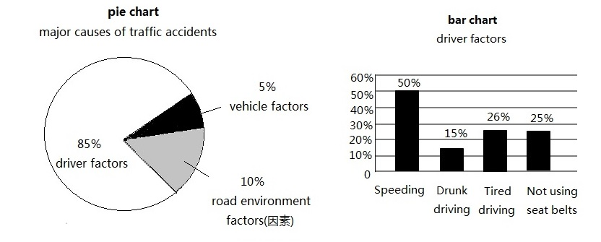
( ) 66.The charts above are about ______ .
A. traffic accidents B. safety C. health
( ) 67.Which is not the factor from drivers ?
A. Drunk driving B. Speeding C. Road environment
( ) 68.How many factors cause traffic accidents ?
A. 7 B. 4 C. 3
( ) 69.What does the word “ vehicle ” mean in Chinese ?
A.安全带 B.机动车辆 C.行人
( ) 70.From the charts we know that ______ .
A. road environment is the main factor of traffic accidents
B. tired driving is the most factor from drivers
C. a quarter of the drivers don’t use seat belts

( D )
Once upon a time, there was a millionaire who loved money more than the other things in the world. He didn’t know exactly how much he had, so he took on a little girl to count all his money for him.
It took the little girl six days to count all the money. When she told the millionaire that he had forty-two million dollars, he was wild with joy and asked, “How much money do you want?” He thought she was only a child and he could give her less money.
The girl said, “Well, I worked for six days, so I think you should pay me for six days. Give me two pennies for the first day. Each day after that, just give me the amount you give me the day before, multiplied(乘) by itself.”
The millionaire thought that in this way he would only have to give her a few dollars. What a foolish girl!
On the first day the millionaire paid her two pennies, and on the second day, two pennies times two pennies, or four pennies.
Each day after that, he gave her the number of pennies he had given her the day before, multiplied by itself. And by the sixth day the foolish millionaire had to give the clever girl all his money.
Fill in the blanks according to the passage .Only one word for each blank.
Long long ago, a millionaire loved money than anything 71 in the world. One day he took on a girl to count his money. The girl spent six days in 72 his money. The millionaire asked the girl how much money he should 73 for what she did. The girl answered he should give her the amount he gave her the day before, multiplied by itself.
The millionaire 74 with the girl. He thought the girl was a 75 . In fact, the girl was so clever. The millionaire had to give the clever girl all his money.
71 72 73 74 75
( E)
Have you seen advertisements about hair care products ? The models(模特) have shining hair like jewels(宝石). But now making hair shine is no longer the task of hair care products, because hair can be made into real jewels. Believe it or not, a company called LifeGem in the US makes it possible.
The company is in the business of taking hair from dead people and making them into diamonds(钻石). Now the company plans to make three diamonds using Beethoven’s hair to show their latest technology. The work will take about 7 months. In the end, Beethoven’s long hair will become three shining diamonds.
Since the great musician died in 1827, you may wonder where they got Beethoven’s hair. A man called John Reznikoff gave the hair to the company. He holds the Guinness World Record for the latest and most valuable collection of celebrity(名人) hair. His collection also includes hair of Napoleon, Albert Einstein, Abraham Lincoln and John F. Kennedy. In total, the collection is worth over five million dollars.
Though it sounds unbelievable, diamonds made with hair are for the families to remember the dead.
Answer the questions according to the passage.
76. What does the company of LifeGem do ?

77. How did the company get Beethoven’s hair ?

78. John Reznikoff doesn’t collect Albert Einstein’s hair, does he ?

79. How long will the work take ?

80. What are the diamonds made with hair for ?

第三部分 书面表达 (共计15分)
得分 | 评卷人

Ⅴ.Writing ( 本题共15分，其中81题5分，82题10分)
（注意：文中不能出现考生真实姓名、校名和师名，否则不得分）
81.上星期五Tom在学校操场拾到一个黑色书包，内有两件T恤衫，一本英汉字典。请失主速与三年四班Tom 联系，电话:13846007166。
Found

Tom

82.(A) 话题作文：2016年5月25日，著名学者杨绛女士逝世，她一生饱读诗书、才华横溢。亲爱的同学们，你们喜欢阅读吗？请以 Let’s Read More 为题，用英语写一篇80-100词的文章。
提示：1.当前存在现象(上网，聊天，玩手机游戏……)
2.读书的益处
3.有关阅读的做法与打算
(B) 图示作文：仔细观察下列四幅图片，展开合理想象，写一篇短文。
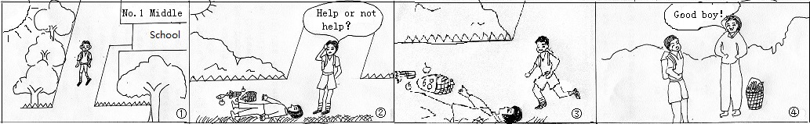
要求：1. 话题作文或图示作文任选其一。
2. 词数在80～100词之间。
3. 要求字迹工整，语法正确，意思连贯，合乎逻辑，可适当发挥。[来源:学#科#网]

[来源:学科网]

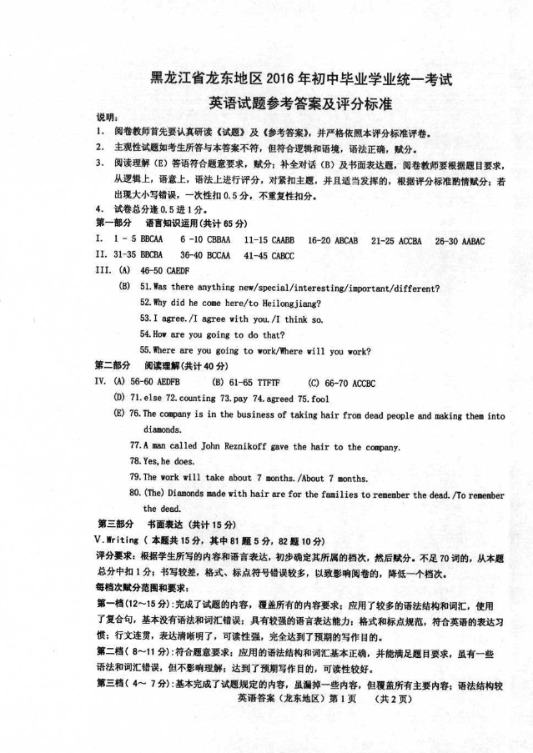

[来源:学科网ZXXK]

