2016年苏州市初中毕业暨升学考试试卷
英 语
注意事项：
1. 本试卷共七大题，满分100分(不含听力口语30分) ，考试用时100分钟；
2. 答题前，考生务必将自己的姓名、考点名称、考场号、座位号用0.5毫米黑色墨水签字笔
填写在答题卡相应的位置上，并认真核对条形码上的准考号、姓名是否与本人的相符合;
3. 答选择题必须用2B铅笔把答题卡上对应题目的答案标号涂黑，如需改动，请用橡皮擦干净后，再选涂其他答案;答非选择题必须用0.5毫米黑色墨水签字笔写在答题卡指定的位置上，不在答题区域内的答案一律无效，不得用其他笔答题;
4. 考生答题必须答在答题卡上，答在试卷和草稿纸上一律无效.
第一部分 单项填空（共15小题；每小题1分，满分15分）
请认真阅读下面各题，从题中所给的A、B、C、D四个选项中，选出最佳选项，并在答
题卡上将该项涂黑。
1. Edward and William are brothers. There is uncommon similarity between
two boys.
A. an ; 不填 B. an ; the C. a ; 不填 D. a ; the
2. — Here’s a box of chocolate on our desk. For me or for your mom ?
— It’s , Dad. Happy Father’s Day !
A. hers B. her C. yours D. you
3. — What does Justin Bieber’s song Never Say Never impress you most ?
— It tells us that we do almost anything if we never give up .
A. can B. have to C. should D. need
4. A good student connects what he reads what he sees around him .
A. for B. with C. in D. on
5. — Oh , dear ! A power cut !
— Sorry , I didn’t know you the washing machine .[来源:学|科|网Z|X|X|K]
A. are using B. used C. use D. were using
6. To make your DIY work perfect , you’d better not start you get all the tools ready .
A. when B. while C. before D. after
7. If the customer rings up for me again , please the call to the sales department .
A. run through B. look through C. go through D. put through
8. — pale you look ! Are you feeling all right ?
—I’m not feeling well . I’ve got toothache .
A. How a B. How C. What a D. What
9. Steve Jobs was full of — always coming up with new ideas which led to great changes in society .
A. instruction B. invitation C. introduction D. invention
10. Our teacher often advises us the habit of making notes while reading .
A. to develop B. develop C. to developing D. developing
11. — Playing video games is a waste of time .
— I can’t agree more . There are meaningful things to do .
A. the most B. the least C. more D. less
12. There’s no ticker left for Lang Lang’s piano concert . you your sister can go to it .
A. Both ; and B. Not only ; but also C. Either ; or D. Neither ; nor
13. —Hobo and Eddie the cinema to watch the film Zootopia .
—Oh , that’s why I can’t find them now .
A. have gone to B. have been to C. has gone to D. has been to
14. —Daniel , could you tell me ?
—Certainly , in Brazil .
A. when the 2016 Olympics will be held B. when will the 2016 Olympics be held
C. where the 2016 Olympics will be held D. where will the 2016 Olympics be held
15. —I’d like to choose yellow as the colour of our bedroom .[来源:Z_xx_k.Com]
— . The colour brings me a warm and comfortable feeling .
A. No way B. Sounds great C. In your dreams D. I can’t decide
第二部分 完形填空（共10小题；每小题1分，满分10分）
请认真阅读下面短文，从短文后各题所给的A、B、C、D四个选项中，选出最佳选项，
并在答题卡上将该项涂黑。
The earliest maps were probably drawn in the Middle East . Some of these maps have
16 and they show us the people at that time thought the earth flat (平的) . As time went by , the pictures became more detailed and maps were more 17 made . Later on , ancient Greeks(希腊人) used their 18 of math and science to make maps . Greek maps tell us the Greeks knew the world was 19 .
From simple pictures , mapmaking has turned into a science . Maps are made 20 surveying(勘测) land . In the 1900s , people around the world started to share information to make
21 maps . With the help of the photographs taken from the sky and space , maps are now more exactly made than ever . 22 the world is always changing , we will always need new maps .
There are many types of maps , but almost all use 23 and pictures to describe what a place is like when the map is made . A map usually tells what the pictures 24 . Some maps may show the whole world . A road map will help you know the 25 from one place to another . Other maps may use pictures to show the temperature and population in different places .
16. A. disappeared B. survived C. gone D. left
17. A. slowly B. simply C. correctly D. carelessly
18. A. knowledge B. courage C. energy D. challenge
19. A. long B. small C. square D. round
20. A. into B. by C. of D. from
21. A. cleaner B. lighter C. better D. older
22. A. Though B. So C. Unless D. Since
23. A. sounds B. models C. words D. stories
24. A. stand for B. go for C. ask for D. wait for
25. A. weather B. distance C. feature D. culture
第三部分 阅读理解（共12小题；每小题2分，满分24分）
请认真阅读下面短文，从短文后各题所给的A、B、C、D四个选项中，选出最佳选项，
并在答题卡上将该项涂黑。
A
Coffee
Our dad’s just bought a coffee machine ,
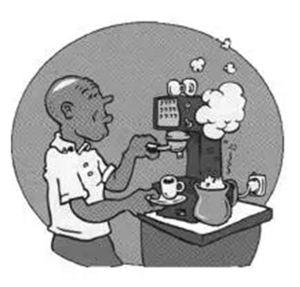
The most unusual thing you’ve ever seen .
It grinds(碾碎) the beans and it heats the milk .
The coffee comes out as smooth as silk .

He makes cappuccino with chocolate on top .
The coffee he makes is as good as the shop .
He can make short black as well as long .
Dad likes his coffee hot and strong .

Mum says that coffee’s not good for me ,
If I want something hot to have Milo or tea .
But in summertime when the weather is hot .
Dad makes iced coffee —I like that a lot !

26. Whenever Dad makes a cup of coffee , he .
A. goes to the coffee shops
B. plays with the machine
C. grinds beans with the machine
D. buys a new coffee machine
27. Which word best describes how Dad feels when he makes a cup of coffee ?
A. Satisfied B. Tired C. Excited D. Touched

B
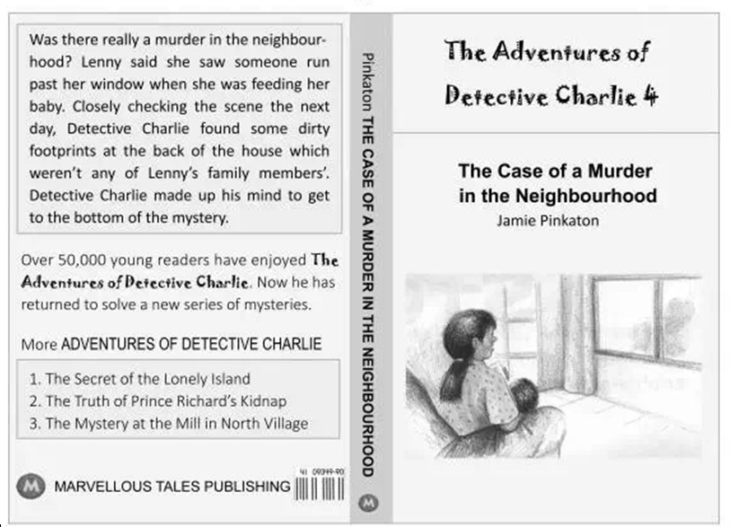

28. The material above is .
A. a book report B. a book list C. a book review D. a book cover
29. Which of the following is NOT included in the Detective Charlie’s series ?
A. The Case of a Murder in the Neighbourhood
B. The Secret of the Floating House on the River
C. The Mystery at the Mill in North Village
D. The Truth of Prince Richard’s Kidnap
30. What can we learn from the material ?
A. The writer of the book is Lenny Pinkaton.
B. Charlie didn’t find any clues till the end of the story.
C. The book was published by Marvellous News Press.
D. Charlie’s series are popular with young readers.
C
During my first two weeks at the University of California , Berkeley , I experienced some unexpected , funny , and sometimes embarrassing(令人尴尬的) situations . Allow me to share some with you .
But first , let me give advice to other foreign students who plan to study in the United States . Check the weather before coming ! I was very sure that California was sunny all year around so I left all my jackets and sweaters in Paris . It was a huge mistake ! It rained almost every day during the first week in Berkeley .
I have to say that I quickly forgot these unlucky events . Life in Berkeley is very pleasant and everything is so easy compared to Paris . For example , in only 24 hours I bought a mobile phone and made the lease(租约) agreement for a flat . What’s more , almost all the shops are open on Sunday , which is very practical for me .
The first thing that surprised me is that students may come late to class . They freely enter and leave the classroom many times during class , In France , students respect the teacher’s lesson , so they are never late and they leave the classroom only at the end of the class .
The local people in California are in general very nice , open and active , However , I am not totally used to their habits yet . Indeed , I was used to shaking my friends’ hands every day in France . During my second day at Berkeley , I shook the hand of one of my classmates whom I had met the day before and he told me “I think we already met !”[来源:学科网ZXXK]
Another funny story happened during the first party I attended : A girl that I meet before came to hug me . I thought she wanted to kiss me like we usually do in France to say hello . So I kissed her and she seemed a little bit embarrassed .
I live a great experience at present , and I would just encourage any student to become a member in a program at UC , Berkeley .
31. According to the writer’s advice , before students study in America , they should .
A. make a lease agreement for a flat
B. leave their warm clothes at home
C. pay attention to the local weather
D. prepare a phone as early as possible
32. When the writer’s classmate said “I think we already met !” , he meant .
A. he and the write had known each other in France [来源:Z,xx,k.Com]
B. Americans needn’t shake hands when they met again
C. he was not used to shaking hands with others
D. the write had forgotten about their last meeting
33. What does the writer mainly want to tell us ?
A. His experience at UC , Berkeley . B. The relationship between classmates .
C. His advice on studying abroad . D. The difference in attending a class .
D
Your body is special – no two people in the world are alike , Although you are different from everyone else , you have exactly the same body parts as the people around you , doing different jobs that keep all of us alive .
What is inside my head ?
Your head houses the most valuable part of your body – your brain . As you are reading , your eyes send pictures to your brain which makes meaning from what you see . Your brain helps you to remember and think , and makes sure your body is doing what it should .
What is my skin(皮肤) for ?
Your skin covers your body . In most parts of your body , the skin is just as thick as half a centimeter . If you have your skin cut , it will have a quick cure and stop viruses from getting into your body . Your skin also helps you feel the heat and coldness of the environment around you . Hair grows from inside the skin . When you feel hot , extra heat comes out through your skin . As a result , your body temperature drops .
How do I move ?
Muscles(肌肉) are found in most parts of your body . They work with your bones to help you move – whenever you cry or smile , eat or speak , walk or dance , etc .
Why do I breathe ?
Your body needs to take in oxygen from the air and give out the unwanted carbon dioxide in the body . When you breathe , air comes through your nose and mouth into your lungs(肺) where oxygen flows to different parts of your body .
What makes me sneeze ?
When dust or a strong smell gets into your nose , you sneeze . This is the way your body cleans up the dust in your nose . Your lungs push out the air and try to clear your nose .
What does my heart do ?
Your heart is a very special muscle . It is slightly bigger than your fist (拳头) and grows bigger as you do . If you place your hand on your heart , you will feel your heart beating which forces blood to move around your body .
34. The underlined word “houses” in the passage probably means .
A. stores B. locks C. creates D. builds
35. If you have no skin covering your body , what would happen ?
A. Extra heat can only stay inside our body .
B. Viruses can’t get into our body easily .
C. We can’t feel the changes in temperature .
D. Our body can be guarded by our hair .
36. What is the true fact about your body ?
A. Our heart is the same size from birth .
B. We take in carbon dioxide to stay alive .
C. Our muscles stop working when we nod .
D. Sneezing is a way to clear our nose .
37. Which is the best title for this passage ?
A. What Your Body Needs B. How Your Body Works
C. Why Your Body Grows D. When Your Body Moves
第四部分 词汇检测（共10小题；每小题1分，满分10分）
根据下列句子及所给汉语注释或通过上下文，在答题卡上标有题号的横线上，写出空缺
处各单词的正确形式。每空只写一词。
38. Although you are young , you can (仍然) make the world more beautiful in your own way .
39. Our government has made laws to (限制) air and water pollution .
40. The artist always (表达) his world view in his works .
41. Now is the time for all Jazz (迷) voices to be heard .
42. As the saying goes , “God helps those who help (他们自己) .”
43. Early this morning I was busy (挖) in the garden to plant trees .
44. Toni Morrison is considered as one of the best writers of the (第二十) century .
45. —Do I look nice in this fur coat , Millie ?
— Mom , please don’t buy it , We should have on wild animals .
46. —What did you do to celebrate Halloween last year ?
— I up as Superman and played “trick or treat” .
47. —How much did you spend on your trip to South Korea ?
— The of it was 3,500 yuan in all .
第五部分 句子翻译（共5小题；每小题3分，满分15分）
将下列句子译成英语，并将所译句子写在答题卡上标有题号的横线上。
48. 为什么不参加校足球队的选拔呢？

49. 他够认真，对所有事三思而后行。

50. 每天大量的申请信被及时处理。

51. 你能猜猜我叔叔买这个机器人多久了？

52. 大自然如此重要以至于我们都在合理保护它。

第六部分 阅读表达（共3小题；53题1分，54题2分，55题3分，满分6分）
阅读下面的短文并用英语回答问题，并将答案写在答题卡上标有题号的横线上。
“Jamila , I just found one dollar sitting on the coffee table ,” said Mrs . Johnson . “Is that your money ?”
Jamila looked up from the book she was reading . “Oops , it’s mine . I emptied my jacket pockets before I left for basketball practice yesterday . I was running late , so I didn’t have time to take it up to my room .” Jamila placed it quickly in the back of her book and went back to reading .
“Jamila , you just put that money into the back of your book . I’m quite sure that you’re not going to be able to find it when you need it .” her mother said . “You see , some of your money is in the pencil case on your desk . Some is in the glove hanging behind the door . I think you might also have a few dollars in your bag . You are such a careless girl .”
“Mom . I’m too busy to take care of my money .”
Mrs . Johnson smiled , “It looks like it’s time for you to get your own bank account (账户).”
“My own bank account ? Is it necessary ? Kids know little about it .” Jamila replied .
The next day , Mrs.Johnson took Jamila to a bank and opened an account for her . The banking manger explained how the money in the account would increase . “The longer the money stays in the account , the more it will earn(获利) ,” he added .
Jamila was surprised to learn that she could earn money just by keeping her money in a bank account . “I wish I had done this a long time ago .”
53. Where did Mrs.Johnson find Jamila’s one dollar ?

54. Why was Jamila thought a careless girl ?

55. Do you want to have your own bank account ? Why or why not ?

第七部分 书面表达（共1题；满分20分）
上海迪斯尼乐园于今年6月16日正式开放，许多孩子打算前往游玩。假如你是一名乐园的志愿者，请你根据下列表格中的要点提示，用英语向孩子们介绍乐园并提醒他们文明游园。
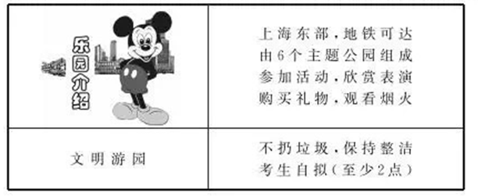
注意：1. 词数90左右。短文的开头和结尾已为你写好，不计入总词数；
2. 短文须包括所有要点，不要逐词解释，可适当发挥，使短文连贯、通顺；
3. 短文中不得出现真实的人名、校名等相关信息。
参考词汇：theme n.主题； firework n.烟火
Good morning , children !
As a volunteer from Shanghai Disneyland , I’d like to say something about the park and tell you how to behave well in it .
写
在
答
题
卷 [来源:Z*xx*k.Com]
指
定
位
置
The park is worth your visit . I hope you will have fun .

