2012年龙岩市初中毕业、升学考试
英 语 试 题
考室座位号

（考试时间：120分钟 满分：150分）
注意：
请把所有答案填涂或书写到答题卡上！请不要错位、越界答题！
在本试题上答题无效。

第一部分 听力测试（共30小题；每小题1分，满分30分）
Ⅰ. 听句子, 选出与句子意思相符的图片。每个句子读两遍。
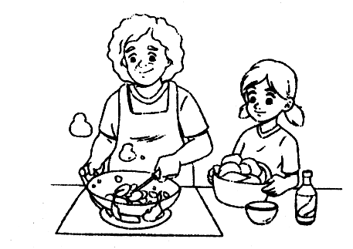
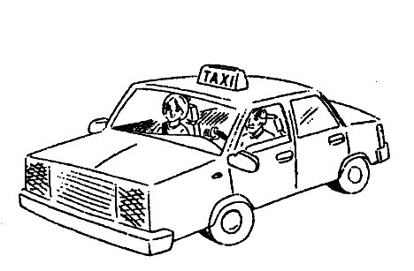
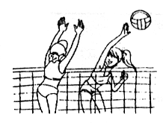
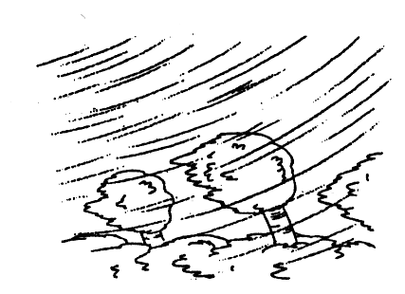


A B C D E
1._____________ 2. _____________ 3. _____________ 4. _____________ 5. _____________
Ⅱ. 听对话，选答案。 听下面10段对话，每段对话后有一个或两个小题，从题中所给的A、
B、C三个选项中选出最佳选项。每段对话读两遍。
听第一段对话，回答第6小题。
6. What time is the Chinese class over?
A. At 8:15. B. At 8:45. C. At 9:45.
听第二段对话，回答第7小题。
7. What does the woman think of the story of the film?
A. Boring. B. Exciting. C. Interesting.
听第三段对话，回答第8小题。
8. Which sport will Maria take part in?
A. The high jump. B. The long jump. C. The girls’ 100-meter race.
听第四段对话，回答第9小题。
9. Where is the man going?
A. To the hospital.
B. To the post office.
C. To the bank.
听第五段对话，回答第10小题。
10. Where will Jane spend the weekend?
A. In the library. B. At home. C. In a park.
听第六段对话，回答第11、12小题。
11. Which subject does Amy like best?
A. Math. B. Chinese. C. History.
12. Why does Amy like it?
A. It’s easy. B. It’s funny. C. It’s attractive.
听第七段对话，回答第13、14小题。
13. When is Alan’s birthday?
A. March 3rd. B. March 13th. C. March 20th.
14. How will Alan celebrate his birthday?
A. Have a party. B. Go out for dinner. C. See a film.
听第八段对话，回答第15、16小题。
15. What does Kangkang invite Maria to do?
A. Go to a concert. B. Visit their teacher. C. Watch a match.
16. What’s Kangkang’s phone number?
A. 7556209. B. 8566109. C. 8566209.
听第九段对话，回答第17、18小题。
17. What is wrong with Betty?
A. She has a fever. B. She has a headache. C. She has a cold.
18. What does the doctor tell Betty to do?
A. Take some medicine. B. Do some exercise. C. Have a rest.
听第十段对话，回答第19、20小题。
19. Where are the speakers talking?
A. On the phone. B. In a store. C. At a railway station.
20. How much should Liu Hong pay for the tickets?
A. ￥500. B. ￥800. C. ￥2,500.
III . 听短文，选择正确答案。听短文，从题中所给的A、B、C三个选项中选出最佳选项。短文读两遍。
21. When did the story happen?
A. One Friday morning. B. One Saturday afternoon. C. One Sunday evening.
22. What was the girl doing while the man was looking for something?
A. Watching TV. B. Seeing a movie. C. Reading a book.
23. Why was the girl angry?
A. The man made a lot of noise.
B. The man was in her way.
C. The man dropped her chocolate.
24. What was the man trying to find?
A. His watch. B. His teeth. C. His chocolate.
25. What’s the relationship between the man and the girl?
A. Father and daughter. B. Teacher and student. C. Strangers.
Ⅳ. 听短文，填表格。听短文，根据短文内容在空格中填入恰当的单词（每空一词）。短文读三遍。
Who | my mother, my 26 and I
Where | at the 27
What | 1. I liked the expensive T-shirt, but we didn’t buy it.  2. A man was singing and people around dropped much money in the 28 .  3. We bought some 29 flowers.  4. My mother bought some 30 and apples for dinner.

第二部分 语言知识运用（满分30分）
Ⅴ. 选择填空（共15小题；每小题1分，满分15分）
从每小题所给的A、B、C三个选项中，选出可以填入空白处的最佳选项。
31. ⎯ Which floor do you live on?
⎯ On ______ fifth floor.
A. a B. an C. the
32. ⎯ Mom, I’m hungry. Is there anything to eat?
⎯ Here’s some ______.
A. bread B. water C. orange
33. The summer holidays are coming. Xiao Li plans ______ on a visit to Hongkong.
A. to go B. go C. going
34. Huangyan Island is part of China. It is about 550 sea miles away from the Hainan Island ______ South China.
A. on B. to C. in
35. ⎯ Sue, I left my Chinese book at home.
⎯ Never mind. You can use ______.
A. my B. mine C. me
36. ⎯ Could you tell me ______? I have something to tell her.
⎯ Sorry, I don’t know.
A. where Lucy is B. where was Lucy C. where is Lucy[
37. Hurry up, ______ you will miss the early bus.
A. and B. or C. but
38. Great changes ______ in my hometown in recent years. We can see tall buildings everywhere.
A. take place B. have taken place C. took place
39. Nowadays more and more young people are becoming interested in Beijing Opera. They think it ______ beautiful.
A. sounds B. smells C. looks
40. ⎯ ______ do you e-mail your friend, Jim?
⎯ Sometimes.
A. How soon B. How long C. How often
41. ⎯ I saw Jane on the street just now.
⎯ It ______ be her. She went back to Canada yesterday.
A. mustn’t B. can’t C. needn’t
42. China ______ a new spaceship, Shenzhou IX, into space on June 16, 2012.
A. put up B. took up C. sent up
43. They ______ a wonderful time at Kangkang’s birthday party the day before yesterday.
A. had B. have C. are having
44. ⎯Do you know Sally?
⎯Yes, she is one of ______ girls in our class.
A. active B. more active C. the most active
45. ⎯Dad, can I play computer games?
⎯Not until your homework ______.
A. will finish B. is finished C. finishes
Ⅵ. 完形填空（共10小题；每小题1.5分，满分15分）
阅读下面短文，从短文后各题所给的三个选项（A、B和C）中，选出可以填入空白处的最佳选项。
If you are interested in learning a language, you shouldn’t be afraid to pronounce difficult words. Don’t be afraid that people will 46 you. How else will you learn a new language? You have to jump right in and 47 new words. Everybody who learns a new language has 48
in the beginning. But if you practice more and put 49 effort into it, you will make progress.
People 50 the world are learning English. Some are also learning Chinese. These are
51 of the most important languages to know. You will be able to communicate with almost
52 in the world if you learn these languages well. The hardest thing is to overcome(克服) your 53 about a new language. When you find a word you don’t understand, look it up in a
54 , or ask your teacher or someone who knows that language to 55 you out. Don’t stop practicing. Don’t stop trying.
46. A. look after B. laugh at C. depend on
47. A. make B. hear C. try
48. A. trouble B. surprise C. luck
49. A. little B. no C. much
50. A. around B. on C. under
51. A. two B. three C. four
52. A. somebody B. everybody C. nobody
53. A. habit B. doubt C. fear
54. A. dictionary B. book C. library
55. A. find B. help C. take
第三部分 口语运用（共10小题；每小题1分，满分10分）
VII. 口语运用
第一节 从方框中选出最佳选项完成下面的对话。
A: Dr. Li gave us a talk about health this afternoon. 56
B: It’s a pity that I missed it! What did he say? What should we do to keep healthy?
A: 57 We should have breakfast and eat the right food.
B: And then?
A: 58 But sometimes it may cause accidents.
B: So we must be careful when we play sports.
A: That’s right. Third, happiness is important for our health.
B: I agree with that. 59
A: Yeah. Last but not least, smoking and drinking can be very dangerous, so we should say no to them.
B: Yes, I think so. 60
A. They’re bad for our health.
B. It was interesting and helpful.
C. We should be happy every day.
D. Playing sports can help us keep fit.
E. First, we need to have healthy eating habits.

第二节 情景选择。根据对话情景，从每题所给的三个选项（A、B和C）中，选出最佳选项。
61. — Happy birthday to you, Kangkang!
— ______
A. Thank you. B. Sorry. C. Have a good day!
62. — How about raising some money for the homeless people?
— ______.
A. I don’t believe it B. It’s a pleasure C. That’s a good idea
63. — ______?
— No, I can’t get used to the weather here.
A. Is everybody here
B. Is everything OK
C. Are you busy now
64. — I failed the English exam again.
— ______ You should practice more.
A. That’s right. B. Sorry to hear that. C. Congratulations!
65. — Could you help me with my physics?
— ______.
A. No problem B. Yes, I could C. That would be fine
第四部分 阅读理解（共20小题；每小题1.5分，满分30分）
VIII. 阅读理解
A：阅读下面材料，从每题所给的三个选项（A、B和C）中，选出最佳选项。
Should friends be different or the same? We asked some people what they think and this is what they said.

 | I like to have friends who are like me. I’m quieter than most of the kids in my class, and my best friend Yuan Li is quiet, too. There are some differences, though. I’m smarter than Yuan Li. She’s stronger than me.  James Green
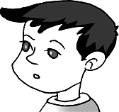 | It’s not necessary to be the same. I like to have friends who are different from me. My best friend Larry is taller and more outgoing than me. We both like sports, but Larry is more athletic than me. He always beats me in tennis. Also, I’m quieter than he is.  Huang Lei
 | I don’t really care. My best friend is Carlo. Carlo is very funny, and more outgoing than I am. But we both like doing the same things. I think differences are not important in a friendship.  Mary Smith
66. Both James Green and Yuan Li are ______.
A. outgoing B. quiet C. funny
67. Who is Mary Smith’s best friend?
A. Huang Lei. B. Larry. C. Carlo.
68. The underlined(划线的) word “athletic” means “______” in Chinese.
A. 强壮的 B. 友好的 C. 聪明的
69. How many opinions about friends are mentioned in the passage?
A. Two. B. Three. C. Four.
70. Which of the following is True according to the passage?
A. There are some differences between James Green and his best friend.
B. Huang Lei likes friends who have the same interests as he.
C. Mary Smith thinks differences are important in a friendship.
B：阅读下面材料，从每题所给的三个选项（A、B和C）中，选出最佳选项。
Autumn is a good time for children to go outside and see the changing colors of nature. The wind is cool, the days are short and the leaves are changing colors. Autumn is a great season for kids to play outside. What outdoor activities do children like?
In China, students often have an autumn picnic held by their school. Usually, they will go to an amusement(娱乐) park or to places that are close to nature.
What kinds of autumn activities are there for children in other countries?
Japanese students often go hiking. It is a perfect way to get exercise while enjoying the outdoors. Mountain climbing in such nice weather is also a good choice.
Children in the US like to go for bike rides in autumn. Take a mountain bike ride and you can explore new trails (小路). Playing in a leaf pile is popular, too. Kids jump into the leaf pile to see the colorful leaves fly all around. They also make leaf rain and leaf beds – all a lot of fun.
In the UK, school kids like to camp outside with their parents. They make snacks over the fire and tell ghost stories.
71. Autumn is a good time for children to go outside because ______.
A. the wind is cool and strong
B. the colors of nature are changing
C. kids can save money by selling leaf beds
72. What do Chinese students often do in autumn?
A. Have a picnic. B. Go hiking. C. Go camping.
73. In autumn, children in the US go to the mountains ______.
A. by bus B. by car C. by bike
74. We can learn from the passage that ______.
A. Japanese kids like to climb mountains in autumn
B. American parents enjoy making snacks at home
C. kids in the UK like to fly colorful leaves
75. The passage is mainly about ______.
A. parks and places close to nature
B. autumn outdoor activities for kids
C. ghost stories from the autumn camp

C：阅读下面材料，从每题所给的三个选项（A、B和C）中，选出最佳选项。
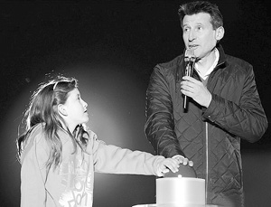
The 2012 London Olympic Games are coming closer and closer. On
May 5, exactly 2,012 hours before the beginning of the Games, the Olympic
Stadium was formally opened.
The stadium, which is at the center of the Olympic Park, can seat 80,000 people. It will host the opening and the closing ceremonies of the London Olympics.
A 9-year-old girl, Niamh Clarke Willis, pressed the button to open the stadium together with London Olympic Committee Chairman Sebastian Coe. About 40,000 people watched the opening and a laser (激光) light show.
The flame (火焰) for the London 2012 Olympic Games was lighted in Greece on May 10. Greek actress Ino Menegaki, acting as High Priestess (女祭司), lighted the Olympic Flame directly from the sun rays.
An eight-day torch(火炬) relay around Greece will follow. The flame flies to Britain on May 18 for a 70-day relay around the UK. It will arrive at London’s Olympic Stadium for the Opening Ceremony on July 27.
76. The London 2012 Olympic Stadium was formally opened on ______.
A. July 27th B. May 10th C. May 5th
77. Niamh Clarke Willis pressed the button to ______.
A. light the torch B. open the stadium C. start the 2012 Olympic Games
78. The torch relay around the UK will last ______.
A. 8 days B. 70 days C. 78 days
79. The passage tells us that the Olympic Stadium ______.
A. lies in the center of the Olympic Park
B. was opened 72 days before the beginning of the Games
C. was designed by London Olympic Committee Chairman
80. Which would be the best title(标题) for the passage?
A. the 2012 Olympics Get Close
B. Greek Actress Light the Olympic Torch
C. the Opening Ceremony of the 2012 Olympics
D：阅读下面短文，从方框内选择恰当的句子填入文中空白处，使短文内容完整、意思连贯。
81 A little boy loved to play around the tree.
Time went by. The boy grew up. One day, he came back to the tree and said, “ 82 ” “You can pick my apples and sell them,” the tree said. Then the boy took all the apples, but he disappeared for a long time.
83 “Come and play with me,” the tree said. “I don’t have time to play. I have to work for my family. We need a house,” the boy replied. “You can cut my branches(树枝) to build a house,” said the tree. So the boy cut all the branches off and left happily. But the tree didn’t hear from the boy for a long time.
84 The tree said, “Sorry, I don’t have anything for you now.” “I am tired. I just need a place to rest,” the boy replied. “Good! Old tree roots(根) are the best place to rest,” said the tree. The boy sat down and the tree was glad and smiled with tears.
In fact, the tree stands for our parents. 85
A. Finally, the boy returned after many years.
B. A long time ago, there was an apple tree.
C. As the apple tree, they give us everything we need.
D. One day, the boy returned and the tree was very excited.
E. I want to play with toys, but I need money to buy them.

第五部分 写（共四大题，满分50分）
Ⅸ. 词汇运用（共5小题；每小题1分，满分5分）
根据汉语提示及句子意思，在句中横线上填入适当的词组（每空限填一词）。
86. Casual shoes are (在那边). Please put them on before you enter.
87. Drivers must (等待) their turns when the traffic light is red.
88. Liu Fang’s father is going to Shanghai (出差). He’ll stay there for two weeks.
89. I (听说) the film Titanic before, but I haven’t seen it.
90. Our teacher tells us to (起草) an outline before writing a composition.
X. 短文填词（共10小题；每小题1分，满分10 分）
阅读下面短文，根据汉语或首字母提示，在每个空格内填入一个适当的英语单词。所填单词要求意义准确，拼写完整、正确。
Liu Wei was born in Beijing in 1987. He lost his arms at the (91) a of ten in an accident. Although at first he was so (92) _______(悲伤的) about his condition, he soon realized he had a choice to make.
In 2002, (93) a Liu Wei got well from the accident, he joined Beijing Swimming Team and (94)w several medals for the disabled players, but he still had a (95) _______(梦想) of being a musician deep inside his heart.
In 2006, he started learning to (96) p the piano with his feet. He practiced
(97) _______(努力地) while his mother kept encouraging him. The (98) _______(结果) was worth the efforts. His first show in the contest in 2010 was an unforgettable performance. Everyone was (99) _______(感动) by his wonderful performance and his spirit which can be described by one sentence “At least I have a (100) p of perfect legs.”
Ⅺ. 任务型阅读 （共5小题；每小题2分，满分10分）
阅读下面短文，根据短文内容回答问题并按要求完成第105题。
On the afternoon of December 12, 2011, Lulu, an 11-year-old schoolgirl in Jiangsu Province, with more than 40 schoolmates, got on the school bus after school as usual. But several minutes later, the bus fell into a ditch (沟渠). Twelve students lost their lives, including Lulu.
According to the Ministry of Education (教育部), traffic accidents are the No. 1 killer of middle school and primary school students. About 18,500 children under 14 die in traffic accidents in China every year. There are about 285,000 school buses in China, but only 10 percent meet a set of standards of technology.
Last month, the Chinese Ministry of Education gave an order: safety checks should be carried out on school buses.
On December 15, Huang Ming, the vice minister of the Ministry of Public Security(公安部副部长), said that school buses should have the right to go before other traffic on the roads. They can also use the bus lanes(车道). “We’ll punish drivers on school buses with no licenses and those carrying too many children,” Huang added.
101. How many students died in the accident in Jiangsu on December 12, 2011?
102. What is the most dangerous killer of middle school and primary school students in China?
103. Do all the school buses in China meet the standards of technology?
104. What will the Ministry of Public Security do to make school buses safe? (选其中一项作答)
105. 请将划线句子翻译成汉语。
Ⅻ. 写作（共两节；满分25分）
第一节 看图写句（共5小题；每小题2分，满分10分）
请根据每题所提供的图画情景和提示词(要求全部用上)，写一个与图画情景相符的句子。
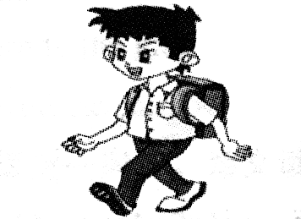
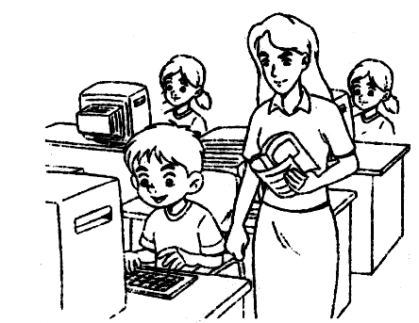
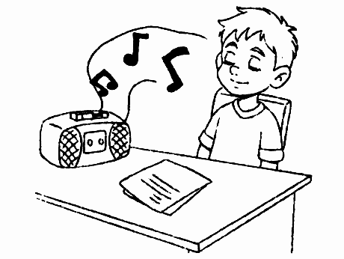

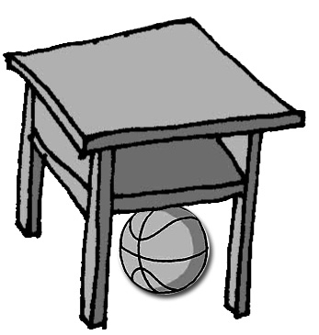

106 107 108 109 110
106. (there be, basketball) 107. (boy, now) 108. (computer, yesterday)
109. (like, bamboo) 110. (Lin Tao, school)
第二节 书面表达（满分15分）
生活中有很多因素会影响我们的情绪，如颜色、音乐、天气变化、身边发生的事情等。通常情况下，哪些因素会使你的情绪发生变化？你的情绪会发生怎样的变化？请根据自身经历选择其中一至二项，用英语写一篇词数80左右的短文加以描述。
提示：
1. 内容应包括：(1)What can affect your feelings? (2)How do your feelings change?
2. 提示词（可选用）： for example, event, in a good/bad mood, happy, relaxed, nervous, worried;
3. 开头部分已给出，不计入总词数。
Many things around us may affect our feelings and moods.

