2013年厦门市初中毕业及升学考试
（二）基础知识与运用（每小题1.5分，共30分）
Ⅴ.选择填空：从A、B、C中，选出一个最佳答案完成句子。
17. Nowadays people care more about the safety of . Everyone wants to eat healthily.
A. foods B. clothes C. houses
18. Emma, can you introduce _______ to Alice? I want to make friends with her.
A. him B. her C. me
19. -- Nothing in the world is ________ if you put your heart into it.
-- I agree. You’ll succeed if you work hard.
- important B. impossible C. necessary
20. -- Can I help you, sir?
-- A cup of coffee milk, please.
- with B. of C. on
21. -- Would you like to come to my party on Saturday, Sam?
-- I’d love to, I can’t. I have to take a piano lesson.
A. and B. but C. or
22. -- is it from our school to the beach?
-- About 7 kilometers.
A. How far B. How long C. How often
23. -- Look, my father bought me a new iPad.
-- I don’t think we need too many expensive things even though our parents can them.
A. allow B. expect C. afford
24. -- How was your holiday last weekend?
-- Good. I _______ to the mountains with my brother.
A. go B. went C. will go
25. -- I missed the early bus and I had to _______ the next one on such a cold morning.
-- Back luck!
A. give up B. put off C. wait for
26. Today, smart phones are really helpful. They ______ everywhere.
A. use B. are using C. are used
27. -- I’m trying to sleep. Would you mind ______ the music, please?
-- Sorry, I’ll listen to it outside.
A. turning down B. turning on C. turning up
28.-- Excuse me. Could you tell me how I can get to the Olympic Park?
--_______. I’m new here, too.
A. That’s all right B. Sorry, I don’t know C. Go ahead, please

VI.完形填空：从A、B、C中，选择一个最佳答案,使短文意思完整。
D.I.Y means: “Do It Yourself. ”More and more people are doin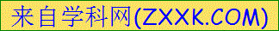g things themselves. There are many 29 for this, and here are some of them. First, D.I.Y is a(an) 30 way to do things. It helps you save money. Second, people enjoy knowing 31 to do something new. They feel better when they learn a new job. Third, some people work better by themselves. They can 32 something that they have, made or done and say 33 , “I did this all by myself.”
One of my friends bought a(an) 34 house a few months ago. Now his house looks as beautiful as a new one after he and his wife 35 all the walls in every room. Another example is my neighbor, John, who owns two cars. He went to a night school to learn how to 36 cars. Now he has learned to do most of the repair work. He enjoys the work very much.
29. A. reasons B. habits C. problems
30. A. easier B. stranger C. cheaper
31. A. why B. how C. who
32. A. look at B. look for C. look up
33. A. carefully B. nervously C. proudly
34. A. wet B. old C. far
35. A. painted B. broke C. covered
36. A. drive B. fix C. sell
（三）阅读理解 （每小题2分，共50分）[来源:Z|xx|k.Com]
VII. 阅读下面五篇短文，根据文章的内容选择最佳答案作答37-61小题。
A
I was going to bed the other night when my wife told me that I had left the light on in the shed（储藏室）. She could see it from the bedroom window. As I looked for myself, I saw that there were thieves in the shed taking things. I phoned the police, but they told me that no one was in this area to help at this time, but they would send someone over as soon as they were free.
I said OK, hung up, and waited one minute, then phoned the police back, “Hello, I just called you a minute ago because there were thieves in my shed. Well, you don’t have to worry about them now because I’ve killed them all.”
Within five minutes there were six police cars in the area. Of course, they caught the thieves very quickly. One of the officers said: “I thought you said that you’d killed them!” I replied with “I thought you said there was nobody free!”
37. There were thieves in the .
A. shed B. bedroom C. kitchen
38. The man when he found the thieves.
A. caught them by himself B. called the police at once C. did nothing but wait
39. The police said that so they couldn’t come and help at first.
A. it was too far B. the car was broken C. they were all busy
40. The police when the man called them again.
A. found it boring B. took it serious C. let it go
41. The thieves were at the end of the story.[来源:学科网]
A. lost B. killed C. caught
B
Good evening and welcome to World Views. Earlier in the day, we spoke to four different people about family traditions. Here’s what they said.
① Christmas presents
One of our traditions is to do with Christmas presents. Most people open their presents in the morning, but we open ours in the late afternoon after Christmas lunch. It’s really nice to do so because opening the presents in the morning makes the rest of the day, you know, it’s boring. Well, that’s what we think.
② Birthday cakes
One tradition we have is to do with birthdays, all our birthday cakes have to be carrot cakes. My dad has to make the cake. He even has to make the cake for his own birthday! Perhaps it’s because my mum doesn’t like other tastes cakes. And the funny thing is, we never have carrot cakes at any other time-only birthdays.
③ Easter (复活节)eggs
When we were kids, my parents used to by little chocolate eggs and hide (藏) them around the house. Then when they’d finished we’d be allowed to come into the house to look for them. I think the tradition started because my mum and dad wanted us to eat less chocolate. And this was a fun way of stopping us eating too much as the eggs were often too small.
④ Special day
We had a tradition in our family for the last day of the summer holidays. The day before we had to go back to school, mum and dad would always take us out for the day. In the morning, we’d get up early and go for a long walk. Next, we’d go for lunch in our favorite restaurant. Then, to the cinema to see a film. Finally, home, where we’d play games. It made going back to school so much better.
42. In the first family, they open their Christmas presents .
A. in the morning B. in the afternoon C. in the evening
43. make(s) the carrot cake for everyone’s birthday.
A. Dad B. Mum C. Kids
44. The parents are afraid that their kids may eat chocolate, so they hide them first.
A. too small B. too expensive C. too much
45. The whole family do a lot of things except on “special day”.
A. going to the library B. playing games at home C. going to the cinema
46. The best title of this passage may be “ ”
A. Common friends B. Unusual traditions C. Special presents

C
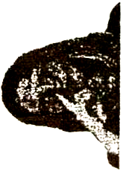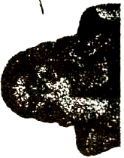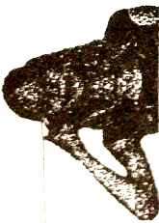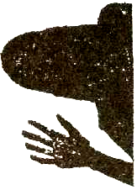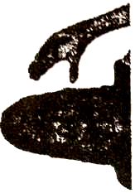
A B C D E
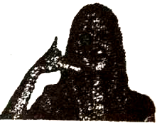
A recent survey lists some hand gestures（手势）people hate the most in the UK. What do you think of them? Are they popular in your country?
- Call me
Method: Use your thumb and little finger to form the shape of a phone. Hold your thumb to your ear, and your little finger to your mouth.
Meaning: Call me! / I’ll call you! / Let’s call one another.
- Blah, blah, blah
Method: Make a mouth shape with your hand. Then, move your fingers and thumb to make the mouth look as if it’s talking.
Meaning: You’re boring me!
- Talk to the hand
Method: Hold up a hand with the palm（手掌）facing someone.
Meaning: Talk to my hand, because I’m not going to listen to you anymore.
- It’s one of your business
Method: Touch your nose with your index finger（食指）.
Meaning: Stop asking me questions about something that’s none of your business.
- I’m watching you
Method: Touch the corner of your eye with your index finger. Or, touch the corners of both eyes with your index and middle fingers.[来源:Z_xx_k.Com]
Meaning: I’m watching you. / Be careful.
47. The underlind word “thumb” refers to the finger that’s pointed in .
A. 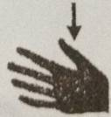 B. 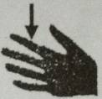 C. 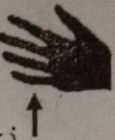
- shows the gesture “Blah, blah, blah”.
A. Picture A B. Picture C C. Picture E
49. Making the gesture of Picture B means “ ”
A. Be polite B. Be careful C. Be brave
- If you make the gesture of Picture D, that means you want somebody to .
A. stop talking B. ask questions C. listen carefully
51. There’re two pictures that belong to the gesture “ ” at the same time.
A. Talk to the hand B. It’s one of your business C. I’m watching you
D
Every James Bond movie starts with a different theme song. It’s usually performed by one of the top artists of the day. Here are three Bond theme songs from the films Diamonds are Forever(1971), A View to a Kill(1985), and Skyfall(2012).
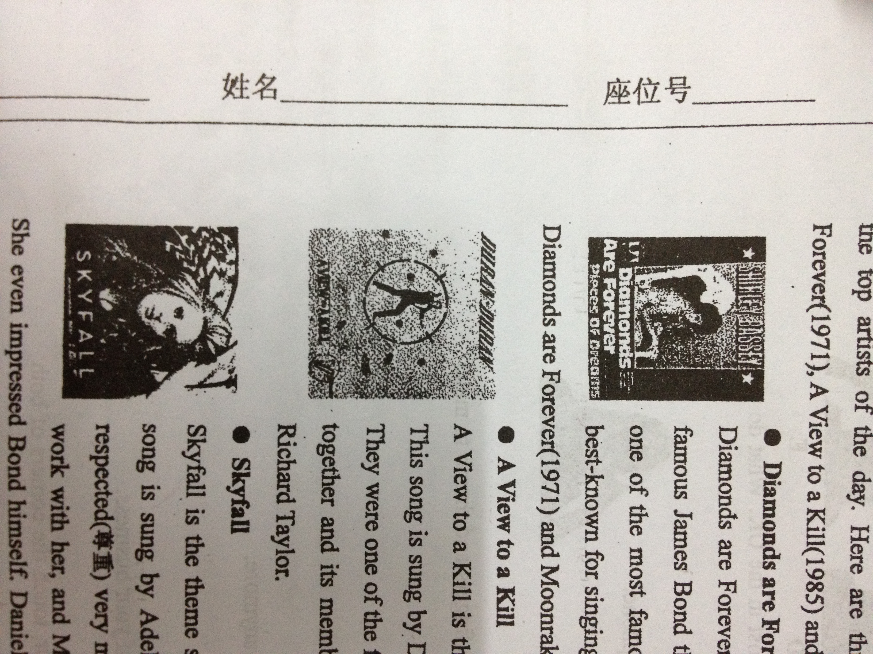
- Diamonds are Forever
Diamonds are Forever(from the movie of the same name) is one of the most famous James Bond theme songs. The song is sung by Shirley Bassey. She’s one of the most famous British singers of the 20th century. She’s probably best-known for singing the theme songs to three Bond films: Goldfinger(1964), Diamonds are Forever(1971) and Moonraker(1979). J
- A View to a Kill
A View to a Kill is the theme song from 1985 Bond film of the same name. This song is sung by Duran Duran, one of the biggest pop groups of the 1980s. They were one of the first groups to appear regularly on MTV. The band is still together and its members are Simon Le Bon, Nick Rhodes, John Taylor and Richard Taylor.
- Skyfall
Skyfall is the theme song from the latest Bond film of the same name. This song is sung by Adele, a 24-year-old English singer-song writer. She’s been respected(尊重)very much by other musicians. Beyonce has said she wants to work with her and Madonna recently said, “Adele is wonderful. I love her!” She even impressed Bond himself. Daniel Craig, the actor who plays 007, said he cried when he first heard the song. He said it “perfectly matches” the film.
- Each of three Bond theme songs enjoys the same name of the .
A. film B. actor C. singer
53.Duran Duran is a famous .
A. pop group B. rock singer C. songwriter
54. Although Adele is very young, she has .
A. sung three Bond theme songs B. joined the biggest pop group C.been greatly respected and loved
55. If you want to see the latest Bond film, will be your right choice.
A. Diamonds are Forever B. A View to a Kill C. Skyfall
56. This passage, mainly introduce us three .
A. James Bond movies B. Bond theme songs C.007 movie actors
E
Scientists have a way they use when they are trying to learn something new. It is called the scientific method of inquiry（科学探究方法）.
The first step is to ask a question. It could be “Why do birds fly south for the winter?” Or it could be “How does water turn into ice?” It could be about anything.
Then the scientist must do research. He or she could learn as much about the topic as possible. Next, the scientist makes a hypothesis. It could be “Bird fly south for the winter because they are cold.” Or it could be “Water will turn into ice when the temperature gets low enough” It’s a so called educated（有根据的）guess. Now, the scientist has a hypothesis, so it must be tested. Scientists do this by conducting experiments in labs, and others do them outdoors.
After the experiments are complete, the scientist must analyze the data（分析数据）. And he should compare it with the hypothesis. Was the hypothesis right or wrong? Even with a wrong hypothesis, scientists can still learn a lot. Finally, they should write about their results. That way, other people can learn, too.
57. The scientific method of inquiry starts from a __________.[来源:学#科#网Z#X#X#K]
A. question B. research C. report
58. The underlined word “hypothesis” means “__________”.
A. guess B. model C.reason
59. We can test a hypothesis by ________.
A. asking a question B. doing research C. doing experiment
60. To the question we ask, we can always have a __________in the end.
A. perfect answer B. useful result C. new invention
- We need __________ steps in all when we use the scientific method of inquiry.
A. two B. four C.six
第二部分（非选择题）
（四）情景交际运用（共15分）
VIII. 根据对话情景，填入恰当的单词。（每空一词，每词1分，共5分）
David：Hi, Kevin. What’s wrong with you? Are you OK?
Kevin：To tell you the truth, I feel 66.__________ . I’ve got a headache and sore throat.
David：That’s too bad. When did it 67.__________?
Kevin：About two days ago.
David：Have you seen a 68.__________?
Kevin：I’m going to the hospital right now.
David：Well, I think you must have got a bad 69.________ .You’ll feel much better when you lie
down and 70._________ .
Kevin：I think so. Thank you.
IX. 根据情景提示，用恰当的短语或句子填空。（每空2分，共10分）
* 当有人对你说 “Thank you so much”, 你应该这样礼貌地回答：
71. ______________________________________________________________________________.
* 你想知道Lily会不会唱英语歌，可以这样问她：
72. ______________________________________________________________English songs, Lily?
* 你想知道Henry每天早上几点上学，可以这样问他：
73. What time ____________________________________________________every moring, Henry?
* 你想告诉别人你最喜欢的科目是数学，可以这样说：
74. ______________________________________________________________________________.
* 你想告诉同桌别在课堂上吃东西，可以这样对他说：
75. Don’t ________________________________________________________________________.

（五）写作（共25分）
X．段落编写（本题10分）
使用所给的词语，编写一个意义相对完整的语段。
提示词：when, dream, for, believe, maybe
要求：1. 使用全部提示词，并在语段中用下划波浪线“ ”标出提示词；
2. 语段具有一个相对合理的主题意义；
3. 词数为50词左右,最多不超过80词。

XI. 短文写作（本题15分）
学会与他人合作，养成良好的团队协作精神是非常重要的。请用英语写一篇80词以上的短文，介绍一两个你曾经参与的团队或小组活动的经历（如俱乐部、兴趣小组或学习小组等），并谈谈自己的感想和收获。
注 意：短文中不允许出现与考生本人相关的真实姓名和校名等信息。

2013厦门市初中毕业及升学考试
英语参考答案
V. 单选（每题1.5分,共18分）
17-21 ACBAB 22-26 ACBCC 27-28 AB
VI. 完形填空（每题1.5分,共12分）
29-36 ACBAC BAB
VII. 阅读理解（每题2分,共50分）
37-41 ABCBC 42-46 BACAB 47-51 ACBAC
52-56 AACCB 57-61 AACBC[来源:学&科&网Z&X&X&K]
Ⅷ. 根据对话情景,填入恰当的单词, 每空一词.（每词1分,共5分）
66. terrible/sick 67. start 68. doctor 69. cold 70. rest
Ⅸ.根据情景提示,用恰当的句子填空。（每句2分,共10分）
71. You’re welcome.
72. Can you sing
73. What time do you go to school
74. My favorite subject is math
75. eat in class
X. 段落编写(共10分)
【段落编写评分参考标准】
5+2 分：包含5个单词的句子基本正确得5分,
所使用的句式比较好加2分,
但所有句子的意义完全不相关的则酌情扣分
2 分： 段落有一个较清晰的中心大意
1 分： 语段有良好的过度和衔接
XI. 短文写作(共15分)
【短文写作评分参考标准】
第一档(13-15分):能清楚地表达自己的观点和想法；语言准确、丰富、流畅,富有个性和说服力；基本无语 法错误。
第二档(9-12分)：能清楚地表达自己的观点和想法；行文比较自热,但语言表达较平淡,个性化和说服力一般, 且存在少量语法错误。
第二档(5-8分)：观点表述不够鲜明,比较缺乏说服力；同时各种语言用法错误较多。
第二档(1-4分)：内容比较空洞或不切题,词汇和句式用法错误很多。

