盐城市2016年初中毕业与升学考试英语试题
第I 卷（选择题，共60分）
一、单项选择（共15小题，每小题1分，计15分）
从A、B、C、D四个选项中选出一个可以填入句中空白处的最佳答案。
1.I think playing ______ football is a good way to learn the spirit of teamwork.
A. a B. an C. the D. /
2. The 3-D film The Angry Birds opened in Chinese cinemas ______ May 20, 2016.
A. on B. at C. in D. to
3. My cousin Andrew is crazy about doing many things by _____.
A. herself B. himself C. him D. her
4. Life is like riding a bicycle. To keep your ______, you must keep moving.
A. promise B. position C. balance D. ability
5. The rich were _____ one of the four main classes in the Aztec society.
A. the most powerful B. the more powerful C. more powerful D. powerful
6. –Is that man Mr. Green?
– It _____ be him. He has gone to Paris on business.
A. may B. must C. can’t D. shouldn’t
7. –_____ do you go to Mrs Rainbow’s colour therapy?
– Once every two weeks.
A. How often B. How soon C. How long D. How far
8. It seems that El Niño ____ some disasters in the world in the past few months.
A. has caused B. is causing C. will cause D. caused
9. My grandma’s hobby is _____ cooking _____ watching TV. It’s square dancing.
A. not only, but also B. neither, nor C. both, and D. either, or
10. Watch out, Peter！ _____ is a little boy playing ahead on the road.
A. It B. This C. That D. There
11. We must do everything we can ______ waste water from running into rivers.
A. prevent B. prevented C. preventing D. to prevent
12. In Switzerland, things like glass and plastic _____ into different groups and then recycled
A. separate B. separated C. are separated D. is separated
13. – I wonder _____.
–Yes, of course.
A. why we will visit this museum B. when we will get to the museum
C. whether the museum is worth visiting D. what we can see in the museum
14. – Thank you very much for giving me some advice on how to deal with stress
– ______.
A. That’s true B. Don’t mention it C. OK. I’ll try D. I don’t think so.
15. “_____”is used for saying that what you do is more important than what you say you will do.
A. Every dog has its day. B. Practice makes perfect.
C. Many hands make light work. D. Actions speak louder than words.
二、完形填空（共15小题，每小题1分，计15分）
阅读下面短文，掌握其大意，然后从各题所给的四个选项中选出一个最佳答案。
One night in November, Itzhak Perlman gave a concert in a theatre. If you have ever been to a Perlman concert, you know that becoming a violinist is not a small 16 for him. He had to walk 17 the help of two walking sticks as a result of the disease he caught as a child.
People sat 18 while he made his way to his chair and began his play. But this time, something went 19 . Just as he finished the first few parts of the music, one of the wrings(弦) on his violin 20 . We thought that he would have to stop the concert. But he didn’t. 21 , he waited a moment, closed his eyes and then 22 the conductor(指挥) to begin again. The orchestra(管弦乐队) began and he played with such strong feeling and purity as they had 23 heard before.
Of course, everyone knows that it is 24 for a violinist to play a pleasant work with just three strings. I know that, and you know that, 25 that night Itzhak Perlman didn’t want to accept that.
When he finished, there was a terrible 26 in the room. And then people rose and 27 from every corner of the theatre.
Perlman was excited. He smiled and said, “You know, sometimes it is the artist’s task to 28 how much music you can still make with what you have left.”
So, suppose our task in this fast-changing world is to make 29 , at first we should try out best with all that we have. And then, 30 it is no longer possible, try to play it with what we have left.
16. A. achievement B. advantage C. accident D. application
17. A. for B. by C. to D. with
18. A. widely B. closely C. quietly D. noisily
19. A. wrong B. well C. smoothly D. slowly
20. A. fixed B. broke C. burned D. lost
21. A. Instead B. Anyway C. Indeed D. Otherwise
22. A. followed B. asked C. directed D. forced
23. A. often B. usually C. already D. never
24. A. comfortable B. possible C. uncomfortable D. impossible
25. A. so B. and C. but D. or
26. A. fear B. silence C. thought D. thunder
27. A. cheered B. left C. smiled D. whispered
28. A. hand out B. carry out C. find out D. put out
29. A. fun B. music C. progress D. money
30. A. unless B. before C. until D. when
三、阅读理解
A. 阅读下列短文，从每题所给的A、B、C、D四个选项中选出最佳答案。（共15小题，每小题2分，计30分）
A
All living things need energy to live and grow. This energy comes first from the sun. Plants use water and sunlight to make their own food. Animals can not make their own food, and they eat plants. Other animals then eat the plant eaters.
A food chain shows what eats what. It might show that zebras eat grass and then lions eat zebras.
Lions also eat other animals. Zebras eat other kinds of plants. So it takes more than one food chain to show how lions and zebras get their energy.
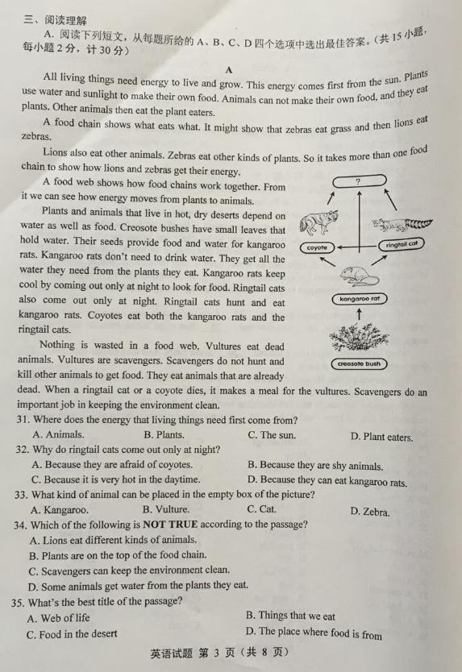
A food web shows how food chains work together. From it we can see how energy moves from plants to animals.
Plants and animals that live in hot, dry deserts depend on water as well as food. Creosote bushes have small leaves that hold water. Their seeds provide food and water for kangaroo rats. Kangaroo rats don’t need to drink water. They get all the water they need from the plants they eat. Kangaroo rats keep cool by coming out only at night to look for food. Ringtail cats also come out only at night. Ringtail cats hunt and eat kangaroo rats. Coyotes eat both the kangaroo rats and the ringtail cats.
Nothing is wasted in a food wed. Vultures eat dead animals. Vultures are scavengers. Scavengers do not hunt and kill other animals to get food. They eat animals that are already dead. When a ringtail cat or a coyote dies, it makes a meal for the vultures. Scavengers do an important job in keeping the environment clean.
31. Where does the energy that living things need first come from?
A. Animals. B. Plants. C. The sun. D. Plant eaters.
32. Why do ringtail cats come out only at night?
A. Because they are afraid of coyotes.
B. Because they are shy animals.
C. Because it is very hot in the daytime.
D. Because they can eat kangaroo rats.
33. What kind of animal can be placed in the empty box of the picture?
A. Kangaroo. B. Vulture. C. Cat. D. Zebra.
34. Which of the following is NOT TRUE according to the passage?
A. Lions eat different kinds of animals.
B. Plants are on the top of the food chain.
C. Scavengers can keep the environment clean.
D. Some animals get water from the plants they eat.
35. What’s the best title of the passage?
A. Web of life B. Things that we eat
C. Food in the desert D. The place where food is from
B
Sunshine Secondary School Science Fair
SUNSHINE SECONDARY SCHOOL PRESENTS
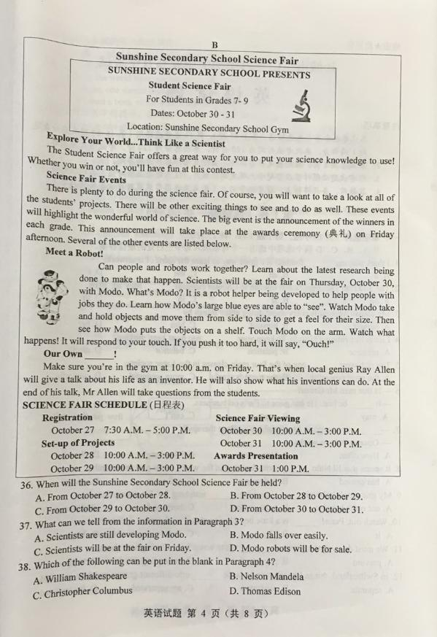
Student Science Fair
For Students in Grades 7-9
Dates: October 30-31
Location: Sunshine Secondary School Gym

Explore Your World …Think Like a Scientist
The Student Science Fair offers a great way for you to put your science knowledge to use! Whether you win or not, you’ll have fun at this contest.
Science Fair Events
There is plenty to do during the science fair. Of course, you will want to take a look at al of the students’ projects. There will be other exciting things to see and to do as well. These events will highlight the wonderful world of science. The big event is the announcement of the winners in each grade. This announcement will take place at the awards ceremony(典礼)on Friday afternoon. Several of the other events are listed below.
Meet a Robot!
Can people and robots work together? Learn about the latest research being done to make that happen. Scientists will be at the fair on Thursday. October 30, with Modo. What’s Modo? It is a robot helper being developed to help people with jobs they do. Learn how Modo’s large blue eyes are able to “see”. Watch Modo take and hold objects and move them from side to side to get a feel for their size. Then see how Modo puts the objects on a shelf. Touch Modo on the arm. Watch what happens! It will respond to your touch. If you push it too hard, it will say, “Ouch”!
Our Own ____!
Make sure you’re in the gym at 10:00 a.m. on Friday. That’s when local genius Ray Allen will give a talk about his life as an inventor. He will also show what his inventions can do. At the end of his talk, Mr. Allen will take questions from the students.
SCIENCE FAIR SCHEDULE(日程表)
Registration Science Fair Viewing
October 27 7:30 A.M.- 5:00P.M. October 30 10:00 A.M. – 3:00P.M.
Set-up of Projects October 31 10:00 A.M. – 3:00P.M.
October 28 10:00 A.M.- 3:00P.M. Awards Presentation
October 29 10:00 A.M.- 3:00P.M October 31 1:00 P.M.
36. When will the Sunshine Secondary School Science Fair be held?
A. From October 27 to October 28. B. From October 28 to October 29.
C. From October 29 to October 30. D. From October30 to October 31.
37. What can we tell from the information in Paragraph 3?
A. Scientists are still developing Modo. B. Modo falls over easily.
C. Scientists will be at the fair on Friday. D. Modo robots will be for sale.
38. Which of the following can be put in the blank in Paragraph 4?
A. William Shakespeare B. Nelson Mandela
C. Christopher Columbus D. Thomas Edison
39. Why will many students be in the gym at 1:00 p.m.on Friday?
A. Modo will appear. B. Registration will take place.
C. The awards will be announced. D. Ray Allen will give an interview.
40. Which of the following belongs in the empty box?

?
Look at student projects
Learn about the latest research on robots
Listen to inventor
Ray Allen

A. A School Science Fair B. A Public Appearance
C. An Awards Ceremony. D. A Schedule of Events
C
I have tried to write a ghost story that won’t make you unhappy with yourselves, with each other, with the seasons, or with me. I hope it haunts your houses pleasantly.
Charles Dickens
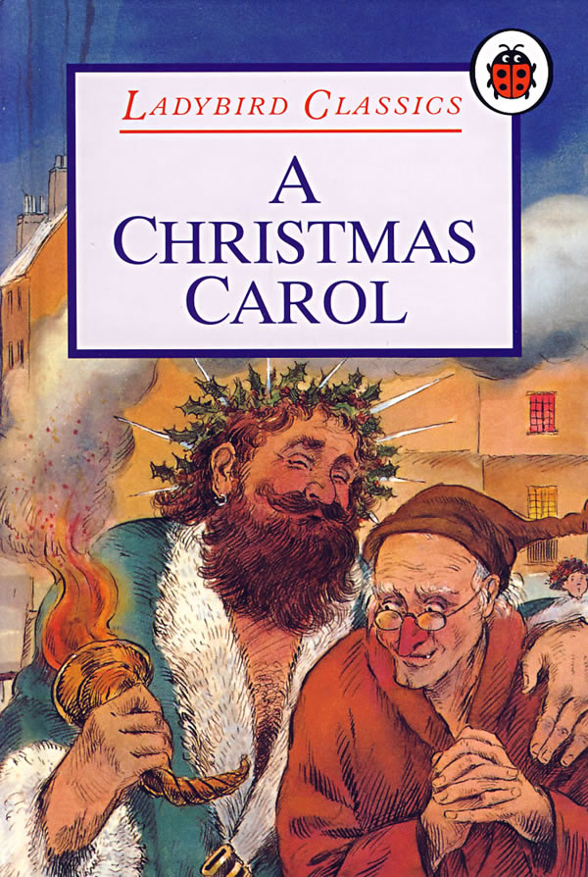
One Christmas Eve, old Scrooge and Bob were working busily in his office. It was a cold, foggy day. The fog was so thick that the houses opposite were like ghosts. It was only three o’clock in the afternoon, but it was already quite dark.
“Merry Christmas, Uncle! God bless you!” cried a happy voice. It was Scrooge’s nephew.
“Bah!” said Scrooge “Humbug(骗人的话)！”
“Christmas is a humbug! Surely you don’t mean that, Uncle.” Said his nephew.
“I do,” said Scrooge. “Merry Christmas! What reason have you got to be merry? You’re poor.”
“OK, then,” replied the nephew cheerfully. “What reason have you got to be sad? You are rich. Don’t be angry, Uncle!”said his nephew.
“What else can I be?” answered the uncle, “I live in a world of fools! Merry Christmas! What’s Christmas time to you? It’s a time for paying bills without money, It’s a time for finding yourself a year older, but not richer. Everyone who goes around saying “Merry Christmas” should have his tongue cut out. Yes, he should!”
“Uncle! Please don’t say that!”said the nephew. “I’ve always thought of Christmas time as a good time, a kind, and a charitable, happy time. And so, Uncle, Christmas has never put any gold or silver in my pocket, but I think it has done me good. And it will do me good. And I say, God bless it!”
Bob, standing in the corner of the room, applauded(鼓掌).He realized his mistake very soon, and went quickly bake to his work, but Scrooge had heard him.
“One more sound from you, Bob Cratchit,” said Scrooge, “and you’ll celebrate Christmas by losing your job!”
“Don’t be angry with him, Uncle. Come and have dinner with us tomorrow.”
“No.” said Scrooge.
“I’m sorry you don’t want to celebrate Christmas. But I do. So a Merry Christmas, Uncle!”
“Good afternoon!” said Scrooge.
“And a Happy New Year! ” said his nephew.
“Good afternoon!” said Scrooge again.
His nephew left the room. He stopped to wish Bob a Merry Christmas. And Bob replied, “A
Merry Christmas to you, too.”
41. In which season did the story take place?
A. Spring. B. Summer. C. Autumn. D. Winter.
42. What did Scrooge think of Christmas wish?
A. It was simple. B. It was important. C. It was stupid. D. It was necessary.
43. What did Scrooge’s nephew mean by saying “ Christmas time is a charitable time”?
A. Christmas was a time to be generous and kind.
B. Christmas was a time to do some challenging work.
C. His uncle should give some money to his family.
D. His uncle should give away his money to the poor.
44. Which of the following is TRUE about Scrooge and Bob?
A. Scrooge was Bob’s uncle. B. Bob worked for Scrooge.
C. Scrooge celebrated Christmas with Bob. D. Bob was Scrooge’s visitor.
45. What can we infer(推断)from the story?
A. Scrooge was working busily in his office before Christmas.
B. No rich people wanted to waste their time to celebrate Christmas.
C. Bob believed in Christmas wish as well as Scrooge’s nephew.
D. Scrooge refused his nephew’s invitation to dinner on Christmas day.
第 II卷（非选择题， 共60分）
B. 任务型阅读。（共10小题，每小题1分，计10分）
阅读下列短文，根据短文内容完成表格中所缺信息，每空一词。
Each different part of China has its own special forms of traditional art. These usually try to represent the things that are important in life such as love, beauty and family. The most common things, from paper to clay to bamboo, are turned into objects of beauty.
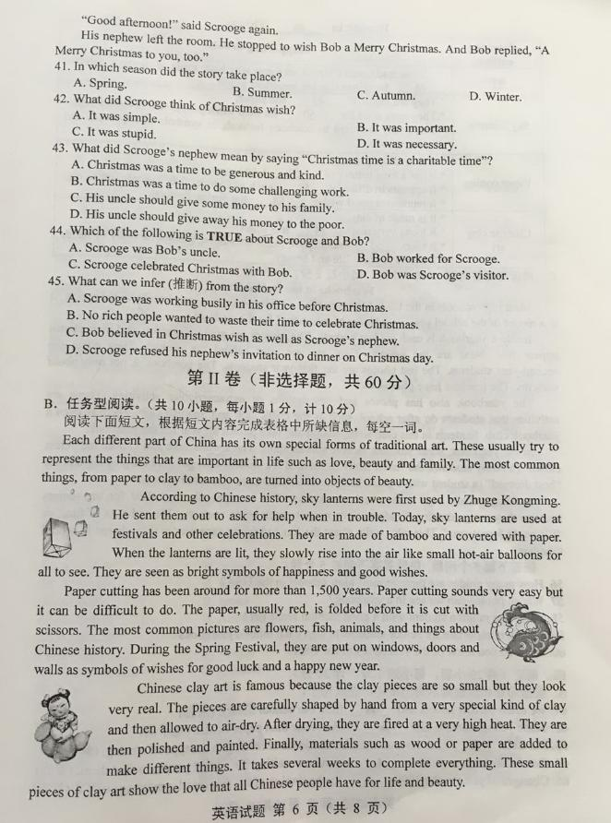
According to Chinese history, sky lanterns were first used by Zhuge Kongming. He sent them out to ask for help when in trouble. Today, sky lanterns are used at festivals and other celebrations. They are made of bamboo and covered with paper. When the lanterns are lit, they slowly rise into the air like small hot-air balloons for all to see. They are seen as bright symbols of happiness and good wishes.
Paper cutting has been around for more than 1,500 years. Paper cutting sounds very easy but it can be difficult to do. The paper, usually red, is folded before it is cut with scissors. The most common pictures are flowers, fish, animals, and things about Chinese history. During the Spring Festival, they are put on windows, doors and walls as symbols of wishes for good luck and a happy new year.
Chinese clay art is famous because the clay pieces are so small but they look very real. The pieces are carefully shaped by hand from a very special kind of clay and then allowed to air-dry. After drying, they are fired at a very high heat. They are then polished and painted. Finally, materials such as wood or paper are added to make different things. It takes several weeks to complete everything. These small pieces of clay art show the love that all Chinese people have for life and beauty.
Beauty in 46 Things
Passage outline | Supporting details
47 | Some traditional Chinese art forms which are made of common objects 48 for things that are important in life
Sky lanterns | They are made of 49 and paper.  They were used for 50 for help when people first invented them.  Now, they are used to celebrate festivals as symbols of happiness and good wishes.
Paper cutting | It is made of paper.  It has a long history of 51 1,500 years.  It appears in different 52 , such as flowers, fish, animals and so on.  It represents good wishes 53 the Spring Festival.
Chinese clay art | It is made of clay.  It looks very real 54 it is small.  It takes 55 four steps to finish after being shaped carefully by hand.  It shows love for life and beauty.

C.阅读与回答问题（共5小题，每小题2分，计10分）
Yearbooks in the United states
Most high schools in the United States publish a yearbook once a year, usually in the spring. It is a record of the school year—a “book of memories” for the students.
Inside a yearbook is each student’s photo. The seniors are graduating soon, and their photos appear first. Next are the juniors. They are one year behind the seniors. Then come the second-year students. The last photos are the first-year students. The yearbook is not only about students. The teachers have photos, too.
The yearbook also has photos and descriptions of extracurricular activities. These are activities that students do after school, such as the chess club and Spanish club. There is even a yearbook club. Students in this club write, design and take photos all year for the yearbook.
In the yearbook, some students receive special titles. The seniors vote and choose the “class clown” (a funny student), the “most likely to succeed”(a student who got the best grades), and the “best dressed”(a student with a good fashion sense). There are also other awards.
Students usually sign each other’s yearbooks. This is especially important for the seniors because they are graduating. Students write notes to each other, such as, “We had a lot of fun,” or “I’ll never forget you.” They also write about the fun and funny experiences they shared in school together.
回答下面5个问题，每题答案不超过5个词。
56. How many grades are there in most high schools in the USA?
57.Whose photos can we see in a yearbook?
58. What title might a student with a good fashion sense get?
59.Why is it important for senior students to sign each other’s yearbooks?
60.What do you think of the yearbook in the USA?
四、词汇（共20小题，每小题1分，计20分）
A. 根据句意和汉语提示写出单词，完成句子。
61. We often borrow novels and _____ from our school library. (杂志)
62. Some young students like _____ books better than paper books. (电子的)
63. Mr. Li is _____ to us how to organize our ideas according to the type of writing. (解释)
64. Good chances always hide _____ around us, waiting for careful people to find them. (某处)
65. Changes of price in the 1990s ______ the beginning of the fast development age of TV. (标志)
B.根据句意用所给的单词的适当形式填空。
66. I remember ______ what Audrey Hepburn looked like in her first film. (exact)
67. Without your support, I am ____ to complete this documentary on time. (able)
68. Many countries in the world have reached an _____ to reduce air pollution. (agree)
69. To be a good citizen, one should draw a clear _____ line between good and bad. (divide)
70.Yang Jiang published a book of her three-member-family’s life We Three in her ____(ninety)
C. 根据短文内容及首字母提示，填写所缺单词，使短文意思完整。
“ Make-A-Wish” is one of the world’s most well-known charities. It makes wishes come true for children who have s 71 illnesses. It gives them hope and helps them forget about their h 72 problems.
It s 73 in 1980 in Phoenix, Arizona. Christopher was a 7-year-old boy who was very sick. He always dreamed of becoming a p74 to fly in the sky. They gave Christopher a tour of the city in a police helicopter(直升飞机) and b 75 a space helmet for him.
There are four kinds of wishes children usually have:
I wish to go. Children usually want to visit some p 76 of interest, like the Statue of Liberty.
I wish to meet. Children sometimes want to meet their f 77 film stars or sports players.
I wish to be. Some children wish to become doctors to help people who don’t have money for m 78 treatment.
I wish to have. Some children want to have a computer, a bike or many other things. L 79 for them, they can get what they want from the charity.
Let’s hope more wishes will come true in the f 80 . People who work in the charity always try for the best. Will you be one of them?
五、书面表达（共1题，计20分）
学校将举办英语写作比赛。请根据所给提示，以“Getting along well with others”为题， 写一篇参赛短文。
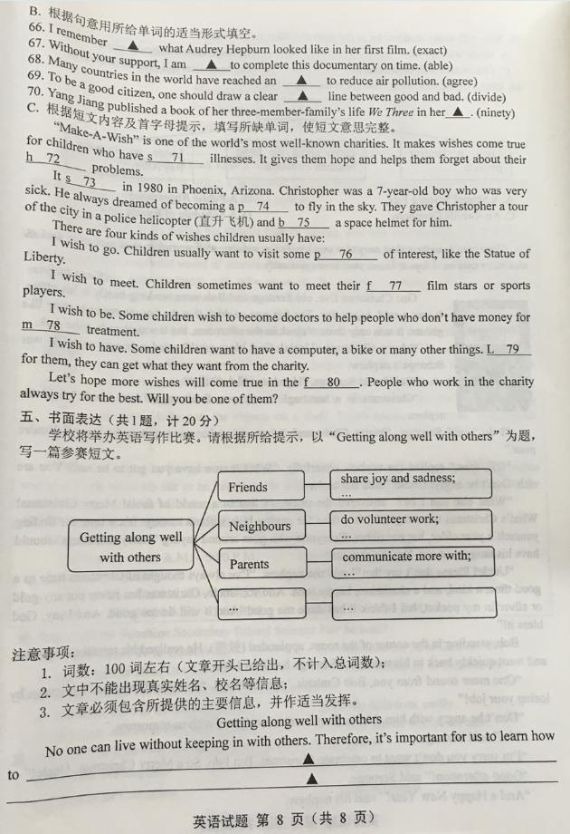
注意事项：
1. 词数：100词左右（文章开头已给出，不计入总词数）；
2. 文中不能出现真实姓名、校名等信息；
3. 文章必须包含所提供的主要信息，并作适当发挥。
Getting along well with others.
No one can live without keeping in with others. Therefore, it’s important for us to learn how to ____________________________
____________________________________________________________________________________________________________________________________________________________________________________________________________________________________________________________________________________________________________________________
一、单项选择
1 | 2 | 3 | 4 | 5 | 6 | 7 | 8 | 9 | 10 | 11 | 12 | 13 | 14 | 15
D | A | B | C | A | C | A | A | B | D | D | C | C | B | D
1. D解析：考查冠词。动词play和表示球类运动的名词构成短语时，在表示球类运动的名词前不加冠词。句意：我认为踢足球是学习团队精神的一个好途径。
2. A解析：考查介词。表示“在具体某一天”时，用介词on表达。句意：在2016年5月20日，3-D电影《愤怒的小鸟》在中国电影院上映。
【解题指导】常用来表示时间的三个介词为：on用于具体某一天；at用于点时间前；in用于年份、季节、月份等。
3. B解析：考查反身代词。by oneself意为“独自；本人”，符合句意“我的表兄弟安德鲁痴迷于自己动手做许多事情。”，主语Andrew提示用himself。
4. C解析：考查名词。前文“骑自行车”提示用keep balance表示“保持平衡”。句意：生活就像骑自行车。要保持平衡，你就得不停的保持运动状态。promise意为:“承诺”; position意为:“位置”; ability意为:“能力”。
5. A解析：考查形容词最高级。下文的of短语提示用形容词最高级形式修饰one。句意：在阿芝特克社会中，富人是四个社会阶层中最有权力的阶层。
6. C解析：考查情态动词。下文的“他去巴黎经商了”提示上文意为“不可能是他”， 表示否定的猜测用can’t，意为“不能”。句意“那个人是格林先生吗？”“不可能是他。他去巴黎出差了。”
7. A解析：考查特殊疑问词。答语“每两周一次”提示问句是提问频率，用how often表示“多久一次”。句意“你多久去做一次彩虹夫人的颜色疗法?”“每两周一次。”
8. A解析：考查动词时态。时间状语in the past few months是指从现在算起“在过去的几个月里”，和现在完成时态连用。句意：在过去的几个月里厄尔尼诺暖流似乎在世界范围内导致了一些灾难。
9. B解析：考查并列连词。下文的“是广场舞”提示前文是被否定的两者，用neither…nor…“既不……，也不……”，符合句意“我奶奶的爱好既不是做饭也不是看电视。而是广场舞。”A意为：“不但……而且……”；C意为：“两者都”；D意为：“或者……或者……”。
10. D解析：考查there be句型。there be句型表示“有”，符合句意“当心，彼得。前面的路上有个小男孩在玩闹。”
【深挖细究】there be 句型中用现在分词作定语表示动作正在进行，用动词不定式表示不正在进行的动作。
11. D解析：考查非谓语动词。空格后是动词不定式表示目的，作目的状语，符合句意“我们必须做我们所能做的一切去阻止废水流进河里。、”
【易错警示】句中的we can是定语从句部分，修饰everything，因为主句谓语动词是do，定语从句中情态动词can后省略了谓语动词do，所以can和后面的prevent没有关系，不要误认为can后跟动词原形。
12. C解析：考查动词语态。主语things“东西”是被分类，用被动语态表达，主语things是可数名词复数，助动词用are。句意：在瑞士像玻璃塑料这样的东西都进行分类，然后循环使用。
13. C解析：考查宾语从句。答语yes提示上句的宾语从句来源是一般疑问句，用whether“是否”引导宾语从句。句意“我想知道这座博物馆是否值得参观”“是的，当然（值得参观）”。
14. B解析：考查情景交际。应答感谢用语用Don’t mention it.表示“不客气；不用谢”。句意“非常感谢你给我提供了有关处理压力问题的建议。”“不客气”。A意为：“那是正确的”； C意为：“好的，我将试一试”；D意为：“我不认为这样”。
15. D解析：考查英语谚语。题干表示的意义是“做比说重要”，四个答案中D答案意为“行动胜于语言”。A：“凡人都有得意日”；B“熟能生巧”；C“团结力量大”；D。故选D。
二、完形填空
16 | 17 | 18 | 19 | 20 | 21 | 22 | 23 | 24 | 25 | 26 | 27 | 28 | 29 | 30
A | D | C | A | B | A | B | D | D | C | B | A | C | B | D
【主旨大意】本文是一篇记叙文。讲述了发生在一位身残志坚的小提琴演奏家伊扎克·帕尔曼身上的故事。在一次演奏时，在断了一根琴弦的情况下，他坚持演奏到结束。这件事向我们展示了伊扎克·帕尔曼作为小提琴演奏家对音乐执着追求的精神。
16. A解析：考查名词辨析。根据后一句中的“He had to walk the help of two walking sticks as a result of the disease he caught as a child.”可知对于他来说，成为一名小提琴演奏家不是一个小的成就了。A意为：“成就”；B意为：“优点”；C意为：“事故”；D意为：“申请”。
17. D解析：考查介词用法。根据横线前的walk和横线后的two walking sticks可知他是在两根拐棍的帮助下行走。with the help of意为“在……帮助之下”，是固定搭配。
18. C解析：考查副词辨析。根据上下文可知人们对身残志坚的帕尔曼很尊重，当他上台准备开始演奏时，观众是安静地坐着。A意为“宽广地”；B意为“紧密地”C意为“静静地”D意为“嘈杂地”。
19. A解析：考查形容词、副词用法。根据下文可知这次演奏中出了点叉子。A意为：“出错”；B意为：“顺利”；C意为：“平滑地”；D意为：“慢慢地”。go wrong 意为：出岔子，出问题，故选A。
20. B解析：考查动词辨析。结合上下文可知，一根琴弦断了。A意为：“修好了”；B意为：“断了”；C意为：“燃烧的”；D意为：“丢失的”。故选B。
21. A解析：考查副词辨析。根据前文“我们认为他会停止演奏，但他没有”，及下文“他闭上眼睛等了一会儿，继续开始”，可知空格处意为“相反的，代替的是”。A意为：“反而，代替”；B意为：“总之”；C意为：“真正地”；D意为：“否则”。故选A。
22. B解析：考查动词辨析。根据上下文可知，他请求指挥再次指挥让他开始演奏。A意为：“按照”；B意为：“请求”；C意为：“导演”；D意为：“强迫”。故选B。
23. D解析：考查副词辨析。副词never表示“从未”，符合句意“他演奏出了他们以前从未听过的具有强烈的感情和纯粹的乐曲。”
24. D解析：考查形容词辨析。根据语境可知，正如大家都知道的，用三根琴弦演奏出如此美妙的乐曲是不可能的。用impossible表示“不可能的”。A意为“舒服的”；B意为“可能的” C意为“不舒服的”。
25. C解析：考查连词。根据上句中大家都知道的事实，以及下句中伊扎克·帕尔曼不接受这个情况，可知它们之间是转折关系，用but表示“但是”。
26. B解析：考查名词辨析。用名词silence表示“寂静的”，符合句意“当他演奏结束，演奏厅里出现了可怕的寂静。” A意为“恐惧”C意为“想法” D意为“雷声”。
27. A解析：考查动词辨析。用cheer表示“欢呼”，符合句意“然后人们站起来，从剧院里各个角落传来了人们的欢呼声”。B意为 “离开” C意为 “微笑” D意为 “嘀咕”。
28. C解析：考查动词短语辨析。用find out“找出；发现”后跟宾语从句，符合句意“有时一个艺术家的任务就是发现用你所遗弃的东西能创造多少音乐。”A意为“分发” B意为 “执行” D意为 “扑灭”。
29. B解析：考查名词辨析。下文的play it提示本句空格处用music“音乐”，符合句意“设想一下我们的任务就是在这变幻莫测的世界里来制作音乐。”A意为“乐趣” B意为“音乐” C意为“进步” D意为 “金钱”。
30. D解析：考查连词辨析。用when“当……时候”，引导时间状语从句，符合句意“当这种情况成为不可能的时候，就试着用你认为所遗弃的东西来演奏它。”
三、阅读理解
31 | 32 | 33 | 34 | 35 | 36 | 37 | 38 | 39 | 40 | 41 | 42 | 43 | 44 | 45
C | D | B | B | A | D | A | D | C | A | D | C | A | B | C
A. A【主旨大意】本文是一篇说明文。介绍了自然界中食物链的构建和循环。
31. C解析：细节理解题。根据文中第一段第二句This energy comes first from the sun.，可知
生物最初需要的能量来源于太阳。
32. D解析：细节理解题。根据文中第五段句子Ringtail cats also come out only at night.
Ringtail cats hunt and eat kangaroo rats. 可知圈尾猫仅在夜间出来是为了捕捉长鼻袋鼠吃。
33. B解析：细节理解题。根据文中最后一段中的When a ringtail cat or a coyote dies, it makes a meal for the vultures.可知秃鹰吃圈尾猫和北美小野狼。
34. B解析：推理判断题。根据第一段中的Plants use water and sunlight to make their own food.
Animals can not make their own food, and they eat plants.可知植物不处于食物链的顶端。
35. A解析：主旨大意题。根据短文内容可知主旨大意是介绍了自然界中食物链的构建和循环。
B【主旨大意】本文是一篇应用文。它是阳光初级中学科学展览会的海报。它宣传了这次展览会的时间，地点和活动安排。
36. D解析：细节理解题。根据海报中的展出时间Dates: October 30-31，可知在十月的30-31日。
37. A解析：段落大意题。通读文中第三段可知，本段介绍了科学家在不断地探索研究机器人的发展情况。
38. D解析：段落大意题。通读文中第四段可知，本段介绍了一位当地的发明家向同学们讲述了他自己的发明经历。选项中四位人物，只有爱迪生是发明家。
39. C解析：推理判断题。根据最后的Awards Presentation :October 31 1:00 M.可推知此时是颁奖仪式。故许多学生在体育馆。
40. A解析：推理判断题。根据题干中提供的几项活动内容可知，这些都是科学展览会的活动安排。
C【主旨大意】本文是一篇记叙文。本文讲述了老斯克鲁奇和他的员工鲍勃在圣诞前夕在工作时，斯克鲁奇听到外甥的圣诞祝福，不以为然，而员工鲍勃对圣诞祝福饱含期望的故事。
41. D解析：细节理解题。根据文中的One Christmas Eve, old Scrooge and Bob were working busily in his office.可知故事发生在圣诞前夕，在冬季。
42. C解析：细节理解题。根据文中的“Bah!”said Scrooge “Humbug(骗人的话)！”，可知他认为圣诞祝福就是骗人的话。
43. A解析：句意理解题。根据文中的I’ ve always thought of Christmas time as a good time, a kind, and a charitable, happy time.可知他认为这是一个友爱，慈善的好时光。
44. B解析：推理判断题。根据文章中的“One more sound from you, Bob Cratchit,” said Scrooge, “and you’ll celebrate Christmas by losing your job!”推断鲍勃是老斯克鲁奇的员工。
45. C解析：推理判断题。根据文中的Bob, standing in the corner of the room, applauded(鼓掌).可知Bob和老斯克鲁奇的侄子一样相信圣诞祝福，故选C。
B. 任务型阅读
【主旨大意】本文是一篇说明文。介绍了中国传统艺术的美蕴含在民间普通艺术品中，如孔明灯，剪纸，制陶等。
46.Common解析：根据上下文可知此处标题应该为，“美藏在普通物品中”；而且要注意标题中每个单词的首字母要大写。
47. Introduction解析：根据文章的结构和右表的内容可知是总体介绍本文的内容。故填Introduction。
48. stand解析：根据句意可知有些由普通物品制成中国传统艺术形式代表它们在生活中的重要的东西。与后面的for 构成词组stand for, 意为“代表，象征”。
49. bamboo解析：根据第二段中的“They are made of bamboo and covered with paper.”，可知孔明灯是由竹子和纸构成。
50. asking解析：根据第二段中的“He sent them out to ask for help when in trouble.”可知最初孔明灯是用来向他人求助的。ask for help意为：“求助”。在介词for后用动名词。
51. over解析：根据第三段的第一句话Paper cutting has been around for more than 1,500 years.可知剪纸历史超过1500年。over与more than同义，意为：“超过”。
52. shapes/forms/pictures 根据第三段中的The most common pictures are flowers, fish, animals, and things about Chinese history. 可知剪纸以不同形状/形式/图画出现。
53. for解析：根据第三段的最后一句可知剪纸代表着对春节的美好祝愿，用represent…for…表达。
54. though解析：根据第四段中的the clay pieces are so small but they look very real.可知它虽然小但逼真。it is small放在后面，所以用though“虽然”，引导让步状语从句。
55. another解析：根据最后一段中的then allowed to air-dry. After drying, they are fired at a very high heat. They are then polished and painted. Finally, materials such as wood or paper are added to make different things. 可知在手工塑型后还有四个步骤，用another表示“还；另外的”。
C. 阅读与回答问题
【主旨大意】本文是一篇说明文。介绍美国高中制作年鉴的对象、内容和意义。
56. 4/Four. 解析：根据文中第二段中的seniors, juniors, the second-year students, the first-year students可知，美国高中有四个年级。
57. The students’ and teachers’. 解析： 根据文中第二段的The yearbook is not only about students. The teachers have photos, too.可知，年鉴中的照片有老师和学生的。
58. The “best dressed”. 解析：根据文中第四段中的the “best dressed(a student with a good fashion sense).可知最有时尚感的学生会得到的标题是the “best dressed”。
59. Because they are graduating. 解析：根据文中第五段的第一句和第二句可知是因为他们要毕业了。
60. Meaningful/....解析：开放式答题。
四、词汇
A. 61.magazines解析：用magazine表示“杂志”，and并列两个复数名词。句意：我们经常从学校图书馆借小说和杂志。
62. electronic解析：形容词electronic表示“电子的”。句意：与纸质书相比，有些年轻人更喜欢电子书。
63. explaining解析：explain表示“解释”，助动词is提示构成现在进行时态。句意：李先生正在向我们解释怎样根据写作类型来组织我们的观点。
64. somewhere解析：“某处”用somewhere表达。句意：好机会就隐藏在我们身边的某个地方，等待着有心的人们去发现。
65. marked解析：用mark表示“标志”，时间状语in the 1990s提示用一般过去时态。句意：20世纪90年代的价格变化标志着电视迅猛发展的年代的开始。
B. 66. exactly解析：副词exactly修饰动词remember，意为“准确地记得”。
67. unable解析：句意“没有你的帮助，我不能按时完成这部纪录片。”提示用able的反义词unable表示“不肯能”。
68. agreement解析：冠词an后用agree的名词形式agreement。句意：世界上许多国家达成协议减少空气污染。
69. dividing解析：修饰名词line用divide的形容词形式dividing，dividing line表示“分界线”。句意：要成为一名好公民，一个人对是非应该有一个清晰的分界线。
70. nineties解析：in one’s nineties表示“在某人90来岁时”。句意：杨绛在她90来岁时出版了一本回忆三口之家生活的书《我们仨》。
C.【主旨大意】本文是一篇说明文。介绍了世界闻名的慈善组织Make-A-Wish的成立以及这个组织的帮助对象和帮助内容。
71. serious解析：根据句意“它帮助患有严重疾病的孩子实现梦想”可知是有严重疾病的孩子，用serious表示“严重的”。
72. health 解析：名词health表示“健康”，修饰problem，符合句意“它带给他们希望，让他们忘记他们的健康问题”。
73. started解析：动词start表示“成立；建立”，符合句意“它建立于1980年”，时间状语提示用一般过去时。
74. pilot解析：下文fly in the sky提示他想成为一名飞行员，用pilot表示“飞行员”。
75. bought解析：buy sth. for sb.“给某人买某物”，符合句意“给他买了一个太空头盔”根据上句可知是用过去时。故填bought。
76. places解析：根据后面的like the Statue of Library可知是想参观一些名胜。 places of interest意为“名胜古迹”。
77. favourite解析：favourite表示“最喜欢的”，符合句意“有些孩子想见他们最喜爱的电影明星或体育运动员”。
78. medical解析：根据句意“有些孩子想成为医生来帮助那些没有钱医学治疗的人”可知是进行医学治疗。用medical表示“医学的”。
79. Luckily解析：luckily for sb意为“对某人来说幸运的是”，用副词形式修饰介词短语。
80. future解析：根据前面的hope可知是祝愿将来更多的愿望实现。in the future意为：“在将来”。
五、书面表达
【写作思路】结合图示围绕“如何和别人相处融洽”之一主题来组织语言材料。通过图示中的提示，说明针对朋友、邻居、父母应该如何去做。接下来可以拓展到在学校里和老师相处等。
【常用短语及句型】
keep in with, it’s important for us to…, how to…, get along well with, We should…., be kind and friendly to, so we can…, make friends, share…with, If we’re…., we can…., do volunteer work, communicate with, both…and…, enjoy oneself
【范文】
Getting along well with others.
No one can live without keeping in with others. Therefore, it’s important for us to learn how to get along well with others. We should be kind and friendly enough to others, so we can make more friends .We can share joy and sadness with our friends. If we are free, we can do volunteer work to help our neighbours. At home, we should communicate more with our parents. They are our closest people in the world. At school, we should respect our teachers. They are like both our parents and friends. Getting along well with others is very important. If we can get along well with others, we will enjoy ourselves every day and succeed when we do anything.

