南京市2011年初中毕业生学业考试
英 语
注意事项：
本试卷共10页。全卷满分96分。考试时间为120分钟。试题包含选择题和非选择题。

选择题(共4 5分)
一、单项填空（共15小题；每小题1分，满分15分)
从A、B、C、D 四个选顼中，选出可以填入空白处的最佳选项，并在答题卡上将该项涂黑。
1． 一What do you usually have for _______ breakfast，Peter?
一A fried egg，three pieces of bread and a glass of milk．
A．a B．an C． the D．不填
2． The wedding of Prince William was held in Westminster Cathedral ______ April 29, 2011．
A．at B．in C．on D．by
3． 一_______ do you watch TV every week ?
一Less than two hours． I often have much homework to do．
A． How many B．How much C．How long D．How often
4．Most children are interested in amazing things, and they wonder ______．
A． when can they see UFOs
B． how can elephants walk on tiptoe
C．why do fish sleep with their eyes open
D．why there is no plant life without lightning
5．一Mr Smith，I don’t think we can get there on time by bike．
一You mean it’s ________ for us to take a taxi?
A．necessary B．important C．possible D．difficult
6．They will try their best in the Dragon Boat Racing ________ they may fail．
A．if B．although C．unless D．until
7．一Mrs Black，could you give me some advice on how to write an application letter?
一With pleasure．Remember that the letter should be written in the formal _______．
A．value B．style C．effect D．mood
8．一Fifty dollars for such a T-shirt!You _______ be joking!
一I’m serious．It’s made of silk.
A．must B．need C．may D．can
9．一It’s said that aliens tried to warn the astronauts on the moon to _______．
一Maybe they didn’t like human beings to get close to them．
A．stay up B．stay out C. stay away D． stay behind
10．It’s reported that Nanjing South Railway Station _______ at the end of this month.
A.has been completed B.is completed
C．was completed D.will be completed
11. 一You can’ t imagine ________ great fun chatting online is.
一Really?But it may cause you a lot of trouble.
A.what B.how C.why D.whether
12．一I’ve not finished my project yet.
一Hurry up! Our friends _______ for us.
A．wait B.are waiting C.will wait D．have waited
13．一What’s wrong with my son, doctor ?
一 ________ serious．Just a slight cold．
A．Something B.Anything C．Nothing D．Everything
14. 一Everybody is playing outside．Can I join them，mom?
一 _______ Not until you have finished practising the piano．
A.Why not? B.Will you? C．I hope so. D.I’m afraid not．
15. 一I’m sorry. That wasn’t of much help．
一 ________.And it was most helpful.
A．Thanks anyway B．It doesn’t matter
C. Of course not D.Sure it was
二、完形填空(共10小题；每小题1分，满分10分)
阅读下面短文，从短文后所给各题的四个选项(A、B、C和D)中，选出可以填人空白处的最佳选项，并在答题卡上将该项涂黑。
Today some people call Amsterdam the“City of Bicycles”because it is a city which is flat and convenient(方便的)for bicycles．
In the 1960s，a group of cycling fans __16__ an idea.They believed that it would be better for everybody if only bicycles were allowed in the city centre．They were __l7__ that this would help to save energy，reduce pollution and provide free public transport．The group painted hundreds of bicycles __18__ and placed them in public places around Amsterdam for people to use．__19__ was allowed to take them and use them for short journeys，whether he was a local or a foreigner．Wherever someone finished a journey，they would __20__took all the bicycles within weeks!
__22__ ，more than thirty years later，the“white bike”is back in town---this time with a
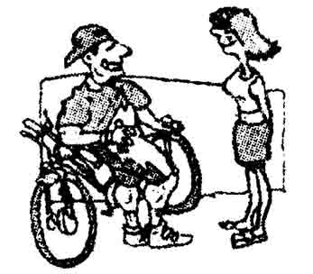
computer chip(芯片)to __23__ its every move!To take a bicycle，you have to put a special card inside．The new“white bike”is not white any more but is an unusual __24__ with bright colours. The bikes are parked at special parking places and people who want to use them have to take them to another place that has enough room.
There is already less traffic in central Amsterdam，__25__ both locals and tourists have been using the white bikes．Thanks to the good ideas of lots of people, like the cycling fans in the 1960s, many people around the world have been enjoying city centre streets without cars for many years．
( )16．A．stole B．had C．refused D．dropped
( )17．A．thoughtful B．helpful C．hopeful D．thankful
( )18．A．black B．brown C．blue D．white
( )19．A．Anyone B．Everyone C．No one D．Someone
( )20．A．take B．leave C．carry D．send
( )21．A．robbers B．shoplifters C．kidnappers D．thieves
( )22．A．However B．Instead C．Therefore D．Though
( )23．A．make B．mark C．record D．describe
( )24．A．design B．idea C．size D．experiment
( )25．A．so B．because C．but D．while
三、阅读理解(共20小题；每小题1分，满分20分)
阅读下列材料，从每题所给的四个选项(A、B、C和D)中，选出最佳选项，并在答题卡上将该项涂黑。
A
Need to know in England | Travelling Season
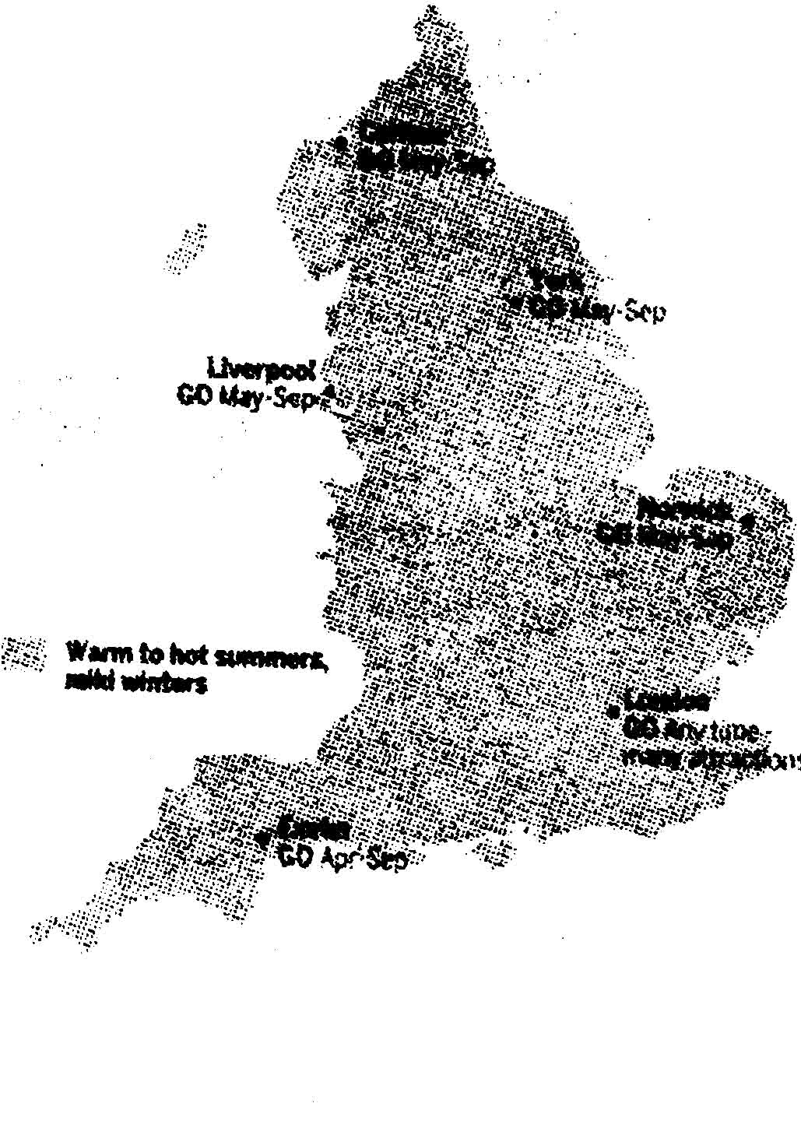 | High Season  (Jun—Aug)  ＊Weather at its best.  Prices at their highest  (especially for August school holidays)．  ＊Roads busy，  especially in seaside areas，national parks and popular cities． | Shoulder  (Easter to end May，mid-Sep to end Oct)  ＊Crowds reduce．  Prices drop．  ＊Weather often good；sun mixes  with sudden rain  March to May． | Low Season  (Dec—Feb)  ＊Wet and cold is  the norm．Snow  falls in mountain  areas．  ＊Opening hours  reduced October  to Easter；some  places shut for the  winter．

England on Shoestring
If you're a shoestring traveller，there's no getting around it---England isn't cheap．Public transport，restaurants and hotel rooms all tend(趋向)to be expensive compared to many other European countries．But you can save money by staying in B&Bs instead of hotels，or hostels instead of B&Bs．You can also save considerably，by prebooking long-distance travel by coach or train---and by avoiding(避开)the times when everyone else is on the move(such as Friday afternoon)．Many attractions are free or offer discounts on quiet days(eg Mondays)．
Arriving in England  ＊Heathrow Airport  Train to Paddington Station every 15 minutes  ＊Gatwick Airport  Train to Victoria station every 15 minutes  ＊Eurostar trains from Paris or Brussels  Arrive at St Pancras International Station in central London  ＊Buses from Europe  Arrive at London Victoria Coach Station | Websites  ＊Enjoy England  (www.enjoyengland．com)Official tourism  Website.  ＊National Traveline  (www.traveline．org．uk)Great portal site  for all public transport around England．  ＊Lonely Planet  (lonelyplanet．corn)Destination information，  hotel bookings，traveller forums and more．  ＊Seize the Days  (lonelyplanet.corn／132 days)  Weekly updates on UK activities and events．
26．Why do some tourists go to England for travelling between June and August?
A。Weather is at its best． B．.0Wet is the norm．
C．Prices drop a lot． D．There are fewer travelers.
27．What does“England on Shoestring”mean in the text?
A．The map of England looks like a pair of shoes.
B．You can visit England without spending much money．
C．It’s necessary to wear a pair of shoes with strings in England．
D．A1l the attractions in England are free for a shoestring traveller．
28．Which station will you arrive at if you take an Eurostar train from Paris according to the text?
A．Paddington Station． B．Victoria Station．
C．St Pancras International Station．D．London Victoria Coach Station．
29．Which of the following websites can help you if you want to watch a football match between Manchester United and Liverpool this weekend?
A．www.traveline．org.uk B．lonelyplanet.com
C．www．enjoyengland．corn D．lonelyplanet．com／132 days
30．What do you think this text is?
A．A tour guide． B．A map of England．
C．A flight timetable． D．An introduction of England．
B
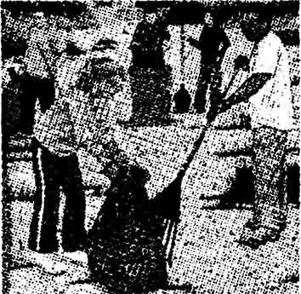
Elena jogged with her dad in some empty lots(小块地)at the edge of town. These out-of-the-way lots were good places to jog. But the lots were fuIl of rocks and rubbish．
One day，Elena saw a sign on the lots．It said，“New City Park．”Elena was excited. Maybe the park would have a jogging trail!
Elena told her parents about the sign．
“I read about the park in the newspaper，”said Elena’s father．“The city wants volunteers to help clean the area. Then the city will build a soccer field and a playground．”
“Will they build a jogging trail?”Elena asked．
“No，the paper didn’t mention a jogging trail．”
“Well，perhaps if I help clean up the lots，they’ll put in a jogging trail，”said Elena．
On Saturday Elena went to the lots．Many adults were working there．Some were picking up rubbish．Some were moving rocks．
“I want to volunteer，”Elena told a man.“What can I do? ”
“This is not a job for children，”said the man．“You’d better go home．”
Elena looked around．She could carry rubbish. She could move rocks．A lady was pulling a bag of rubbish．Elena saw a box of rubbish bags. She took an empty bag．
“I’ll take this bag to the Dumpster，”said Elena．“Here’s a new bag．”
“Thanks，”said the lady.“Keep those new bags coming．”
Elena dragged rubbish bags. She told everyone she was glad to help build the park．She explained that she hoped the park would have a jogging trail.
Elena went to the area every week. Soon everyone knew her and she told everyone how wonderful a jogging trail would be．
Soon the volunteers cleared the lots．The city could start building．The mayor(市长)gave a speech．He showed a drawing of the new park．He told them about the soccer field and the baseball diamond．There would be picnic tables．There would be a playground．The park would even have basketball courts．There was no sign of a jogging trail．
The mayor thanked the volunteers．Then he asked if they had any suggestions．The volunteers said they wanted to build a jogging trail around the park．
They told the mayor how helpful Elena had been and how she wanted a jogging trail．The mayor said，“A jogging trail won’t be hard to build．Let’s do it!”
Everyone clapped and cheered．Elena cheered loudest of all.
31．How did Elena feel at the beginning of the story?
A．Happy and proud． B．Sad and shy．
C．Excited and hopeful． D．Unhappy and disappointed．
32．How did Elena know the city needed volunteers to help clean the lots?
A．Her father told her about it． B．She read it in the newspaper．
C．She learned it from a sign． D．She was told by other volunteers．
33．Why did Elena want to help clean the lots?
A．She wanted to play on the playground.
B．She wanted her name in the newspaper.
C．She wanted to work with other volunteers．
D．She wanted the city to build a jogging trail．
34．Why did the volunteers tell the mayor they wanted to build a jogging trail?
A．They needed a park to jog around．
B．They wanted to thank Elena for her help．
C．They thought it was a good place for jogging．
D．They hoped the mayor could jog with them every day．
35．What can be the best title for the story?
A．Elena and a Mayor B．Elena and New City Park
C．Elena and Some Volunteers D．Elena and a jogging Trail
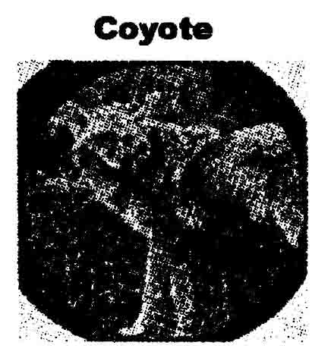
C
Long ago，Bluebird's feathers were the colour of dust. She did not like her ugly colour．She was attracted by the colour of the lake near her home．It was as blue as the sky after a storm．Bluebird wanted to be the colour of that beautiful lake very much．
Flapping her wings one morning，Bluebird flew from her tree to the blue lake. Then she bathed in the water three times．After each bath，she sang，“Blue water．Still water．I went in．I am blue．”Bluebird repeated this every morning. On the third day，she came out ot the lake with beautiful blue feathers.
Now Coyote was a trickster(骗子)---and hungry too. He stayed behind Bluebird ‘s tree for a long time every day and watched her go to the lake．He pretended(伪装)to be interested in everything she did．He wanted Bluebird for lunch，but he was afraid of the blue water. On the third
Morning, Coyote saw Bluebird come out of the lake with beautiful blue feathers．Impressed，he sat next to Bluebird’s tree and waited for her．When she returned, he asked，“How did you get blue feathers?I want to be blue like the mountains too．”Bluebird didn't believe Coyote，but she taught him how to bathe three times each morning and how to sing her song．Coyote did what she said, and after three days of bathing in the lake，his white fur turned deep blue．
Convinced(确信的)that blue fur was even more beautiful than blue feathers，Coyote forgot all about being hungry．He ran as fast as he could to the top of the hill. Standing on his back legs, he raised his front legs off the ground and howled．But Coyote slipped(滑倒)and rolled down the hill．He couldn’t stop himself，and the dust and dirt covered his new blue fur．He rolled and rolled until he hit into Bluebird’s tree heavily．No matter how much he tried，foolish Coyote could not shake the dust from his fur. And so the fur of all coyotes has the dull colour of dust to this very day.
36．How many times did Bluebird bathe every morning before she had beautiful blue feathers?，
A．Three times。 B．Four times． C．Five times．D．Six times．
37．Why was Coyote a trickster?
A．He wanted to fly like Bluebird near the mountains．
B．He wanted to eat Bluebird but pretended to be curious．
C．He wanted to swim in the lake but was afraid of the water．
D．He wanted to sing Bluebird’s song but didn't know the words.
38．Where did Coyote go after his fur turned blue?
A．To the lake． B．To the tree． C．To the cave．D．To the hill．
39．Why did Coyote forget all about being hungry?
A．Because his fur had the dull colour of dust．
B．Because the dust and dirt covered his new blue fur．
C．Because he hit into Bluebird’s tree and hurt himself．
D．Because he thought blue fur was much more beautiful．
40．What words does the writer use to help you imagine the colour blue?
A．sky，lake，mountains B．bird，coyote，storm
C．flapped，climbed，bathed D．fur，feathers，dust
D
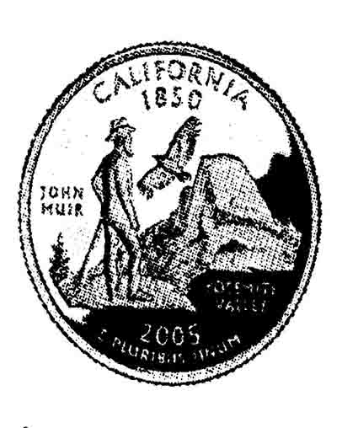
Look carefully at the back of a California state quarter．A man with a walking stick is pictured there．A bird called a California condor(大秃鹫)is flying overhead. Who is this man，and why is he so important that he is featured(处于显著地位)on the back of a coin?
The man on this quarter is John Muir．Even as a child, Muir loved watching nature. As a young man，he spent much of his life exploring the beauty of the wilderness．He walked more than a thousand miles across the country，through fields and woods．John Muir liked writing about the places he visited，describing their beauty.
Muir also wrote about problems．In order to create more farmland for sheep and cattle, rnany trees were being cut down．This made Muir unhappy and worried，because he knew that trees were important to forests and to the animals that lived in them．Muir believed that nature should be conserved(保护)instead of being changed by human beings．He wrote articles in magazines and newspapers to spread the word about conserving forests．Soon，others began to listen．
Muir wrote letters to important people，such as President Theodore Roosevelt．The president admired Muir’s love for nature．When Roosevelt came to visit Muir in California.Muir convinced(说服)the president to go camping with him for three nights under the trees so they could talk about conservation．Later，President Roosevelt set aside 148 million acres of land for national forests and established(建立)five national parks．National parks are large areas of land that are protected from development. This means that people cannot build homes or businesses there. One of these parks is Yosemite National Park，the area that is featured on the back of the California quarter．
Though it has been almost one hundred years since John Muir died，people continue his work today．His work as a conservationist helped us to see the beauty of our natural world．John Muir made us understand the importance of protecting our earth and our resources---then，now，and for the future．
41．What did John Muir spend much of his life doing when he was a young man?
A．Watching natural views．
B．Writing about the places he visited．
C．Exploring the beauty of the wilderness．
D．Creating farmland for sheep and cattle．
42．Why did President Theodore Roosevelt visit John Muir?
A．Because Roosevelt loved watching nature．
B．Because Roosevelt received letters from John Muir．
C．Because Roosevelt admired John Muir’s love for nature.
D．Because Roosevelt was sad about the problems with farmland．
43．What happened after President Roosevelt went camping with John Muir?
A．Many trees were cut down．
B．Five national parks were established．
C．More homes and businesses were built.
D．More farmland was used for sheep and cattle.
44．Why is John Muir featured on the back of a California state quarter?
A．Because he walked over a thousand miles across the country．
B．Because he helped people understand the importance of protecting the natural world.
C．Because he wrote articles to spread the word about conserving forests．
D．Because he once wrote several letters to President Theodore Roosevelt．
45．What is the writer’s purpose of writing this article?
A．To advise readers to become active conservationists.
B．To make us interested in the story about a great man．
C．To tell us something about an important person in history．
D．To give information about how to conserve the environment．
非选择题(共51分)
四、填空(共16小题；每小题1分，满分16分)
A)根据括号中所给的汉语写出单词，使句子意思完整正确，并将答案填在答题卡标号为46-50的相应位置上。
46．It’s the _________ (第一)time for Nanjing to hold the Asia Bike Show．It is sure to be a great success．
47．We should thank all our _________ (老师)for their help，care and love during the past three
years.
48．Harry keeps exercising every morning．As a result，he's a few kilos_________ (轻的)than
he used to be．
49．一Kitty，why do you look so happy today?
一I happened to meet an old friend of _______ (我的)in the Confucius Temple this morning.
50．It’s reported that Shen Jian，director of the Provincial Education Department of Jiangsu, was __________(采访)by 11 primary school students about some present issues.
B)根据句子意思，用括号中所给单词的适当形式填空，并将答案填写在答题卡标号为51-56的相应位置上。
51．It’s _________ (polite)to ask a lady about her age in western countries.
52．The story _________ (it)is interesting，but it’s a little difficult for children．
53．Look!The teenagers are making cards _________ (show)love for their mothers．
54．Anna doesn’t like playing computer games. Sometimes she does it _________ (simple)to
Relax.
55．Zhang Jike，a 23-year-old player，won the gold medal in the _________ (man)singles of the
World Table Tennis Championships last month．
56．In order to provide better services for foreigners during the 2nd Youth Olympic Games,lots of
bus and taxi drivers are busy __________ (learn)English．
C)根据对话内容，从下面方框中选择适当的单词或短语填空，使对话内容完整正确，并将答案填写在答题卡标号为57-61的相应位置上。
What else because of live answer so that
A：What should we do if we need to call the emergency(紧急情况)services?
B：Well，you need to know the number of the emergency services in the place where you __57__.
A：OK．What happens when we call the emergency number?
B：When you do so，an operator will __58__ your call. The operator asks you which service you need-the police，the fire department，or an ambulance service．You should tell the operator clearly what the situation is and which service you need．It is important to speak calmly and clearly __59__ the operator can understand you.
A：Does the operator ask for any other information?
B：Yes．The operator asks the caller where he or she is calling from and also asks for the caller’s
name．
A：I see．__60__ should we remember when making an emergency call?
B：It is very important to keep calm．Many people forget to give very important information to the operator. For example, they tell the operator about a fire on Mason street but they do not mention which part of the city the fire is happening in．
A：And there may be more than one Mason Street in the same city．
B：Exactly．Sometimes，__61__ receiving wrong or incomplete information，the emergency
services waste time by going to the wrong place．
A：Thank you for telling me how to use the emergency services．
五、阅读填空(共20小题；每小题1分，满分20分)
A)阅读下面短文，根据所读内容，在文章后第62-71小题的空格里填入一个最恰当的单词，并将答案填写在答题卡标号为62-71的相应位置上。注意：每个空格只填1个单词。
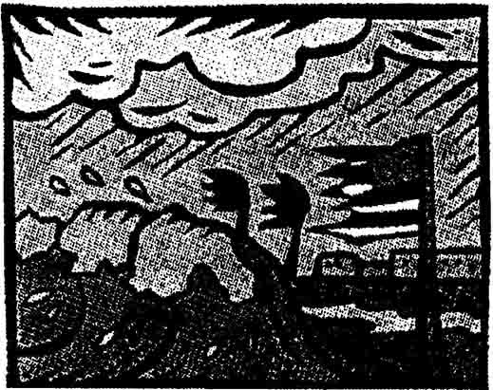
What is a hurricane?
You may already know that hurricanes are storms that can cause devastating(毁灭性的)waves，wind，and rain．They happen during“Hurricane Season，”which is from June 1st until November 30th in the Atlantic Ocean and from May 15th until November 30th in the Pacific Ocean.
Categories(类别)of Hurricanes
There are five categories of hurrlcanes, which are based on wind speeds. The categories help people know how much damage(危害)a hurricane may cause because the greater the wind speed，the more dangerous the storm．For example，a Category 5 hurricane has winds over 155 miles per hour，which are strong enough to destroy the buildings along the shorelines completely．
Hurricane Dangers
When a hurricane happens together with heavy rainfall，there can be a devastating flood．The centre of a hurricane is called the eye．While most of a hurricane has dangerously strong winds，the eye is actually(事实上)a calm area in the storm．When the eye of a hurricane passes over land，people might think that it’s over，but before long the wind and rain increase again as the second part of the hurricane moves through．
Hurricane Safety Tips
There is no way to stop a hurricane or make it change direction，so if you ever find yourself in the path of a hurricane，be sure to remember the following safety tips．
·Be sure you have a radio，batteries，fresh drinking water，and enough food．
·Tell neighbours，friends，and family members your emergency plans．Tell them where you’ll go if you need to leave your home．
·If you live near the ocean，leave your home and travel to a safe place．You could stay with a friend or a family member，in a hotel／motel，or in an emergency shelter area．
·Stay inside during the storm．You could be seriously injured(受伤)if you go outside．

Hurricanes
Characteristics | ☆Hurricane Season usually __62__ about 6 months in the Atlantic Ocean  and 6.5 months in the Pacific Ocean．  ☆Devastating waves，wind，and rain are usually the __63__ of hurricanes.
Categories | ☆Hurricanes have been __64__ into five categories by scientists，based on wind speeds．  ☆A Category 5 hurricane can destroy all the __65__ along the shorelines.
___66___ | ☆When a hurricane comes together with heavy rainfall，a terrible __67__ may happen．  ☆The eye is the __68__ of a hurricane．Soon after it passes，the wind and rain increase again．
Safety Tips | ☆It’s __69__ to stop a hurricane or change its direction．  ☆Don’t __70__ the safety tips if you find yourself in the path of a hurricane．  ☆Stay inside during the storm，__71__ you could be seriously injured.
B)根据短文内容及首字母提示，填写所缺单词，并将答案填写在答题卡标号为72-81的相应位置上。
As we know，museums are buildings where many valuable and important objects are kept so
that people can go and see them．For example，art museums are places where people can learn about v__72__ cultures．More and more popular“design museums”that are opening today，however，perform quite a different role。U__73__ most art museums，the design museum shows objects that are easily found in our daily life, such as fridges and washing machines．
The a__74__ of design museums is that they are places where people feel familiar with the
exhibits(展品)．Being different from the art museum visitors，design museum visitors s__75__ feel
frightened or puzzled．This is partly because design museums clearly show how and why mass-products(批量产品)work and look as they do，and how design has i__76__ the quality of our lives．Art museum exhibits, on the other hand, would most probably fill visitors with a feeling that there is something b__77__ their understanding.
Several new design rnuseums have opened their doors in r__78__ years. Each of these museums has tried to satisfy(满足)the public’s growing interest in the field with new i__79__．
London’s Design Museum，for example，shows a collection of mass-produced objects from electric typewriters to a group of Italian fish-tins. The choices open to design museums seem f__80__ less strict than those to art museums，and visitors may also sense(感觉到)the humorous part of our society while walking around such exhibits as interesting and unusually attractive toys c__81__ from our everyday life．

72.v_________ 73.U_________ 74.a__________ 75.s__________ 76.i__________
77.b_________ 78.r__________ 79.i__________ 80.f__________ 81.c__________

六、书面表达(满分15分)
假如你是李平，准备参加学校组织的英语征文比赛。请根据下面所提供的信息，介绍
今天在你校操场举行的“ONE for ONE”图书义卖活动的情况并谈谈你的感受。
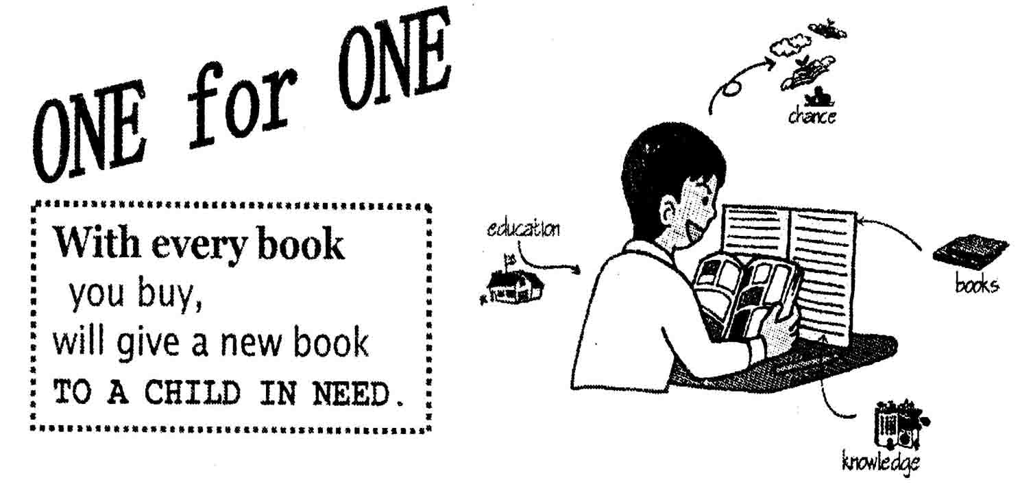
注意：1．文中不得出现你的真实姓名和学校名称。
2．语言通顺，意思连贯，书写规范。
3．词数80左右。文章的开头已经给出，不计入总词数。
This afternoon a charity sale was held on the playground in our school. _____________
_______________________________________________________________________________
_______________________________________________________________________________
_______________________________________________________________________________
_______________________________________________________________________________
_______________________________________________________________________________
_______________________________________________________________________________

南京市2011年初中毕业生学业考试
英语试题参考答案及评分标准
说明：本评分标准每题给出了一个或几个答案供参考，如果考生的答案与本答案不同，
参照本评分标准的精神给分。
一、单项填空（共15小题；每小题1分，满分15分)
1-5 DCCDA 6-10 BBACD 11-15 ABCDD
二、完形填空(共10小题；每小题1分，满分10分)
16-20 BCDAB 21-25 DACAB
三、阅读理解(共20小题；每小题1分，满分20分)
26-30 ABCDA 31-35 CADBD 36-40 ABDDA 41-45 CCBBC
四、填空(共16小题；每小题1分，满分16分)
A)根据括号中所给的汉语写出单词，使句子意思完整正确。
46．1st／first 47．teachers 48．1ighter 49．mine 50．interviewed
B)根据句子意思，用括号中所给单词的适当形式填空。
51．impolite 52．itself 53．to show 54．simply 5 5．men’s 56．learning
C)根据对话内容，从下面方框中选择适当的单词或短语填空。
57．live 58．answer 59．so that 60．What else 61．because of
五、阅读填空(共20小题；每小题1分，满分20分)
A)阅读下面短文，根据所读内容，在文章后第62-71小题的空格里填入一个最恰当的单词。
62．lasts 63．results 64．divided 65．buildings 66．Dangers
67．flood 68．centre／center 69．impossible 70．forget 71．or／ot herwise
B)根据短文内容及首字母提示，填写所缺单词。
72．various 73．Unlike 74．advantage 75．seldom 76．improved
77．beyond 78．recent 79．ideas 80．far 81．collected
六、书面表达(满分15分)
This afternoon a charity sale was held on the playground in our school. Its purpose was
to donate books to children in poor areas．If you bought one book，you gave a new one to a child in need at the same time．All the teachers and students took an active part in this event．Everyone looked quite happy．
As we know，books are bridges to knowledge. If a child in poor areas can receive a better education and get more knowledge, he will have more chances of success. In this way，his life can be greatly improved．

