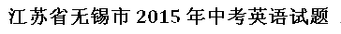
本试题分两卷。第I卷（客观题）在第1至第6页，第II卷（主观题）在第7至第8页。
考试时间为100分钟。试卷满分为90分。
注意事项：
1．答题前，考生务必用0.5毫米黑色墨水签字笔将自己的姓名、准考证号填写在答题卡的相应位置上，并认真核对条形码上的姓名、准考证号是否与本人的相符合。
2．答客观题必须用2B铅笔将答题卡上对应题目的正确选项涂黑。如需改动，用橡皮擦干净后，再选涂其他答案。答案不能答在试题卷上。
3．答主观题必须用0.5毫米黑色墨水签字笔作答，答案写在答题卡各题目指定区域内相应位置上。如需改动，先划掉原来的答案，然后再写上新的答案。不准使用铅笔和涂改液。不按以上要求作答的答案无效。
4．考生必须保持答题卡的整洁。考试结束后，将试题卷和答题卡一并交回。
第I卷（客观题共50分）
一、单项选择在A、B、C、D四个选项中，选出可以填入空白处的最佳选项，并在答题卡
上将该项涂黑。（本大题共14小题，每小题1分，共14分）
1.Listen up, everybody! Show me your licence. Don’t ask . Just do it!
A. what B.when C.how D.why
【答案】D
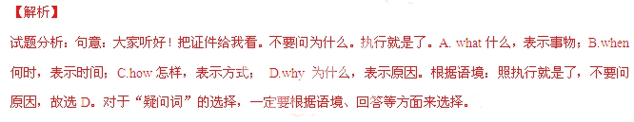
【考点定位】：考查疑问词辨析。
2.— is it from the New Town to the old city centre?
—Less than 30 minutes by underground.
A. How soon B. How often C. How long D. How far
【答案】D
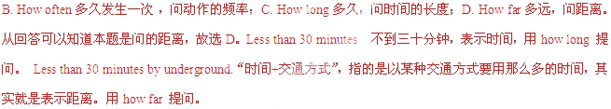
【考点定位】：考查疑问副词辨析。
3.It's really you not to tell your parents about the problems. Do you think you can solve them on your own?
A. smart of B. smart for C. silly of D.silly for
【答案】C
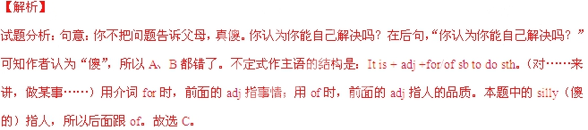
【考点定位】：考查形容词及介词辨析。
4.—I think we need to sit down and have a talk.
—I agree more. Let's take the bench over there.
A. could B. couldn't C. should D. shouldn't
【答案】B
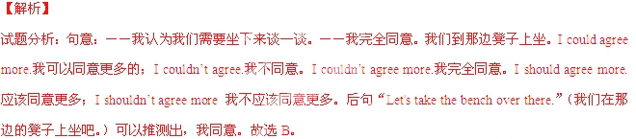
【考点定位】：考查情态动词。
5.The governments should the use of new types of energy to make a greener world.
A. push in B. push for C. put out D. put up
【答案】B
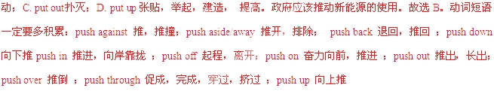
【考点定位】：考查动词短语辨析。
6.—The stuntman is planning to walk on the wings of a flying plane.
—What?! I've never heard of idea before.
A. a crazier B. the crazier C. a craziest D. the craziest
【答案】A
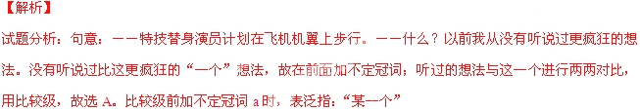
【考点定位】：考查形容词的比较等级及冠词辨析。
7.Why did she get so mad? It was only a joke.
A. hopeless B. hopeful C. harmless D. harmful
【答案】C
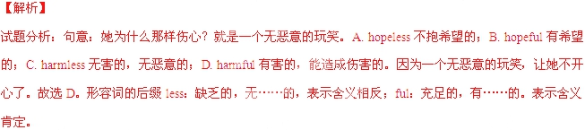
【考点定位】：考查形容词辨析。
8.—The school network will be shut down for safety reasons.
—That doesn't me at all.I'm not a net-worm, anyway.
A.satisfy B.surprise C.worry D.include
【答案】C
【解析】
试题分析：句意：――学校的络因为安全原因要关闭。――那根本不让我担心。至少我不是虫。A.satisfy满意；B.surprise惊奇，惊喜；C.worry担心，烦恼；D.include包括。后面说“我不是虫”，说明断不让我担心，故选C。worry sb某人担心；worry about sb 担心某人
【考点定位】：考查动词辨析。
9.Too many people were absent. The chairperson warned that he the meeting if necessary.
A. would cancel B. cancelled C. would start D. started
【答案】A
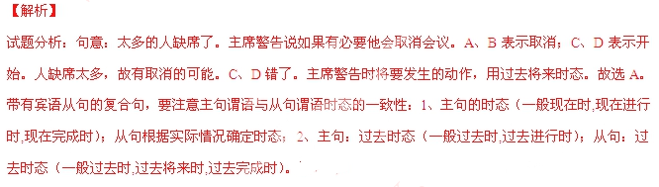
【考点定位】：考查动词辨析及宾语从句的时态。
10.—Is your sleeping problem getting better?
—No. And . They gave me the wrong medicine this time. Can you believe that?
A. a good miss is as good as a mile B. it never rains but it pours
C. the early bird catches the worm D. every dog has its day
【答案】B
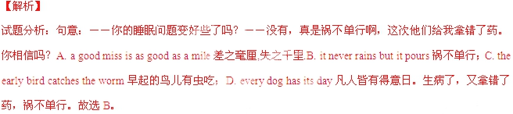
【考点定位】：考查英语谚语。
11.I think you should complain, , of course, you are happy with the situation.
A. unless B. however C. until D. though
【答案】A
【解析】
试题分析：句意：我认为你应该抱怨。当然，除非你对情况满意。A. unless如果不，除非，表示相反的条件；B. however然而，表示转折；C. until 直到，在……之前。表示时间；D. though尽管，虽然，表示条件。如果你对情况不满意，你就抱怨。表示相反的条件，用unless。故选A。连词的考点集中在两个方面，一是根据句意及语境来选择相应的连词（本题）；二是承接连词与并列连词不能连用，即although与but；because与so不能连用。
【考点定位】：考查连词。
12.—What language is that guy speaking? I can hardly catch a single word!
— . He's from India, so I guess it is Hindi.
A. Neither I can B. Neither can I C. So I can D. So can I
【答案】B
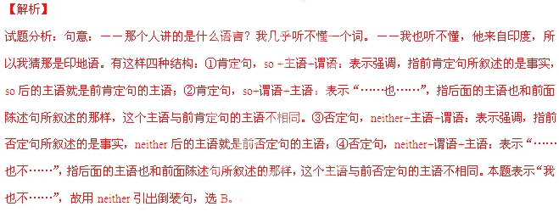
【考点定位】：考查倒装句。
13.I know he's been curious about everything, but that's . Be patient!
A. what do kids like B. what kids like C. what are kids like D. what kids are like
【答案】D
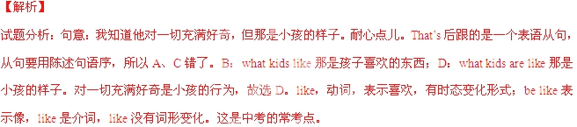
【考点定位】：考查宾语从句。
14.—I've decided to give up my job, Mum.
— You’d better think twice.
A. Sounds great! B. What a pity! C. Guess what? D. Are you serious？
【答案】D
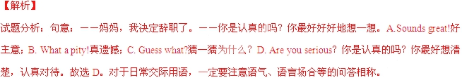
【考点定位】：考查交际用语。
二、完形填空 先通读下而的短文，掌握其大意，然后在每小题所给的四个选项中，选出可以填入空白处的最佳选项，并住答题卡上将该项涂黑。（本大题共 10小题，每小题1分，共10分）
I sat with my friend in a well-known coffee shop. As we enjoyed our coffee, a man entered and sat down beside us. He called the waiter and ordered, "Two cups of coffee, 15 of them there on the wall." We heard this with great 16 and saw that he was served with one cup of coffee but he paid for two. As soon as he left, the waiter 17 put a piece of paper on the wall saying "A Cup of Coffee". While we were still there, two other men had two cups of coffee but paid for three. 18 , the waiter did the same thing. It seemed that this was usual at this place. However, it was something strange for us. Since we had nothing to do with the 19 , we finished our coffee, paid and left.
After a few days, we again had a 20 to go to this coffee shop. While we were enjoying our coffee, a man entered. The way this man was dressed did not match the 21 of this coffee shop. As he seated himself, he looked at the wall and said, "One cup of coffee from the wall." The waiter served coffee to this man with the same 22 . The man had his coffee and left without paying. The waiter took off a piece of paper from the 23 and threw it in the dust bin. Now there was no 24 for us. The great kindness for the people in need shown by the people of this town filled up our eyes with tears.
15.A. both B. neither C. one D. none
16.A.joy B.interest C.effort D.fear
17.A. quickly B. suddenly C. wisely D. properly
18.A.Instead B.Again C.Indeed D.Anyway
19.A. shop B. waiter C. matter D. men
20.A. hurry B. time C. wish D. chance
21.A. style B. standard C. furniture D. colour
22.A.respect B.courage C.result D.custom
23.A. board B. table C. bill D. wall
24.A. choice B. clue C. doubt D. hope
【答案】
15.C
16.B
17.A
18.B
19.C
20.D
21.B
22.A
23.D
24.C
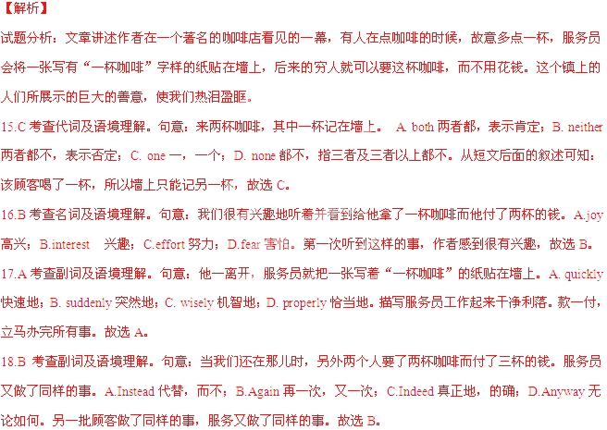
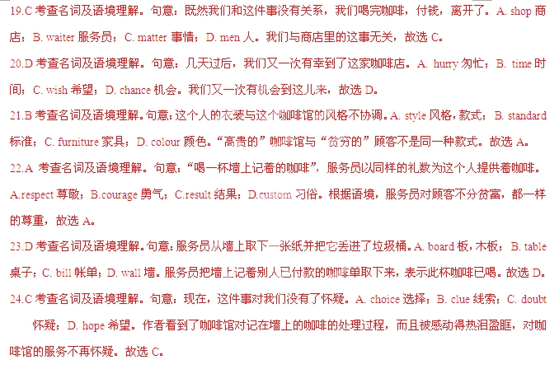
【考点定位】：考查生活故事类短文阅读。
三、阅读理解阅读下面的短文，然后根据短文内容，在每小题所给的四个选项中选出最佳
选项，并在答题卡上将该项涂黑。（本大题共13小题，每小题2分，共26分）
A
From: annel@freemai14all.com Sent: Wed., Oct. 19
To: tss_liam@kidstarmail.net
Subject: Hello!
-----------------------------------------------------------------------------------------------------------------------
Hi, Liam!
So you're my new pen friend. Let me tell you a bit about myself. I'm 14 years old and I live in
Calgary, Canada. I have two older brothers, Brian and Sam. I'm the only girl.
I love sports and I'm always looking for exciting new hobbies to try. I like playing baseball in winter.
It's fun beating the boys! But summer is my favourite time of the year. I love skateboarding and
rock climbing in summer.
Skateboarding's great because it's so fun and easy to learn! I often skateboard after school. There
are many places in the park where I can do stunts. I'm good at stunts like jumping and turning the
skateboard!
Rock climbing is also really fun. I usually climb with my dad on weekends. We can't do it on real
mountains very often because we live in the city. We do indoor rock climbing instead but it's not as
challenging.
So that's me! How about you? Please write back soon!
Bye for now!
Anne
25.Who wrote this email?
A. Liam. B. Brian. C. Sam. D.Anne.
26.What is the writer like?
A.Active. B.Shy. C.Lazy. D.Kind.
27.The writer sent this emailin order to
A. describe some exciting sports B. look for a suitable pen friend
C. make a self-introduction D. show others his/her hobbies
【答案】
25.D
26.A
27.C
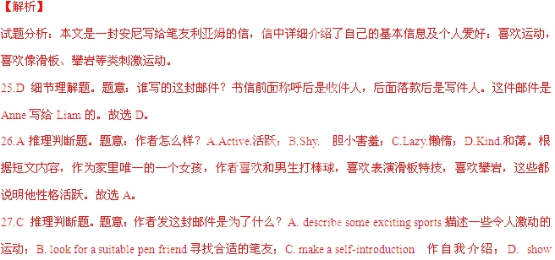
【考点定位】：考查书信类短文阅读。
B
SCENE I
One dollar a week
The doorway of the house where Chandler has a room. He is dressed in his best clothes, ready for
his evening out. He is going out as his friend, Jeff 'White, comes in.
WHITE What are you doing this evening, Towers?
CHANDLER (Smiling) Tonight I'm going to live like a man with a million dollars!
WHITE What are you talking about? You haven't got a million dollars!
CHANDLER How much money are you and I paid each week, Jeff?
WHITE Eighteen dollars. Why?
CHANDLER And how much of that eighteen dollars do you spend each week?
WHITE All of it, of course.
CHANDLER Well, I don't. Each week I save one dollar out of my eighteen. Then,
every ten weeks, I can buy myself an evening to remember.
WHITE What do you do?
CHANDLER I put on my finest clothes, go to one of the best restaurants in New York,
eat the most expensive food on the menu, drink the best wine, and then
take a taxi home!
WHITE ( 29 ) Why?
CHANDLER Why? Because it makes me feel wonderful to sit with some of 'the richest
people in America, and to make them think that I'm rich, too.
WHITE You're crazy!
CHANDLER (Laughing) Perhaps I am!
Mrs Black comes in.
MRS BLACK Ah, Mr Chandler. I wanted to see you.
CHANDLER Good evening, Mrs Black. What a lovely evening!
MRS BLACK Lovely evening perhaps, but you haven't paid me for your room this
month. When am I going to get the money?
CHANDLER Soon, Mrs Black. Very soon.
Mrs Black looks at Chandler s clothes.
MRS BLACK You can spend money on expensive clothes, but you can't pay for your
room. Is that right?
CHANDLER (Hurrying away) Good night, Mrs Black!
28.This is most probably part of .
A. a play B. a novel C. a poem D. a speech
29.Which of the following is the most suitable for 29 ?
A. Excited B. Surprised. C. Bored. D. Scared
30.What can we learn about Chandler?
A. He is a man of great wealth. B. He is a man of great wisdom.
C. He is not very practical. D. He is not very confident.
【答案】
28.A
29.B
30.C
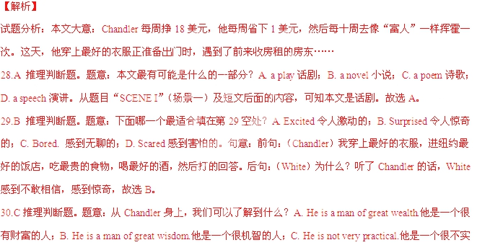际的人；D. He is not very confident.他不是很自信的人。一个周入18美元的人，却要去穿上最好的衣服，进纽约最好的饭店，吃最贵的食物，喝最好的酒……这样挥霍的人，不切实际。故选C。
【考点定位】：考查故事类短文阅读。
C
"Well, just take a look at that wheel（航轮）!” Earl Cooper said to Candy, his wife. "It must be older than anything we have back home."
Earl was looking at the wall outside the pub（酒馆）. The pub's name, The Old Swan, was on the wall. Next to the name was a wooden ship's wheel and in the middle of the wheel was the name of a ship, HMS Swan. The wheel was old, Earl could tell.
The next morning, Earl asked to see Tony Thatcher. The Old Swan was Tony's pub. He took Earl to his office while Candy had a coffee outside by the river. Earl said he could give Tony a lot of money for the ship's wheel. He told Tony that Benjamin Cooper, his grandfather, went to America on the ship HMS Swan. But Tony said no at first. After all, the wheel was very old and it was part of the pub's past.
"You can think of the past, Mr. Thatcher - can I call you Tony? - or you can think of today. And with the money, Tony, you can buy a good car. Maybe a new Jaguar? And, as I've told you, the wheel is part of my family's past too. So you could say it's going back home, in a way. So, what do you say?"
A month later, Earl and Candy were smiling as they looked at the wall of their house in Houston, Texas. Earl thought to himself that, at last, he had a piece of his family's past. He was happy.
In Portsmouth, Tony Thatcher was happy, too. He was putting his new Jaguar into his large garage（车库）. He was careful not to drive into any of the six ship's wheels in the garage. A friend of his made the wheels for him. They were just like the one that Earl bought. And there was another wheel on the outside wall of The Old Swan now. Old or new - Tony thought there was no way that a tourist could ever know which was which. Never in a hundred years.
31.Why did Tony refuse to sell the wheel at first?
Because he thought it was old and part of the pub's past.
Because he wanted to show it was important to his pub.
Because he tried to sell it to someone else at a higher price.
Because he did not really believe what Earl had told him.
32.What can we infer(椎断) from the story?
Earl had looked for such a wheel for a long time before that.
Earl would soon find out the truth and become rather angry.
Tony had sold quite a few wheels like that ancl got wealthy,
Tony would play the same trick again to make more money.[来
33.Which ofthe following can be the best title ofthe story?
A. The Wheel on the Wall B. An Excellent Buy
C. Old or New - Who Knows D. the Family's Past
【答案】
31.B
32.D
33.A
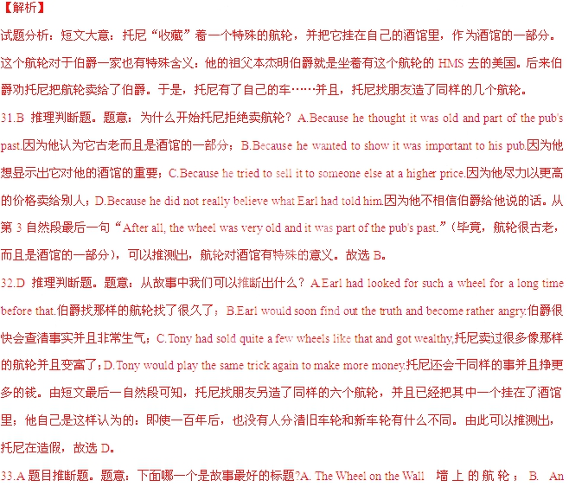 Excellent Buy一次极好的购买；C. Old or New - Who Knows旧的新的，谁知道？ D. the Family's Past家的过去。本文讲的是酒馆墙上的航轮，酒馆老板借此敛财，与航轮相关的人们做着非常认真的事。故本文最好标题是A。
【考点定位】：考查故事类短文阅读。
D
An early form of a game in which a ball was kicked around a field is recorded in 1004 B.C. Japan. Some sports historians believe that the game of soccer began in England in the third century, however. They say that early English warriors（武士） kicked around the head of a killed enemy. This may or may not be true, but it is certain that soccer is an ancient sport.
Without doubt, the English played soccer during the times of King Edward I in the 1300s. In fact, the king passed a law against playing it. The law said, "There is great noise ... caused by kicking large balls from which many ghosts may appear." Anyone caught playing soccer at that time was put into prison. Two hundred years later, Queen Elizabeth I still had people put into prison for playing this "vulgar" sport.
Although there were such laws, soccer grew more popular. In 1681 it became an official(正式的) sport in England. By the 1800s, people throughout the country played soccer. By the 18th century, upper-class boys played it at schools. Its popularity grew among all English people.
At a meeting held in an English school in 1843, the first rules were suggested. In 1863 the heads of English soccer teams met in London to agree on some official rules. They organized an English football association（协会）. By 1871 all of the English clubs were following these rules. Today all soccer teams play by them.
Soccer is called "football" everywhere but in the United States. The game is played mostly with feet. No players except the goalie (守门员 ) may touch the ball with their hands. They may control the ball with any part of the body except their hands.
Soccer is by far the world's most popular sport. Every four years, nearly every country in the world tlghts for the World Cup. Tens of billions of soccer fans from around the world watch the World Cup on television.
34.According to the passage, a "vulgar" sport probably
A. appears to be rude B. appears to be old
C. requires lots of energy D. requires good teamwork
35.Which ofthe following shows the right order ofthe development ofthe game?
Upper-class boy students played it at schools.
An English football association was organized.
It became a popular sport throughout England.
The rules were accepted by all English clubs.
Playing the game was considered to be guilty.
A. e-c-a-b-d. B. e-c-a-d-b. C. e-a-c-b-d. D. e-a-c-d-b.
36.What can we learn from the passage?
It is certain that soccer has a history ofover l,800 years.
The English had to play soccer in secret for two centuries.
Football is called "soccer" in the US because of the rules.
The king passed the law against the game for a stupid reason.
37.This passage is mainly about
A. why the game is so popular B. how the game has developed
C. what the game is like D. where the game first began
【答案】
34.A
35.C
36.D
37.B
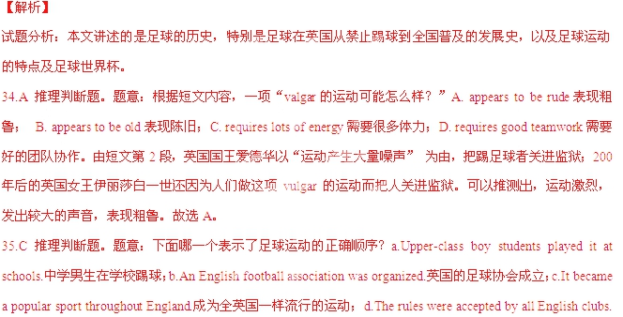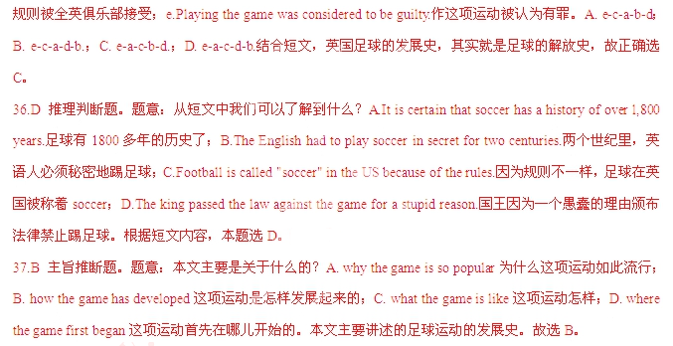
【考点定位】：考查文化类短文阅读。
笫II卷（主观题共40分）
四、词汇运用 （本大题共8小题，每小题1分，共8分）
(A)根据句意和汉语注释，在答题卡对应题号的横线上，写出单词的正确形式。
1.Life is like a （赛跑）.You either take the lead or fall behind.
2.I thought about what she had said and stayed （醒着的）all night.
3.Hey! Relax! No one will （强迫）you to do that if you're not willing to.
4.Many countries speak （高度地）of China's high-speed railway technologies.
(B)根据句意，在答题卡对应题号的横线上，写出括号内所给单词的适当形式。
5.Don't look at me like that! I'm telling you the （true).
6.It is not polite to ask a stranger questions about his （person) life.
7.Red lanterns are often （hang) along the streets before Spring Festival.
8.The new system is now （wide) used by IT companies all over the world.
【答案】
1.race
2.awake
3.force
4.highly
5.truth
6.personal
7.hung
8.widely
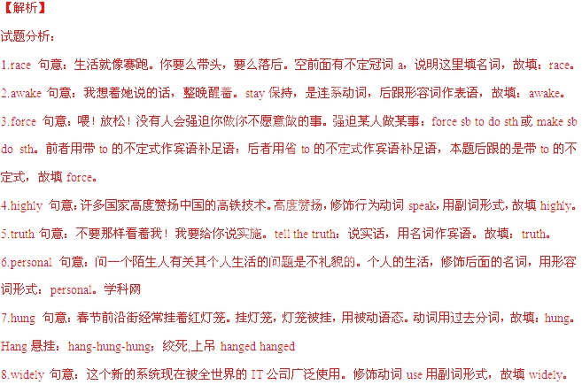
【考点定位】：考查词汇运用。
五、动词填空 用括号内所给动词的适当形式填空，并将答案写在答题卡对应题号的横线上。
（本大题共8小题，每小题1分，共8分）
1.Trust me. I (keep) it between you and me, I promise. Talk now.
2.I'm so sorry that I (not understand) you, but I do now.
3.Sally loves chocolate. -That (explain) why it's hard for her to lose weight.
4.If you have any trouble (use) the website,just click on this icon for help.
5.—Why didn't you answer my call?
—I (take) a shower. But I called you back as soon as I got out.
6.A big parade was held on Red Square (remember) the dead in World War II.
7.Cleverness is a gift; kindness is a choice. Gifts are easy - they (give) after all. Choices can be hard.
8.—Is the little baby in this photo me, Dad?
—It is. And now you (grow) into a young man. Where does the time go, huh?
【答案】
1.will keep
2.did not understand
3.explains
4.using
5.was taking
6.to remember
7.are given
8.have grown
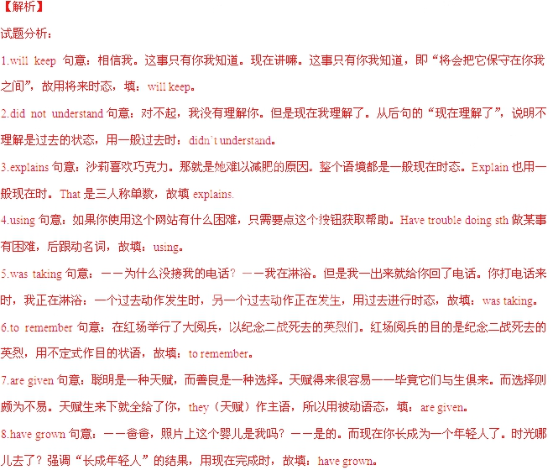
【考点定位】：考查词汇运用。
六、阅读填空 先通读下面的短文，然后根据短文内容，在文章后表格的空格内填入一个最恰当的单词。所填单词必须写在答题卡对应题号的横线上。每个空格只能填一个单词。（本大题共5小题，每小题1分，共5分）
A "blog"is a shortened name for a'web log". People write blogs about all kinds of things, from news and events to hobbies and reviews. Some people use them just as a simple record of what they have done.
“Blogging" has become very popular as more and more people use the Internet. New technologies have made keeping a blog an easy thing to do, so millions of people now have their own blogs. They are usually free to set up and are easy to update. You can upload pictures onto a blog and link to other websites. To many people, these features make blogs much more useful than traditional diaries.
We are now able to send texts, pictures and videos from our mobile phones directly onto the Web. New technologies like this are making blogging even easier, People also think that blogs are better than newspapers for finding out about news, events and opinions. They like to use blogs because they can get information from everywhere. It looks like blogs are going to become one of the most important ways to find and share information in the near future.

What is a blog? | •“Blog” is 1 for “web log”.  ••Writing blogs is like keeping a 2 online
Why are blogs so popular? | ••The number of the Internet users is 3 .  •They are easy to use and cost noting.
4 are blogs developing? | •Text, pictures and videos can be sent directly onto the Web from mobile  Phones now.  •Blogging will be one of the most important ways to find and share information 5 .
Title：Basic Knowledge of A Blog
【答案】
1.short
2.diary
3.increasing
4.How
5.soon
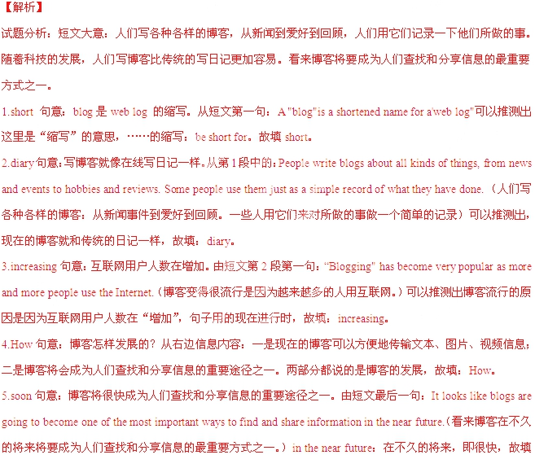 soon。
【考点定位】：阅读填空。
七、完成句子按所给的汉语，用英语完成下列句子，并将答案与在答题卡对应题号的横线上。（本大题共6小题，每小题1.5分，共9分）
1.我记忆中的父亲不苟言笑，对我严格要求。
In my memory, Father was a man of few words and he .
2.这些短信很无聊，不值得回复。
These short messages are so boring that they .
3.为生价值并不取决于你是谁，而是你做什么。
The value of life does not ，but what you do.
4.这对新人相爱多年，今天终成眷属。真好！
The new couple with each other for many years and they are finally
getting married today. How nice!
5.《新天鹅湖》的特别之处在于它是以现代方式编曲的。
What makes New Swan Lake special is that .
6.别做白日梦了！别指望你会碰巧引起导演的注意。
Stop daydreaming! Never expect that you'll .
【答案】
1.was strict with me
2.aren’t worth replying to
3.depend on who you are
4.have been in love
5.it’s made up in a modern way
6.happen to catch the director’s attention
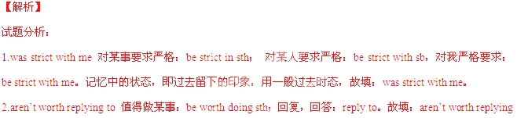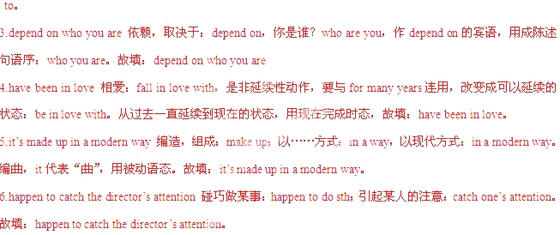
【考点定位】：完成句子。
八、书面表达（本大题共10分）
假设你是悉尼大学一名华裔学生，名叫Jason Wu。你从China Daily上看到该报正在开展主题为Change for a Better China的环保讨论活动。你打算结合自己所居住的小镇的变化，给报社写一封英文信参与讨论。内容提示见下表：
注意事项：
1．英文信须包括表格中所有提示内容，要求语句通顺、意思连贯；
2．表格中“感想建议”一栏须用2-3句话展开合理想象，作适当发挥；
3．词数在90个左右，信的首尾己在答题卡上给出，不计入总词数；
4．信件内容必须写在答题卡指定的位置上。
小镇概况 | Hartwell, 人口约5，0000， “澳洲最美小镇”之一
过去状况 | 当地人冬天燃木取暖，引起空气污染、树木被伐
应对措施 | 理发阻止此类活动，鼓励使用清洁能源
感想建议 | ……
参考词汇：
澳洲最美小镇(Australia's Nicest Towns) 清洁能源(clean energy)
【答案】
Dear Editor,
I am a student of Sdyney University. I am living in a small town called Hartwell with a population of around 5000.It is one of the “Australia’s Nicest Towns”. But things were very different in the past. The local people used to burn wood to keep their houses warm in winter. That caused serious air pollution and a lot of tress were cut down. Laws were soon made to stop this and people were encouraged to use clean energy. I think we can do something similar in China. Perhaps we can start with using less oil. I believe we can make our world a better place if we keep trying.
Yours sincerely,
Jason Wu
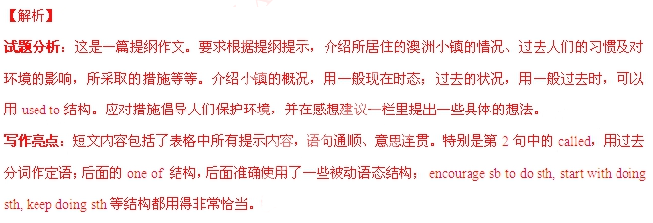【考点定位】：考查提纲类短文写作。

