2013 江苏泰州中考英语试题
(总分：120分 时间：120分钟)
选择题(共70分)
一、 单项填空(共15小题；每小题1分，满分15分)
从A、B、C、D四个选项中，选出可以填入空白处的最佳选项。
【2013江苏泰州】( )1. — His you heard of Hou Yifan, ________ female world chess champion(冠军)?
— Yes, she is from ________ Taizhou. We're proud of her.
A. B. C. D.
1.【答案】 A
【2013江苏泰州】( )2. — How can I get more information about the donation to Ya'an?
— You can e－mail Mr Wang ________ yaanearthquake@163.com.
A. on B. in C. at D. by
2.【答案】 C
【2013江苏泰州】( )3. — Shall we go ________ on Sunday? I love water sports.
— That's a good idea.
A. hiking B. swimming C. cycling D. skating
3.【答案】 B
【2013江苏泰州】( )4. — Have you got anything to do this afternoon, Lucy and Lily?
— Yes. ________ of us are going to the home for the elderly.
A. Each B. Either C. Both D. All
4.【答案】 C
【2013江苏泰州】( )5. Don't be crazy about computer games, ________ your parents will be worried.
A. and B. or C. but D. so
5.【答案】 B
【2013江苏泰州】( )6. — What do you think of the song “You and Me”？
— It ________ great. I love singing it.
A. tastes B. looks C. smells D. sounds
6.【答案】 A
【2013江苏泰州】( )7. — Here comes the bus! Where is our principal?
— She can't go to the museum with us. She ________ some visitors around our school.
A. is showing B. shows C. has showed D. was showing
7.【答案】 A
【2013江苏泰州】( )8. — Don't keep water running when you wash hands.
— ________．
A. I hope so B. I'm afraid not C. Sorry, I won't D. It's nothing
8.【答案】 C
【2013江苏泰州】( )9. “I'm a singer” is ________ an interesting TV show ________ many people like watching it.
A. so; that B. such; that C. so; as D. such; as
9.【答案】 A
【2013江苏泰州】( )10. — It's ________ of Yang Xiangming to save the boy who fell into the river.
— Yes. He is a great man of our times.
A. patient B. energetic C. brave D. confident
10.【答案】 C
【2013江苏泰州】( )11. — “Frog”， Mo Yan's latest novel, please!
— Sorry, it ________ just now. But it will come out again soon.
A. sold out B. is sold out C. has sold out D. was sold out
11.【答案】 D
【2013江苏泰州】( )12. — I feel stressed from time to time. Could you give me some advice?
— ________ sharing your worries with your parents?
A. Why don't you B. How about
C. Why not D. Would you like
12.【答案】 B
【2013江苏泰州】( )13. — It's too hard for me to be a trailwalker.
— Never ________. Believe in yourself!
A. put up B. give up C. hurry up D. look up
【答案】 B
【2013江苏泰州】( )14. — I'm sorry that I shouted at you this morning.
— ________， but please don't get angry so often.
A. All right B. No problem C. Never mind D. With pleasure
【答案】C
【2013江苏泰州】( )15. — Would you please tell me ________？
— Bus No.22 will take you there.
A. who will we go with to Meilanfang Theater
B. what can we see in Qinghu Wetland Park
C. when we will leave for the Weland Park
D. how we can get to the Old Street
15.【答案】 D
二、【2013江苏泰州】 完形填空 阅读短文，从每题所给选项中选出可以填入空白处的最佳选项。(15分)
What comes to your mind when you talk about donations? You probably think of a group of people with __16__ in hand asking people to donate money. But my school came up with a __17__ way of raising funds—Fun Night.
Fun Night is like a party. Students pay money to get in and have dinner at school. The __18__ they pay will go towards helping poor children __19__.
Two months ago, I took part in Fun Night. There were all kinds of __20__ in Fun Night. The most popular game was the “jousting ring”(夺环). I “jousted” with several of my __21__ and managed to knock plenty of them off the ring. __22__， they developed different strategies(策略) to win, such as starting in a crouched position(蹲姿) to gather more strength when pushing.
Sometimes they attacked me __23__ I was ready. It would usually be __24__ as cheating(作弊), but we didn't care and __25__ playing. After all(毕竟), it was just a game, not __26__.
The best of Fun Night was not the fun activities. The fact was that we raised a lot of money by having a __27__ time. A lot of students at my school wouldn't __28__ money if they were simply asked to hand it over. But this kind of event not only made them __29__ to give, but also allowed them to have a great time playing games with friends. I realized that __30__ can be fun. We raised 2，000 yuan on that night.
( )16. A. boxes B. books C. schoolbags D. clothes
( )17. A. common B. different C. silly D. realistic
( )18. A. sit B. attention C. stationery D. money
( )19. A. in danger B. in need C. in trouble D. in love
( )20. A. cheeches B. subjects C. games D. lessons
( )21. A. neighbours B. cousins C. visitors D. friends
( )22. A. However B. Luckily C. Otherwise D. Hopefully
( )23. A. brfore B. unless C. after D. if
( )24. A. named B. considered C. described D. discovered
( )25. A. finished B. started C. continued D. stopped
( )26. A. a competition B. an opinion C. a research D. an experiment
( )27. A. tiring B. hard C. long D. good
( )28. A. save B. make C. donate D. spend
( )29. A. afraid B. glad C. sorry D. angry
( )30. A. friendship B. knowledge C. charity D. experience
【主旨大意】本文是一篇记叙文，记叙了传统的捐款都是拿着箱子叫人们捐钱，而我们学校是通过“愉快的夜晚”来组织一系列的活动，同学们出钱才可以参加这样的活动，从而达到了为贫穷地区孩子筹款的目的。
16. A17. B18. D19. B20. C21. D22. A23. A24. B25. C26. A27. D28. C29. B30. D
三、 阅读理解 阅读下列短文，根据短文内容选择最佳答案。(40分)
(A) 【2013江苏泰州】
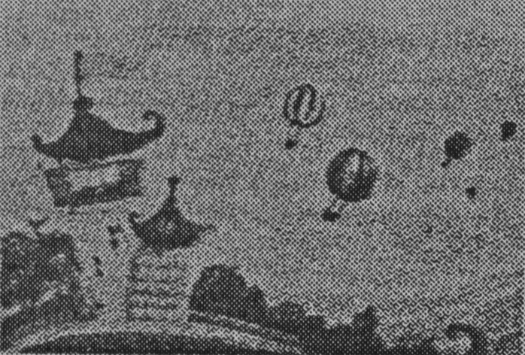
(Renee—a beautiful princess Broo—a blue bear Nahloo—a magical place)
When the Princess Renee heard about Broo, she came down form her castle. She found Broo while he was buy eating honey.
“Mr. Bear，” the Princess said, “you can welcome in Nahloo. Here we share with each other. We don't take things from each other.”
Broo thought about it for a moment and realized that he had made a mistake. “Well, he said, ”“maybe drinking all that milk wasn't the best idea.”
The Princess continued, “Mr. Bear, you can drink and eat, but you won't feel good because you have never made any contributioin to anyone else. I think you'll find that it is better to be full in your heart, not just in your stomach.” After saying this, the Princess went back to the castle, leaving Broo alone.
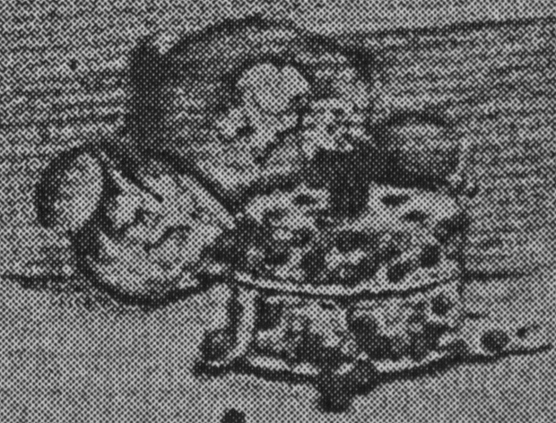
One day, Broo was going to take lots of cookies from the rabbits, then he remembered what the Princess said to him. So Broo decided not to eat the cookies. The rabbits were surprised and said, “Thank you for your kindness, Mr. Bear. Now these cookies will taste sweeter because they are given by you, my friend. If you like, come back tomorrow and we can have the cookies together.”
Broo was filled with joy and went through the land. He gave back everything he had taken. In ceturn, he received a promise from everyone to share their food with him. Broo was so singted that he started dancing in the moonlight with the Princess as his partner.
( )31. What the Princess Renee came down, Broo was ________．
A. watching with rabbits B. eating honey
C. living everything back D. having cookies.
( )32. In Nahloo, ________．
A. the Princess Renee stayed with Broo all the time
B. everyone was happy to share with each other
C. Broo took a lot of cookies from rabbits
D. Broo never realized his mistake
( )33. Broo felt ________ after he gave the cookies back to the rabbits.
A. sad B. surprised C. happy D. hungry
( )34. The passage is probably form ________．
A. an advertisement B. a tour guide
C. an application D. a story book
( )35. What can we learn from the passage?
A. It's better to give than to receive.
B. Every dog has its day.
C. The early bird catches the worm.
D. Many hands make light work.
【答案】31. B 32. B 33. C 34. D 35. A
【主旨大意】本文属童话故事。讲述了一位漂亮的公主教育一只蓝色的熊要学会奉献，不要总是想着吃，否则不会快乐的。后来， 这只熊在公主的影响下学会与别人分享一切，从此人间变得更加的美好。
(B) 【2013江苏泰州】
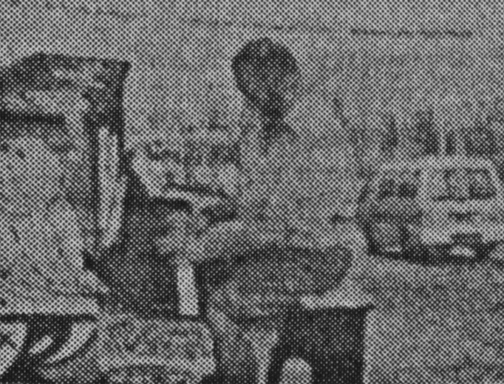
Perhaps your childhood piano lessons made you never want to play the piano again. Perhaps a piano is too expensive for you to afford. Now, thanks to a program in Sydney called “Play Me, I'm yours”， people are able to play the piano in public places for free. They share beautiful music, and the program also helps them communicate with each other.
Thirty pianos have been placed in different parts of the city, including in several parks, at a bus stop and on some streets. The pianos have the logo “Play Me, I'm yours” on them. People are invited to play music or sing songs with the pianos, no matter what level of ability they have. Lots of people have been attracted to the program and stopped to watch or play the pianos.
“Play Me, I'm yours” is a part of the Sydney Festival. It is a project of the British artist, Luck Jerram. He wants to help people in the city connect with each other. He thinks that so many people are sitting in front of computers and busy with their work all hours, and they almost have no chance to enjoy music. So the purpose of the project is to help them relax and make new friends.
The program “Play Me, I'm yours” has also reached England and Brazil(巴西) before. It was warmly welcomed there. But its greatest success seems to come at the Sydney Festival. “It's a chance for people to be creative, connect with strangers and just have some fun，” Jerram said.
( )36. According to the first sentence of the passage, your childhood piano lessons may be ________．
A. boring B. valuable C. interesting D. meaningful
( )37. Thirty pianos are placed in parts of the city except ________．
A. in parks B. at a bus stop C. on streets D. in a school
( )38. The aim of the project is to help people ________．
A. sun songs B. play the piano for free
C. relax and make friends D. enjoy beautiful music
( )39. ________ countries have had the program.
A. Two B. Three C. Four D. Five
( )40. What can be the best title for the passage?
A. Beautiful music B. A British artist, Luck Jerram
C. The Sydney Festival D. A program “Play Me, I'm yours”
【答案】36. A 37. D 38. C 39.B 40. D
【主旨大意】本文属于叙事的记叙文。记叙了卢克举行的公益活动“请弹吧，我就是你的！”，让更多的人坐在钢琴前弹奏得以放松的同时，也为人们之间的交流提供了一个机会。

(C) 【2013江苏泰州】
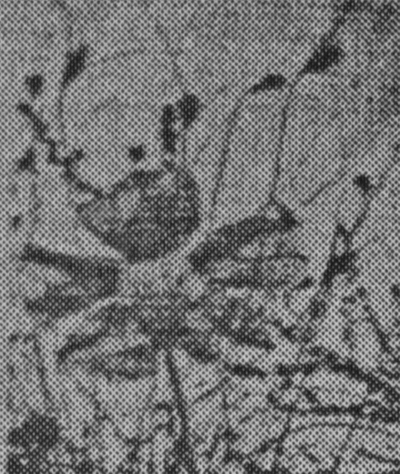
A well－known poem by Tang dynasty poet Du Mu tells of a sad scene in early April: “Rains fall heavily as Qingming comes, and passersby with lowered spirits go.”
This scene takes place on Tomb Sweeping Day, also known as Qingming Festival. Tomb Sweeping Day is a traditional Chinese festival. It began in the Zhou dynasty, over 2,500 years ago. Chinese people celebrate it to remember and honor their ancestors(祖先). This year, it falls on April 4. Tomb Sweeping Day became a public holiday in the Chinese mainland in 2008. People have one day off for that day.
On this day, families bring flowers, food and wine to the grave sites(墓地) of their ancestors. They place cakes, fruits in front of the graves and some may burn joss paper, as money for the dead. After that, they sweep the tombs and cherish(怀念) the memories of their dead family members.
Tomb Sweeping Day gives us a chance to show respect to our ancestors and family members who have passed away and show that we miss them. This tradition shows that family values are an important part of Chinese culture.
Tomb Sweeping Day is also the beginning of the time for gardening and outdoor activities in China. Families often get together for outings or to fly kites at this time.
( )41. The Chinese meaning of the underlined word “passersby” is ________．
A. 行人 B. 陌生人
C. 故人 D. 古代人
( )42. Tomb Swepping Day is celebrated for people to ________．
A. go out to fly kites
B. have a public holiday
C. get together with their families
D. remember and honor their ancestors
( )43. What can people take to the grave sites according to the passage?
A. Flowers, food, fruits and umbrellas.
B. Flowers, food, wine and joss paper.
C. Food, fruits, joss paper and kites.
D. Flowers, wine and pets.
( )44. Which of the following is NOT mentioned in the passage?
A. We have on day off for Tomb Sweeping Day.
B. Tomb Sweeping Day began in the Zhou dynasty.
C. People in the world celebrate Tomb Sweeping Day.
D. Family values play an important role in Chinese culture.
( )45. What does the passage mainly discuss?
A. People bring many things to the grave sites.
B. Du Mu wrote a poem about Qingming
C. Tomb Sweeping Day is a traditional Chinese festival.
D. Qingming Festival is a good time for outdoor activities.
【答案】41. A 42. D 43. B 44. C 45. C
【主旨大意】本文是一篇说明文，介绍了中国的传统节日—清明节的起源以及人们祭祀祖先的活动目的和意义。

(D) 【2013江苏泰州】
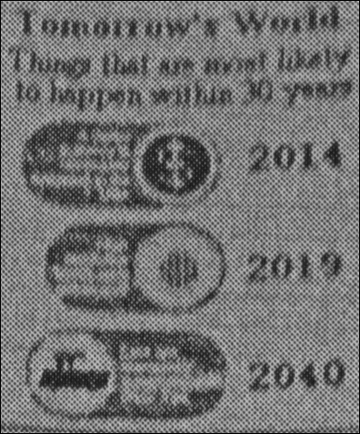
What's going to happen in the future? Will robots control our planet? Will computers become smarter than us? Not likely. But here are some things that scientists say are most likely to happen in 10 to 30 years from now, according to the BBC.
Digital money
We used to pay with cash(现金) for everything we bought. Now when we use a credit card(信用卡) to shop online, money is spent without us seeing it. That means we are already using digital money. Using a card is much easier than searching our pockets for change. It is also safer than carrying a lot of cash.
When ATM cards were first introduced, they were not accepted everywhere. But now it's hard to live without them. It's reported that people in Sweden completely stopped using cash last year, and the US might be next.
Bionic(仿生的) eye
It's no longer something only in a science fiction movie. People who are blind may have a chance to get their sight back—by wearing bionic eyes.
A blind eye can no longer sense light, but a bionic eye can use a camera to “see” the environment and send data(数据) to the mind. Now the bionic eye only allows patients to see lights and unclear shapes. A high resolution(高清的) image could be just a few years away.
Self－driving cars
Unlike a human driver, a self－driving car won't get distracted(分钟) by phone call, the radio or something outside the window. Sensors(探测器) and cameras on the car would allow it to stick reduce the number of road accidents. You could even take a nap while the car driver itself. In the future, driverless cars would be widely accpted.
( )46. ________ has stopped using eash completely.
A. Swden B. ATM C. BBC D. America
( )47. What does the writer mainly tell us about digital money?
A. We use digital money to shop online without paying money.
B. Digital money is most likely to be used instead of cash.
C. Using cash is easier and safer than a credit card.
D. ATM cards are always popular.
( )48. Which of the following statements is TRUE?
A. Bionic eyes only appear in the science fiction film.
B. Human drivers won't get distracted by something outside.
C. The blind wearing bionic eyes may see clearly in the future.
D. There will be no road accidents at all if self－driving cars are used.
( )49. From the report, we can learn some information about ________．
A. culture and art
B. industry and farming
C. science and technology
D. traffic and journey
( )49. Which of the following can be predicted(预测) from the passage?
A. There would be a number of self－driving
B. The blind could use cameras to see things around.
C. We would live a hard life with digital money.
D. Robots would control the world.
【答案】46. A 47.C 48.C 49.C 50.A
【主旨大意】本文是一篇科普文章。BBC介绍了未来10－30年科技发展中电子货币，仿生眼，无人驾驶汽车对人们日常生活中重大变化。

非选择题(共50分)
四、 【2013江苏泰州】阅读表达 阅读短文，按要求完成短文后的各项任务。(10分)
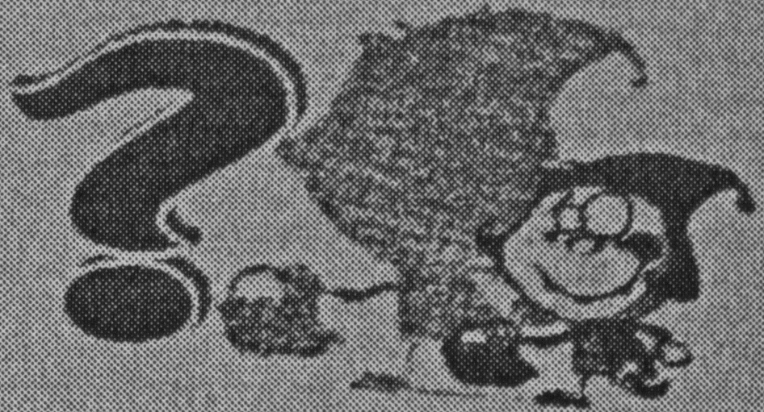
Have you ever thought about one question: why do we need to learn math?
It is an interesting question. Kids around the world have been asking it for years. For US students, they may get the answer from a new exhibition called “MathAlive!” (1) 47 activities are designed to teach kids how math is used in everyday life. For example, at one exhibiton station, visitors can test that a person's arm span(臂展) equals their height. At another station, visitors can control the robot with the help of math skills.
The exhibition will visit 15 US and international cities in the next five years. Organizers say they want more kids to learn why math is important in daily life. Think of simple things, like clocks. They tell time, but only if you know how to read them. That means using math. How much longer until school ends? How long did you sleep last night? That's all math, too.
(2) When you go ________， you also do lots of ________. How much change would you get if you paid for a 25.99－yuan sweater with two twenties? How would you calculate a 30% discount? Even when you're not doing math, it's all around you. The computer you use to surf the Internet is a machine to do binary (二进制) math very fast.
So enjoy math, not for exams, but for the wonderful world it helps to build.
1. 将(1)句译成中文。
2. 在(2)句的空白处分别填入一个适当的词使句意完整、上下文通顺。
3. 回答问题：Why will the organizers hold the exhibition in 15 US and international cities?
4. 在文中找出与Math skills can help visitors control the robot at the exhibition.意思相近的句子，并将它写在答题卡上。
5. 在文中找出最能表达该短文主题的句子，并将它写在答题卡上。
【主旨大意】本文介绍了美国人设计47项来让孩子们认识在日常生活中使用数学的重要意义。
【答案】1.设计47项活动来教育孩子们在日常生活中如何使用数学。
2.shopping, match
3.Because they want more kids to learn why math is important in daily life.
4.Visitors can control the robot with the help of match skills.
5. So enjoy match, not for exams, but for the wonderful world it helps with build.

五、词汇运用 用括号内所给词的适当形式填空(每空不限一词)。(10分)
【2013江苏泰州】1. I think Wu Qilong is one of the most popular ________(actor). I am his fan.
【2013江苏泰州】2. If you can answer all the questions ________(correct), you will get a gift form the host.
【2013江苏泰州】3. Who do you think is the most suitable for the ________(student) Union?
【2013江苏泰州】4. To reduce air pollution, we'd better ride more often instead of ________(drive)．
【2013江苏泰州】5. — Did you hear anything ________(usual) in the next door?
— No, I was chatting online with friends.
【2013江苏泰州】6. David fell ________(sleep) in class because he stayed up too late last night.
【2013江苏泰州】7. Take exercise one hour a day, you'll become ________(healthy) than before.
【2013江苏泰州】8. We organized a lot of activities to celebrate our school's ________(fifty) birthday last month.
【2013江苏泰州】9. Wearing red can help you make a ________(de)
【2013江苏泰州】10. We're talking about where ________(spend) our coming summer holiday.
【答案】1. actors 2. correctly 3. students' 4. driving 5. unusual 6. asleep 7. healthier 8.fiftieth 9.decision 10. to spend
六、【2013江苏泰州】 短文填空 根据短文内容及首字母提示，补全空格内单词，使短文完整、通顺。(10分)
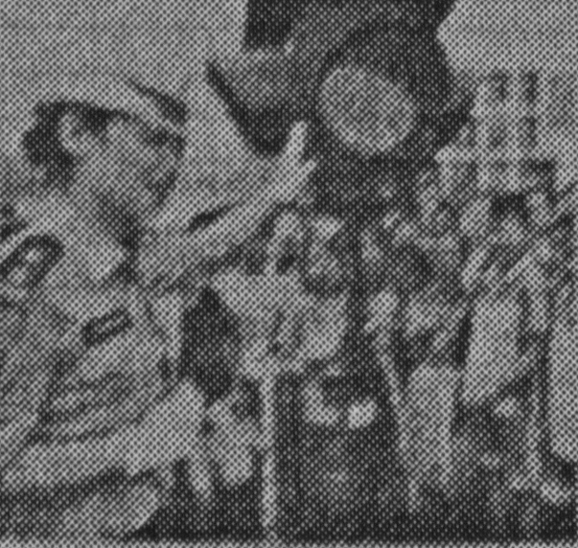
How can we students keep ourselves safe? Here are some tips.
On your way home or to school: Wait for the g__1__ traffic light, and look left and right before you cross the road. If you see a car coming, don't cross until it really s__2__. Dress in bright colors, so the drivers can see you e__3__.
At school: When students around you begin to push, try to hold onto something, or stay in a safer corner. If you f__4__ down in a crowed place, cover your head w__5__ both hands.
When there's a fire: Stay calm and leave quickly. Use a piece of wet cloth to cover your mouth and nose so that you don't breathe in s__6__. If your clothes catch fire, drop to the ground and roll from side to side to p__7__ out the fire.
For eating: Wash f__8__ like apples or pears carefully before you eat them. Cheek the expiration dates(保质期) and if your food looks or smells b__9__， don't eat it.
For riding on the escalator(自动扶梯): Hold onto the handrails(扶手) and stand on the right side of the escalator because right arms are stronger. It is d__10__ to run up and down on them. You may fall down because escalator steps are ont designed for running.
【答案】1. green 2. stops 3. clearly 4. fall 5. with 6. smoke 7. put 8. fruit 9. bad 10. dangerous
七、 【2013江苏泰州】书面表达(20分)
校团委正举行“畅想未来”的征文活动，请根据提示，以“My ideal school life”为题，写一篇100词左右的短文。
现 在 | 未 来
至少写两点现在的情况。 | 1. 多彩的校园生活(课外活动……)
至少写两点现在的情况。 | 2. 多样的学习方式(网上学习……)
至少写两点现在的情况。 | 3. 和谐的人际交往(交友互助……)
至少写两点现在的情况。 | 4. 丰富的校外活动(做志愿者……)
要求：
1. 所写内容必须包括表格中所有的信息，并作适当的发挥；
2. 开头及结尾已给出，不计入总词；
3. 不得出现真实的人名、校名、地名等相关信息。
My ideal school life
I am a student in Grade 9, ______________________________________________________

I hope ______________________________________________________________________

This is my ideal school life. I hope my dream will come true some day.
【答案】
My ideal school life
Everyone has their own ideal school. I think my ideal school life is meaningful and colorful. I’m very happy to study in the school.
We have five classes every day. I like all the lessons, because the lessons are very interesting. And we can choose our favorite lessons to learn. At noon, we have an hour’s rest time. During the rest time, we can chat with classmates.
I hope our after-school activities are rich and colorful. We can play many ball games after school every day. There are many organizations and clubs in our school. I would like to join in the organizations which I am interested in. I would like to join many clubs. too. Of course, if you want to live in the school, you can do it. Most of the students like staying in school ,because the school is very comfortable.
Doing homework is part of the school life, but the work is not much, and very easy. We often use emails to send our homework to the teacher. Our teachers and classmates are very helpful and kind. If you have a problem, you can ask the teacher and classmates, they will help you. During my holidays, I want to be volunteer to help others in need.
In a word, my ideal school is like this. I hope my dream will come true one day.

