徐州市2012年初中毕业、升学考试
英 语 试 题
姓名 考试证号

注意事项
- 考生答题前请认真阅读本注意事项及各题答题要求。
- 答题前，请将自己的姓名、考试证号用0.5毫米黑色墨水签字笔写在本试卷及答题卡指定的位置。
- 答案全部涂、写在答题卡上，写在本试卷上无效。考试结束后，请将本试卷和答题卡一并交回。

一、选择填空（共15小题，每小题1分，满分15分）
从A、B、C、D四个选项中选出可以填入空白处的最佳选项。
- “Will the charity show be ________ success?” I kept asking myself.
A. a B. an C. the D. 不填
- The 30th London Olympic Games will begin _______ 27th July 2012.
A. in B. on C. at D. for
- ----That’s a heavy box. Can I give you a hand?
----______. I’m strong enough to carry it.
A. Yes, you could B. Sure C. No, thanks D. No, never mind
- Which animal comes from China?

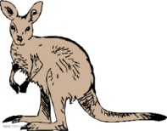

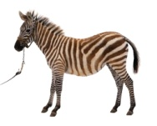

A B C D
- Don’t forget to take your bag when you ________ the bus.
A. get off B. take off C. turn off D. put off
- ----________ shall we paint the walls?
---- I prefer white. It makes us feel calm and peaceful.
A. How B. How often C. Why D. What colour
- ----How many birds can you see in the tree?
----_______. All the birds have flown away.
A. None B. No one C. Nothing D. A few
- ----Why not _______ John a toy car for his birthday?
----Good idea! He is crazy about cars.
A. buy B. buying C. to buy D. buys
- I know a little about Thailand, as I ________ there three years ago.
A. have been B. have gone C. will go D. went
- You can choose to watch TV at home _______ go shopping with me.
A. and B. but C. so D. or
- ----Why are you so _______,Amy?
----I thought I lost my purse, but I didn’t. I found it in my study!
A. angry B. happy C. sad D. nervous
- The room _______ every day. You can live it now.
A. cleans B. is cleaning C. is cleaned D. has cleaned
- Which is a traffic sign?
A. B.
KEEP QUIET
DO NOT DISTURB

C. D.
TURN LEFT
SOLD OUT

- ----Tom, please tell me____________.
----In Sunshine Second School.
A. where will the match take place B. where the match will take place
C. when will the match take place D. when the match will take place
- ----Hurry up, we must be the first to interview the pop star.
----Sure.____________.
A. East or west, home is the best B. The early bird catches the worm
C. Many hands make light work D. Don’t put all your eggs in one basket
二、完形填空（共15小题，每小题1分，满分15分）
根据短文内容，从各题所给的A、B、C、D四个选项中选出最佳选项。
Lisa has always been overweight. She wanted to lose weight, not just because she wanted to 16 more beautiful and he healthier, but also because it would make life easier. For example, it was 17 for Lisa to find ready-made clothes that would fit. She had to ask a tailor(裁缝) 18 clothes that were large enough. In school, she needed a special chair 19 was bigger and stronger than the other chairs. If she went for a walk, she got tired very quickly. She was also unhappy about the way people treated 20 sometimes. “People look at me and even make fun of me. That’s unfair! It’s true that I’m overweight, but I don’t think people 21 treat me differently because I’m big. I can’t enjoy 22 with my friends because I’m afraid of getting fatter.” Her friends and family never made fun of her. They tried to help her 23 . They wanted her to be happy and healthy. Sometimes when Lisa was feeling sad, she didn’t want to speak to 24 .
But now things 25 quite different. Last month her classmates were preparing for the School 26 Week. Someone advised Lisa to play the lead role of the proud Queen(女王) who was tall and fat. Lisa 27 and practiced a lot.
Soon after the play, Lisa became the star! She did 28 well that everybody remembered the proud Queen. They stood around her and said “ 29 ” to her. She even won the School Best Actress Award for her wonderful performance.
Now Lisa doesn’t worry 30 being fat any more. She believes in the English saying “Every dog has its day.”
- A. see B. watch C. notice D. look
- A. easy B. difficult C. wrong D. right
- A. making B. makes C. make D. to make
- A. who B. what C. which D. whose
- A. her B. him C. me D. you
- A. can B. may C. should D. must
- A. having dinner B. to have dinner C. doing sports D. to do sports
- A. however B. instead C. though D. either
- A. nobody B. someone C. anyone D. everyone
- A. was B. is C. were D. are
- A. Sports B. Art C. Science D. Environment
- A. agreed B. disagreed C. refused D. allowed
- A. very B. too C. such D. so
- A. Sorry B. Good luck Congratulations D. Good-bye
- A. with B. about C. in D. for
三、阅读理解 （共10小题，每小题1.5分，满分15分）
阅读下面三篇短文，从各题所给的A、B、C、D四个选项中选出最佳选项。
A
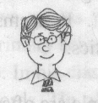
Saturday, 17th March  Today I got my dream job in New York! However, it’s far away from my home town and I’ve never visited New York before. Yesterday I took the train here and one of my workmates met me at the railway station. Then he showed me to the company. There they had a welcome party for me. Great!  My company offered no living place, so I had to find somewhere to live. I stayed in a hotel while I looked for a new home. | Sunday, 1st April  I’ve found the perfect flat! It’s small but very nice. It’s near my office, so I can walk to work. The only problem is that it’s $1,000 a month. That’s too much for a young man like me!  I’ve soon got used to the life here. I love it! There’s a supermarket nearby and some restaurants I can go to when I do not want to cook. My workmates and new neighbours are friendly. It’s April Fool’s Day today and I even played a trick on my neighbour next door. Cool!

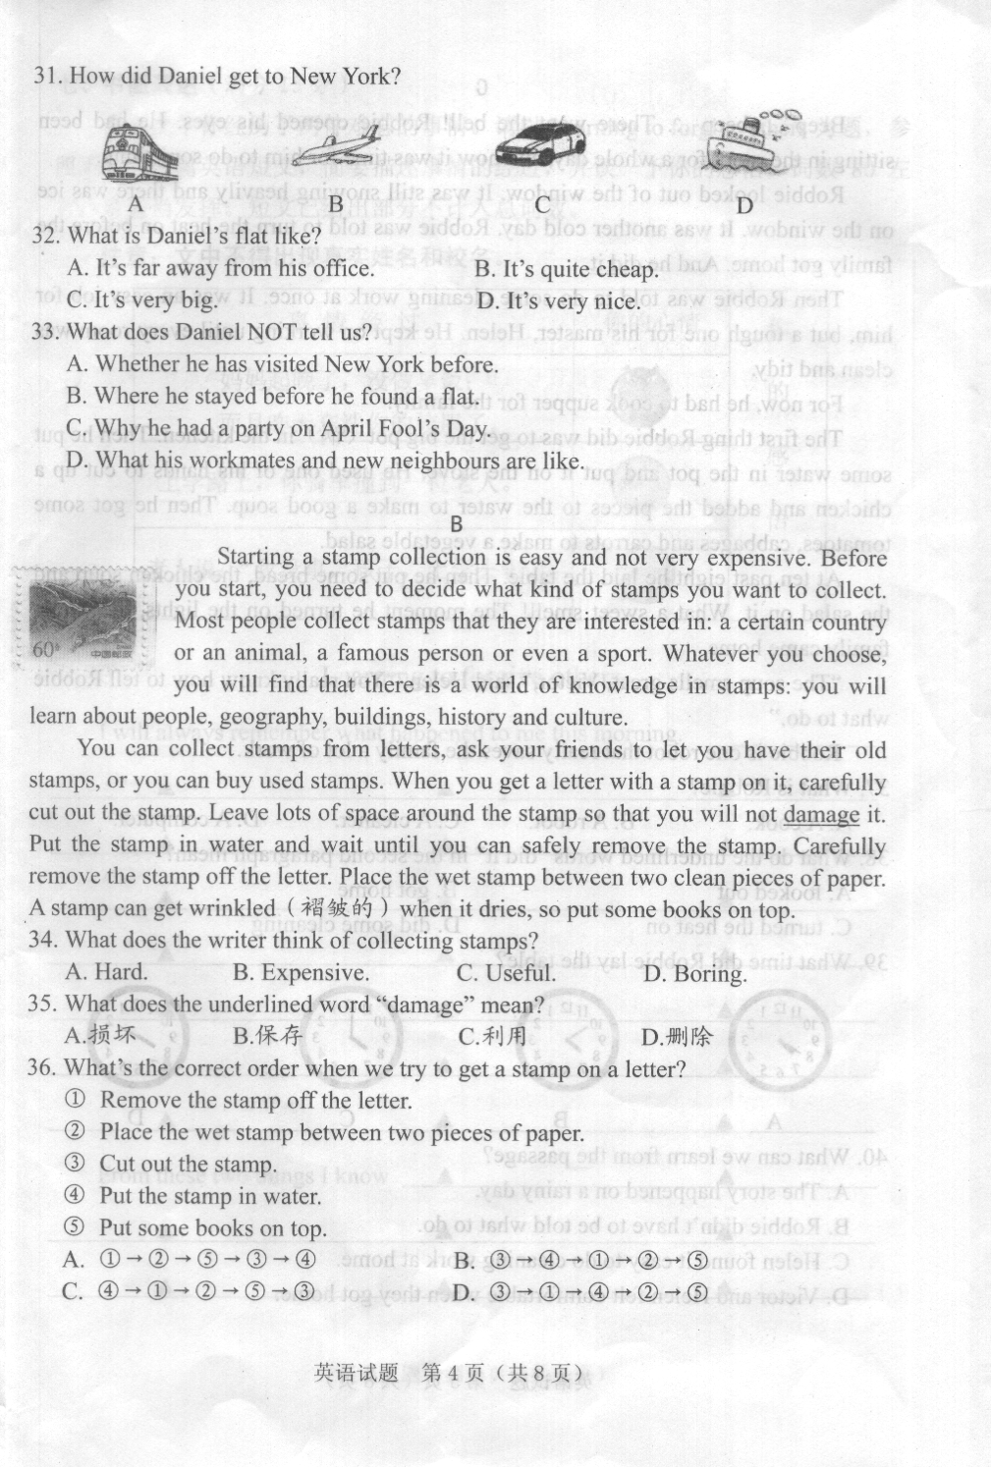
- How did Daniel get to New York?

- What is Daniel’s flat like?
A. It’s far away from his office. B. It’s quite cheap
C. It’s very big. D. It’s very nice.
- What does Daniel NOT tell us?
A. Whether he has visited New York before.
B. Where he stayed before he found a flat.
C. Why he had a party on April Fool’s Day.
D. What his workmates and new neighbours are like.
B
Starting a stamp collection is easy and not very expensive. Before you start, you need to decide what kind of stamps you want to collect. Most people collect stamps that they are interested in: a certain country or an animal, a famous person or even a sport. Whatever you choose, you will find that there is a world of knowledge in stamps: you will learn about people, geography, building, history and culture.
You can collect stamps from letters, ask your friends to let you have their old stamps, or you can buy used stamps. When you get a letter with a stamp on it, carefully cut out the stamp. Leave lots of space around the stamp so that you will not damage it. Put the stamp in water and wait until you can safely remove the stamp. Carefully remove the stamp off the letter. Place the wet stamp between two clean pieces of paper. A stamp can get wrinkled(褶皱的) when it dries, so put some books on top.
- What does the writer think of collecting stamps?
A. Hard B. Expensive C. Useful D. Boring
- What does the underlined work “damage” mean?
A.损坏 B.保存 C.利用 D.删除
- What’s the correct order when we try to get a stamp on a letter?
①Remove the stamp off the letter.
②Place the wet stamp between two pieces of paper.
③Cut out the stamp.
④Put the stamp in water.
⑤Put some books on top.
A. ①→②→⑤→③→④ B. ③→④→①→②→⑤
C. ④→①→②→⑤→③ D. ③→①→④→②→⑤
C
Beep …beep … There went the bell! Robbie opened his eyes. He had been sitting in the room for a whole day, and now it was time for him to do something.
Robbie looked out of the window. It was still snowing heavily and there was ice on the window. It was another cold day. Robbie was told to turn the heat on before the family got home. And he did it.
Then Robbie was told to do some cleaning work at once. It was an easy job for him, but a tough one for his master, Helen. He kept on working until every room was clean and tidy.
For now, he had to cook supper for the family.
The first thing Robbie did was to get the big pot(锅) in the kitchen. Then he put some water in the pot and put it on the stove. He used one of his hands to cut up a chicken and added the pieces to the water to make a good soup. Then he got some tomatoes, cabbages and carrots to make a vegetable salad.
At ten past eight he laid the table. Then he put some bread, the chicken soup and the salad on it. What a sweet smell! The moment he turned on the lights, the whole family came home.
“The soup smells great, Victor,” said Helen. “You really know how to tell Robbie what to do.”
Robbie is one robot that really saves the family a lot of work.
- What is Robbie?
A. A cook. B. A robot C. A cleaner D. A computer
- What do the underlined words “did it” in the second paragraph mean?
A. Looked out B. got home
C. turned the heat on D. did some cleaning
- What time did Robbie lay the table?
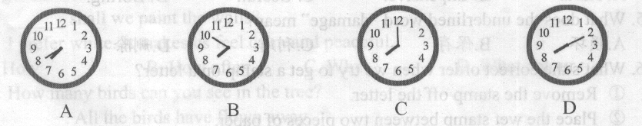

- What can we learn from the passage?
A. The story happened on a rainy day.
B. Robbie didn’t have to be told what to do.
C. Helen found it easy to do cleaning work at home.
D. Victor and Helen felt comfortable when they got home.
四、词汇（共10小题，每小题1分，满分10分）
注意：每空限填一个单词
A) 根据句子意思，用括号中所给单词的正确形式填空。
- A friend of ▲ (I) is getting married tomorrow.
- Look at the ▲ (photo). How beautiful they are!
- I know him probably ▲ (well) than anybody else.
- The boy doesn’t show good manners to others. He is ▲ (polite).
- I think his idea is worth ▲ (consider).
B) 根据句子意思及汉语提示，写出所缺单词。
- Take the ▲ (第二) turning on your right and you’ll see the museum.
- Her ▲ (声音) sounds sweet on the phone.
- I was ▲ (写) a report when the doorbell rang.
- There is no plant life ▲ (没有) lightning.
- When you get home, give a call to let me know you’ve ▲ (到达) safely.
五、阅读填词（共10小题，每小题1分，满分10分）注意：每空限填一个单词
阅读短文，根据所读内容在短文后图表中的空格里填入一个恰当的单词。
Some people believe that your nationality can influence your personality. This is why you might hear someone saying “She is a typical(典型的) Australian” or “He is so French”. It seems that people from a certain country share certain similar characteristics.
French
French people are often seen as romantic and outgoing people with a great love for life, food and wine. They are good at singing and dancing.
Chinese
Chinese are friendly people who are hard-working. They are polite because they are careful about “saving face” when dealing with other people.
Australians
Australians are merry people who spend a lot of time outdoors. They enjoy a slower life. They laugh a lot but sometimes people think they are loud and rude.
Germans
Germans are often described as being serious and careful. They are hard workers and pay a lot of attention to details. However, sometimes people say Germans have no sense of humour.
All these national types can be true for some people, but very wrong for others. For example, you might meet a German who is a confident singer with a great sense of humour, or an Australian who is shy and quiet.!

Personalities and Nationalities
Opinion | People from a certain country (51) ▲ similar characteristics
Examples | French | - Romantic and (52) ▲  - Love life, food and wine  - Good singers and (53) ▲
Examples | (54) ▲ | - Friendly, hard-working and polite  - Afraid of “(55) ▲ face” before others.
Examples | Australians | - Like to stay (56) ▲ ,enjoy a slower life.  - (57) ▲ a lot.  - Merry, sometimes loud and rude.
Examples | Germans | Pay attention to (58) ▲ .  Serious and careful, not (59) ▲ .
Conclusion | Nationalities may(60) ▲ personalities, but not for all!

六、任务型阅读（共5小题，每小题2分，满分10分）
阅读下面短文，按要求完成相关任务。
Ma Hua graduated from Fudan University. He had a good career in IT and a great life in Shanghai, but he felt there was something missing from his life. He wanted to help others to improve their lives, so in March 2003 he gave up his job. Then he moved to south-west China to do voluntary work in a village primary school.
He soon became an important member of the local people. In his class, he painted pictures on the walls to help students remember English words. He also spent his money building a playground for the children.
Ma Hua quickly got used to his new life. He got great satisfaction from his work and felt very happy, even though life there was hard---he had to melt(融化) ice for water and grow vegetables for food. When he was free, he wrote poems describing the peace and beauty around him. Sometimes he would go walking in the mountains and enjoy the beautiful view.
Sadly Ma Hua was killed in a car accident in July 2004 at the age of 31. His death was a great loss to all those who knew him, but it is a comfort to know that he lived happily, doing what he loved and enriching the lives of others.
- When did Ma Hua give up his job in Shanghai? ▲
- What did Ma Hua build for the primary school children? ▲
- Did Ma Hua enjoy his life in the village? ▲
- What did Ma Hua do in his free time? Give ONE example. ▲
- What can we learn from Ma Hua? ▲

七、书面表达（满分15分）
今天上午你经历了两件难忘的事情。请以 Learning to forgive others 为题，参照下表写一篇英语短文，简要描述事情的经过，并谈一下你的感悟。词数80左右，可适当发挥。短文已给出部分不计入总词数。
注意：文中不得出现真实姓名和校名。
事情经过 | 你的心情 | 你  的  感  悟  …
妈妈起晚了，没做早饭；  而且昨天忘洗你的校服了。 |  | 你  的  感  悟  …
上学路上，你骑车撞倒一位老人 |  | 你  的  感  悟  …
老人说：“我没事，孩子，上学去吧。” |  | 你  的  感  悟  …

Learning to forgive others

I will always remember what happened to me this morning.
▲ ▲ ▲
▲ ▲ ▲
▲ ▲ ▲
▲ ▲ ▲
▲ ▲ ▲
▲ ▲ ▲
▲ ▲ ▲
▲ ▲ ▲
▲ ▲ ▲
From these two things I know ▲ ▲
徐州市2012年初中毕业、升学考试
英 语 参 考 答 案
一、选择填空(共15小题, 每小题1分, 满分15分)
1. A 2. B 3. C 4.C 5.A 6.D 7.A 8.A 9.D 10.D 11.B 12.C 13.C 14. B 15. B
二、完形填空（共15小题，每小题1分，满分15分）
根据短文内容，从各题所给的ABＣＤ四个选项中选出最佳选项。
16.D 17.B 18.D 19.C 20. A 21. C 22.A 23. B 24.C 25. D 26 B 27 A 28 D 29 C 30 B
三、阅读理解(共10小题, 每小题1.5分, 满分15分)
阅读下面三篇短文, 从各小题所给的A、B、C、D四个选项中选出最佳选项。
31 A 32 D 33 C 34 C 35 A 36 B 37. B 38 C 39 D 40 D
四、词汇(共10小题, 每小题1分, 满分10分) 注意: 每空限填一个单词
A）根据句子意思，用括号中所给单词的正确形式填空。
41. mine 42. photos 43. better 44. impolite 45. considering
B）根据句子意思及汉语提示，写出所缺的单词。
46. second 47. voice 48. writing 49. without 50. Arrived
五、阅读填词（共10小题，每小题1分，满分10分）注意：每空限填一个单词
阅读短文，根据所读内容在短文后图表中的空格里填入一个恰当的单词。
51. share 52. outgoing 53. dancers 54. Chinese 55. losing
56. outdoors 57. Laugh 58. details 59. humorous 60. influence/affect
六、任务型阅读（共5小题，每小题2分，满分10分）
阅读下面短文，按要求完成相关任务。
61. In March 2003.
62. He built a playground for the primary school children.
63. Yes, he did./Yes.
64. He wrote poems describing the peace and the beauty around him. / He would go walking in the mountains and enjoy the beautiful view.
65. We should try to help others like him.
七、书面表达（满分15分）
(略)

