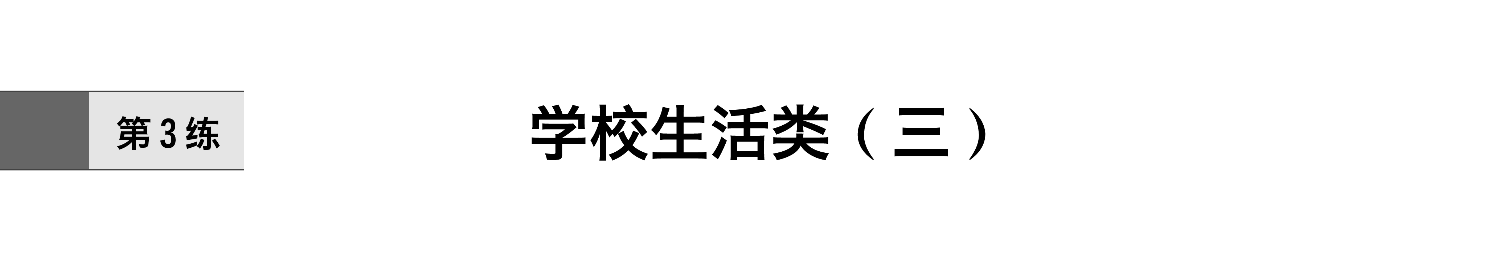


单词识记：
match nervous praise relax
spare volunteer spirit authority
equip monitor majority physics
playground scholarship assess handwriting
debate obtain enrich encouragement
短语扫描：
make up one’s mind 下定决心
check out结账离开
make progress in 在……方面取得进步
make an effort (to do sth.) 努力(做某事)
do/conduct/carry out/perform an experiment 做实验
explain sth.to sb.向某人解释某事
make use of利用
come up with想到；提出
have a good knowledge of 对……很熟悉；通晓
show interest in对……表现出兴趣
[跟踪训练]
在空格处填入适当的词(1个单词)或所给词的正确形式
1．Her success (encouragement) me to try the same thing.
2．A bit of exercise will help lift his (spirit)．
3．It’s (relax) to listen to music after a day’s work.
4．It’s vital we are as fresh as possible for those (match)．
5．When they leave school，they will (equip) for obtaining office jobs.
6．I’ve thought about it a lot，and now I’ve made my mind.
7．The desk was made use to help me to get the bottle.
8．An experiment was carried to check on the reliability of certain criteria.
9．He made progress English bit by bit with the help of his teacher.
10．She has showed great interest American drama since she was a child.

Ⅰ.语法填空
According to the Hong Kongbased newspaper Ta Kung Pao，Jackie Chan has participated 1. the promotion of many famous brands of clothing，shoes and food in recent years.Several days ago，he showed the public a 2. (limit) edition car,3. is especially made 4. his personal taste.
At the press conference in Singapore a few days ago，Jackie said that he 5. (cooperate) with Parjero，but the plan was stopped because of the sudden death of the car 6. (design)．Later he decided to work with Ralliart，one of the brands of Mitsubishi，and finally rolled out (正式推出) this car.Only 50 such cars will be available in the world.
As a car fan，Jackie has joined in 7. car design himself.The car,8. (decorate) with the symbols of “dragon”，is said to be comfortable and powerful.Jackie said that making this car was 9. (fulfill) his dream，not to make money.The price of the car has not been announced yet due to 10. status of the limited edition and different taxation systems all over the world.
Ⅱ.短文改错
On the first day when I went to high school，I felt exciting.After 9 years’ study，I felt I was so closely touniversity.During the first year，I made many friends.I got to know all of my classmates.Because the school work was tough，I shared happiness and sorrow for my friends.When second year came，I was arranged to other class.I was worried that no one could talk to me，but I made new friends quickly.Now it was the last year of my high school life，and I’m determined to study harder and make a greater progress.High school life is challenged for me，but I won’t give out.
Ⅲ.佳作背诵(学校生活)
(2013·四川)
某中学生英文报近期开辟专栏，讨论学习习惯问题。请你结合自身学习实际，按以下提示，用英文为该专栏写一篇稿件。
1．说明学习习惯与学习效果之间的关系；
2．介绍一种好的学习习惯并提出养成该习惯的建议；
3．描述自己在学习习惯方面存在的某个问题并给出改进措施。
注意：1.词数120左右，开头语已为你写好；
2．可以适当增加细节，以使行文连贯。
3．文中不得透露个人姓名和学校名称。
It’s useful and necessary to discuss learning habits.

参考范文
It’s useful and necessary to discuss learning habits.Our good learning habits will make us study more easily and efficiently and absorb knowledge completely.
Time is precious for us students，so in my opinion，making a suitable timetable is necessary and important for us to make good use of our time.Besides，the timetable should be updated according to the progress of our study from time to time.What’s more，once the timetable is made，we should follow it strictly.
But in fact，I often don’t quite follow my timetable because of some reasons.For example，playing football and watching TV take up much of my spare time.So I think we should have our parents or someone else supervise us every day.
A good learning habit is the key to success.To have a good learning habit is simple.Just make good use of your time！
加练半小时 英语答案精析
第3练 学校生活类(三)
高考高频单词与短语识记排查
1．encouraged 2.spirits 3.relaxing 4.matches 5．be equipped 6.up 7.of 8.out 9.in 10.in
知识运用与写作能力专练
Ⅰ.1.in 2.limited 3.which 4.to 5.should have cooperated 6.designer 7.the 8.decorated 9.to fulfill 10.its
Ⅱ.
On the first day when I went to high school，I felt .After 9 years’ study，I felt I was so to university.During the first year，I made many friends.I got to know all of my classmates. the school work was tough，I shared happiness and sorrow my friends.When \s\up7(∧) second year came，I was arranged to class.I was worried that no one could talk to me，but I made new friends quickly.Now it the last year of my high school life，and I’m determined to study harder and make a greater progress.High school life is for me，but I won’t give .

